# digitalocean/vulcan:

Vulcan extends Prometheus adding horizontal scalability and long-term storage

https://github.com/digitalocean/vulcan

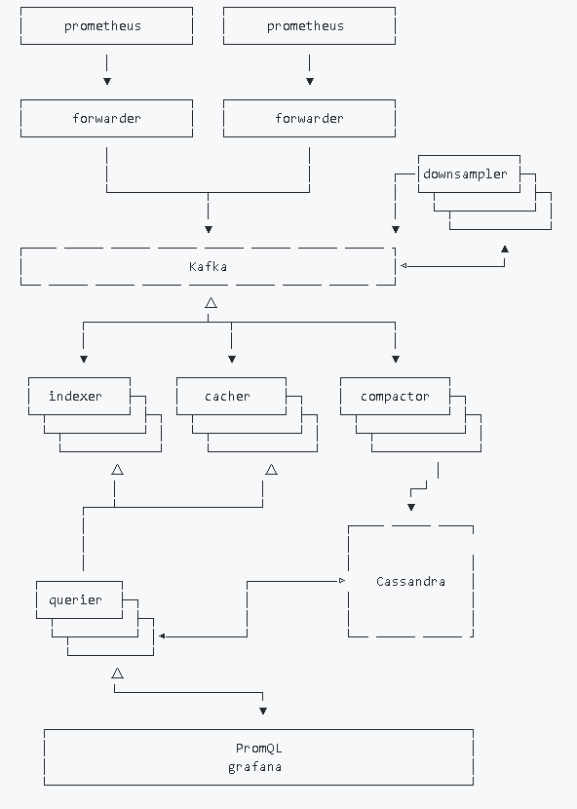

Vulcan

Vulcan extends Prometheus adding horizontal scalability and long-term storage.

Vulcan is highly experimental.

Why

Prometheus has an upper-limit on the number of samples it can handle and manually sharding Prometheus is difficult. Prometheus provides no built-in way to rebalance data between nodes once sharded, which makes accommodating additional load via adding nodes a difficult, manual process. Queries against manually-sharded Prometheus servers must be rethought since each Prometheus instance only has a subset of the total metrics.

It is difficult to retain data in Prometheus for long-term storage as there is no built-in way to backup and restore Prometheus data. Mirroring Prometheus (running multiple identically-configured Prometheus servers) is an option for high availability (and good for the role of monitoring), but newly created mirrors lack historical data and therefore don't provide historical data or any additional replication factor.

Vulcan is horizontally scalable and built for long-term storage. In order to accommodate growing load, add more resources to Vulcan. There is no need to think about how to shard data and how sharding will affect queries.

Prometheus (as of v1.2.1) is able to forward metrics to Vulcan. Existing Prometheus deployments can easily reconfigure their Prometheus servers to forward all (or just some) metrics to Vulcan. Prometheus can continue operating as a simple and reliable monitoring system while utilizing Vulcan for long-term storage.

Why the name Vulcan?

Vulcan is the roman god of fire, metalworking and of the forge. Raised in the [digital] ocean, Vulcan was charged with crafting the tools and weaponry.

Vulcan aims to enhance the Prometheus ecosystem. Thank you Prometheus for stealing us fire in the first place.

Architecture

Refer to [architecture.md](https://github.com/digitalocean/vulcan/blob/master/architecture.md)

Contributing

Refer to [CONTRIBUTING.md](https://github.com/digitalocean/vulcan/blob/master/CONTRIBUTING.md)

Contact

The core developers are accessible via the [Vulcan Developers Mailinglist](https://groups.google.com/forum/#!forum/vulcan-developers)

Ethos

Vulcan components should be stateless; state should be handled by open-source databases (e.g. Cassandra, Kafka).

Vulcan should be API-compatible with Prometheus. e.g. PromQL discussions and improvements should happen in the Prometheus community, committed to Prometheus, and then utilized in Vulcan.

License

Apache License 2.0, see [LICENSE](https://github.com/digitalocean/vulcan/blob/master/LICENSE).

# DigitalOcean's API-compatible alternative to Prometheus - 推酷

http://www.tuicool.com/articles/QfeaMrR

时间 2016-08-25 23:06:04  [Github](http://www.tuicool.com/sites/fyAnyi)

原文  [https://github.com/digitalocean/vulcan](http://www.tuicool.com/articles/hit/QfeaMrR)

主题 [DigitalOcean](http://www.tuicool.com/topics/11450143)[数据库](http://www.tuicool.com/topics/11000064)

Vulcan

Vulcan is an API-compatible alternative to Prometheus. It aims to provide a better story for long-term storage, data durability, high cardinality metrics, high availability, and scalability. Vulcan is much more complex to operate, but should integrate with ease to an existing Prometheus environment. Vulcan aims to be familiar to Prometheus with configuration and queries by understanding the Prometheus scrape configuration file and the Prometheus Query Language.

Vulcan is highly experimental.

Contributing

Refer toCONTRIBUTING.md

Contact

The core developers are accessible via the [***Vulcan Developers Mailinglist***](https://groups.google.com/forum/#!forum/vulcan-developers)

Ethos

Vulcan should use open-source databases (e.g. Kafka, ElasticSearch, Cassandra)

Vulcan should strive to be API-compatible with Prometheus. E.g. additional scraper job service discovery should be committed upstream to Prometheus then included in Vulcan. E.g. PromQL discussions and improvements should happen in the Prometheus community.

Architecture

┌─────────────────────┐

│prometheus exporters ├─┐

└─┬───────────────────┘ ├─┐

└─┬───────────────────┘ │

└─────────────────────┘

△

│

│

▼

┌─────────────────┐

│ scrapers ├─┐

└─┬───────────────┘ ├─┐ ┌────────────┐

└─┬───────────────┘ │ ┌─│downsamplers├─┐

└─────────────────┘ │ └─┬──────────┘ ├─┐

│ │ └─┬──────────┘ │

│ │ └────────────┘

▼ ▼ ▲

┌───────────────────────────────────────────────┐ │

│ KAFKA │────────────┘

└───────────────────────────────────────────────┘

△

┌────────────────┴─┬────────────────────┐

│ │ │

▼ ▼ ▼

┌────────────┐ ┌─────────────┐ ┌─────────────┐

│ indexers ├─┐ │ ingesters ├─┐ │ compactors ├─┐

└─┬──────────┘ ├─┐ └─┬───────────┘ ├─┐ └─┬───────────┘ ├─┐

└─┬──────────┘ │ └─┬───────────┘ │ └─┬───────────┘ │

└────────────┘ └─────────────┘ └─────────────┘

│ │ │

┌┘ └─┬──────────────────┘

│ │

▼ ▼

┌──── ───── ───── ┐ ┌──── ───── ────┐

│ │

│ │ │ │

│ ElasticSearch │ Cassandra │

│ │ │ │

│ │ │

└ ───── ───── ────┘ └── ───── ───── ┘

△ △

└──┬──────────────────┘

│

▼

┌──────────┐ ┌───────────┐

│ queriers ├─┐ │ PromQL │

└─┬────────┘ ├─┐ ┌────────▶│ grafana │

└─┬────────┘ │◁────────┘ └───────────┘

└──────────┘

Components

Scrapers

Scrapers put metrics onto the Vulcan metrics bus from prometheus exporters. They are a pool of workers that coordinate to share the load of polling all configured prometheus exporters and writing the polled metrics onto the bus (Kafka). Scrapers are configured in a familiar way to configuring the scrape jobs of a Prometheus server.

Downsamplers [ NOT IMPLEMENTED ]

Downsamplers put lower resolution metrics onto the Vulcan metrics bus. They are a pool of workers consuming the metrics bus populated by the scrapers and writing their lower resolution version of those same metrics back onto the bus (but in a different topic). Lower resolution data can be more easily retained for long periods of time. Downsamplers are configurable to a target resolution. This allows a scraper configured for a high-frequency 15s resolution to passively also write metrics at a lower 10m resolution.

Indexers

Indexers are a pool of workers that consume the metrics bus into a search database. Indexers do not care about the datapoints, rather, just what metrics exist. The search database is utilized by the querier in order to support the Prometheus Query Language.

Ingesters

Ingesters are a pool of workers that consume the metrics bus into a datapoint database. The datapoints recorded should be queryable as soon as they are written. Ingesters read both the scraper's topic and the downsampler's topic into separate databases. The querier can decide based on the Prometheus QueryL what resolution database is most appropriate to fulfil the query.

Compactors [ NOT IMPLEMENTED ]

Compactors are a pool of workers that consume the metrics bus into a datapoint database. Unlike the ingesters, the compactor does not immediately make metrics from the bus queryable. The compactor waits for a configurable time (e.g. 2 hours) per metric so that datapoints can be compressed and written into the datapoint database in a much more compact format. The querier attempts to fulfil a query from compacted data first, and then uncompressed data written by the ingesters. Compactors read both the scraper's topic and the downsampler's topic into separate databases.

Queriers

Queriers are a pool web nodes that provide the Prometheus HTTP query API. The querier parses PromQL and queries the appropriate databases to get the raw datapoints and evalutates the PromQL functions on the data.

License

Apache License 2.0, seeLICENSE.

# WebMuseum: Baburen, Dirck van: Prometheus being Chained by Vulcan

https://ibiblio.org/wm/paint/auth/baburen/prometheus/

Baburen, Dirck van 

Prometheus being Chained by Vulcan

1623; Oil on canvas, 202 x 184 cm; Rijksmuseum, Amsterdam

On the floor in a smithy lies Prometheus. The gods' smith, Vulcan, is fastening handcuffs on him, chaining him to a rock. Filled with pity, the messenger of the gods, Mercury watches this happening. The eagle which is to devour his liver every day - Prometheus' punishment for stealing fire from the gods and giving it to mankind - is hovering ominously in a corner. Van Baburen has presented this story from Greek mythology in all its dramatic power and significance. Prometheus, his face creased in anguish, churns the air with his arms. The treatment of light and the lifesize figures reflect the influence of the Italian painter [Caravaggio](https://ibiblio.org/wm/paint/auth/caravaggio/), with contrasts of light and shade, dramatic expressions and unidealized people with sun-tanned hands and faces.

Punishment

In the struggle between the gods of Olympus and the Titans, the Titan Prometheus supported the father of the gods, Jupiter. But when Jupiter revealed his repressive tendencies, Prometheus (meaning 'he who thinks ahead') chose for the side of humans. And against the wishes of Jupiter, he gave humankind the gift of fire. Enraged at this, Jupiter sentenced Prometheus to a terrible punishment. He was to be chained for all eternity to a rock, and an eagle was to peck out his liver every day. This torture would never cease, because during the night the liver would grow back again. But finally the torture was brought to an end by Hercules, Jupiter's own son, who unchained Prometheus.

Caravaggist

Dirck van Baburen spent some time in Italy. Like several other painters from Utrecht he came under the influence of the Italian artist, Caravaggio. The latter's dramatic treatment of light greatly appealed to Baburen, as did his tendency to use ordinary people as models. In his Prometheus painting he has used working men and women as lifesize models. The tanned hands and faces of Vulcan and Prometheus stand out in sharp contrast to the white skin of their bodies. The scene is dramatically illuminated with bright light. The artist Gerard van Honthorst made a drawing after Caravaggio's painting of the crucifixion of St Peter. Similar figures would have served as examples for Baburen's painting of Prometheus.

Painting style

Everything about this painting is huge and solid: both the figures and the clothes they are wearing. Van Baburen has placed small areas of paint side by side and made definite contours. Seen close-up, the painting is not smoothly finished. Some details appear inaccurate, such as the almost club-feet of the main character. However, Prometheus' hanging head and the foreshortening of his body are admirably presented. The double signature on the painting presents a puzzle. There is a clear signature below the right-hand shoulder of Prometheus. During a restoration of the painting a second signature was discovered at the lower left by Prometheus' hand.

There is a creation story connected with Prometheus. It relates how he made people from clay and then stole fire (knowledge) in order to give them life. At an auction in 1707 a painting by Baburen of Adam and Eve was sold together with the chained Prometheus. It is likely that the two works formed a pair. Indeed, Adam and Eve are associated with the Christian version of the creation story just as Prometheus is with the classical version.

Credits: [The Rijksmuseum](https://ibiblio.org/wm/about/credits.html#rijks), Amsterdam.

# 魔羯座守护神——权神伏尔甘（Vulcan）

_星座频道_新浪网 http://astro.sina.com.cn/l/2011-05-30/162072369.shtml

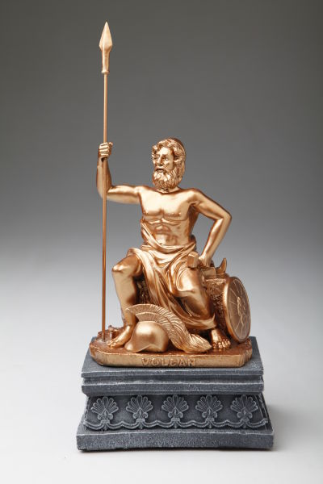魔羯座守护神——权神伏尔甘（Vulcan）

**简介**

　　伏尔甘是天神朱庇特之子，虽然其貌不扬，但他的灵魂和才智却十分卓越，而且天生具有操控火的能力，所以他能够轻而易举地冶炼出各式各样威力无穷的武器。诸神手中的神器几乎都是由他打造，比如福玻斯驾驶的太阳战车、爱神厄洛斯的金箭、铅箭和朱庇特的神盾等等，而且他还在奥林匹斯山上建筑了诸神的宫殿。可以说是伏尔甘分配了诸神的职权，建立了诸神的统治结构。他冶炼出的神器代表了诸神的权力和职责，所以在西方，将伏尔甘视作为象征权力的权神。

**伏尔甘的故事**

　　【伏尔甘与阿喀硫斯】

　　希腊的无敌战士阿喀硫斯是河神忒提斯所生，传说忒提斯在儿子出生后将其浸在冥河之中，阿喀硫斯因此获得不死之身。阿喀硫斯刚进军队时并没有得到多少拥戴，因为众将士认为他只是仗着自己的父亲柏硫斯爬上来的。在攻打特洛伊城时，正是由于军心没有统一，所以希腊人输的一败涂地。阿喀硫斯的母亲忒提斯知道，要打胜仗就要先得人心，稳定自己儿子的军权，于是她向权神伏尔甘求助。伏尔甘本身就站在希腊人的一边，因此他毫不犹豫就答应了。他亲自动手打造了一副比黄金还要闪亮的铠甲，比磐石还要坚硬的盾牌，比蛛丝还要坚韧的胫甲，还有一顶金光闪闪的头盔。阿喀硫斯穿上了这一身装备，显得威猛无比，浑身上下散发出一股强烈的王者气势。周围的军士们看到他，都以为是天神下凡，纷纷伏地跪拜。由此，阿喀硫斯被推崇为希腊军队中的战神与精神领袖，象征着无敌与胜利。

　　【伏尔甘与普罗米修斯的锁链】

　　普罗米修斯为了人类而偷盗天火的行为触怒了天神朱庇特，为了惩罚普罗米修斯，朱庇特想了很多办法，但都无一例外地失败了。因为普罗米修斯拥有非常聪明的头脑，任何情况下他都有办法逃脱制裁。最后，愤怒的朱庇特找到伏尔甘，恳请他打造一条最为坚固的锁链来捆住普罗米修斯。为了显示天庭的权威，伏尔甘用了三天三夜打造了一条坚固无比的锁链，后来普罗米修斯就一直被这条锁链缚在高加索山巅上，人类也因此再也不敢怀疑诸神的权威。

**伏尔甘的宝物**

　　【奥林匹斯熔炉】

　　前身是乌尔肯山，也是世间最大的一座火山，后来成为伏尔甘用来冶炼金属的熔炉，因为放置在奥林匹斯上而得名。太阳神的黄金战车、爱神的黄金弓箭、雅典娜的埃葵斯盾等神器都是出自于此。所以后人将奥林匹斯熔炉视为权力的源泉。

**伏尔甘在西方**

　　伏尔甘象征了经过千锤百炼之后获得的成功，同时亦代表了扎实稳固的权力。他给诸神打造神器，充当着一位幕后的权力分配者，这相当于企业中的管理人员和经济活动中的生产要素持有者，一个是分配权限和职责范围，另一个是提供生产要素。所以，西方的大型企业或是政坛中的掌权者往往都会供奉一尊伏尔甘的雕像来祈求自身权力的稳定与持久。

**魔羯座(也称山羊座)Capricorn  12.22-1.19**

　　魔羯座位于南天，是个主要由恒星构成的星座。它拥有清晰的轮廓，大而醒目，但是由于它没有一颗亮星，所以看起来显得严肃古板。

　　魔羯座的性格特点：严肃，现实，理智，孤独，坚强，执著，权利欲，控制欲过强，势力。

　　魔羯座所主宰的身体部位：骨关节、胆囊、周围神经。