Table of Contents

1. Introduction to Deep Learning 2

Lesson 1: Welcome to the Deep Learning Nanodegree 2

Lesson 2: Knowledge, Community, and Careers 2

Lesson 3: Get Help with Your Account 2

Lesson 4: Anaconda 3

Lesson 5: Applying Deep Learning 3

Lesson 6: Jupyter Notebooks 3

Lesson 7: Matrix Math and NumPy Refresher 3

2. Neural Networks 4

3. Convolutional Neural Networks 5

4. Recurrent Neural Networks 6

5. Generative Adversarial Networks 7

6. Deploying a Model 8

# 1. Introduction to Deep Learning

## Lesson 1: Welcome to the Deep Learning Nanodegree

## Lesson 2: Knowledge, Community, and Careers

1.1 Instructor: Cezanne & Matt & Luis

1.2 Program Structure

## Lesson 3: Get Help with Your Account

1.3 Community Guidelines

1.4 Career Portal

## Lesson 4: Anaconda

1.5 Anaconda

a. Create a conda environment: conda create -n [env_name] python=[2|3] *or* conda -n [env_name] python=[2|3] [package names]

b. Enter a conda environment: conda activate [env_name

c. List the libraries installed : conda list

d. Install packages (and dependencies): conda install numpy pandas matplotlib

e. Install Jupyter Notebook: conda install jupyter notebook

f. Remove a package: conda remove [package name]

g. Update a package version: conda update [package name *or* conda update --all

h. Search a package: conda search [package name] *(wildcard can be used, e.g.* conda search ‘*nump*’*)*

i. Exit from a conda environment: conda deactivate

j. Export a conda environment to a YAML file: conda env export > conda_environment.yaml

k. Create an environment with the name specified in the file from an YAML file: conda env create -f conda_environment.yaml

l. List all conda environments: conda env list *(* is the current env)*

m. Remove an environment: conda env remove -n [env name]

n. Practices :

* Create Python 2 environment: conda create -n py2 python=2
* Create Python 3 environment: conda create -n py3 python=3
* Create an conda environment for each project
* It is a good practice to share your conda & pip environment using conda env export > conda_environment.yamland pip freeze > pip_requirements.txt while sharing projects on GitHub

1.6 Anaconda & Miniconda

a. Anaconda

Anaconda is a distribution of software that comes with conda, Python, scientific packages and their dependencies.

b. Miniconda

Miniconda is a smaller distribution that includes only conda and Python

c. Conda

Conda is a program (a package and environment manager). It is similar with `pip`, default package manager

`pip` focuses on general use, while `conda` focuses on data science

1.7 Python 2 and Python 3

a. a print function works for Python 2.6+

|  |
| --- |
| *from __future__ import print_function*  *print(“Hello World”)* |

## Lesson 5: Applying Deep Learning

1.8 Deep learning applications

a. Style Transfer (go ./reference applications/Fast Style Transfer)

b. Deep Traffic (go ./reference applications/Deep Traffic/)

c. Flappy Bird (go ./reference applications/Flappy Bird/)

## Lesson 6: Jupyter Notebooks

1.9 Jupyter Notebook

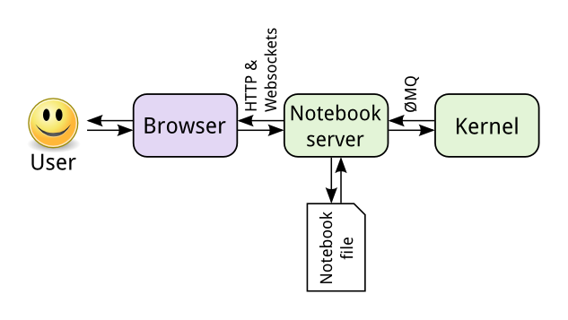

*(image from Jupyter documentation)*

Notebook seen by browser is a web application.

The web application connects Python/R/other kernel through notebook server.

Kernel runs Python/R code and sends back the results to server, then is rendered in the browser.

Saving the code actually saves a “.json” file on the server and a code text file “.ipynb”

**Advantages:**

1) Notebook and kernel are separate, so code in any language can be sent between server and kernel.

2) We can access to a remote server at anywhere where the data and notebook files are stored, e.g. Amazon EC2.

**Install Jupyter Notebook:**

Run conda install jupyter notebook or pip install jupyter notebook

**Launch jupyter notebook:**

Run jupyter notebook on the terminal

Default URL: http://localhost:8888

**Install kernels**: <https://ipython.readthedocs.io/en/latest/install/kernel_install.html>

**Install Notebook conda**: Run conda install nb_conda helps to manager conda envs

**Panels**



1) Files: files & folders

2) Running: list all currently running notebooks

3) Clusters: is taken over by *ipyparallel*

4) Conda: help manager conda environments

**Attention:**

1) Before shutting down, save all the changes in notebook

## Lesson 7: Matrix Math and NumPy Refresher

# 2. Neural Networks

# 3. Convolutional Neural Networks

# 4. Recurrent Neural Networks

# 5. Generative Adversarial Networks

# 6. Deploying a Model