Class04.R
liyixuan
2026-01-16
x <- 1:50
plot(x)
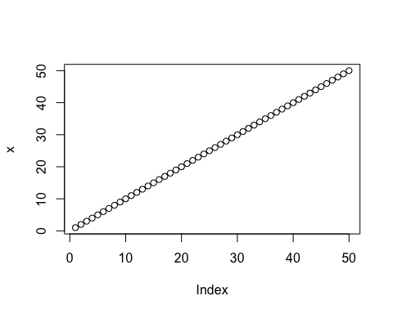
plot(x,sin(x),typ="l",col="blue",lwd=3, xlab="Is it lunch time yet")
