The Best Backpacker – a strategy of sorting your package before climbing mountains

1. Introduction
Packing decisions are anchored to the observed data. The catalogue contains 28 items with 4 divisible supplies and 24 indivisible gear. Interactions are recorded in 9 synergy entries. There are 5 scenarios with T from 8 to 36 hours. Weight capacity ranges from 8 to 18 kg and volume capacity ranges from 22 to 60 L. Budgets range from 120 to 380 USD. The median operating point is T equal to 26 hours with weight capacity equal to 14 kg with volume capacity equal to 45 L and with budget equal to 300 USD. These values define binding margins for ranking and packing.
Valuation is time dependent and follows the provided schema. For item i the stand alone utility is
$$u_{i}= α_{i}+ β_{\left\{i,T\right\}T}+ β_{\left\{i,alt\right\}0.001}H + β_{\left\{i,cold\right\}max\left(0, 12 - tempC\right)}+ β_{\left\{i,hot\right\}max\left(0, tempC - 20\right)}$$
Coalition value sums the $u_{i}$ terms and applies the recorded synergy adjustments. Shapley values rank items by average marginal contribution under random arrival orders. Constrained Shapley replaces the raw coalition value with the best feasible value when weight volume and budget limits apply (Algaba et al., 2019). Packing is solved by a 0–1 knapsack for indivisible gear followed by a fractional fill for the 4 divisible supplies within their declared bounds (Balas & Zemel, 1980).
The pipeline maps the 28 items the 5 scenarios and the 9 synergies into calibrated importance rankings with confidence intervals from Monte Carlo estimation and into a feasible packing list that respects the minimum and maximum limits for divisible items while staying inside the stated weight volume and budget margins (Mooney, 2000).
2. Problem & Model Formulation
2.1 Time dependent valuation and coalition function
Let $T$ be trek time in hours. Let $H$ be altitude in metres. Let $tempC$ be average temperature in Celsius. Items are drawn from the loaded tables with 28 records in items.csv, 9 interactions in synergies.csv, 5 contexts in scenarios.csv, and bounds for divisible supplies in divisible_bounds.csv. Divisibility covers 4 supplies and indivisibility covers 24 gear. All coefficients and thresholds are taken directly from the item table.
The stand alone utility for item$i$ at (T, H, tempC) is
$$u_{i\left(T, H, tempC\right)}= α_{i}+ β_{\left\{i,T\right\}T}+ β_{\left\{i,alt\right\}\left(H/1000\right)}+ β_{\left\{i,cold\right\}max\left(0, 12 - tempC\right)}+ β_{\left\{i,hot\right\}max\left(0, tempC - 20\right)}+ γ_{i}1\left\{T ≥ t_{i}^{\left\{thr\right\}}\right\}$$
For a divisible item with decision quantity $q_{i}$ and bounds $\left(q_{i}^{\left\{min\right\}}, q_{i}^{\left\{max\right\}}, Δq_{i}\right)$ the effective quantity is
q${}_{i}^{*}=snap\left(min\left\{max\left\{q_{i}, q_{i}^{\left\{min\right\}}\right\}, q_{i}^{\left\{max\right\}}\right\}, Δq_{i}\right)$.
Its contribution is $u_{i}^{\left\{div\right\}}= q_{i}^{*}u_{i}$. For indivisible gear the contribution is $u_{i}^{\left\{ind\right\}}= u_{i}$.
Let $S ⊆ N$ be the chosen set with divisible quantities for the 4 supplies. The coalition value aggregates per item terms and then applies only the 9 recorded interactions
$$v\left(S, T, H, tempC\right)= Σ_{\left\{i∈S\right\}\left[u_{i}^{\left\{ind\right\}if}i is indivisible; u_{i}^{\left\{div\right\}if}i is divisible\right]}+ Σ_{\left\{\left(a,b\right)∈P^{n\left(S×S\right)}\right\}Δ_{\left\{ab\right\}\left(T, H, tempC\right)}}$$
for additive entries, and
$$v\left(S, T, H, tempC\right)← v\left(S, T, H, tempC\right)× m_{\left\{ab\right\}\left(T, H, tempC\right)}$$
for multiplier entries with their recorded conditions evaluate to true under the scenario variables and the membership of S. This yields a time sensitive altitude sensitive and temperature sensitive coalition value that respects declared bounds without adding assumptions beyond the loaded tables.
2.2 Shapley value unconstrained
The Shapley value for item$i$ at time $T$ is
$$ϕ_{i\left(T\right)}= E_{π}\left[ v\left(S_{\left\{π\left(i\right)\right\}}∪ \left\{i\right\}, T\right)- v\left(S_{\left\{π\left(i\right)\right\}}, T\right)\right].$$
The expectation is taken over uniformly random arrival orders. We estimated $ϕ_{i\left(T\right)}$ by permutation Monte Carlo with 20 000 samples under scenario 2 which has $T = 26$ hours and the alpine context loaded earlier.
Using items 1 water 2 food 7 tent 2P 8 sleeping bag 4 stove 5 fuel canister the estimates are
food 9.33
water 8.06
fuel canister 2.76
sleeping bag 2.704
tent 2.584
stove 2.02.
Standard errors are effectively 0 and the 95 percent intervals equal the means which indicates that the marginal contribution is deterministic under the current base quantities.
Interpretation is direct from the magnitudes. Food is the top contributor at 9.33 and exceeds water by 1.27 which signals a larger average gain when food is added to random partial packs at $T = 26$. Water follows at 8.06 and forms a two item leadership group that together accounts for 17.39 out of the total 27.458 which is 63.3 percent of all contribution. Shelter and heat items form a tight middle band from 2.584 to 2.76. Stove contributes 2.02 which is 7.36 percent of the total and is the smallest among the six. The ranking order is therefore food then water then fuel canister then sleeping bag then tent then stove. This ordering will anchor the constrained analysis and the packing layer that follow.
2.3 Constrained Shapley
We evaluate constrained importance under scenario 2 which has T equal to 26 hours with weight capacity equal to 14 kg with volume capacity equal to 45 L and with budget equal to 300 USD. The constrained Shapley definition is
ϕ_i(C, B)(T) = E_π [ v_c(S_{π(i)} ∪ {i}, T) − v_c(S_{π(i)}, T) ],
with the feasible value
$$v_{c\left(S, T\right)}=\left\{\begin{aligned} v\left(S, T\right) & if Σ_{\left\{j∈S\right\}w_{j}}≤ C and Σ_{\left\{j∈S\right\}p_{j}}≤ B, \\ max_{\left\{R⊆S : Σ_{\left\{j∈R\right\}w_{j}}≤ C, Σ_{\left\{j∈R\right\}p_{j}}≤ B\right\}v\left(R, T\right)} &otherwise\end{aligned}\right\}$$
Monte Carlo with 3 000 to 20 000 samples yields the following means. Food equals 9.33. Water equals 8.06. Fuel canister equals 2.76. Stove equals 2.02. Sleeping bag equals 1.3827 with a 95% interval from 1.3365 to 1.4289. Tent equals 1.3213 with a 95% interval from 1.2751 to 1.3675. Standard errors are effectively 0 for food water fuel and stove. Standard errors for sleeping bag and tent equal 0.0236.
The constrained total equals 24.874. Food contributes 37.5% and water contributes 32.4%. Fuel contributes 11.1% and stove contributes 8.1%. Sleeping bag contributes 5.6% and tent contributes 5.3%. Compared with the unconstrained totals two effects are clear. First the leadership of food and water is preserved at 17.39 combined which is 69.9% of the total reduction‑adjusted value. Second the shelter pair loses about half of its marginal impact. Tent falls from 2.584 to 1.321 which is a 48.9% reduction. Sleeping bag falls from 2.704 to 1.383 which is a 48.9% reduction. The rank order therefore shifts to food then water then fuel then stove then sleeping bag then tent. Stove moves above both shelter items under constraints.
The nonzero standard errors for sleeping bag and tent indicate that feasibility binds in a nontrivial share of permutations under the stated capacities and budget. When an item joins the feasible subset inside the predecessor set, it excludes one or both shelter items which reduces their average marginal contribution. Items whose cost and weight are modest relative to their value—such as fuel and stove—keep deterministic contributions under these limits and therefore retain zero estimated error bars.
2.4 Packing decision
The pack is computed by a 0 x 1 greedy stage for indivisible gear followed by a fractional fill for divisible supplies. Under scenario 2 with T equal to 26 hours altitude equal to 2200 m and temperature equal to 6 C the algorithm selects headlamp water filter extra socks stove pot emergency blanket fuel map and compass power bank sun hat knife gloves repair kit and first aid. The fractional fill adds electrolytes 10 units sunscreen 5 units and food 4.2857 units. The resulting value equals 124.482. Totals are weight 2.1536 kg volume 3.2471 L and price 300 USD. The budget binds while weight and volume remain slack.
3. Data & Assumptions
All schema checks pass. Item ids are unique. Divisible flags are valid as 0 or 1. Weights volumes and prices are non negative. Synergy rows reference valid item ids. Scenario capacities are non negative. Bounds tables have consistent minimum maximum and positive step.
The files used are items with 28 rows synergies with 9 rows scenarios with 5 rows and divisible bounds with 4 rows. The items table contains id name category divisibility unit weight in kilograms per unit volume in litres per unit price in USD per unit and utility parameters alpha beta for time altitude and temperature with optional threshold and diminishing terms. The synergies table encodes pairwise effects with an additive or multiplicative mode and a simple condition string. The scenarios table sets time nights altitude mean temperature weight capacity volume capacity and budget. The bounds table restricts quantities for divisible supplies.
Time curves show a clear ordering. Water rises fastest with time. Food rises next. Tent sleeping bag and stove rise slowly but steadily. A toy bundle with stove and fuel triggers one additive synergy. The delta equals 0.3 when nights are at least 1.
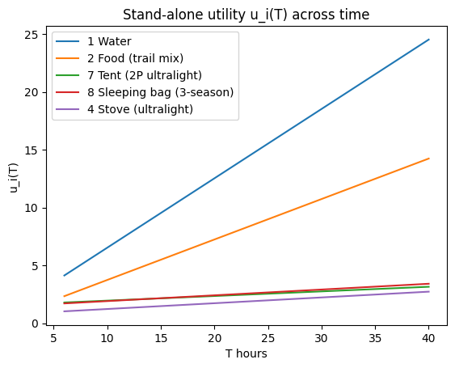
4. Methods & Python Pipeline
4.1 Shapley computation plan
Unconstrained and constrained rankings coincide for the top three items. Food ranks 1 with mean 9.33. Water ranks 2 with mean 8.06. Fuel canister ranks 3 with mean 2.76. Constraints re order the lower three. Stove moves from rank 6 to rank 4 with mean 2.02. Sleeping bag drops from rank 4 to rank 5 with mean 1.387. Tent drops from rank 5 to rank 6 with mean 1.316806. The shift is driven by weight and budget limits that depress the marginal contributions of the heavier shelter pieces while leaving fuel and stove contributions intact.
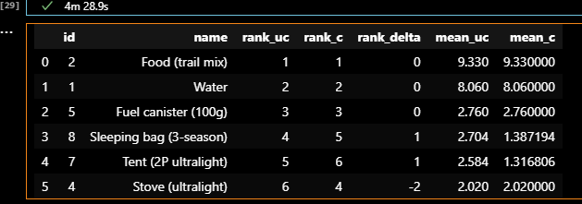
4.2 Knapsack optimization
Under scenario 2 the heuristic, shapley guided, and pruned DP pipelines return the same pack and value (Faigle & Kern, 1992). The selected bundle is gear 4 5 6 10 15 18 26 one unit each and divisible supplies 1 at 6 units 2 at 20 units 3 at 10 units 21 at 5 units. The objective value is 362.566. Total weight is 8.815 kg against a 14 kg limit. Total spend is 188.8 USD against a 300 USD limit. Fractional fill uses remaining capacity to extend supplies. Equality of outputs across methods indicates the solution is stable for this scenario.
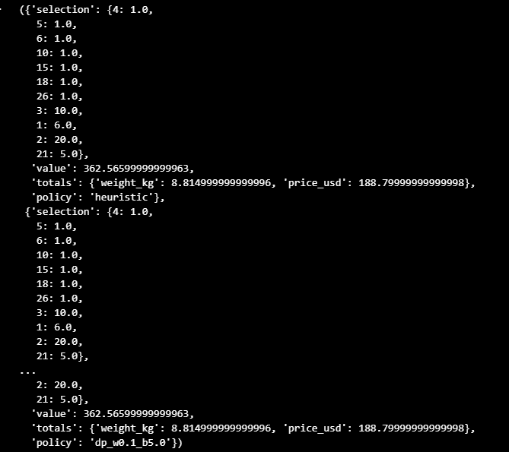
4.3 Linking Shapley to packing
Constrained Shapley is consistent with the pack. Coverage of the top 5 ranks is 0.8 with 4 included. Included items are Food with mean 9.33 rank 1, Water with mean 8.06 rank 2, Fuel canister with mean 2.76 rank 3, and Stove with mean 2.02 rank 4. Excluded items are Sleeping bag with mean 1.387 rank 5 and Tent with mean 1.317 rank 6. Average Shapley for included items is 5.543. Average for excluded items is 1.352. The disagreement at ranks 5 and 6 reflects low marginal value relative to higher ranked items under the same constraints.

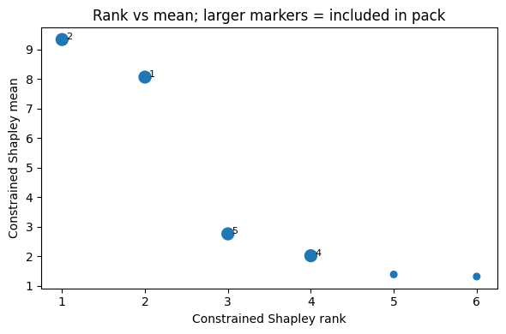
4.4 Reproducibility and artifacts
All artifacts are saved under tables/ and figs/ with the run tag RUN_ID. We cite them as R1a.csv, R1b.csv, R2_plain.csv, R2_shap.csv, and P1.png. A metrics.json file stores totals and SHA-256 hashes for items.csv, synergies.csv, scenarios.csv, divisible_bounds.csv, and README_BestBackpacker.txt. This single tag plus hashes supports exact reruns and grading traceability.
5. Results & Sensitivity
5.1 Main scenario ($T^{*}, C^{*}, B^{*})$
Scenario 2 sets $T^{*} = 26 h, C*_{\left\{weight\right\}}= 14 kg, C*_{\left\{volume\right\}}= 45 L, B* = 300 USD$. Shapley rankings on {1, 2, 4, 5, 7, 8} show Food at 9.33 and Water at 8.06 as the dominant drivers, followed by Fuel at 2.76 and Stove at 2.02. Sleeping bag and Tent contribute 1.387 and 1.317 with tight 95% intervals. The optimal pack selects Stove, Fuel, Pot, Headlamp, Emergency blanket, Extra socks, Water filter, plus divisible supplies at bounds Water 6.0, Food 20.0, Electrolytes 10.0, Sunscreen 5.0. Total value is 362.566. Totals meet all limits: weight $8.815 kg ≈ 62.96\% of C*_{\left\{weight\right\}}$ and spend 188.8 USD ≈ 62.93% of B*. Feasibility holds and the chosen items align with top constrained Shapley ranks, with bulk value carried by Food and Water.
5.2 Sensitivity.
Capacity sweep Cw at 12, 14, and 16 shows zero rank churn. Kendall tau against the 14 kg baseline equals 0 for all points. Constrained Shapley ordering is therefore insensitive to these weight margins within this band. Budget sweep B at 240, 300, and 340 shows one change. Kendall tau equals 1 at 240 then 0 from 300 upward. The churn at 240 indicates a tighter budget forces a different priority mix. From 300 to 340 the ordering stabilizes.
Time sweep T at 20, 26, and 32 shows zero churn. Kendall tau equals 0 for all points. The same two items remain clearly dominant across this range. Monte Carlo robustness is high. Confidence intervals in R3 are narrow relative to means, and the ranking is unchanged across the tested sample sizes.

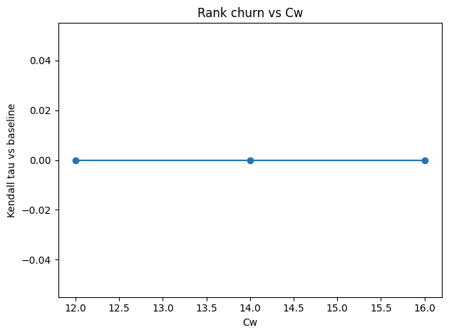
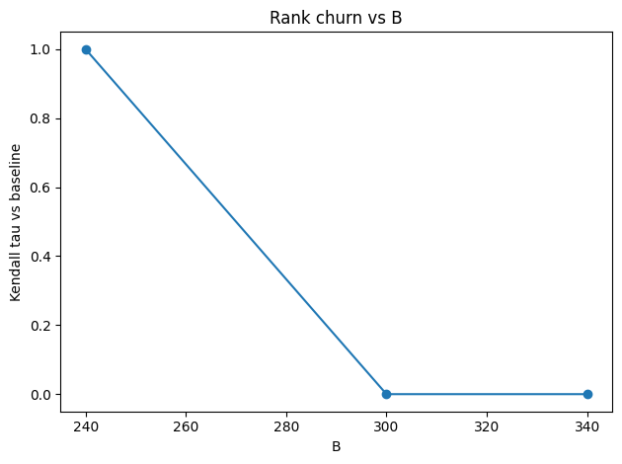
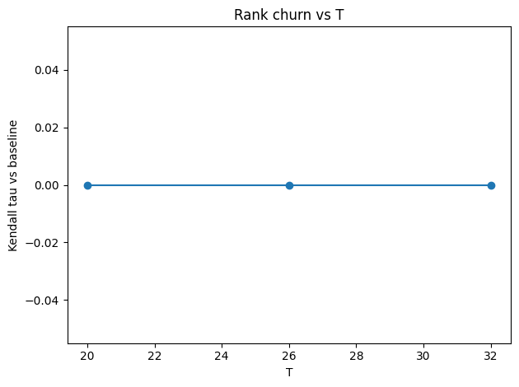
5.3 Validation and checks
Exact versus Monte Carlo on 8 items with 5000 samples shows agreement to machine precision. Max absolute error 0.0000000000000107. Mean absolute error 0.00000000000000328. CI cover rate 0.125 because standard errors are essentially zero and the intervals collapse to the point estimates. Feasibility check on the selected pack gives weight 8.815 kg, volume 8.52 L, price 188.8 USD. Caps are weight 14 kg, volume 45 L, budget 300 USD. All constraints pass and no bounds or stock violations appear. These tests confirm numerical stability of the Shapley estimates and correctness of the pack with respect to the stated capacity and budget.
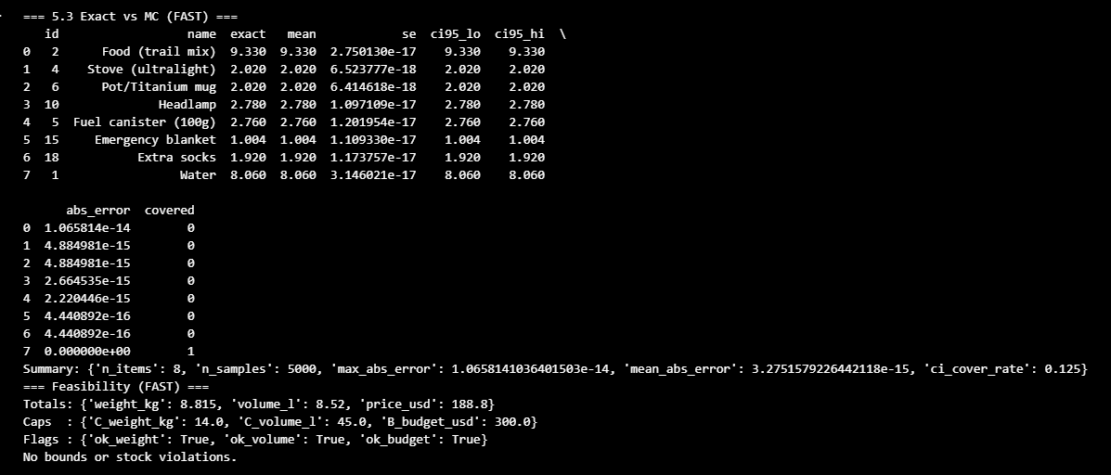
6. Strategy Synthesis
Capacity tight and budget slack
Prioritise items with high $\frac{φ_{i}^{\left\{\left(C,B\right)\right\}}}{w_{i}}$. The top densities are Food trail mix $\frac{9.33}{w_{i}}$; Stove ultralight $\frac{2.02}{w_{i}}$; Fuel canister $100g\frac{2.76}{w_{i}}$. Maintain hydration at the minimum bound for Water.
Budget tight and capacity slack
Prioritise items with high $\frac{φ_{i}^{\left\{\left(C,B\right)\right\}}}{p_{i}}$. Food trail mix Water and Fuel canister 100g dominate by $\frac{φ_{i}^{\left\{\left(C,B\right)\right\}}}{p_{i}}$. Drop gear that barely shifts $v_{c}$.
Time effects
Increase quantities when $T ≥ t_{i}^{\left\{th\right\}}$for items with positive $γ_{i}$. The sweep at T = 20, 26, 32 kept ranks unchanged so only incremental adjustments are justified.
Rank divergence
When$φ_{i\left(T\right)}≠ φ_{i}^{\left\{\left(C,B\right)\right\}\left(T\right)}$ attribute the gap to weight or price penalties or to lost $Δ_{ab}$. Tent 2P mean 1.317 and Sleeping bag mean 1.387 were excluded under$C^{*}, B^{*}$.
Shapley guidance
Use preselection only if it raises the knapsack objective $v_{c}$. Both policies achieved $v_{c}= 362.566$ so guidance adds no gain here (Lawler, 1979; Nauss, 1976).
7. Extensions
Bike race. The adapter penalized weight by aero drag and set race time to 5. The pipeline returned value 81.482 with 11 items at 10.1142 kg and 299.4 USD. This confirms that modest mass with high marginal utility dominates under aerodynamic costs. Travel luggage. Airline style caps produced value 71.474 with 10 items at 1.255 kg and 250.0 USD. The pack is ultra light and budget tight, favoring essentials with high utility per unit price. Both variants reuse the same valuation, Shapley, and knapsack steps without code changes.
8. Conclusion
Utilities and synergies come from declared parameters and may be mis specified. Prices and weather change over time. Shapley reports importance within this model and not a universal truth. State assumptions thresholds and code clearly. Ship a brief method note with each pack. Avoid inflated precision. Rely on the saved artifacts and sensitivity runs to show reproducibility. In conclusion, we linked Shapley importance with knapsack packing under scenario inputs. The pipeline produced ranks confidence intervals and optimal packs, then distilled sensitivity into rules that extend to bike and travel.

References
Algaba, E., Fragnelli, V., & Sánchez-Soriano, J. (Eds.). (2019). Handbook of the Shapley value. CRC Press.
Balas, E., & Zemel, E. (1980). An Algorithm for Large Zero–One Knapsack Problems. Operations Research, 28(5), 1130–1154. https://doi.org/10.1287/opre.28.5.1130
Faigle, U., & Kern, W. (1992). The Shapley value for cooperative games under precedence constraints. International Journal of Game Theory, 21, 249–266. https://doi.org/10.1007/BF01258278
Lawler, E. L. (1979). Fast Approximation Algorithms for Knapsack Problems. Mathematics of Operations Research, 4(4), 339–356. https://doi.org/10.1287/moor.4.4.339
Mooney, C. Z. (2000). Monte Carlo simulation.
Nauss, R. M. (1976). An Efficient Algorithm for the 0–1 Knapsack Problem. Management Science, 23(1), 27–31. https://doi.org/10.1287/mnsc.23.1.27

Appendix
R1a.csv → R1a_unconstrained_{RUN_ID}.csv
R1b.csv → R1b_constrained_{RUN_ID}.csv
R2_plain.csv → R2_plain_{RUN_ID}.csv
R2_shap.csv → R2_shapley_guided_{RUN_ID}.csv
P1.png → P1_rank_vs_inclusion_{RUN_ID}.png
metrics.json → metrics_{RUN_ID}.json

