Assessing the Wildfire Impacts on Terrestrial Vertebrate Biodiversity in Los Angeles Using MaxEnt and Remote Sensing
Abstract
This study aimed to quantify the impacts of the 2025 Los Angeles wildfires and to examine whether different taxonomic groups exhibit heterogeneous responses to fire severity for better post-fire biodiversity management. Using 10‑m Sentinel‑2 imagery and a U‑Net deep learning model, we mapped burn extent and severity. Habitat changes for 224 species were modeled with MaxEnt, followed by Generalized Additive Models to identify ecological tipping points and Multiscale Geographically Weighted Regression to assess spatial non‑stationarity. The fires burned 213.52 km², with 56.1% of the study area experiencing species richness declines (up to 41 species per pixel). Amphibians suffered the most widespread loss (70.96% of research area), reptiles showed the highest sensitivity (tipping point: −0.06), while mammals exhibited complex behavior. Areas away from places that fire happened also showed biodiversity decline. All these phenomena may due to the characteristics of different taxon, the wildfire history, fire-caused soot deposition and microclimatic changes. Fire effects were non‑stationary, including a positive buffering patch in the southern Palisades fire boundary. Based on these findings, we propose a differentiated post‑fire conservation framework that integrates fire intensity zoning, micro‑refugia creation for reptiles and amphibians, dynamic buffer zones along fire boundaries to support mammal congregation, and taxon‑specific intervention thresholds to provide a case study for adaptive management in Mediterranean‑climate regions.
Keywords: Wildfire; MaxEnt; U-Net; Fire intensity; Biodiversity conservation; Biodiversity

1. Introduction
Global warming has intensified the frequency and severity of extreme wildfires. As a major natural disturbance in terrestrial ecosystems, wildfires trigger cascading ecological effects(Yue Chao et al., 2020). They reshape vegetation structure and carbon cycling, and by destroying habitats and food resources, force species to migrate or lead to local extinction(Mosquera-Guerra et al., 2024; North et al., 2024). However, ecosystem responses to fire disturbance are highly heterogeneous(Steel et al., 2019). Moderate wildfire regimes can create diverse microhabitats and unique ecological niches, maintaining community dynamics and species reproduction(Zheng et al., 2025), whereas extreme wildfires may drive population collapses.
Southern California’s Mediterranean climate, characterized by wet winters and dry summers, promotes rapid biomass accumulation followed by abundant summer fuels. In January 2025, the Los Angeles experienced two major wildfires—the Eaton Fire and the Palisades Fire—ranked as the second and third most destructive in California’s history(Insurance Institute for Business ＆ Home Safety, 2025). While the socio‑economic impacts of these fires have been widely reported(Defense, 2025; The Los Angeles Wildfires, 2025), their effects on suitable habitats and biodiversity remain poorly understood. Los Angeles harbors rich biodiversity, compared to highly mobile birds(Mendelsohn et al., 2008), terrestrial vertebrates (amphibian, reptile, and mammal) are more sensitive to habitat alteration and possess limited dispersal capacity under acute disturbance, making them ideal indicator groups for assessing wildfire impacts. Nevertheless, comparative studies examining how wildfires impact distribution patterns across these three classes are scarce.
Species distribution models (SDMs), particularly MaxEnt, are widely used to assess potential habitats(Cai J et al., 2014). However, most applications focus on gradual changes in climate and land cover(Song et al., 2026), with few incorporating fire as a dynamic disturbance. Recent advances in multi‑source remote sensing enable efficient monitoring of fire boundaries, burn severity, and vegetation succession, allowing large‑scale, high‑spatiotemporal‑resolution assessment of fire effects(Xu et al., 2025). Key habitat variables—such as fractional vegetation cover (FVC), land use and land cover (LULC), and topographic wetness index (TWI)—can be derived from remote sensing, providing a reliable basis for quantifying pre‑ to post‑fire habitat changes.
Traditional global regression models assume spatial stationarity and are increasingly inadequate for capturing the spatially heterogeneous effects of fire. In reality, the impacts of fire on species distributions are modulated by topography and vegetation heterogeneity, resulting in significant spatial non‑stationarity. Geographically weighted regression (GWR) is well‑suited to capture such heterogeneity(Lu et al., 2020), Multiscale Geographically Weighted Regression (MGWR), evolved from GWR, is an ideal tool to analysis this kind of spatial heterogeneity(Fotheringham et al., 2017). Although GWR and its variants has been applied to analyze wildfire drivers(Pahlavani et al., 2024), its use in assessing spatial variation in biodiversity responses to fire remains under‑explored.
This study aims to address three objectives:(1) delineating the extent and severity of wildfire using high‑resolution Sentinel‑2 imagery and a U‑Net convolutional neural network;(2) mapping the changes in distribution hotspots of terrestrial vertebrate species (mammal, amphibian, and reptile) before and after the 2025 Los Angeles wildfires using MaxEnt;(3) assessing the fire tolerance of different species and the spatial heterogeneity of fire impacts, based on these findings, we have ultimately proposed a preliminary framework for post-fire biodiversity conservation in Los Angeles, along with a practical approach to post-fire management.

2. Materials and Methods

2.1 Study Area
Los Angeles is located in southern California, USA, with a land area of approximately 1,215 km². Situated in a Pacific coastal basin, land use there comprises a highly heterogeneous urban–natural mosaic, natural land cover is concentrated mainly in the central mountains and parts of the southwestern coast, whereas the southern and southeastern areas are predominantly built-up. Los Angeles has a Mediterranean climate, wet winters and dry summers drive rapid biomass accumulation and the subsequent formation of abundant summer fuels(Rundel et al., 2018), and frequent wind events promote the ignition and rapid spread of extreme wildfires. These wildfires frequently encroach upon the urban–natural interface(Ermitão et al., 2024; Zabeo et al., 2025), severely disrupting species habitats and biodiversity(Goldberg et al., 2025). The unique climate–fire regime and complex land surface of the region provide a typical model for quantifying the ecological effects of wildfires on biodiversity and their spatial heterogeneity.
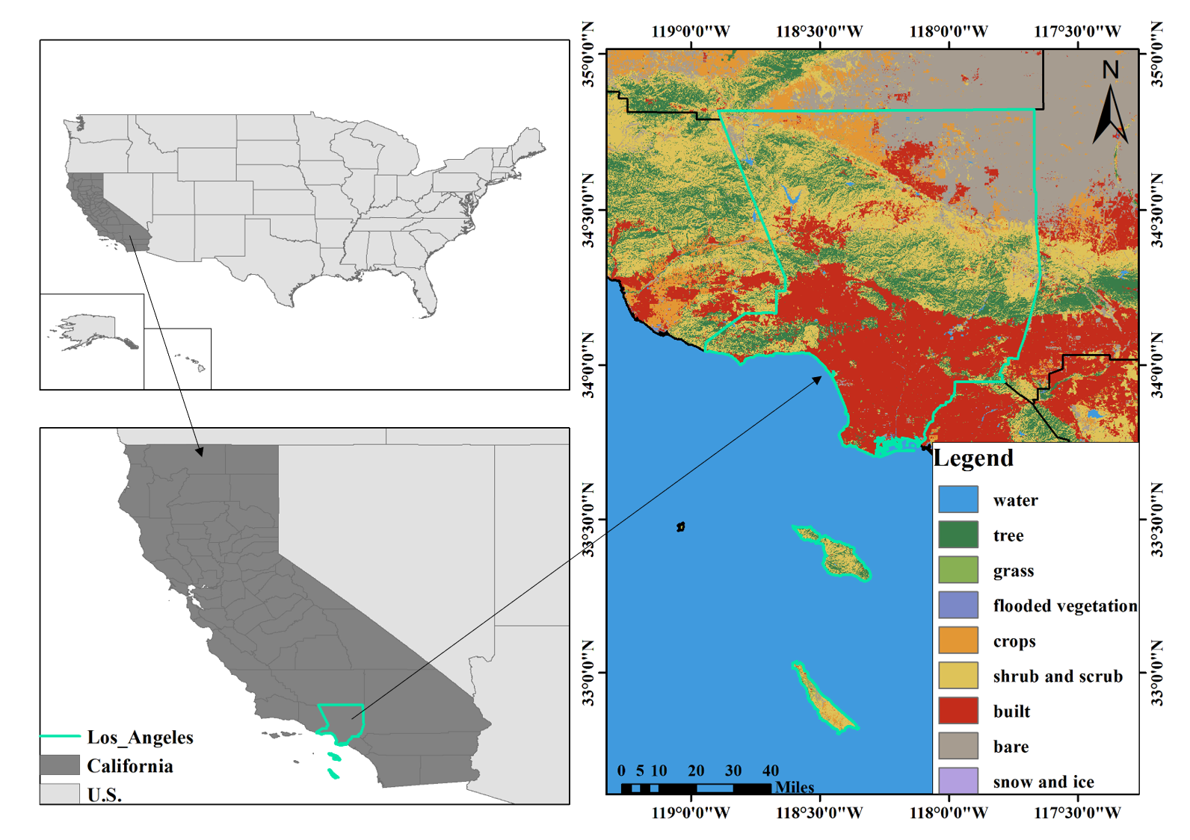
Figure 1. Overview of the study area. Left: location of the study area; Right: land use and land cover within the study area

2.2 Wildfire Extraction Using Sentinel-2 and U-Net
Currently widely used global burned area products (such as MCD64A1, GFED4 and GIO-GL1) have relatively coarse spatial resolution, which limits their ability to identify small-scale and highly fragmented wildfire events(Roy & Boschetti, 2009). Furthermore, due to mixed-pixel effect, these products are often subject to a high degree of uncertainty in landscapes characterized by significant heterogeneity(Chuvieco et al., 2019). To improve the spatial accuracy of wildfire-affected area identification, this study utilized 2025 Sentinel-2 multispectral imagery with a spatial resolution of 10 m to extract the extent of the wildfire. The Normalized Burn Ratio (NBR) and the Differenced Normalized Burn Ratio (dNBR) effectively reflect changes in the spectral characteristics of vegetation before and after burning, and are important indicators for mapping wildfire-affected sites(Giglio et al., 2018; Loboda et al., 2007). Consequently, for wildfire detection, NBR and dNBR were calculated using the following formulas:
$$\begin{aligned}NBR={(ρ}_{NIR}−ρ_{SWIR2})/{(ρ}_{NIR}+ρ_{SWIR2})\#(1)\end{aligned}$$
$$\begin{aligned}dNBR={NBR}_{preFire}−{NBR}_{postFire}\#(2)\end{aligned}$$
where $ρ_{NIR}$ and $ρ_{SWIR2}$ denote the surface reflectance in the near-infrared and shortwave infrared bands, respectively. In addition, to reduce interference from water in the identification of burned areas, this study further computed the Normalized Difference Water Index (NDWI) as follows:
$$\begin{aligned}NDWI=(ρ_{Green}−ρ_{NIR})/(ρ_{Green}+ρ_{NIR})\#(3)\end{aligned}$$
where $ρ_{Green}$ and $ρ_{NIR}$ denote the surface reflectance in the green and near-infrared bands, respectively.
In the preliminary identification of burned areas, a threshold-based classification was used to screen potential burned pixels. Pixels were classified as potential burned when they simultaneously satisfied ${NBR}_{preFire}>0$, ${NBR}_{postFire}<0$, $dNBR>0.25$, and $NDWI<0.3$. Burned samples were then extracted from contiguous 32 × 32–pixel image patches in which all pixels were identified as burned, yielding 1,229 positive samples. An equal number of negative samples were randomly selected from unburned areas to construct the training dataset.
Based on the above dataset, this study constructed and trained a convolutional neural network model (U-Net) to learn the spatial distribution characteristics of wildfires(Rana et al., 2026; Ronneberger et al., 2015). Given the limited number of training samples, data augmentation strategies such as random rotation and horizontal and vertical flipping were employed during model training to enhance the model’s generalization ability. Information entropy is used to quantify the pixel-level uncertainty of fire detection results, as shown in the following formula:
$$\begin{aligned}f(P)=−P\log{P}−(1−P)\log{(1−P)}\#(4)\end{aligned}$$
where P represents the probability that a pixel is predicted to be a burnt pixel. The higher the information entropy, the greater the uncertainty in the classification result.
Furthermore, to evaluate the destruction level within the detected burned areas, fire severity was characterized by dNBR. Based on the United States Geological Survey (USGS) standards (www.usgs.gov), the specific dNBR thresholds used for severity classification in this study are presented in Table 1.
Table 1. Fire severity classification thresholds based on dNBR
Burn Severity Level | dNBR Range
High growth | < -0.25
Low growth | -0.25~-0.1
Unburnt | -0.1~0.1
Low | 0.1~0.27
Moderate-low | 0.27~0.44
Moderate-high | 0.44~0.66
High | > 0.66

2.3 Species Suitable Modeling Habitat Coupling Remote Sensing and MaxEnt
Species Distribution Models (SDMs) have been widely applied in research within the field of biodiversity conservation(Jia Yihang et al., 2025), among these, MaxEnt is frequently used for habitat suitability assessments due to its low dependence on occurrence data and high robustness(Fateme Ghareghan et al., 2020). This study uses the area under the receiver operating characteristic curve (AUC, range 0–1) to assess the accuracy of the model fit, a higher value indicates better model performance(Phillips et al., 2006). We utilized the 0–1 probability distribution data provided by the model and applied a logical threshold method based on “equal training sensitivity and specificity” to determine the presence or absence of a species(Teng & Liu, 2022), thereby converting the continuous suitability probability output by the model into a binary (present/absent) suitable habitat classification.
Focusing on terrestrial vertebrates with limited dispersal capacity and sensitivity to wildfire disturbance, we collected distribution data of mammal, reptile and amphibian, data was obtained from the Global Biodiversity Information Facility (GBIF, https://www.gbif.org/). Furthermore, SDMTools was used to eliminate spatial autocorrelation and reduce the effects of sampling bias. After excluding species with fewer than 10 valid records, a final dataset comprising 224 species across 43,213 occurrence points was obtained, including 109 mammal, 28 amphibian and 87 reptile. Drawing on relevant studies of suitable habitats(Jin et al., 2016), taking regional characteristics and fire-relevant factors into account, this study constructed a variable system comprising 30 impact factors across three dimensions: climate, environment and human disturbance. Of these, 19 bioclimatic variables were sourced from the WorldClim 2.0 platform. Environmental factors included the Aridity Index (AI), Elevation, Slope, Land Use and Land Cover (LULC), Fractional Vegetation Cover (FVC), Normalized Difference Water Index (NDWI), Normalized Difference Vegetation Index (NDVI), Aspect, Topographic Wetness Index (TWI) and Distance to water, the human disturbance factor is represented by Distance to roads. To avoid overfitting of the model caused by multicollinearity among the impact factors, variable correlation tests were conducted using SDMTools (correlation results are shown in Appendix A.1), variables with a correlation coefficient |r| ≥ 0.8 were excluded. Ultimately, we utilized a total of 16 impact factors. Impact factors, their spatial resolution and sources are shown in Table 2, whilst data processing is detailed in Appendix A.2.
Table 2. Impact factors
variable category | variable name | resolution | source
bioclimatic variables | Annual mean temperature | ~1km | https://worldclim.org/
 | Isothermality
 | Maximum temperature of warmest month
 | Mean temperature of driest quarter
 | Annual precipitation
 | Precipitation seasonality
 | Precipitation of driest quarter
Environmental Variables | Aspect | 30m | https://opentopography.org/
 | Slope
 | FVC | 100m | Based on the Landsat Collection 2 Level-2 Surface Reflectance product, see Appendix A.2 for the index calculation.
 | NDWI
 | TWI |  | Based on the HydroSHEDS dataset, https://www.hydrosheds.org/products/hydrorivers, see Appendix A.2 for the index processing.
 | LULC |  | Dynamic World V1, the data we used is from the year 2024 and 2025, based on Google Earth Engine.
 | AI | 500m | generated from climate data, see Appendix A.2 for the index processing.
 | Distance to water |  | Road and surface water data are sourced from OpenStreetMap (OSM): https://download.geofabrik.de/north-america/us/california/socal.html, see Appendix A.2 for details on data processing.
human disturbance variables | Distance to roads
Previous studies have shown that macro-climatic changes before and after a fire are relatively minor(Varner et al., 2015)，therefore, we assumes that bioclimatic variables do not vary significantly before and after fire. To investigate the impact of fire, we included environmental variables that are significantly affected by fire, including AI, FVC and LULC. Based on species’ suitable niches calculated by MaxEnt prior to 2024, post-fire distribution hotspots were mapped to facilitate a comparative analysis of the potential impacts of fire.

2.4 Nonlinear and Spatial Heterogeneity Response of Vertebrate Biodiversity to Wildfire

2.4.1 Identification of Ecological Tipping Points via Generalized Additive Models (GAM)
Due to the complex, non-linear, and non-monotonic nature of wildfire disturbance impacts on ecosystems and biodiversity(Sapkota et al., 2025), conventional linear regression frameworks fall short of accurately capturing their dynamic evolution. Therefore, we introduces Generalized Additive Models (GAMs) to flexibly fit the non-linear responses of different vertebrate taxa to wildfire burn severity(Wood, 2017). GAMs establish a non-linear, non-parametric relationship between the explanatory variables and the expected value of the dependent variable through non-parametric smoothing functions, expressed mathematically as follows:
$$\begin{aligned}g\left(E\left(Y\right)\right)=β_{0}+\sum_{j=1}^{p}{s_{j}\left(X_{j}\right)}\#\left(5\right)\end{aligned}$$
where Y represents the dependent variable, E(Y) is the expected value of the dependent variable, g(·) is the link function, implemented here as the identity link given the operational data characteristics, $β_{0}$is the global intercept, $X_{j}$ denotes the explanatory variables, with the core predictor being wildfire burn severity (dNBR), and $s_{j}$(·) represents the smoothing spline function characterizing the non-linear response relationship. To prevent model overfitting and ensure objective smoothing estimation, thin plate regression splines are utilized as base functions, with the optimal estimated degrees of freedom (EDF) automatically selected based on the Generalized Cross-Validation (GCV) criterion(Wood, 2017).
To precisely pinpoint the ecological tipping points where vertebrate community structures undergo fundamental transitions, the first derivatives of the fitted GAM smoothing curves are calculated. In ecological research, an ecological tipping point is typically defined either as the location where the sign of the first derivative switches, or where the absolute value of the first derivative reaches a local maximum, signifying the most abrupt rate of species reduction or gain(C. Wissel, 1984; Groffman et al., 2006), in this article, we chose the second one as our definition of ecological tipping point. By constructing simultaneous confidence intervals for the first derivatives at a 95% confidence level, the statistical significance of the identified tipping points is rigorously verified, thereby quantitatively characterizing the taxonomic variations in sensitivity to the initial phases of wildfire disturbance.

2.4.2 Spatial Heterogeneity Characterization via Multiscale Geographically Weighted Regression (MGWR)
To further investigate the spatial non-stationarity of the driving effects of wildfire burn severity on biodiversity, this study employs Multiscale Geographically Weighted Regression (MGWR)(Fotheringham et al., 2017). In contrast to traditional Geographically Weighted Regression (GWR), which restricts all independent variables to a single uniform spatial scale, MGWR allows each explanatory variable to possess an independent and specific spatial bandwidth. Consequently, it can simultaneously capture environmental driving mechanisms operating at global, regional, and micro-patch scales. The mathematical structure of the model is formulated as follows:
$$\begin{aligned}Y_{i}=β_{0}\left(u_{i},v_{i}\right)+\sum_{j=1}^{k}{β_{bwj}\left(u_{i}{,v}_{i}\right)X_{ij}}+ε_{i}\#\left(6\right)\end{aligned}$$
where $Y_{i}$ is the total vertebrate biodiversity change (ΔHotpot_Total) at observation point i, $\left(u_{i}{,v}_{i}\right)$ denotes the geographic coordinates of the spatial centroid of point i, $β_{0}\left(u_{i},v_{i}\right)$ represents the spatially varying local intercept, $X_{ij}$ is the jth explanatory variable at point i, encompassing the core independent variable of wildfire burn severity (dNBR) alongside topographic control variables to eliminate confounding terrain effects, bwj represents the optimal spatial bandwidth specific to the estimation of the regression coefficient for the jth variable, $β_{bwj}\left(u_{i}{,v}_{i}\right)$ is the local regression coefficient of explanatory variable j at point i, whose sign and magnitude directly reflect the direction and intensity of the wildfire impact on biodiversity, $ε_{i}$ is the spatially independent random error term(Fotheringham et al., 2017).
During parameter estimation, an adaptive bisquare kernel function is utilized to construct the spatial weight matrix, and the minimization of the corrected Akaike Information Criterion (AICc) serves as the convergence criterion. The optimal bandwidth for each variable is iteratively determined using a back-fitting algorithm. Finally, the statistical significance of the coefficients is evaluated using local t-test statistics to comparatively analyze the spatial patchiness and significance patterns of wildfire severity impacts across the Hughes, Palisades, and Eaton fire.
All statistical analyses were performed in R 4.5.0, ArcGIS 10.7 was used for visualization.

2.5 Technical Workflow Overview
The technical workflow of the study is shown in Figure 2.
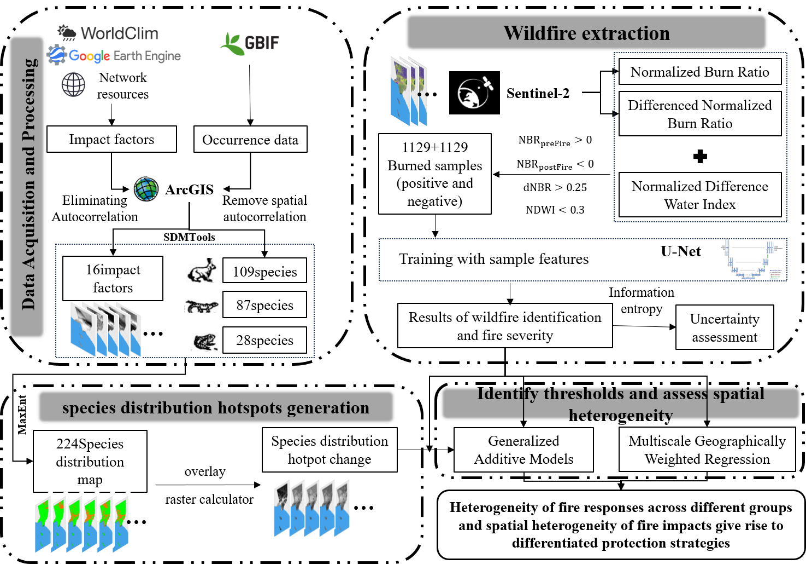
Figure 2. Research Roadmap

3. Results

3.1. Wildfire Distribution and Severity Interpreted by Remote Sensing and U-Net
The burned area map of the 2025 Los Angeles fires derived from U-Net-based extraction is presented in the left panel of Figure 3. By exploiting Sentinel-2 imagery at 10 m spatial resolution, the method successfully delineates three major wildfire events—Palisades, Eaton and Hughes(CAL FIRE, 2025). Compared to operational fire products from moderate-resolution sensors such as MODIS (500 m), our result captures the dominant fire trend with markedly higher spatial detail (see Appendix A.3, taken fires happened in January as an example). Based on the fire map (Figure 3), we have identified a total burn area of approximately 213.52 Km². The largest of these wildfires—Palisades, Eaton and Hughes—covered approximately 82.48, 41.21 and 40.48 Km² respectively (Figure 3.b, Figure 3.c, Figure 3.a). The largest burnt areas are concentrated in the central-western and south-western parts of Los Angeles.
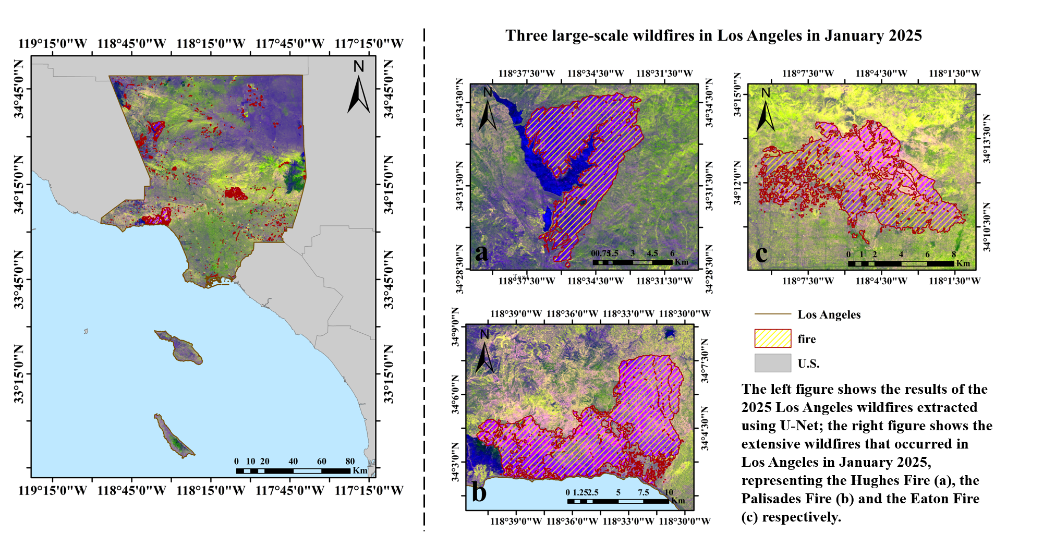
Figure 3. Wildfire Extraction Based on Sentinel-2 and U-Net
Fire severity is illustrated in Figure 4. Overall, the burned areas in Los Angeles exhibited relatively high burn severity. Among the three major wildfires with the largest affected areas (Figures 4a, b, and c), the Palisades Fire displayed a predominantly large proportion of high-severity burn areas, accounting for 45.58% of its total extent, followed by the Eaton Fire at 27.35%.
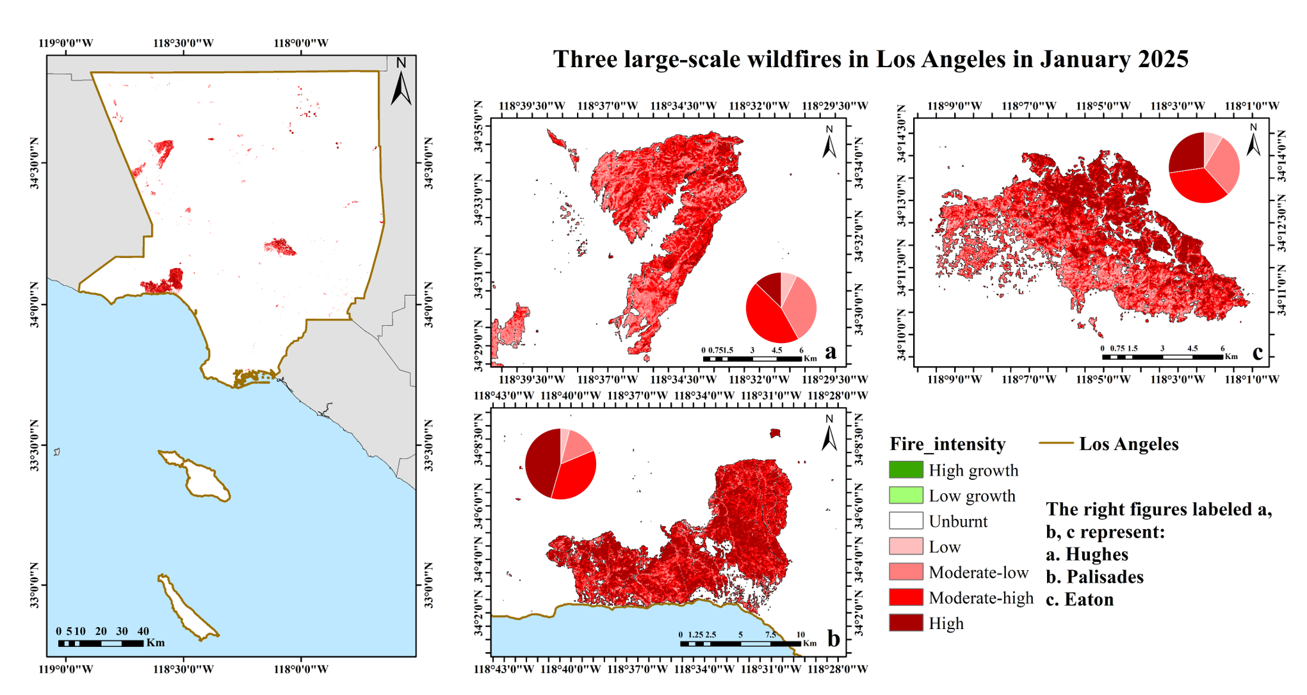
Figure 4. Fire intensity map

3.2. Post-wildfire Change in Terrestrial Vertebrate Biodiversity
Changes in species distribution hotpots following a fire are shown in Figure 5, overall, the wildfire induced a profound spatial reorganization of terrestrial vertebrate richness across Los Angeles. The spatial overlay analysis revealed that 56.1% of the study area experienced a decline in species richness (ΔHotpot < 0). The most severe biodiversity loss was concentrated in the core zones of the Palisades fire, where the local species richness dropped by up to 41 species per pixel (accounting for 18.3% of the species we studied).
Distinct taxon-specific responses were observed among the three vertebrate classes. Among them, the most affected is amphibian, with about 70.96% of the study area experienced species’ decline, followed by reptile (65.17%) and then mammal (54.97%). Spatially, the areas which suffer the most severe decline are just the place where the wildfires occurred and the rise areas most concentrate on the mid-western of Los Angeles. However, while mammal richness decreased in the high-intensity burn cores, a marginal increase (+3 to +19 species) was detected in Hughes fire boundaries, also there are some increases detected when considering amphibian (+2 to +4 species).
In addition, we find that areas that locate far away from the wildfire, also experienced some species’ decline, such as the south-eastern coastal area of Los Angeles.

Figure 5. Post-wildfire changes in potential distribution hotpots for different species groups and all species we studied

3.3 Identification of Ecological Tipping Points and Spatial Heterogeneity of Wildfire Severity Impacts on Vertebrate Biodiversity Loss
To further describe the relationship between fire intensity and changes in species distribution hotspots, we selected three major fire areas for quantitative analysis, Hughes, Palisades and Eaton, separately.
The Generalized Additive Models (GAMs) demonstrated pronounced non-linear relationships between wildfire burn severity (dNBR) and biodiversity change (ΔHotpot) across the three vertebrate taxa (Figure 6), with the ecological tipping points of each community exhibiting clear correspondences with specific fire severity levels. Specifically, the ecological tipping point for reptile was identified at dNBR = -0.06, falling within the Unburnt (-0.1 to 0.1) category. Below this threshold, reptile exhibited marked species gain (ΔHotpot > 0), but as burn severity crossed this point into the Low (0.1 to 0.27), Moderate-low (0.27 to 0.44), Moderate-high (0.44 to 0.66), and High (>0.66) levels, the biodiversity change rapidly dropped below zero, transitioning into species loss (ΔHotpot < 0) and reaching the maximum value of species reduction at approximately dNBR = 0.80 within the High severity level.
The ecological tipping points for amphibian and mammal were delayed to dNBR = 0.46, precisely corresponding to the Moderate-high (0.44 to 0.66) severity level. Among them, the estimated smoothing curve for amphibian remained entirely below the zero axis (ΔHotpot < 0) across the entire monitored spectrum, showing that amphibian experienced species loss across all fire severity levels, with a change in loss rate occurring at the Moderate-high threshold and reaching its absolute maximum species reduction at approximately dNBR = 0.75 within the High severity level. Mammal consistently exhibited species gain (ΔHotpot > 0) across the Unburnt, Low, and Moderate-low ranges, with peak gains recorded at the leftmost extreme and at a local high point within the Moderate-low interval, however, after crossing the Moderate-high threshold of 0.46, the curve entered the negative zone of species loss (ΔHotpot < 0), peaking in species reduction at approximately dNBR = 0.80 within the High severity level.
In terms of response sensitivity, all three vertebrate taxa suffered severe species reduction under the High fire severity level. Reptile underwent the transition from species gain to species loss within the Unburnt level, displaying the highest sensitivity to the initial burn. Conversely, mammal maintain species gains under low and moderate-low severities until triggering a structural threshold shift toward species loss at the Moderate-high level, while amphibian manifested a continuous negative response of species loss.
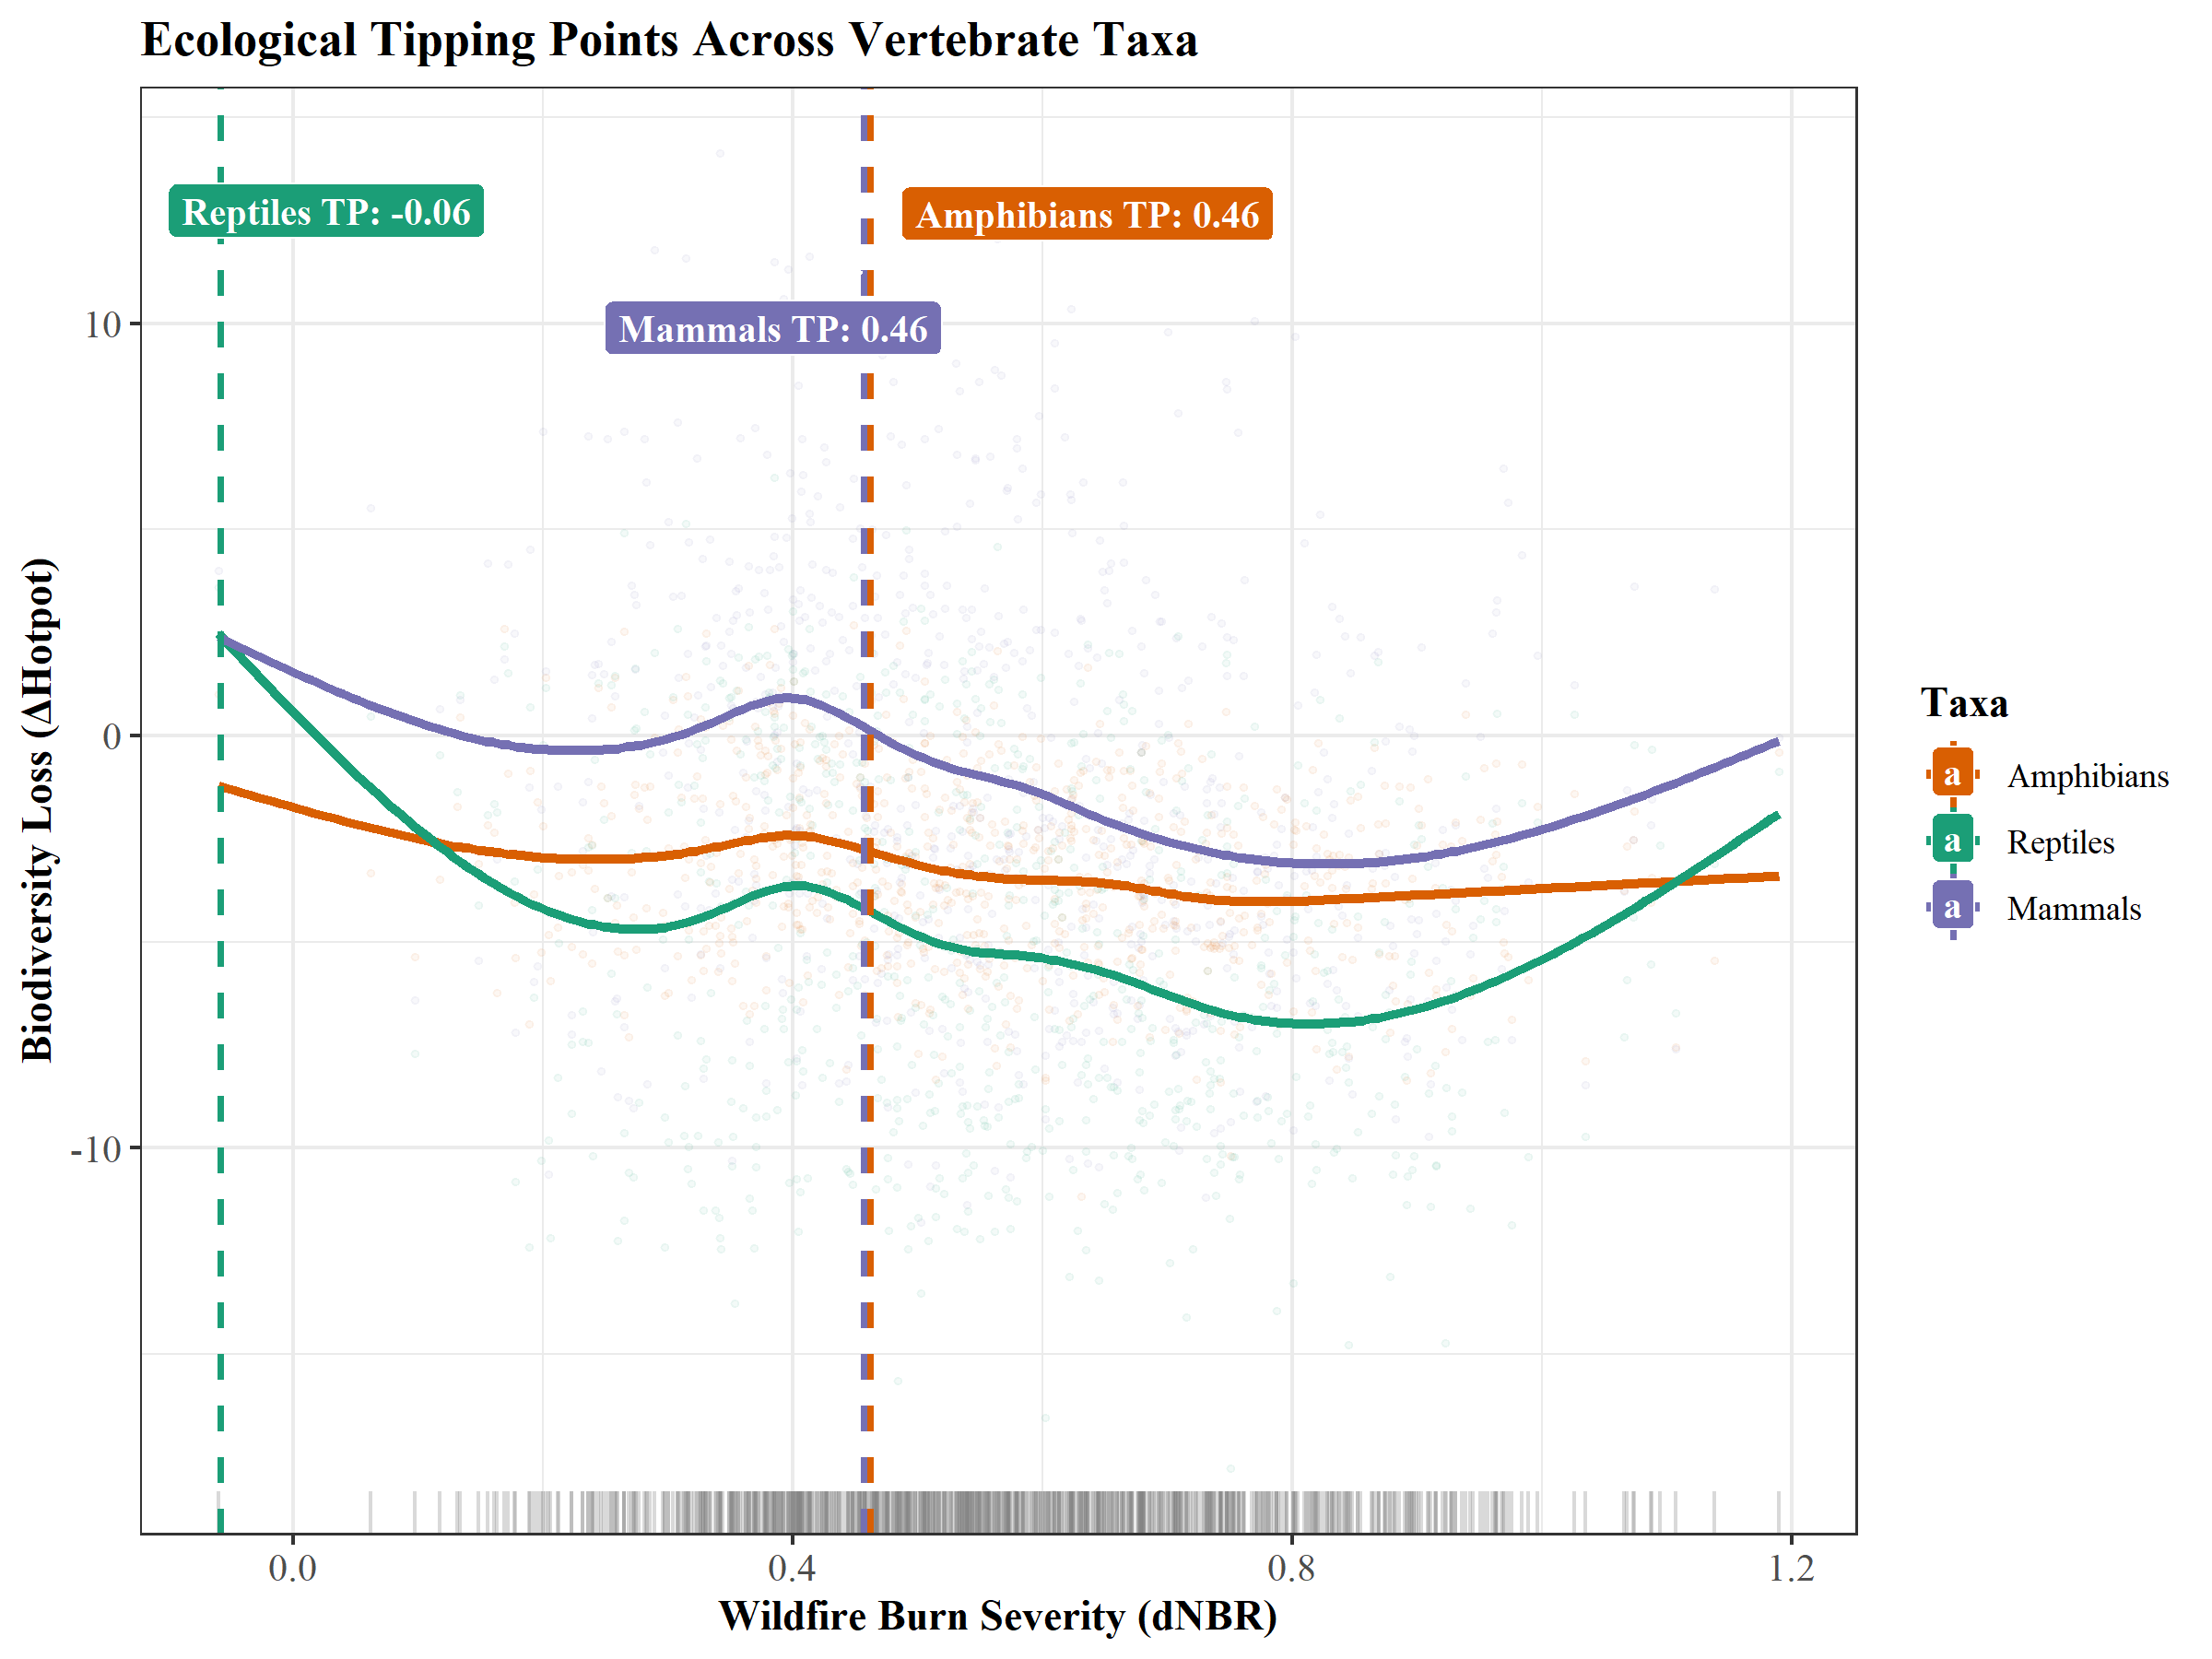
Figure 6. Generalized Additive Model (GAM) smoothing curves and identified ecological tipping points of biodiversity change (ΔHotpot) in response to wildfire burn severity (dNBR) across three vertebrate taxas
After controlling for environmental covariates including elevation and slope, the Multiscale Geographically Weighted Regression (MGWR) model unveiled spatial heterogeneity in the response of vertebrate biodiversity change to wildfire burn severity (X = dNBR). The extracted local regression coefficients manifested variations in both operational direction and magnitude across different fire perimeters.
Within the perimeter of the Hughes fire (Figure 7.a), the impact of wildfire burn severity on vertebrate biodiversity change was found to be statistically non-significant throughout the entire spatial domain. Conversely, within the Eaton fire (Figure 7.c), the statistically significant local regression coefficients were predominantly governed by negative values. In light of the overarching baseline trend where the number of vertebrate species consistently declined across Eaton fire boundaries, these negative correlations demonstrate that higher wildfire burn severity further exacerbated the reduction in biodiversity within the Eaton fire.
In stark contrast, within the coastal Palisades fire perimeter (Figure 7.b), along its southern boundary, a conspicuous cluster of "Positively high" coefficients (red patches) emerged. This positive relationship indicates that within this specific localized patch, an increase in burn severity corresponded to an increase in biodiversity. However, the northern and eastern sectors of the Palisades fire perimeter were concurrently occupied by statistically significant clusters of "Negatively high" coefficients (green patches), indicating that higher burn severity in these particular geographic directions similarly resulted in a further degradation of biodiversity.
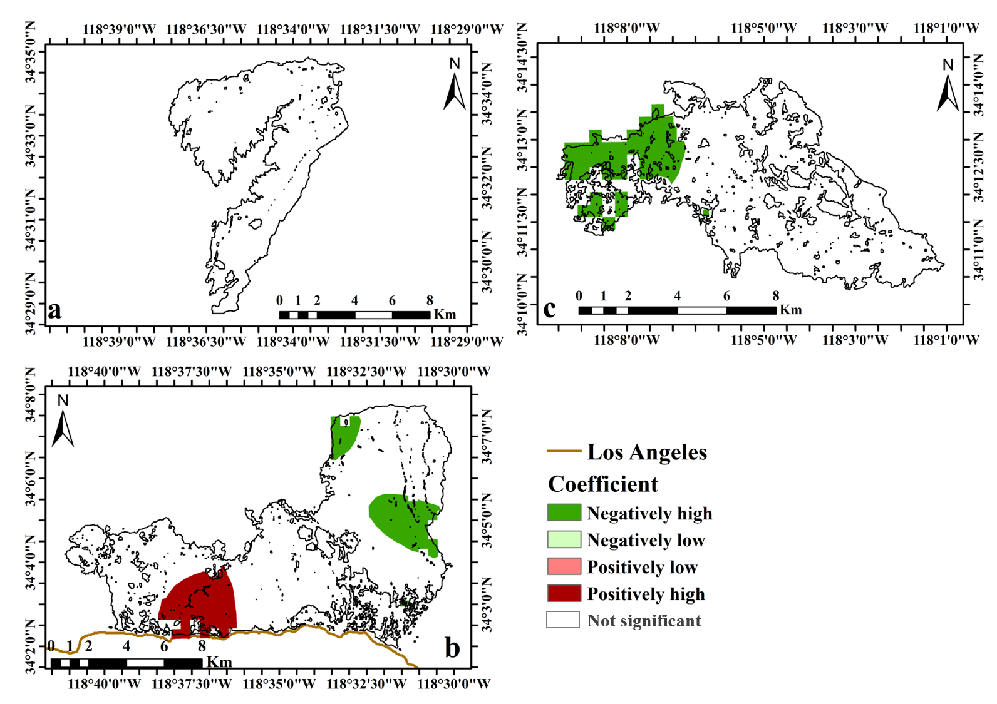
Figure 7. Spatial distribution of Multiscale Geographically Weighted Regression (MGWR) local coefficients representing the impacts of wildfire burn severity (dNBR) on vertebrate biodiversity change across three fire perimeters (a: Hughes; b: Palisades; c: Eaton).

4. Discussion

4.1 Results of fire intensity and extent analysis
The overall burned area is concentrated in the midwestern and coastal mountainous regions, while the northern and inland areas contain only sparse, small-scale fire occurrences, which may closely tied to regional topography, fuel continuity, and wind regimes (Keeley et al., 2009), Critically, the use of 10 m resolution sentinel-2 imagery(Howe et al., 2022) combined with a U-Net architecture that inherently aggregates neighborhood context allows our product to simultaneously capture fine-scale spatial details that are entirely absent in coarser-resolution fire products. By successfully resolving the three major fire events, we identified a total burned area of 213.52 km² (compared to 202 km² as reported(Britannica, 2026)), and by identifying fine‑scale spatial structures, this study demonstrates that deep learning‑based high‑resolution remote sensing can fundamentally improve the accuracy of fire extent delineation.
Regarding the spatial distribution of fire intensity, dNBR-based assessments reveal strong spatial non-stationarity. The Palisades fire was extremely destructive, with high-intensity burned areas accounting for as much as 45.58%, followed by the Eaton fire (27.35%), consistent with the relevant reports(Insurance Institute for Business ＆ Home Safety, 2025).

4.2 Reaction Heterogeneity Among Different Taxa under Fire
Fires triggered spatial reorganization of terrestrial vertebrate species richness in Los Angeles, species in different taxa have varied behavior when facing fire, also, the influence of wildfire burn severity on vertebrate biodiversity dynamics is highly non-uniform and inconsistent across distinct wildfire events and specific localized geographic patches, all these mentioned above poses great challenge for post conservation and management.
Our results shows that amphibian was the most severely impacted by the fires, with a decline in suitable habitat covering as much as 70.96% of the study area. However, although they suffered the most suitable habitat decline, they are somehow more resistant to fire intensity change compared to mammal and reptile(Driscoll et al., 2024). Reptile also exhibited a significant decline trend and they showed the highest sensitivity to initial changes in fire intensity, tipping point occurred at -0.06, taken the ecology meaning of NBR into account(Chuvieco et al., 2019), means reptile may prefer environment with good vegetation cover and ample water(Habitat Preferences of Different Reptile Species, 2024). High point at a dNBR of approximately 0.4, the decline in reptile populations began to ease, as reptile metabolism is highly sensitive to temperature(Sinervo et al., 2010), we speculate this may due to the fact that as the fire happened frequently, most reptile have adapted to a relatively dry and open environment(Pausas & Parr, 2018).In contrast, mammal exhibited complex bidirectional responses, with a relatively low proportion of habitat decline (54.97%), and demonstrated a marked local increase in species richness at the Hughes fire boundary (an increase of 3 to 19 species). This phenomenon is primarily attributable to mammal’s superior mobility(Nimmo et al., 2021), behavioral plasticity(Jacobs, 2022), and the ability of small mammals to hibernate(Stawski et al., 2015). Highly mobile mammal can rapidly flee the fire’s core and congregate in undisturbed fringe areas or low-intensity patches, leading to a short-term surge in species richness in these peripheral zones. At the same time, low-intensity burning removes litter from the soil surface, promoting the germination of seeds and the recovery of highly nutritious herbaceous plants, providing herbivorous and opportunistic mammal with abundant early-successional food resources, thereby creating a local positive response in space.
In addition, the coastal area south of Los Angeles outside the main fire zones, also showed significant hotspot declines, revealing that indirect mechanisms such as soot deposition and microclimatic changes can extend wildfire ecological impacts to distant unburned areas(de Andrade et al., 2026).

4.3 Protection Strategy and Framework Development
The management of wildfires and subsequent post-fire biodiversity recovery present extraordinary ecological challenges due to the spatial non-stationarity of fire intensity and the starkly heterogeneous responses among distinct biological taxa. Proactive ecological restoration must combine landscape-scale prioritization with microhabitat-level engineering. A foundational requirement is the implementation of a complementarity-based spatial optimization framework, which intentionally shifts conservation focus away from simple species-richness hotspots toward identifying network configurations that collectively satisfy the discrete habitat requirements of all affected biological groups (Ward et al., 2022). For severely impacted amphibian and reptile, immediate intervention must prioritize the physical stabilization and creation of micro-refugia within low-intensity burn islands. Because reptile and amphibian exhibit sharp thresholds tied to microclimatic and thermal shifts, targeted actions like retaining unburned coarse woody debris, re-establishing canopy shading, and securing localized water access are critical to mitigating post-fire desiccation(Pausas & Parr, 2018). Concurrently, managing mammalian responses requires designating dynamic, non-intervention buffer zones along fire boundaries where opportunistic species congregate. Restricting anthropogenic disruption and salvage logging in these peripheral ecotones preserves vital migration corridors and protects the influx of highly nutritious herbaceous plants that emerge after litter removal(Archibald et al., 2019), thereby supporting the natural behavioral plasticity and energetic requirements of mobile wildlife. These localized efforts must be contextualized within broader historical fire frequency analyses to ensure that contemporary interventions are ecologically aligned with long-term landscape evolutionary pathways.

4.4 Methodological Limitations and Future Directions
Although the framework of this study has identified changes in biodiversity under fire conditions, there remain several inherent academic limitations that require further exploration and refinement in future research.
Firstly, the species distribution data were sourced from the Global Biodiversity Information Facility (GBIF). As a typical big data platform, GBIF exhibits significant spatial sampling bias, which may lead to a degree of uncertainty in the MaxEnt predictions for remote, uninhabited areas. Secondly, whilst 10-metre resolution Sentinel-2 imagery performs excellently at the regional scale, for small-bodied terrestrial vertebrates with extremely stringent microclimatic requirements, a 10-metre pixel still encompasses a significant degree of microhabitat heterogeneity. Current remote sensing resolution remains insufficient to fully capture these microrefugia, thereby underestimating, to some extent, the species’ in situ survival capacity during fires. Finally, this study relies primarily on extrapolations from macroecological models and satellite remote sensing indices, lacking immediate post-fire field surveys and long-term fixed-point monitoring; consequently, it is unable to directly verify species’ actual mortality rates, post-fire migration routes, and behavioral-physiological responses at the micro-level, the assumption that bioclimatic factors remain unchanged for a prolonged period following a disaster also introduces uncertainty into the results.
Future research could be systematically improved through the following approaches: (1) Integrating data from multiple citizen science platforms for cross-validation, to minimize spatial heterogeneity noise in GBIF data; (2) Coupling higher-resolution commercial satellite constellation data or utilizing unmanned aerial vehicles (UAVs) equipped with multispectral and LiDAR sensors to conduct high-resolution three-dimensional habitat interpretation of typical fire patches, thereby directly quantifying the distribution of vertical structure and micro-refuges; (3) Establish an integrated “air-space-ground” monitoring network, deploying large-scale arrays of camera traps, environmental DNA (eDNA) sampling of water and soil, and acoustic monitoring equipment immediately following a fire to obtain the most up-to-date field survey data, thereby enabling precise empirical calibration of multi-scale spatial modelling.
It must be emphasized that, despite the aforementioned limitations, the macro-trends, ecological tipping points and spatial polarization patterns identified in this study retain immense and irreplaceable conservation value. Through rigorous screening for variable multicollinearity and statistical tests of multiple models, the taxon-specific thresholds and spatially non-stationary driving mechanisms revealed in this paper are statistically highly significant and robust. At the macro-scale, this study provides critically important spatial insights and scientific evidence for post-disaster wildlife rescue, the delineation of differentiated ecological red lines, and adaptive fire management within the Mediterranean climate region of Los Angeles.

5.Conclusion
This study successfully established and applied an integrated research framework comprising high-precision remote sensing extraction, maximum entropy habitat evolution mapping, and spatial econometric analysis of non-linearity and non-stationarity, systematically elucidating the macro-spatial restructuring effects of the 2025 Los Angeles wildfires on terrestrial vertebrate biodiversity. The study confirms that the impact of megafires on biodiversity is not homogeneous, but rather depends on the physiological and behavioral characteristics of species taxa, as well as the spatial topological intensity of the fire. The vulnerability of amphibian and reptile, coupled with their extremely low ecological thresholds, highlights the urgency of early post-disaster intervention, whilst the complex responses of mammal and the positive coefficient patches south of the Palisades strongly support the role of moderate burning in promoting the creation of habitats for certain species and heterogeneous habitats. The non-linear tipping points and spatial polarization patterns revealed in this study demonstrate the inevitability of a shift from traditional, mechanized, area-wide fire suppression towards a spatially differentiated, dynamic and adaptive fire management paradigm. The differentiated conservation framework proposed in this study theoretically enriches the empirical body of knowledge on spatial non-stationarity in fire ecology, whilst in practice delineating precise spatial coordinates for post-disaster ecological restoration in highly fragmented metropolitan areas, thereby holding significant value for macroecological applications and policy reference.
Acknowledgement
We would like to thank Jeff and other ecologists for their contributions to improving the quality of this article; This research was funded by the Intergovernmental International Science and Technology Innovation Cooperation Program Under National Key Research and Development Plan (2024YFE0198600)
Author Contributions
Conceptualization: Sisi Chen, Zengrui Tian, Junyu Deng and Jinsong Deng; Data curation: Sisi Chen, Zengrui Tian, Junyu Deng and Zhiyun You; Formal analysis: Sisi Chen, Zengrui Tian, Zhijun You, Junyu Deng and Fanghong Ye; Funding acquisition: Jinsong Deng; Methodology: Sisi Chen and Zengrui Tian; Supervision: Sisi Chen, Shanshan Lv and Junyu Deng; Visualization: Sisi Chen and Junyu Deng; Writing – original draft: Sisi Chen, Junyu Deng and Yun He; Writing – review and editing: Sisi Chen and Zengrui Tian.
Data Availability Statement
The data that support the findings of this study are available from the corresponding author upon reasonable request, the raw data all came from open datasets.

During the preparation of this work, the author(s) used Deep seek for language translation. The author(s) reviewed and edited the output as needed and take full responsibility for the content of the published article.

References
Archibald, S., Hempson, G. P., & Lehmann, C. (2019). A unified framework for plant life-history strategies shaped by fire and herbivory. New Phytologist, 224(4), 1490–1503. https://doi.org/10.1111/nph.15986
Britannica. (2026, May 7). Los Angeles wildfires of 2025 | Deaths, Damage, & Facts | Britannica. https://www.britannica.com/event/Los-Angeles-wildfires-of-2025
C. Wissel. (1984). A universal law of the characteristics return time near thresholds. Oecologia, 65(1), 101–107. https://doi.org/10.1007/BF00384470
Cai J, Zhang, M., Hai-Jun, S., & Hai-bo, Z. (2014). Application of Ecological Niche Models for Selection of Species Habitat. 18, 47–53. https://doi.org/10.13326/j.jea.2014.0012
CAL FIRE. (2025). 2025 Fire Season Incident Archive. CAL FIRE. https://www.fire.ca.gov/incidents/2025
Chuvieco, E., Mouillot, F., van der Werf, G. R., San Miguel, J., Tanase, M., Koutsias, N., García, M., Yebra, M., Padilla, M., Gitas, I., Heil, A., Hawbaker, T. J., & Giglio, L. (2019). Historical background and current developments for mapping burned area from satellite Earth observation. Remote Sensing of Environment, 225, 45–64. https://doi.org/10.1016/j.rse.2019.02.013
de Andrade, A. C., Harrison, M. E., & McConkey, K. R. (2026). Going up in smoke: Hazardous ecological consequences of wildfire emissions. Global Ecology and Conservation, 66, e04123. https://doi.org/10.1016/j.gecco.2026.e04123
Defense, F. W. (2025, September 25). Impact of the LA Fires. Frontline. https://www.frontlinewildfire.com/wildfire-news-and-resources/impact-of-la-fires/
Driscoll, D. A., Macdonald, K. J., Gibson, R. K., Doherty, T. S., Nimmo, D. G., Nolan, R. H., Ritchie, E. G., Williamson, G. J., Heard, G. W., Tasker, E. M., Bilney, R., Porch, N., Collett, R. A., Crates, R. A., Hewitt, A. C., Pendall, E., Boer, M. M., Gates, J., Boulton, R. L., … Phillips, R. D. (2024). Biodiversity impacts of the 2019–2020 Australian megafires. Nature, 635(8040), 898–905. https://doi.org/10.1038/s41586-024-08174-6
Ermitão, T., Gouveia, C., Bastos, A., & Russo, A. (2024). Recovery Following Recurrent Fires Across Mediterranean Ecosystems. Global Change Biology, 30. https://doi.org/10.1111/gcb.70013
Fateme Ghareghan, Gholamabbas Ghanbarian, Hamid Reza Pourghasemi, & Roja Safaeian. (2020). Prediction of habitat suitability of Morina persica L. species using artificial intelligence techniques. Ecological Indicators, 112, 106096. https://doi.org/10.1016/j.ecolind.2020.106096
Fotheringham, A. S., Yang, W., & Kang, W. (2017). Multiscale Geographically Weighted Regression (MGWR). Annals of the American Association of Geographers, 107(6), 1247–1265. https://doi.org/10.1080/24694452.2017.1352480
Giglio, L., Boschetti, L., Roy, D. P., Humber, M. L., & Justice, C. O. (2018). The Collection 6 MODIS burned area mapping algorithm and product. Remote Sensing of Environment, 217, 72–85. https://doi.org/10.1016/j.rse.2018.08.005
Goldberg, J., Rodman, K., & Jones, G. (2025). Characterizing climate- and fire-driven habitat vulnerability for an old-forest species. Landscape Ecology, 40. https://doi.org/10.1007/s10980-025-02171-4
Groffman, P. M., Baron, J. S., Blett, T., Gold, A. J., Goodman, I., Gunderson, L. H., Levinson, B. M., Palmer, M. A., Paerl, H. W., Peterson, G. D., Poff, N. L., Rejeski, D. W., Reynolds, J. F., Turner, M. G., Weathers, K. C., & Wiens, J. (2006). Ecological Thresholds: The Key to Successful Environmental Management or an Important Concept with No Practical Application? Ecosystems, 9(1), 1. https://doi.org/10.1007/S10021-003-0142-Z
Habitat preferences of different reptile species. (2024, May 1). https://animalnepal.org/habitat-preferences-different/
Howe, A. A., Parks, S. A., Harvey, B. J., Saberi, S. J., Lutz, J. A., & Yocom, L. L. (2022). Comparing Sentinel-2 and Landsat 8 for Burn Severity Mapping in Western North America. Remote Sensing, 14(20), 5249. https://doi.org/10.3390/rs14205249
Insurance Institute for Business ＆ Home Safety. (2025, April 23). 2025 LA County Wildfires: Early Insights from Field Observations. CTIF. https://www.ctif.org/zh-hans/news/2025-nianluoshanjiyehuodezaoqidongchabaogao
Jacobs, I. (2022). Animal Response to Fire. In Encyclopedia of Animal Cognition and Behavior (pp. 314–317). Springer, Cham. https://doi.org/10.1007/978-3-319-55065-7_2095
Jia Yihang, Shu Huilin, Lei Gang, Yang Yang, & Qi Lianghua. (2025). Species distribution models: Conceptual typologies, modeling predictions, and applications in ecosystem management. Science of Soil and Water Conservation, 24(2), 7–17. https://doi.org/10.16843/j.sswc.2025104
Jin, Y., Zhou, K., Gao, J., Mu, S., & Zhang, X. (2016). Identifying the priority conservation areas for key national protected terrestrial vertebrate species based on a random forest model in China. Acta Ecologica Sinica, 36(23), 7702–7712. https://doi.org/10.5846/stxb201512082454
Keeley, J., Safford, H., Fotheringham, C., Franklin, J., & Moritz, M. (2009). The 2007 Southern California Wildfires: Lessons in Complexity. Journal of Forestry, 107, 287–296. https://doi.org/10.1093/jof/107.6.287
Loboda, T., O’Neal, K. J., & Csiszar, I. (2007). Regionally adaptable dNBR-based algorithm for burned area mapping from MODIS data. Remote Sensing of Environment, 109(4), 429–442. https://doi.org/10.1016/j.rse.2007.01.017
Lu, B., Ge, Y., Qin, K., & Zheng, J. (2020). A Review on Geographically Weighted Regression. Wuhan Daxue Xuebao (Xinxi Kexue Ban)/Geomatics and Information Science of Wuhan University, 45, 1356–1366. https://doi.org/10.13203/j.whugis20190346
Mendelsohn, M. B., Brehme, C. S., Rochester, C. J., Stokes, D. C., Hathaway, S. A., & Fisher, R. N. (2008). Responses in bird communities to wildland fires in southern California. Fire Ecology, 4(2), 63–82. https://doi.org/10.4996/fireecology.0402063
Mosquera-Guerra, F., Moreno-Niño, N., Garcia-Suabita, W., & Armenteras-Pascual, D. (2024). Impact of wildfires on the suitability habitat of the lowland tapir in a native savanna landscape of northern South America. Discover Conservation, 1(1), 15. https://doi.org/10.1007/s44353-024-00013-z
Nimmo, D., Carthey, A., Jolly, C., & Blumstein, D. (2021). Welcome to the Pyrocene: Animal survival in the age of megafire. Global Change Biology, 27, 5684–5693. https://doi.org/10.1111/gcb.15834
North, T. D., Markle, C. E., Fallas, R. Y., Moore, P. A., & Waddington, J. M. (2024). Initial impacts of wildfire on overwintering conditions for a Species-at-Risk snake. Global Ecology and Conservation, 56, e03258. https://doi.org/10.1016/j.gecco.2024.e03258
Pahlavani, P., Raei, A., Bigdeli, B., & Ghorbanzadeh, O. (2024). Identifying Influential Spatial Drivers of Forest Fires through Geographically and Temporally Weighted Regression Coupled with a Continuous Invasive Weed Optimization Algorithm. Fire, 7(1), 33. https://doi.org/10.3390/fire7010033
Pausas, J., & Parr, C. (2018). Towards an understanding of the evolutionary role of fire in animals. Evolutionary Ecology, 32. https://doi.org/10.1007/s10682-018-9927-6
Phillips, S. J., Anderson, R. P., & Schapire, R. E. (2006). Maximum entropy modeling of species geographic distributions. Ecological Modelling, 190(3), 231–259. https://doi.org/10.1016/j.ecolmodel.2005.03.026
Rana, S. M. S., Lee, J., Kang, Y., & Im, J. (2026). Exploring the impacts of dual-polarized vegetation indices and U-shaped deep learning architectures on SAR-based burned area mapping. International Journal of Applied Earth Observation and Geoinformation, 146, 105141. https://doi.org/10.1016/j.jag.2026.105141
Ronneberger, O., Fischer, P., & Brox, T. (2015). U-Net: Convolutional Networks for Biomedical Image Segmentation. In N. Navab, J. Hornegger, W. M. Wells, & A. F. Frangi (Eds.), Medical Image Computing and Computer-Assisted Intervention – MICCAI 2015 (pp. 234–241). Springer International Publishing. https://doi.org/10.1007/978-3-319-24574-4_28
Roy, D. P., & Boschetti, L. (2009). Southern Africa Validation of the MODIS, L3JRC, and GlobCarbon Burned-Area Products. IEEE Transactions on Geoscience and Remote Sensing, 47(4), 1032–1044. https://doi.org/10.1109/TGRS.2008.2009000
Rundel, P., Kalin, M., Keeley, J., Lamont, B., Pausas, J., & Vargas, P. (2018). Fire and Plant Diversification in Mediterranean-Climate Regions. Frontiers in Plant Science, 9, 851. https://doi.org/10.3389/fpls.2018.00851
Sapkota, D. P., Edwards, D. P., Massam, M. R., & Evans, K. L. (2025). A Pantropical Analysis of Fire Impacts and Post-Fire Species Recovery of Plant Life Forms. Ecology and Evolution, 15(2), e71018. https://doi.org/10.1002/ece3.71018
Sinervo, B., Mendez-de-la-Cruz, F., Miles, D. B., Heulin, B., Bastiaans, E., Cruz, M. V.-S., Lara-Resendiz, R., Martinez-Mendez, N., Calderon-Espinosa, M. L., Meza-Lazaro, R. N., Gadsden, H., Avila, L., Morando, M., Riva, I. D. L., Sepulveda, P., Rocha, C., Ibarguengoytia, N., Puntriano, C., Massot, M., … Sites, J. (2010). Erosion of lizard diversity by climate change and altered thermal niches. Science, 328(5980), 894–899. https://doi.org/10.1126/science.1184695
Song, J., Ali, M., Yang, J., Huang, Z., Fang, Z., Han, B., Zhang, J., Zhang, Y., & Bai, Y. (2026). Climate change effect on the habitat suitability of Clausena lansium in China via an optimized maximum entropy (MaxEnt) model. Ecological Frontiers, 46(2), 759–770. https://doi.org/10.1016/j.ecofro.2025.12.008
Stawski, C., Körtner, G., Nowack, J., & Geiser, F. (2015). The importance of mammalian torpor for survival in a post-fire landscape. Biology Letters, 11. https://doi.org/10.1098/rsbl.2015.0134
Steel, Z. L., Campos, B., Frick, W. F., Burnett, R., & Safford, H. D. (2019). The effects of wildfire severity and pyrodiversity on bat occupancy and diversity in fire-suppressed forests. Scientific Reports, 9(1), 16300. https://doi.org/10.1038/s41598-019-52875-2
Teng, J., & Liu, X. (2022). The spatio-temporal impact of domestic dogs (Canis familiaris) on giant panda (Ailuropoda melanoleuca) in Baishuijiang National Nature Reserve. Biodiversity Science, 30(1), 21204. https://doi.org/10.17520/biods.2021204
The Los Angeles Wildfires: When Climate Disaster Strikes, Community Leads. (2025, January 22). The Solutions Project. https://thesolutionsproject.org/the-los-angeles-wildfires-when-climate-disaster-strikes-community-leads/
Varner, J., Lambert, M. S., Horns, J. J., Laverty, S., Dizney, L., Beever, E. A., & Dearing, M. D. (2015). Too hot to trot? Evaluating the effects of wildfire on patterns of occupancy and abundance for a climate-sensitive habitat specialist. International Journal of Wildland Fire, 24(7), 921–932. https://doi.org/10.1071/WF15038
Ward, M., Carwardine, J., Watson, J., Pintor, A., Stuart, S., Possingham, H., Rhodes, J., Carey, A., Auerbach, N., Reside, A., Yong, C., & Tulloch, A. (2022). How to prioritize species recovery after a megafire. Conservation Biology, 36. https://doi.org/10.1111/cobi.13936
Wood, S. N. (2017). Generalized Additive Models: An Introduction with R, Second Edition (2nd ed.). Chapman and Hall/CRC. https://doi.org/10.1201/9781315370279
Xu, Z., Li, J., Cheng, S., Rui, X., Zhao, Y., He, H., Guan, H., Sharma, A., Erxleben, M., Chang, R., & Xu, L. L. (2025). Deep learning for wildfire risk prediction: Integrating remote sensing and environmental data. ISPRS Journal of Photogrammetry and Remote Sensing, 227, 632–677. https://doi.org/10.1016/j.isprsjprs.2025.06.002
Yue Chao, Luo Caifang, Shu Lifu, & Shen, Z. (2020). A review on wildfire studies in the context of global change. Acta Ecologica Sinica, 40, 385–401.
Zabeo, C., Mengist, M., Ogunyemi, O., & Barbati, A. (2025). Unveiling short-term variability in post-fire recovery of Mediterranean vegetation with Sentinel-2 time series analysis. Ecological Informatics, 92, 103508. https://doi.org/10.1016/j.ecoinf.2025.103508
Zheng X., Liu Y., Si L., Shu L., Chen F., Wang Q., Wang S., & Zhang J. (2025). Research progress on effects of fire disturbance on stand structure and vegetation regeneration. Journal of Beijing Forestry University, 47(1), 156–162. https://doi.org/10.12171/j.1000-1522.20240029

