# Report for portfolio optimization and forecasting

1.Introduction 2

2. Data Source 2

(1)Ethics and Privacy 2

(2)Integrity 2

(3)Validity 2

(1)Data Dates 2

(2)Nature of Data 2

(3)Data Structure 2

4. Data Deficiencies 3

5.Analytics approaches 3

**Step 1**: Select the Top 20 Stocks by Market Capitalization 3

**Step 2**: Constructing the Portfolio 5

**Step 3**: Forecasting with LSTM and use predicted prize optimize portfolio 7

**Step 4**: Identifying Trading Opportunities 12

5. Conclusion 13

6. Personal Reflection 14

7. Reference 15

# 1.Introduction

Financial markets are complex, with non-linear relationships and significant noise, making analysis challenging. This project builds a portfolio of the top 20 stocks by market capitalization, using machine learning to optimize predictions and identify buy/sell points. Data from Yahoo Finance and Wikipedia was used to filter these stocks, and the mean-variance model (Markowitz, 1952) was employed to construct the portfolio, balancing risk and return. Future stock prices were forecasted using an LSTM model (Hochreiter & Schmidhuber, 1997) , suitable for capturing time dependencies in financial data, followed by portfolio optimization to maximize returns through identified trading opportunities.

# 2. Data Source

The data is sourced from Yahoo Finance (using the yfinance Python library) and Wikipedia.

(1)Ethics and Privacy: The data is publicly available, related to market information, and does not contain Personally Identifiable Information (PII). It is used responsibly for research purposes only to create optimized portfolios. No privacy concerns or anonymization are required.

Reliability: Yahoo Finance data is from official exchanges and financial providers, generally reliable for major stocks and indices. The analysis uses historical data, so delays are not an issue.

(2)Integrity: Missing values in the historical data are handled by dropping NaN entries during data cleaning.

(3)Validity: Financial data is affected by market volatility, which impacts forecast validity. Machine learning is used for time series forecasting instead of traditional methods.

**3.** Data Characteristics

(1)Data Dates: The data spans from 1 January 2013 to 31 December 2023, covering different market conditions. Five years of data is used for neural network forecasting.

(2)Nature of Data: The data is time series and consists of adjusted closing prices for multiple stocks. Daily returns are calculated as input features for optimization and forecasting.

(3)Data Structure: The data is stored in a pandas DataFrame with stock symbols as columns and dates as rows.

# 4. Data Deficiencies

Missing values are handled using forward and backward filling methods, and removing rows/columns with all null values. Stocks with less than 1000 trading days are filtered out. However, These processes may cause problems due to market instability.

# 5.Analytics approaches

## **Step 1**: Select the Top 20 Stocks by Market Capitalization

The process involved selecting the top 20 companies by market capitalization from the S&P 500 component stocks. Specifically, the selection criteria included:

Market Capitalization: Each company's market capitalization was calculated to determine the largest firms by total value.

Data Collection: Historical stock data for each company was downloaded from Yahoo Finance for the period between January 1, 2013, and December 31, 2023. A retry mechanism was implemented to handle data retrieval issues, such as "Too Many Requests" errors.

Minimum Data Requirement: Companies with insufficient historical data (fewer than 1000 records) were excluded to ensure data quality.

Top 20 Stocks by Market Cap: After calculating the market capitalization, the top 20 companies were selected for visualization.

This step relied on quantitative analysis to identify companies with the highest total value in the market, reflecting investor confidence and the overall size of these firms. The visualization showed these companies' market capitalizations, highlighting the largest players in the S&P 500.

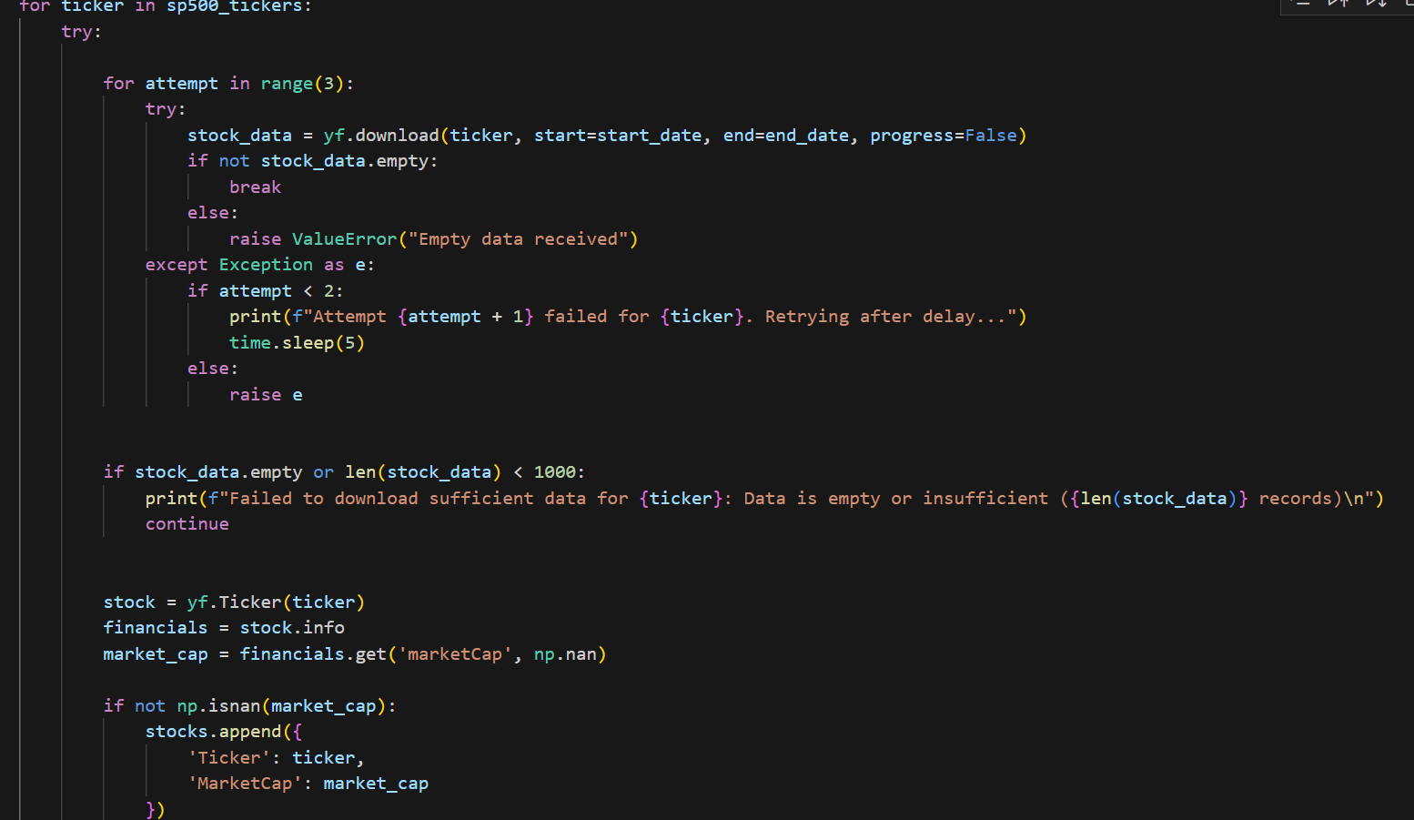

Fig 1. The main part of select Top 20 Stock

Libraries /tools used

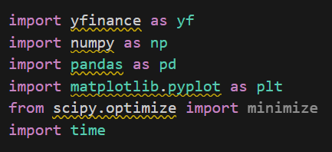

Fig 2. Python library used in this step

Visualization

The under visualization showed the top 20 Stock. It also shows the stock market capitalization in descending order to provide a pool of stocks for later portfolio building using Markowitz's model(mean-variance).

Fig 3. Top 20 Stock by market capitalization

## **Step 2**: Constructing the Portfolio

A portfolio of selected stocks was constructed using a simple mean-variance optimization technique to allocate weights to different stocks. The use of optimization (such as minimizing variance while maximizing return) ensures a balanced risk-reward ratio. By selecting weights that maximize Sharpe Ratio or minimize risk, the constructed portfolio aims to achieve optimal performance.

Stock Selection and Data Collection: A list of top 20 stock tickers was provide. The historical price data for these stocks was downloaded using the Yahoo Finance API (yfinance). The data was collected for the period from January 2013 to December 2023, focusing on the adjusted closing prices.

Data Cleaning and Filtering: Stocks with insufficient trading data (less than 1,000 trading days) were filtered out to ensure the reliability of the dataset. This filtering step ensured that only those stocks with significant trading history were included in the portfolio.

Mean and Covariance Calculation: Daily returns were calculated for the filtered stocks, and their mean returns and covariance matrix were computed. These values are fundamental inputs for portfolio optimization.

Mean-Variance Optimization: The portfolio was optimized using a mean-variance approach, specifically aiming to maximize the Sharpe ratio (Sharpe , 1994) . The Sharpe ratio is a measure of risk-adjusted return, calculated by taking the difference between the portfolio return and a risk-free rate (set at 2% in this case), divided by the portfolio's risk (volatility). The optimization used the Sequential Least SQuares Programming (SLSQP) method to find the optimal weights that would maximize the Sharpe ratio.

Portfolio Allocation: The optimized weights were extracted, and stocks with very small allocations were filtered out. The resulting portfolio was visualized using a pie chart to represent the weight allocation of each stock. The goal of this approach was to achieve a balanced risk-reward ratio by investing in growth stocks that offered the best trade-off between expected returns and risk.

Results: The expected annual return, risk (volatility), and Sharpe ratio of the optimal portfolio were calculated and displayed, along with the optimal allocation of weights to different stocks. The mean-variance optimization technique ensured that the portfolio was designed to provide the best possible performance for a given level of risk.

The use of mean-variance optimization, such as maximizing the Sharpe Ratio or minimizing risk, ensures a balanced risk-reward ratio. This optimization approach provides a structured method to allocate investments across the growth stocks in a manner that aims to maximize the return for a given risk level, resulting in an optimal portfolio.

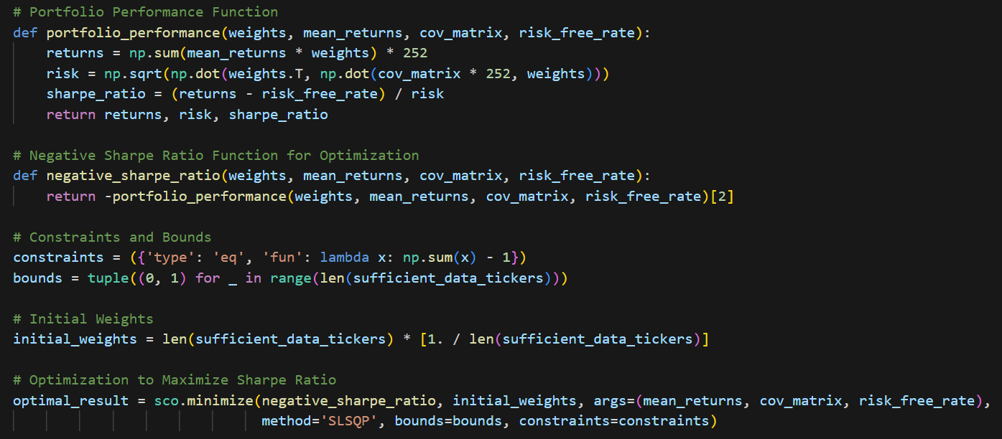Fig 5.The main part portfolio allocation coding

Libraries /tools used

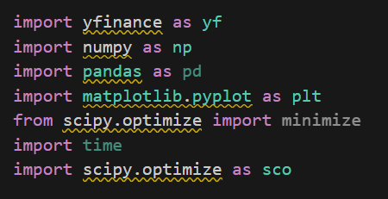

Fig 6. Python library used in this step

Visualization

This visualization showed the allocation of the portfolio of top 20 stock that is selected by market capitalization .

Fig 7.Optimal Portfolio Weight Allocation

## **Step 3**: Forecasting with LSTM and use predicted prize optimize portfolio

The LSTM model was chosen because of its applicability to time series data, which is crucial in financial forecasting.LSTM is able to learn long term dependencies and therefore is effective in capturing market trends and volatility. LSTM can handle continuous data better than traditional machine learning models, and it handles nonlinear models better than other time series models (ARIMA), which is why the use of LSTM in financial forecasting is common.

Analysis Conducted

The analysis involved collecting historical stock data, preprocessing it, training an LSTM model, and using it for predictions. This was followed by portfolio optimization based on the predicted returns. Below are the key components of the analysis:

Data Fetching and Preprocessing: Historical stock data for six major companies ('AVGO', 'COST', 'LLY', 'NVDA', 'TSLA', 'UNH') was collected using yfinance from January 1, 2013, to November 20, 2024. Missing values were handled using forward and backward filling. The data was then scaled using MinMaxScaler to normalize the values, stabilizing the LSTM learning process.

Data Transformation: The scaled data was transformed into sequences suitable for LSTM input with a look-back window of 50 days. This window size captures enough temporal information to make accurate predictions while maintaining computational efficiency.

Model Architecture and Training: An LSTM model with two layers, each having 128 units, was used. Dropout layers with a rate of 0.2 were added to prevent overfitting. The model was compiled using the Adam optimizer and trained with a validation split of 20%. To avoid overfitting and ensure efficient learning, callbacks such as ReduceLROnPlateau and EarlyStopping were used.

Evaluation and Prediction: The model was evaluated using Mean Squared Error (MSE), Mean Absolute Error (MAE), and R-squared (R²). If the evaluation metrics were satisfactory (MSE < 10,000, MAE < 50, R² > 0.7), the model was used to predict stock prices for 2024. Predictions were generated iteratively, with the last 50 days of training data used as input for each prediction.

Portfolio Optimization: Expected returns were calculated from the predicted prices, and portfolio optimization was performed using scipy.optimize.minimize to maximize the Sharpe ratio. The optimization included constraints to enforce diversification, with bounds set for each stock weight between 0.05 and 0.4.

Libraries/Tools Used

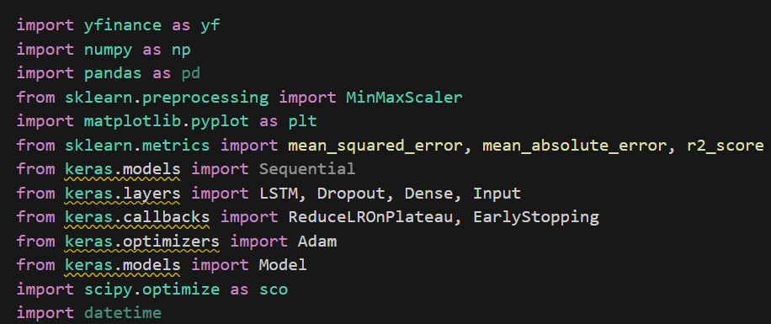

Fig 8 . Python library used in this step

Answering Research Questions Using the Models

The LSTM model was used to predict future stock prices, and the predicted prices were then used to estimate expected returns. This allowed us to answer questions related to the expected performance of each stock. The optimization step provided insights into how the portfolio could be adjusted to maximize returns while minimizing risk, thereby addressing questions related to optimal investment strategies.

Assumptions and Dataset Modifications

Assumptions: It was assumed that the historical price data could adequately represent future market conditions, which is common in financial modeling. Additionally, a look-back period of 50 days was assumed to be sufficient to capture relevant trends without overfitting.

Dataset Modifications: The data was normalized using MinMaxScaler to ensure that all features were on a comparable scale, aiding in the stability of LSTM training. Missing values were handled by forward and backward filling to ensure continuity in the time series, which is crucial for LSTM models.

Fig 9.The main part of LSTM forecasting

Visualization

This visualization, Shows a comparison between the predicted (Orange Line) and actual performance (Blue Line) of each stock in the portfolio that I have selected and optimized for mean-variance over the course of 24 years, with indices such as R-squared MAE and the images showing that the predictions are better allowing for the optimization of portfolio and the use of predictive models for post-November '24 trading opportunities.

Fig 10. Price forecasts for individual stocks in the original portfolio

After the forecasting of LSTM Based on the projected future returns, we optimized the portfolio again, using the same mean-variance model with the following weightings for each stock in the portfolio. This visualization, showing the optimized portfolio weight shares

Fig 11. Optimal portfolio weight allocation

In order to prove that the optimized portfolio (Orange Bar) has significant advantages over the first portfolio (Blue Bar) based on mean-variance, I measured the Sharpe ratio return and volatility of this portfolio, and the data shows that the optimized portfolio based on LSTM prediction has higher return and Sharpe ratio, and less volatility, and the visualization shows the comparison between the two.

Fig 12. Comparison of portfolio in step2 and step3

## **Step 4**: Identifying Trading Opportunities

The analysis used Moving Average Convergence Divergence (MACD) and Simple Moving Averages (SMAs) to identify price trends and generate buy/sell signals. MACD effectively highlights momentum shifts, while SMAs smooth out price data to reveal trends. These techniques are well-supported in financial literature.

A smoothed price was calculated using an exponential moving average (EMA) to reduce noise. SMAs were then computed over different periods (15, 30, 60, 100) to identify crossover points like the Golden Cross. MACD was calculated as the difference between 20-period and 50-period EMAs, with a 9-period Signal Line. Buy/sell signals were based on MACD/Signal Line crossovers.

Libraries/Tools Used

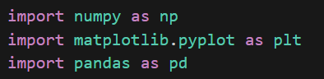

Fig 13 . Python library used in this step

The model was primarily used to answer the following questions:

When to Buy?: By identifying golden cross points using SMAs, buy signals were generated whenever shorter-term averages crossed above longer-term averages.

When to Sell?: RSI values were used to determine overbought conditions, generating sell signals when RSI exceeded 70, indicating high price momentum and potential reversal.

The predictive model was applied to the 2024 price data to generate both SMA crossovers and RSI indicators. These signals were then used to recommend potential buy and sell opportunities within the year.

Assumptions and Modifications

It was assumed that historical price trends and the relationships captured through SMAs would continue to be indicative of future price movements.

Market efficiency was partially relaxed, assuming that technical indicators could identify short-term opportunities not immediately reflected in the price.

The dataset was filtered to focus on high-growth companies, assuming their future performance would yield substantial returns. Outliers and missing data points were removed to ensure model robustness and avoid undue influence on results.

Visualization

The “Buy Signal” (green triangle) and “Sell Signal” (red triangle) are marked on the chart to help investors recognize when it might be a good time to buy or sell.

The blue line, which represents the smoothed projected price action, can help to see the overall trend of the portfolio's stock price in 2024.

The MACD line (purple dashed line) and the signal line (orange dashed line) are used to assist in analyzing changes in price action in order to identify trend reversals.

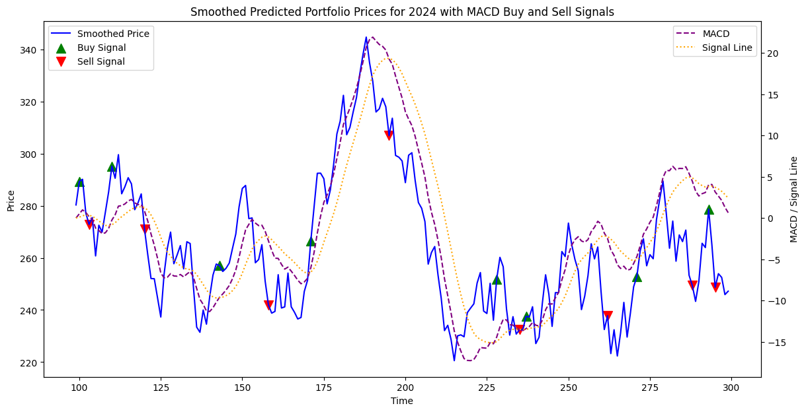

Fig 14. buy and sell signals

# 5. Conclusion

In general, the findings demonstrated that combining traditional financial models (mean-variance) with machine learning techniques (LSTM) effectively achieved the aim of maximizing returns while minimizing risks. The constructed portfolio was optimized to handle different market conditions, and the forecasting and trading signals provided actionable insights for decision-making.

However, there are several limitations on my project:

Missing Data: Using forward or backward filling assumes past or future values are accurate estimates, which can be problematic in volatile markets. This approach risks introducing biases, making forecasts less reliable. For example, during significant market events like the 2020 pandemic, using simple imputation may lead to incorrect trend estimations. Exploring other methods, such as using LSTM to predict and fill missing values, could provide better accuracy.

Model Complexity and Overfitting: LSTM's complexity increases the risk of overfitting, particularly with noisy financial data. Although dropout layers were used, high training accuracy does not always translate well to real-world performance, especially under volatile market conditions. For example, when applying the model during a sudden market downturn, overfitting to stable historical trends may fail to adapt adequately.

Mean-Variance Optimization Limitations: Mean-variance assumes normally distributed returns and stable covariance, which rarely hold in financial markets that often exhibit fat tails and volatility clustering. During extreme market conditions, such as 2008's financial crisis, the optimized portfolio might not protect well against significant losses due to these flawed assumptions.

Technical Indicators and Market Efficiency: SMA and MACD are based on historical patterns, conflicting with the efficient market hypothesis, which claims all information is already priced in. For example, using MACD signals may not consistently lead to profits in highly efficient markets where new information is instantly reflected in stock prices.

Bias from Assumptions: Assumptions like a 50-day look-back period and stable market conditions influenced results, limiting their applicability. For instance, a different look-back period might yield vastly different outcomes, affecting the reliability of portfolio optimization decisions during different market phases.

And when managers or retail investors in the use of the above problems may lead to poor prediction ability, affecting the specific use. And because the above needs to be experimented with frequently based on updated data, it is not applicable to the general public.

# 6. Personal Reflection

In this project, I tried for the first time to use LSTM models for predictive portfolio optimization. Also encountered many difficulties in this process:

One major challenge I faced was handling the significant amount of missing data when using historical stock prices. I tried forward and backward filling methods, but I soon realized that these approaches were not suitable during high market volatility, as they led to biased forecasts. To solve this, I experimented with using LSTM-based imputation, which provided better accuracy and more realistic data patterns. This experience taught me the importance of adapting data handling techniques to the specific characteristics of financial data. Additionally, during the LSTM model training process, I faced issues with overfitting, particularly with noisy data. To address this, I added dropout layers and experimented with different learning rates. Although it was a time-consuming process, this iterative tuning allowed me to achieve better generalization.

Lastly, I initially tried using a Convolutional Neural Network (CNN) alongside LSTM, hoping to improve prediction accuracy. However, due to the increased model complexity and risk of overfitting, I decided to simplify the model and focus on optimizing the LSTM. This taught me the value of balancing model complexity with practicality, especially in financial forecasting. In future projects, I plan to explore other portfolio optimization methods, such as support vector regression (SVR), and consider incorporating bonds or futures to diversify the investment options.

# 7. Reference

1. Markowitz, H. M., & Markowitz, H. M. (1967). Portfolio selection: efficient diversification of investments. J. Wiley.
2. Hochreiter, S. (1997). Long Short-term Memory. Neural Computation MIT-Press.
3. Sharpe, W. F. (1994). The sharpe ratio. Journal of portfolio management, 21(1), 49-58.

Code in GitHub：

[portfoliooptimization/portfoliooptimization.ipynb at main · YiyunXia926/portfoliooptimization (github.com)](https://github.com/YiyunXia926/portfoliooptimization/blob/main/portfoliooptimization.ipynb)