Rosuber

Feng, Yizhi & Wang, Fangyuan

Project Outline

1. Abstract
2. Functional Requirements
3. Mock

Abstract

Thinking how to get to the airport? Looking for someone who can pick you up in Indy? Airport shuttles have really inflexible schedules. No airport shuttles before class begins. Uber is too expensive and is not available in Terre Haute. Parking at the airport is costly. Friends are unavailable while no one replies your requests from Sharepoint. But now, Rosuber can be your friendly driver, and customer.

Rosuber is a web app that is specialized for Rose students to request and offer pick-up service between the campus and the airport. Rosuber aims to be a safe transportation app. As an applicant, you can simply make a request on Rosuber and it will quickly show you available schoolmates, who will be your potential Rose driver on the day you flying out or back. As a Rose driver, on the other hand, you can also go to Rosuber and offer a time window when you are free to give your schoolmates a ride. Rosuber gives you an opportunity to meet new friends and make money.

Functional Requirements

* Rosefire Login
* Google Login
* Add Applications & Offers
* Edit Applications & Offers
* Cancel Applications & Offers
* Demonstrate Available Requests & Offers
* Demonstrate Trip History
* Contact Drivers/Passengers

Mock

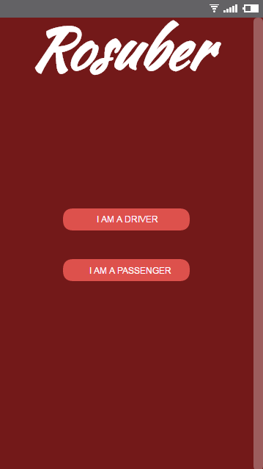

For now, it is designed for mobile users.

See link for demo:

<https://www.fluidui.com/editor/live/preview/p_OWXc5tqERJaTsIrNOSCyeo2BhAKtIyN6.1474329844070>