*2.2 Training and online analysis process*

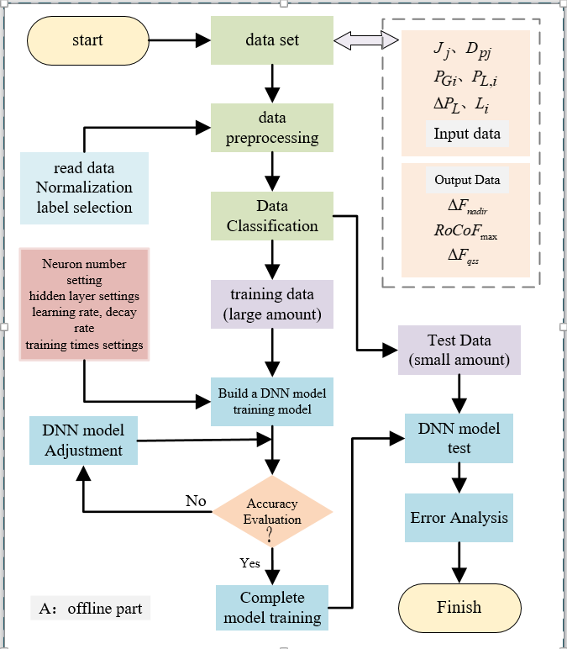

Fig.1. Training Flow Chart

Step 1: Set the system operating conditions, select the fault size, fault location, system inertia level, damping level, etc., perform time-domain simulation offline, obtain big data samples, and build an input and output database.

Step 2: Preprocess the obtained input feature data and output feature data, and data preprocessing is to normalize the data to avoid some data affecting the weight due to excessive deviation. The normalized data conforms to the standard normal distribution with a mean of 0 and a standard deviation of 1, and can speed up the training and solution of neural networks and improve the calculation accuracy. The normalization conversion function is expressed as:



In the formula：  is the sample value,  is the mean of all sample data, and is the standard deviation of all sample data.

Step 3: Classify the data, In the formula 90% of the data is put into the training set for model training and 10% of the data is put into the test set to test the accuracy of the model.

Step 4: Set the number of network layers for the trained model, the number of neurons in each layer, the type of activation function, and the number of trainings.

Step 5: Start training and continuously train the weight matrix of the optimized iterative model so that the model loss function takes the value of the minimized value. The desired goal of this paper is to minimize the error between the predicted value and the actual value, that is, to minimize the mean squared error as the goal, and the mathematical expression of the mean squared error is:



In the formula: subscript  represents the actual value of the sample, and subscript  represents the predicted value of the sample.

Step 6: Complete model training, test with test set data, and perform error analysis.

For frequency-safe online analysis, it is first necessary to obtain the input feature dataset online, then input the input data into the trained deep neural network model, and finally output the frequency safety constraints and comprehensively perform the frequency safety analysis.

*3.2 Constraint condition*

If the set that defines the scheduling time is , the node set is, the node generator set is , and the definition  is the set containing all the lines of the system, then there is line ，In the formula  represents the beginning and end node number. Then the basic active power balance equation of the system at moment t can be expressed as**：**



In the formula: represents the three-phase active output power of the generator connected to the node at t moment; represents the three-phase inflow active power of t moment node k, and represents the three-phase outflow active power of t moment node k; represents the three-phase active load size of node k at t moment; means to take the real part; indicates the three-phase voltage amplitude of the t moment node k; represents the parallel admittance matrix of line .

Similarly , the reactive power flow equation for a system can be expressed as：



In the formula： indicates the three-phase reactive power output power of the generator connected to the node at the t moment; The three-phase inflow active power of t moment node k is, and  represents the three-phase outflow reactive power of t moment node k; represents the three-phase reactive power load size of node k at t moment;  means to take the imaginary part.

At the same time, the active and reactive power equations for line transmission are:





In the formula: is the three-phase voltage of node k, is the three-phase voltage of node m, is the three-phase voltage amplitude of node m, is the three-phase voltage phase angle of node m, and  represents the diagonal matrix. The branch current of one of the phases  can be expressed as:





Further, bring， and  into the equation (18), and the line transmission power is respectively:





In the formula: phase angle difference , phase angle difference . The real imaginary decoupling equation of equation (12) can be written as:





In the formula: phase angle difference, phase angle difference.

In summary, the linearization process of the linear power flow model including equation (4), equation (5), equation (9)-equation (12) and equation (9)-equation (12) is shown in the appendix. Because the voltage square term and trigonometric nonlinear term are included in the power balance constraint, they need to be expressed linearly.

Equations (9) and (12) approximate one of the squared terms of the voltage to 1, that is, equivalent:





*4.1 Frequency Prediction*

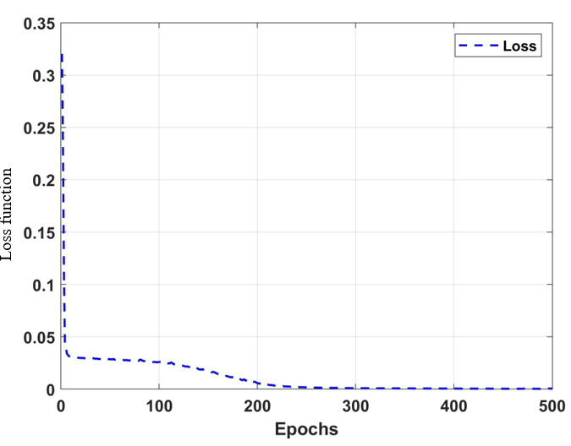

Fig.2 .Loss Function

Given the small amount of input features, this paper constructs a three-layer neural network model, including one input, one hidden layer and one output, with a training breadth of 256 samples each time, a total of 500 training times, and the optimization algorithm adopts the Adam algorithm. The expected value change of the training process of the trained model is shown in Fig.2. The loss function represents the mean squared error function expression (2), and Epochs represents the number of training times.

Analyzing the changing trend of the loss function during the training process of the neural network model in Fig.2, it can be seen that with the increase of the number of training, the neural network gradually enters the training state, and at about 250 times, the total mean squared error value between all sample outputs and the predicted output gradually changes from 0.32 to 0, indicating that the training is close to the target value at this time, and the neural network model built has good prediction accuracy.

*4.2 Analysis of scheduling results*

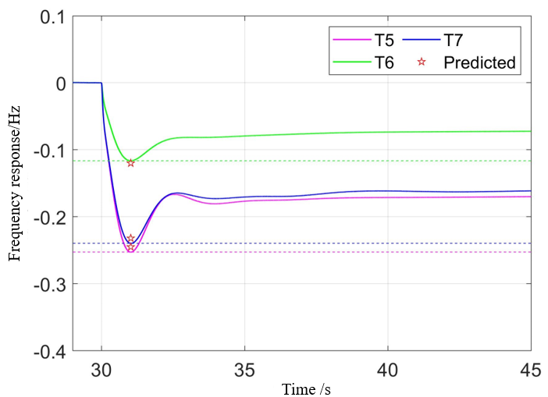

Fig. 3. Frequency Response.

Fig.3 shows the system frequency deviation response curve under the load disturbance during T5, T6 and T7 scheduling periods under the frequency constraint conditions, and analyzing Figure 1, it can be seen that the deep neural network model can predict the frequency response safety index of the system with high precision and provide information for frequency safety control and analysis.