**Introduction to RDBMS:**

* A relational database refers to a database that stores data in a structured format, using rows and columns.
* This makes it easier to locate and access specific within the database.
* It is called “relational” because the values within each table are related to each other. Tables may also be related to other tables.
* The relational structure makes it possible to run queries across multiple tables at once.

**Features of RDBMS:**

* Every piece of information is stored in the form of tables
* Has primary keys for unique identification of rows
* Has foreign keys to ensure data integrity
* Provides SQL for data access
* Uses indexes for faster data retrieval
* Gives access privileges to ensure data security

**Normalization**

* Decompose larger, complex table into simpler and smaller ones
* Moves from lower normal forms to higher normal forms

**Normal Forms:** *First Normal Form (1NF), Second Normal Form (2NF), Third Normal Form (3NF), Higher Normal Form (BCNF, 4NF, 5NF,. . . .)*

**Need for normalization**

* In order to produce good database design
* To ensure all database operations to be efficiently performed
* Avoid any expensive DBMS operations
* Avoid unnecessary replication of information

**Some most important SQL Commands:**

* SELECT: extracts data from database
* UPDATE: updates data in database
* DELETE: deletes data from a database
* INSERT INTO: inserts new data into database
* CREATE DATABASE: creates a new database
* CREATE TABLE: creates a new table
* ALTER TABLE: modifies a table
* DROP TABLE: deletes a table
* CREATE INDEX: creates an index (search key)
* DROP INDEX: deletes an index

**What is SQL?**

MySQL is a relational database management system (RDBMS) developed by Oracle that is based on Structured Query Language (SQL).

*EXAMPLE –* Telephone Directory, Customer data, Product inventory, weather records, etc

It is a programming language specifically designed for working with database to. . . .

* + Create
  + Manipulate
  + Share/access data

**Why SQL?**

SQL is widely popular because it offers the following advantages:

* + Allows users to communicate i.e., access and manipulate the database
  + Allows users to retrieve data from a database
  + Allows users to create, update, modify and delete the database
  + SQL is a language for defining the structure of a database.

**SQL TERMS:**

* Data – is defined as facts or figures, or information that’s stored in or used by a computer
* Database – is a organized of data/information so that it can be easily accessed, managed and updated.

**SQL Data Types**

* Numeric – bit, int, decimal, numeric, float, real
* Character/String – Char, Varchar, text
* Date/Time – Date, time, datetime, timestamp, year
* Miscellaneous – Json, XML

**SQL Constraints**

* Not Null – Ensures that a column does not have a NULL value
* Default - Provides a default value for a column when none is specified
* Unique – ensures that all the values in a column are different
* Primary – Identifies each row/record in a database table uniquely (Database table – is a collection of rows and columns that contains relational/relevant data i.e. the data that are related to each other)
* Check – ensures that all values in a column satisfy certain conditions
* Index – creates and retrieves data from the database very quickly

**Some important SQL Commands –**

***SELECT:*** extracts data from database

***UPDATE:*** updates data in database

***DELETE:*** deletes data from a database

***INSERT INTO:*** inserts new data into database

***CREATE DATABASE:*** creates a new database

***ALTER DATABASE:*** modifies a database

***CREATE TABLE:*** creates a new table

***ALTER TABLE:*** modifies a table

***DROP TABLE:*** deletes a table

***CREATE INDEX:*** creates an index (search key)

***DROP INDEX:*** deletes an index

**DBMS Operations: -** add new files, inserting data, retrieving data, modifying data, removing data, removing files.

**SQL Command Groups:**

* *DDL (Data Definition Language):* creation of objects
* *DML (Data Manipulation Language):* manipulation of data
* *DCL (Data Control Language):* assignment and removal of permissions
* *TCL (Transaction Control Language):* saving and restoring changes to a database

**Data Definition Language (DDL) –**

|  |  |
| --- | --- |
| **Command** | **Description** |
| *Create* | *Creates objects in the database/database objects* |
| *Alter* | *Alters the structures of the database/database objects* |
| *Drop* | *Deletes objects from the database* |
| *Truncate* | *Removes all records from a table permanently* |
| *Rename* | *Renames an object* |

1. **CREATE TABLE Command:** **How to create a table in MySQL?**

*Syntax:* **CREATE TABLE** table_name

(

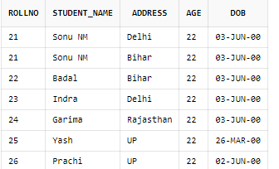 Column1 datatype,

Column2 datatype,

Column3 datatype,

. . . . . . . . .

);

*Example:* CREATE TABLE student_details (

rollNo number(3),

student_name varchar(20),

address varchar(30),

age number(2) NOT NULL,

dob date

);

insert into student_details values (21, 'Sonu NM', 'Bihar', 22, '03-june-2000');

insert into student_details values (22, 'Badal', 'Bihar', 22, '03-june-2000');

insert into student_details values (23, 'Indra', 'Delhi', 22, '03-june-2000');

insert into student_details values (24, 'Garima', 'Rajasthan', 22, '03-june-2000');

insert into student_details values (25, 'Yash', 'UP', 22, '26-march-2000');

insert into student_details values (26, 'Prachi', 'UP', 22, '02-june-2000');

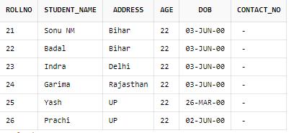

Select * from student_details;

1. **ALTER TABLE Command:**

The *‘ALTER TABLE’* command is used to add, delete, or modify columns in an existing table.

*SYNTAX: -* **ALTER TABLE** table_name **ADD** (column_name datatype);

*Example: -* ALTER TABLE student_details

ADD (contact_no int);

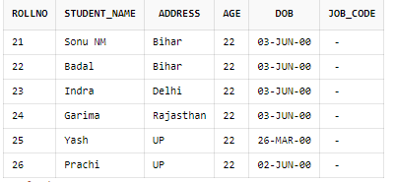

1. **RENAME TABLE Command:**

ALTER TABLE student_details

RENAME COLUMN contact_no to job_code ;

1. **TRUNCATE TABLE Command:**

The ‘TRUNCATE TABLE’ statement is used to remove all records from a table in Oracle. It is used to delete the data inside a table, but not the table itself.

*Syntax -* TRUNCATE TABLE table_name;

1. **DROP TABLE Command:**

The ‘DROP TABLE’ command is used to remove the whole data including data present inside it. It is irreversible in nature. It means that once the user drops a table, there is no way to undo the command. Therefore, the drop table must be used with extensive care.

*Screenshot (311).pngSyntax -* DROP TABLE table_name;

**Data Manipulation Language (DML) –**

* *DDL (Data Definition Language)* helps you to define the database structure, while *Data Manipulation Language (DML)* allows you to manage the data stored in the database.
* DDL command is used to create the database schema/structure, while DML command is used to manipulate the database.
* In DDL, SQL statement can’t be roll-backed; while in DML, SQL statement can be roll-backed (restore a database to previous state).

|  |  |
| --- | --- |
| **Command** | **Description** |
| *Insert* | *Insert data into a table* |
| *Update* | *Updates existing data into a table* |
| *Delete* | *Deletes specified/all records from a table* |

1. **INSERT Command –**

The ‘INSERT INTO’ statement is used to insert new records in the table. There are two ways to write the ‘INSERT INTO’ statement:

* *Specify both the column names and the values to be inserted*

INSERT INTO column_name(column1, column2, column3, . . . . )

VALUES (value1, value2, value3, . . . . );

* No need to specify the column names. However make sure that orders of the values are in the same order as the columns in the table.

INSERT INTO table_name

VALUES (value1, value2, value3, . . . . . );

***EXAMPLE -***  insert into student_details values (21, 'Sonu NM', 'Bihar', 22, '03-june-2000');

1. **UPDATE Command –**

The ‘UPDATE’ statement is used to modify the existing records in the table.

*Syntax:* UPDATE table_name

SET column1 = newvalue1, column2 = newvalue2, . . . . .

WHERE condition ;

//The WHERE Clause specifies which records should be updated

*Example:* UPDATE student_details

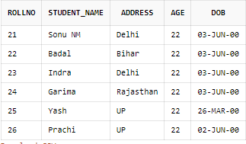 SET address = 'Delhi' WHERE rollNo = 21 ;



1. **DELETE Command –**

The ‘DELETE’ command is used to delete existing records in a table.

*Syntax:* DELETE FROM table_name WHERE column_name IN (condition);

// The WHERE clause specifies which records should be deleted

*Example:* DELETE FROM student_details WHERE rollNo IN (22, 23);

*Output:* 2 row(s) deleted.

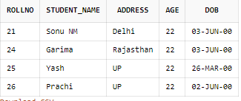

**Data Control Language (DCL) –**

* DCL is used to control user access in a database.
* This command is related to the security issues.
* Using DCL commands, it allows/restricts the user from accessing data in database schema/structure.
* DCL commands: ***Grant*** and ***Revoke***.
* It is used to grant or revoke access permissions from any database user.

1. **GRANT Command :**

* It gives user’s access privileges to the database.
* This command allows specified users to perform specific tasks.

*Syntax:* GRANT <Privilege list>

ON <relation name or view name>

TO <user/role list ;

1. **REVOKE Command:**

* It is used to cancel previously granted or denied permissions.
* This command withdraws access privileges given with the GRANT command.
* It takes back permissions from the user.

**Syntax:** REVOKE <privilege list>  
 ON <relation name or view name>  
 FROM <user name>;

**Difference between GRANT and REVOKE command.**

|  |  |
| --- | --- |
| **GRANT** | **REVOKE** |
| **GRANT command** allows a user to perform certain activities on the database. | **REVOKE command** disallows a user to perform certain  activities. |
| It grants access privileges for database objects to other users. | It revokes access privileges for database objects previously  granted to other users. |

**Transaction Control Language (TCL) –**

* This command is used to manage the changes made by DML (Data Manipulation Language) statements.
* Transactional Control commands are only used with the DML commands such as – INSERT, UPDATE and DELETE only.
* There are 3 Transaction Control Language (TCL) commands: COMMIT, ROLLBACK and SAVEPOINT command.

1. **COMMIT Command:**

* It saves all the work done.
* It ends the current transaction and makes permanent changes during the transaction.
* *Syntax-* COMMIT;

1. **SAVEPOINT Command:**

* It creates points within the group of transactions in which to ROLLBACK.
* Basically it’s a point in a transaction when you can roll the transaction back to a certain point without rolling back the entire transaction.
* *Syntax-* SAVEPOINT <savepoint_name>

1. **ROLLBACK Command:**

* It is used to restore the database to last committed state.
* ROLLBACK command restores database to original since the last COMMIT.
* It undo the transaction that have not been modified in the database.
* *Syntax –* ROLLBACK ;

.