Documentation:

Website name: FitPeo.com

url: <https://fitpeo.com/>

Testing: Automation

Tools used: Java, selenium, TestNG, Maven

1. **Prerequisites:**

* Install Java Development kit (JDK). Ensure you have Java 8 or later installed.
* Set up Eclipse IDE or any Java supported IDE.

Note: I used Eclipse for scripting

1. **Steps to set up:**

* Create a new maven project in IDE.
* Then go to .POM file, add the selenium-java, WebdriverManager, TestNG dependency. You can find the following dependencies below.

<dependency>

<groupId>org.seleniumhq.selenium</groupId>

<artifactId>selenium-java</artifactId>

<version>4.26.0</version>

</dependency>

<dependency>

<groupId>org.testng</groupId>

<artifactId>testng</artifactId>

<version>7.10.2</version>

<scope>test</scope>

</dependency>

<dependency>

<groupId>io.github.bonigarcia</groupId>

<artifactId>webdrivermanager</artifactId>

<version>5.9.2</version>

</dependency>

* After adding the following dependencies to pom file. Just update the project, and then maven dependencies should be added to your working directory. Then only you are able to run the code. Otherwise, please the check the pom file.
* Then create the following project structure

Src/main/java:

Fitpeo.utilities (package)-> browsersetup.class,propertyhandlerclass.

Src/main/resource:  
create (data) file with properties extension

Src/test/java:

Fitpeotestcases(package)-> testcases.class, testCasesHelperClass.class.

Src/test/resource:

Create a xml file with extension (.xml)

* For code reusability I used browsersetup class
* For fetching the data to eliminate the values duplication, I used properties file
* For test cases I created test cases class under src/test/java
* Why I used XML file instead of direct run from the class we can control the script more accurately from the XML file.

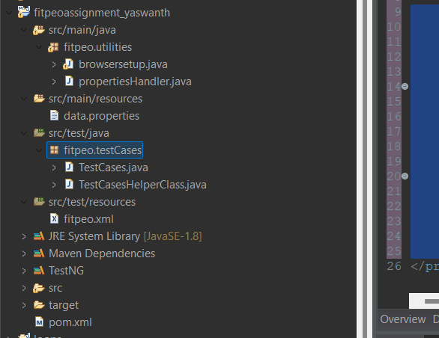

1. **Running the script:**

* Write the Script or paste the script from the following source code.
* Run the script via IDE from XML file which I created under src/test/resource
* The following output should be

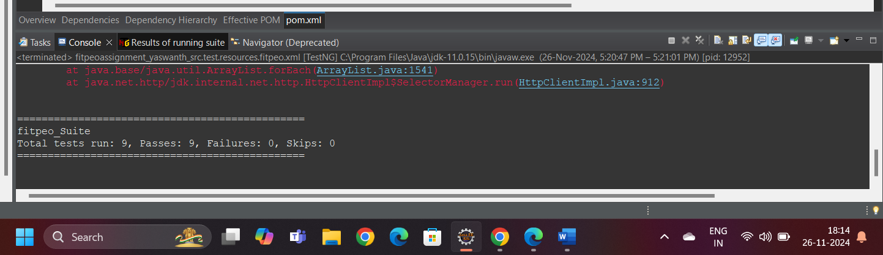

1. **Why java?**

Java is a pure object oriented programming and also is developed in the basis of real time experience. Has more security. Easy to understand.

1. **Why testNG?**

* Advanced to JUNIT.
* And provide more annotations and Additional features like priority, dependycies, more annotations and XML file also.
* Parallel execution: You can our tests in parallel to save time with help of threads.
* Default reports to know the status of our testcases
* Cross browser testing, even I also used this testing method only.

1. **What are the difficulties I have faced while developing the script?**

* **NoSuchElementFound:** while handling the fitpeo_tc004, I faced this issue. I used lot of locators to find the better way. At-last I achieved the target using keyboard controls
* **FileNotFound:** While handling with properties file, like giving the wrong path of the properties file.
* **IllegalArgumentsr:** To save the memory allocation, I created object to Actions class statically at class level. Later I found that was the mistake. Why the error is I declared the driver in action class statically, while declaring any thing statically it will be saved for the life time of project. Over riding is not possible.
* **TimeoutException**
* **ElementNotInterectable:** Used implicit wait to overcome
* **SessionNotCreated**: As I discussed in FileNotFound exception