**8x8 LED Matrix Scrolling Display with Arduino Control**

*A Report on Mini Project-2*

*Submitted in the Partial Fulfilment of the Requirement for the degree of*

Bachelors of Technology

(Electrical Engineering)

by

Yogesh Kumar Chauhan (Enrollment No.-510617058)

Nishant Bansal (Enrollment No.-510617062)

Hariom Gupta (Enrollment No.-510617063)

Ritik Raj (Enrollment No.-510617064)

Kapil Agarwal (Enrollment No.-510617067)

Jitin Chandolia (Enrollment No.-510617078)



DEPARTMENT OF ELECTRICAL ENGINEERING

INDIAN INSTITUTE OF ENGINEERING SCIENCE AND TECHNOLOGY, SHIBPUR

HOWRAH- 711103, WEST BENGAL

**DEPARTMENT OF ELECTRICAL ENGINEERING**

**INDIAN INSTITUTE OF ENGINEERING SCIENCE AND TECHNOLOGY, SHIBPUR**

**HOWRAH- 711103, WEST BENGAL**



**ACKNOWLEDGEMENT**

This project expended tremendous measure of work, research and commitment. Yet, this report would not have been possible if we didn’t have the back of individuals from IIEST, Shibpur. Hence, we would like to extend my true appreciation to every one of them. Lastly, we thank our parents and friends for their constant encouragement without whom this project would not be possible.

Dated:

Indian Institute of Engineering Science and Technology,

Shibpur, Howrah-711103

Students Signature:

Yogesh Kumar Chauhan __________________________

Nishant Bansal __________________________

Hariom Gupta __________________________

Ritik Raj __________________________

Kapil Agarwal __________________________

Jitin Chandolia ­______­­­­­­­­­­­____________________

Index

Contents Page No.

1. INTRODUCTION 4

2. COMPONENTS 5-6

3. CIRCUIT DIAGRAM 7

4. WORKING PRINCIPLE 8

5. LED MATRIX 9

6. SHIFT REGISTER 10-11

7. ARDUINO BOARD (UNO R3) 12-13

8. APPLICATIONS 14

9. ADVANTAGES AND DISADVANTAGES 15-16

10. REFERENCES 17

Introduction

These days we are surrounded by electronics gadgets. We are surrounded by various applications via microelectronics circuit. These devices are generally found with display screen embedded with it, which are used to display information of/by the machine. However, these devices use dot matrices of low pixel resolution.

The display consists of a dot matrix of lights or mechanical indicators arranged in a rectangular configuration (other shapes are also possible, although not common) such that by switching on or off selected lights, text or graphics can be displayed. A dot matrix controller converts instructions from a processor into signals which turns on or off lights in the matrix so that the required display is produced.

Pixels to a picture is like atom to matter i.e; the smallest single component of a digital image. These displays are used in various places like in calculators, in marriage broadcasts, in information displays etc. In fact we can use the display control by programs by microelectronics circuits i.e; the information can be fed in via user and the input is displayed on the screen by the use of different lights of matrix.

In this project we are going to design an **8x8 LED matrix display**, for that we are going to interface an 8x8 LED matrix module with Arduino Uno. An 8x8 LED matrix contains 64 LEDs (Light Emitting Diodes) which are arranged in the form of a matrix, hence the name LED matrix.

Components

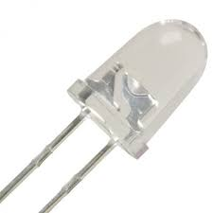1. LED Lights

* 5mm Orange LEDs
* Quantity: 64
* Operating Voltage: 2.2V

2. ARDUINO Uno

* 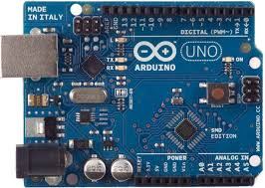Microcontroller: ATmega328P
* Operating Voltage: 5V
* Input Voltage: 7-8V (limit: 6-20 V)
* Analog Input Pins: 6(A0-A5)
* Digital I/O Pins: 14 (6 output pins)
* DC current on i/o pins: 40mA
* Flash Memory: 32KB
* Frequency(Clock speed): 16MHz

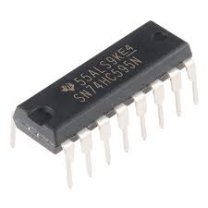3. SN74HC595N IC

* 8-bit SIPO (Serial in parallel-out) Shift Register
* Operating voltage range: 2-6V
* Input Current(maximum): 1mA
* Output Drive at 5V: ±6-mA

4. Other components

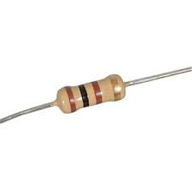

* Resistor 400Ω (8pcs)

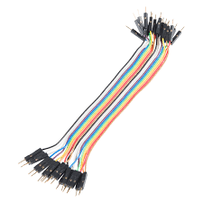

* Jumper wires

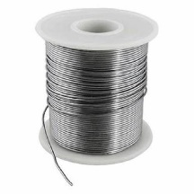

* Solder wire

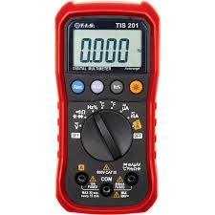

* Multimeter



* Soldering Iron

CIRCUIT DIAGRAM

Circuit diagram is shown below: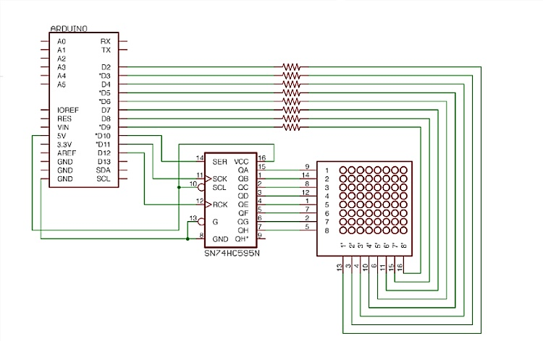

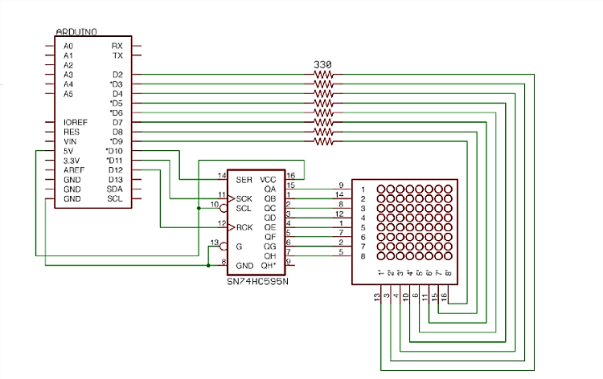

An example of printed data (Alphabet ‘A’):

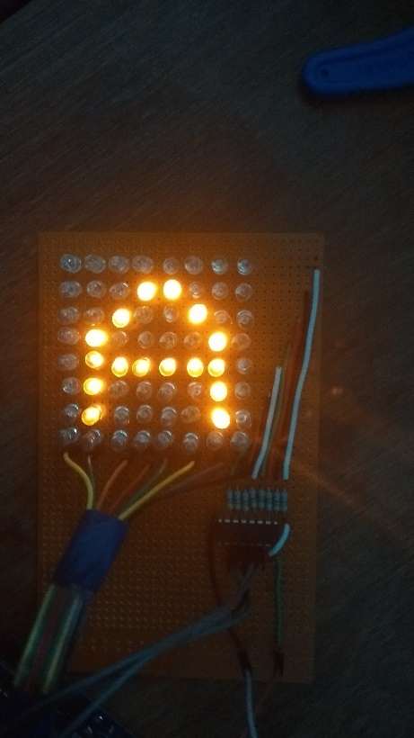

WORKING PRINCIPLE

This project uses Shift registers, Arduino board, led lights as its main components. We also use programming to control the mechanism and use the concept of turning on lights with enough frequency so that human eye can not notice the difference between on and off delays. The supply is given to Arduino board and then it is connected to shift register then to the matrix via resistors and cathode terminal is connected to digital pins of Arduino board. Shift register ic is given supply from a 5V DC source.

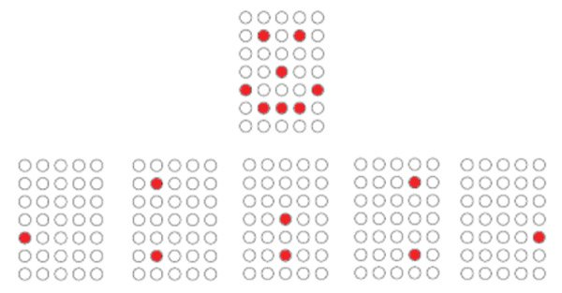At the output terminals of ic patterned outputs are obtained and fed to anode terminals via resistors. The cathode terminals are connected to digital output terminals of Arduino. The cathode terminals are low one-by-one (according to program written in Arduino) so that in 1-byte output of shift register ic each row is powered with a delay of 1ms that cannot be detected by human eye and hence we see a single data (ex. alphabet ‘A’) at once. This is how this LED matrix work. This is also called ‘multiplexing’.

Multiplexing Technique

***1.******LED Matrix***

The dimension of LED Matrix chosen for our project is 8*8. It is chosen since it is relatively easy to design a character or a number in such configuration. Furthermore, since the project implies the use of parallel ports with 8 output pins, the matrix can be friendly for the port interface. In any case, a LED matrix with 8*8 dimension implies controlling of 64 LEDs at any time. To reduce this difficulty the configuration of the LED matrix is done in following way:

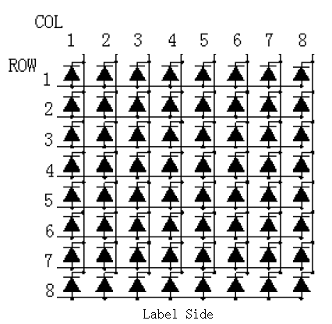

The configuration shown in figure allows reduction of points to be controlled for the LED Matrix Display. Instead of controlling each individual LED, the configuration allows us to control entire row and column at any instance. In the configuration, the anodes of the LEDs are connected along a row and the cathodes are connected along a column. This allows control of an individual LED in any instance. For example, if we wish to control a LED at position 2×2, we can do it by controlling voltage supply at 2nd row and ground supply at 2nd column. In this way any LED in the matrix can be controlled. In case of 8*8 LED matrix, this configuration reduces the control points to 64 from 16.

***2. Shift Register***

For controlling these 64 LEDs (without shift register) requires 64 pins which is not available in microcontroller. The solution for this is to use a ‘Shift Register’. A shift register allows you to expand the number of I/O pins we can use from our Arduino. The 595 has two registers (which can be thought of as “memory containers”), each with just 8 bits of data. The first one is called the Shift Register. The Shift Register lies deep within the IC circuits, quietly accepting input.

Whenever we apply a clock pulse to a 595, two things happen:

* The bits in the Shift Register move one step to the left. For example, Bit 7 accepts the value that was previously in bit 6, bit 6 gets the value of bit 5 etc.
* Bit 0 in the Shift Register accepts the current value on DATA pin. At the rising edge of the pulse, if the data pin is high, then a 1 gets pushed into the shift register. Otherwise, it is a 0.

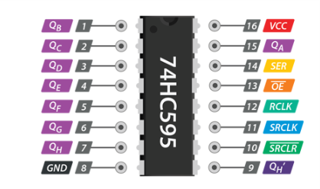On enabling the Latch pin, the contents of Shift Register are copied into the second register, called the Storage/Latch Register. Each bit of the Storage Register is connected to one of the output pins QA–QH of the IC, so in general, when the value in the Storage Register changes, so do the outputs.

The following is the timing diagram of SIPO Shift Register :

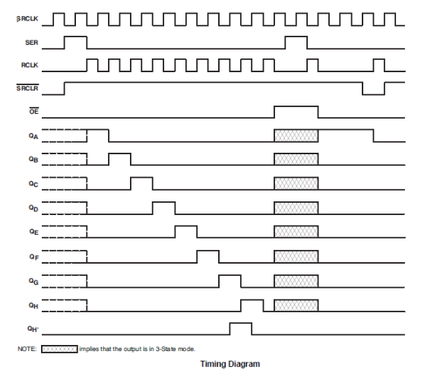

The following is the functional block diagram of this IC :

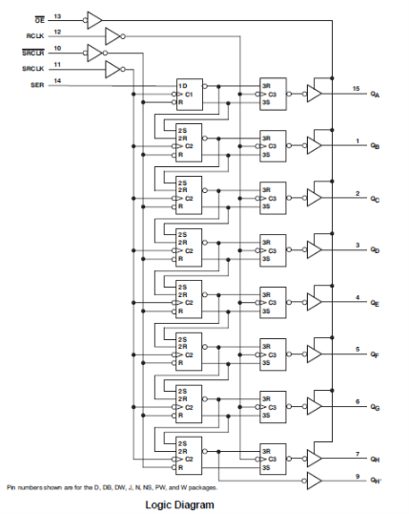

***3. ARDUINO BOARD (UNO R3)***

Arduino is an open source programmable circuit board that can be integrated into a wide variety of projects both simple and complex.  This board contains a microcontroller which is able to be programmed to sense and control objects in the physical world.   By responding to sensors and inputs, the Arduino is able to interact with a large array of outputs such as LEDs, motors and displays.  Because of its flexibility and low cost, Arduino has become a very popular choice for creating interactive hardware projects. This can again be programmed according to our need to fulfil our requirement.

***Why Arduino?***

1. It is inexpensive
2. It comes with an open source hardware feature which enables users to develop their own kit using already available one as a reference source.
3. The Arduino software is compatible with all types of operating systems like Windows, Linux, and Macintosh etc.
4. It also comes with open source software feature which enables experienced software developers to use the Arduino code to merge with the existing programming language libraries and can be extended and modified.
5. It is easy to use for beginners.
6. We can develop an Arduino based project which can be completely stand alone or projects which involve direct communication with the software loaded in the computer.
7. It comes with an easy provision of connecting with the CPU of the computer using serial communication over USB as it contains built in power and reset circuitry.

Arduino pin diagram is shown below:

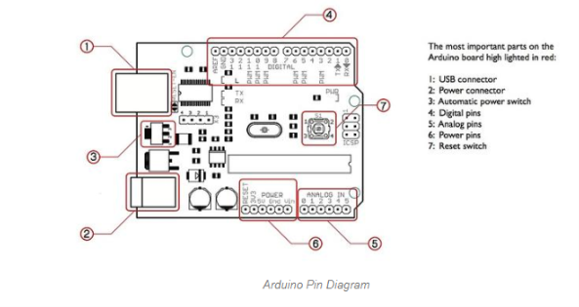

APPLICATION

* *For Displaying Information*

Arduino based 8 x 8 LED matrix display uses only 3 pins of the Microcontroller. Hence, it can be used in applications where displaying information is a part of the system in which other pins of the microcontroller can be used for other peripherals.

* *In Public Transportation Vehicles*

LED Matrix is a basic form of display device that is used for displaying information at public places like bus or train stations.

* *In Large Displays*

Multiple LED matrices can be combined to form large displays and can be used to display images with multi colours.

* *In Weddings*

These LED matrices are used in decorations at several functions and also are used in light ropes to provide facility of sliding names or patterns.

* *In Traffic Signalling*

A key requirement of each LED traffic sign is its functionality and a long distance visibility in bad weather. The directed LED's provide excellent visibility in all conditions, while built-in ambient light sensor and automatic brightness adjustment regulates the LEDs so they don't blind the approaching drivers.

Advantages:

* LED dot matrix display board can be very bright and eye-catching. Display signs used for advertising or for displaying direction or other information to motorists have an important feature in common. They should be eye-catching and their information should be easy to absorb.
* LED dot matrix’s produce more light per watt than incandescent bulbs; this is useful in battery powered or energy-saving devices.
* LED dot matrix’s, being solid state components, are difficult to damage with external shock.
* LED dot matrix’s can have a relatively long useful life.
* LED dot matrix’s can be very small and are easily populated onto printed circuit boards.

Disadvantages:

* The output created by dot matrix printers is not of high quality. Likewise, the color printout is limited while print speed is lesser compared to printers that are non-impact.
* **Pins Can Bend Easily**
* Dot matrix printers are only best when it comes to cost in which print quality should be compromised.
* Colour uniformity is not good.
* Character sizes are limited by the resolution of dot matrix.

REFERENCES:

* [www.circuitdigest.com](http://www.circuitdigest.com)
* [www.digikey.in](http://www.digikey.in)
* [www.electronicshub.org](http://www.electronicshub.org)
* [www.components101.com](http://www.components101.com)
* [www.circuitstoday.com](http://www.circuitstoday.com)
* [www.instructable.com](http://www.instructable.com)
* [www.youtube.com](http://www.youtube.com)
* [www.medium.com](http://www.medium.com)