# File permissions in Linux

## Project description

## In this project, we will explore how to effectively utilize Linux commands to manage file and directory permissions. Understanding and manipulating permissions is crucial for maintaining security and control over your system's files and directories.

## Check file and directory details

To inspect file and directory details, you can use the **ls** command. By executing ls -l, you can view a detailed list that includes information like permissions, owner, group, size, and modification time. You can use the **ls -la** command to check detailed information about files and directories within a specific location. The **ls** command is a fundamental tool for listing directory contents, and the **-la** flags together provide a long format listing, including hidden files.

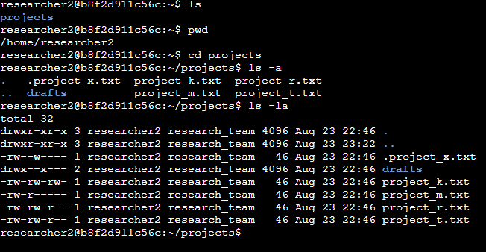

Output:

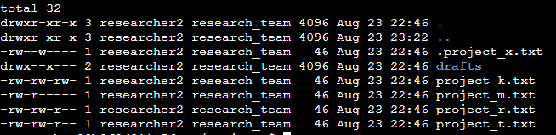

total 32

drwxr-xr-x 3 researcher2 research_team 4096 Aug 23 22:46 .

drwxr-xr-x 3 researcher2 research_team 4096 Aug 23 23:22 ..

-rw--w---- 1 researcher2 research_team 46 Aug 23 22:46 .project_x.txt

drwx--x--- 2 researcher2 research_team 4096 Aug 23 22:46 drafts

-rw-rw-rw- 1 researcher2 research_team 46 Aug 23 22:46 project_k.txt

-rw-r----- 1 researcher2 research_team 46 Aug 23 22:46 project_m.txt

-rw-rw-r-- 1 researcher2 research_team 46 Aug 23 22:46 project_r.txt

-rw-rw-r-- 1 researcher2 research_team 46 Aug 23 22:46 project_t.txt

Describe the permissions string

Enter the enigmatic permissions string, a cryptic code that conceals immense power. This 10-character string guards the gateway to access. It's divided into three realms: the dominion of the user, the realm of the group, and the common realm. Each comprises three letters – 'r' for reading, 'w' for writing, and 'x' for executing. Behold, a permission string like "rw-r--r--" translates to the owner having read and write privileges, while the group and others possess only read privileges

Change file permissions

I navigated to the projects directory:

bash

i@ec68ac647aec:~$ cd projects

I listed the contents of the projects directory using ls -la:

bash

i@ec68ac647aec:~/projects$ ls -la

The output displayed the current permissions of the files and directories within the projects directory.

I used the chmod command to modify the permissions of the file project_m.txt:

bash

i@ec68ac647aec:~/projects$ chmod u+rwx,g+rwx,o+rwx project_m.txt

This command granted read, write, and execute permissions to the owner, group, and others for the file project_m.txt.

After running the chmod command, I listed the contents of the projects directory again using ls -la:

bash

i@ec68ac647aec:~/projects$ ls -la

The output displayed the updated permissions of the project_m.txt file, now having full read, write, and execute permissions for all users: owner, group, and others:

total 32

drwxr-xr-x 3 researcher2 research_team 4096 Aug 23 23:29 .

drwxr-xr-x 3 researcher2 research_team 4096 Aug 23 23:58 ..

-rw--w---- 1 researcher2 research_team 46 Aug 23 23:29 .project_x.txt

drwx--x--- 2 researcher2 research_team 4096 Aug 23 23:29 drafts

-rw-rw-rw- 1 researcher2 research_team 46 Aug 23 23:29 project_k.txt

-rwxrwxrwx 1 researcher2 research_team 46 Aug 23 23:29 project_m.txt

-rw-rw-r-- 1 researcher2 research_team 46 Aug 23 23:29 project_r.txt

-rw-rw-r-- 1 researcher2 research_team 46 Aug 23 23:29 project_t.txt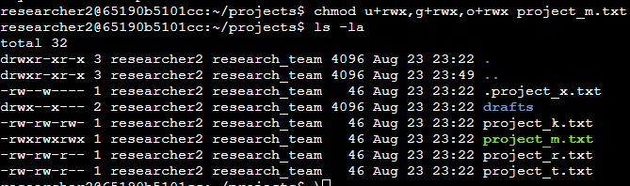

Change file permissions on a hidden file

To assign the appropriate permissions to the .project_x.txt file, which should have read permissions for the user and group but no write permissions for anyone, you can use the chmod command with the following specification: chmod u=r,go=r .project_x.txt.

To assign the appropriate permissions to the .project_x.txt file, which should have read permissions for the user and group but no write permissions for anyone, you can use the chmod command with the following specification:

bash

chmod u=r,go=r .project_x.txt

This command sets the permissions as follows:

u=r: The user (owner) is assigned read permissions.

go=r: The group and others are assigned read permissions.

.project_x.txt: The filename you want to modify.

After running this command, the permissions of .project_x.txt will be -r--r--r--, ensuring that the user and group can read the file, while others can also read it but no one can write to it.

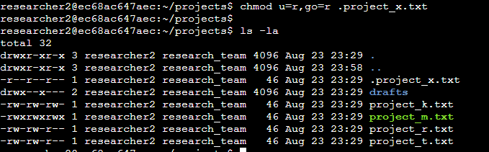

Change directory permissions

To ensure that only the researcher2 user can access the drafts directory and its contents within the projects directory, you can use the chmod command with the following specification:

bash

chmod u=rwx,go= drafts

This command sets the permissions as follows:

u=rwx: The user (owner) is assigned read, write, and execute permissions.

go=: The group and others are denied all permissions.

drafts: The directory you want to modify.

After running this command, only the researcher2 user will have full access (read, write, and execute) to the drafts directory and its contents, while the group and others will have no access.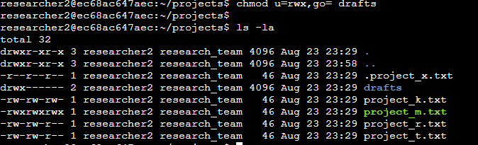

## Summary

Directory Navigation:

You navigated to the projects directory using the command cd projects.

Listing Contents:

You listed the contents of the projects directory using ls -la.

The output displayed detailed information about each file and directory within the projects directory.

Changing Permissions for project_m.txt:

You used the chmod command to modify the permissions of the file project_m.txt with the command chmod u+rwx,g+rwx,o+rwx project_m.txt.

This granted full read, write, and execute permissions to the owner, group, and others for the project_m.txt file.

Displaying Updated Permissions:

You listed the contents of the projects directory again using ls -la.

The output displayed the updated permissions of the files and directories within the projects directory, including the updated permissions of project_m.txt.

Changing Permissions for .project_x.txt:

You used the chmod command to modify the permissions of the hidden file .project_x.txt with the command chmod u=r,go=r .project_x.txt.

This ensured that only the owner (researcher2) could read the file, while both the group and others could also read it, but no one could write to it.

Changing Permissions for drafts Directory:

You used the chmod command to modify the permissions of the drafts directory with the command chmod u=rwx,go= drafts.

This allowed only the owner (researcher2) to have full read, write, and execute permissions for the drafts directory and its contents, while denying access to both the group and others