
UBT
Computer Science and Engineering

Machine Learning Models Lab Report
Diabetes Prediction using Classification and Clustering Techniques

Professor |  | Students
Phd. Greta Ahma |  | Eljana Gjeçbitirq  Ylldrit Qallakaj

Date: May 2025
- Software Environment
Programming Language: Python 3.x
Libraries and Versions:
- numpy: For numerical computations and array operations
- pandas: For data manipulation and analysis
- matplotlib: For data visualization and plotting
- eaborn: For statistical data visualization
- cikit-learn: For machine learning algorithms and evaluation metrics
- train_test_split: Data splitting functionality
- StandardScaler: Feature scaling
- MLPClassifier: Neural Network implementation
- Perceptron: Perceptron algorithm
- KNeighborsClassifier: k-Nearest Neighbors algorithm
- DecisionTreeClassifier: Decision Tree algorithm
- KMeans: K-means clustering algorithm
- SelectKBest, f_classif, RFE: Feature selection methods
- RandomForestClassifier: For feature importance analysis
- LeaveOneOut: For cross-validation
- Various metrics: classification_report, confusion_matrix, accuracy_score, adjusted_rand_score
- tqdm: For progress bars during cross-validation

- Dataset and Preprocessing
Dataset Description
- Dataset: Pima Indians Diabetes Dataset
- Samples: 768 patients
- Features: 8 clinical features
  - pregnancies: Number of pregnancies
  - glucose: Plasma glucose concentration
  - blood pressure: Diastolic blood pressure
  - skin thickness: Triceps skin fold thickness
  - insulin: 2-Hour serum insulin
  - bmi: Body mass index
  - diabetes pedigree: Diabetes pedigree function
  - age: Age in years
Target: Binary classification (0: Non-diabetic, 1: Diabetic)

Data Preprocessing
- Missing Value Handling:Invalid zero values in glucose, blood pressure, skin thickness, insulin, and bmi were replaced with NaN and then filled with median values
- Feature Scaling: StandardScaler applied to normalize all features (mean=0, std=1)
- Train-Test Split:70% training, 30% testing (random state=42)

- Classification Analysis
3.1 Implemented Classifiers
Neural Network (MLP Classifier)
- Architecture: Multi-layer perceptron with hidden layers (32, 16, 8)
- Activation Function: ReLU (Rectified Linear Unit)
- Solver: Adam optimizer
- Max Iterations (maxEpochs): 600
- Early Stopping: True
Topology Explanation:
- Input layer: 8 neurons (one for each feature)
- First hidden layer: 32 neurons
- Second hidden layer: 16 neurons
- Third hidden layer: 8 neurons
- Output layer: 2 neurons (binary classification)
- Progressive reduction in layer size allows for hierarchical feature learning
- Early stopping to stop training the model when no improvement is made
Perceptron
- Max Iterations (maxEpochs):1000
- Algorithm: Single-layer linear classifier
- Random State: 42 for reproducibility
k-Nearest Neighbors (k-NN)
- Number of Neighbors (k): 5
- Distance Metric: Euclidean distance (default)
- Algorithm: Brute force neighbor search
Decision Tree
- -Splitting Criterion: Gini impurity (default)
- -Random State: 42 for reproducibility
- -No maximum depth specified (grows until pure leaves)

3.2 Classification Results
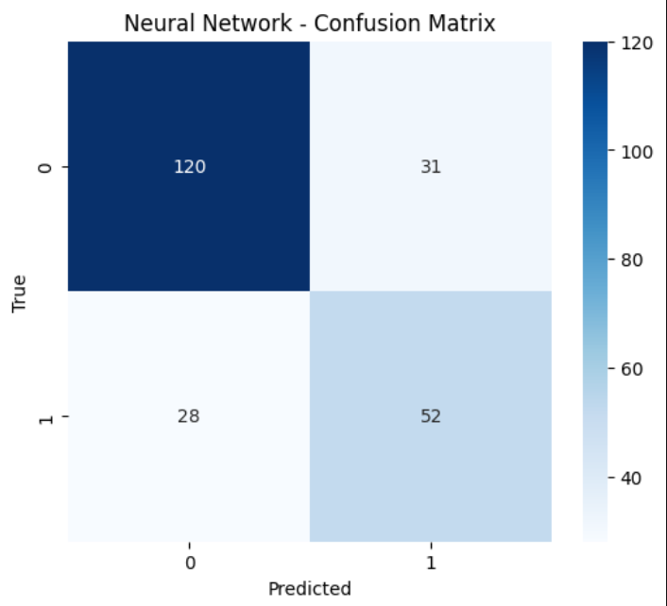
Neural Network Confusion Matrix
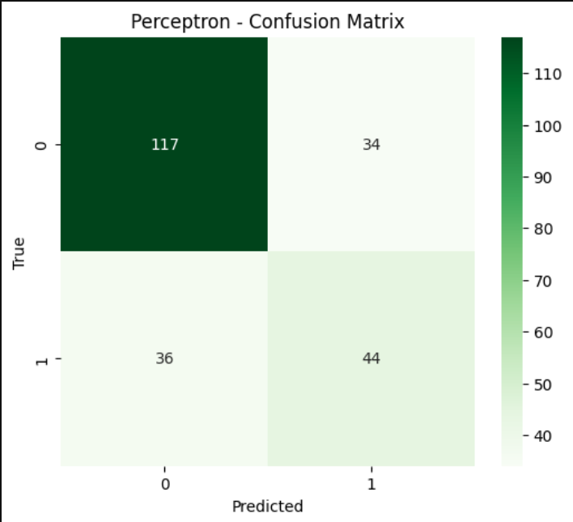
Perceptron Confusion Matrix
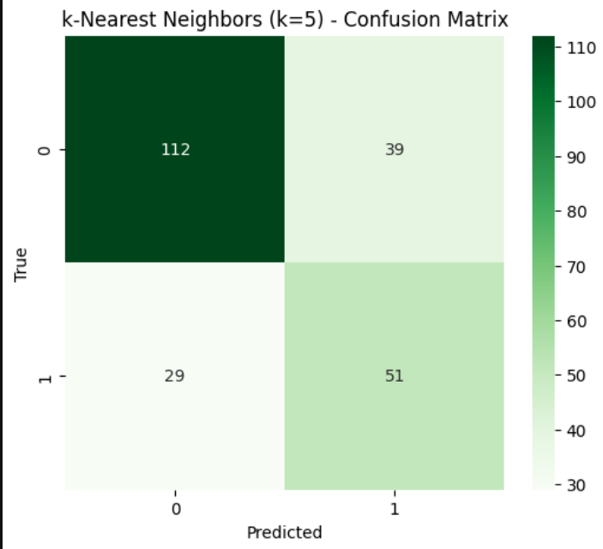
k-NN Confusion Matrix
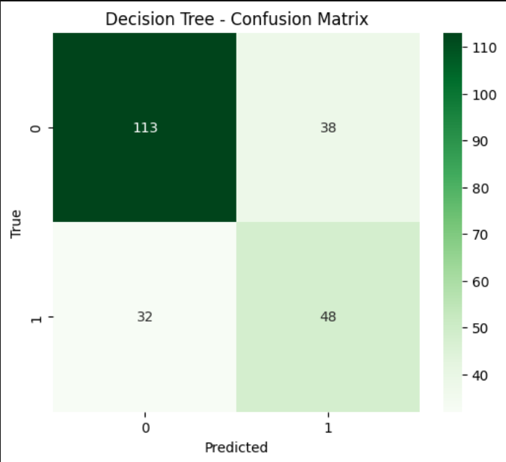
Decision Tree Confusion Matrix
Performance Summary Table
Model | Accuracy | Precision | Recall | F1-Score
Neural Network | 0.7446 | 0.6265 | 0.6500 | 0.6380
Perceptron | 0.6970 | 0.5641 | 0.5500 | 0.5570
k-NN | 0.7056 | 0.5667 | 0.6375 | 0.6000
Decision Trees | 0.6970 | 0.5581 | 0.6000 | 0.5783

Best Performing Model: Neural Network achieved the highest accuracy (74.46%) and F1-score (63.80%)

3.3 Leave-One-Out Cross-Validation Results
LOOCV was performed on the training set to assess model stability:
Model | LOOCV Accuracy
Perceptron | 0.7095
k-NN | 0.7542
Decision Trees | 0.7132

Analysis: k-NN showed the most stable performance under LOOCV, suggesting good generalization capability.
- Feature Selection Analysis
4.1 Feature Selection Methods Implemented
Method 1: ANOVA F-test (SelectKBest)
- Approach: Univariate statistical test
- Metric: F-statistic measuring relationship between each feature and target
- Configurations: Top 4, 6, and 8 features selected
Method 2: Recursive Feature Elimination (RFE)
- Approach: Iterative feature elimination using Random Forest as estimator
- Process: Recursively removes least important features
- Configurations: 4 and 6 features selected
Method 3: Feature Importance Analysis
- Method: Random Forest feature importance scores
- Metric: Mean decrease in impurity across all trees

4.2 Feature Selection Results
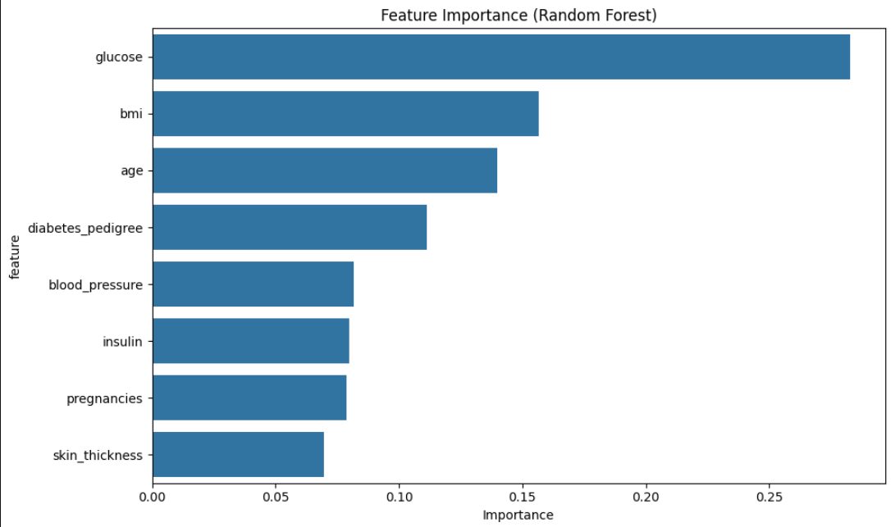
Feature Importance Bar Chart

Feature Importance Ranking:
- glucose: 0.2829 (highest importance)
- bmi: 0.1565
- age: 0.1397
- diabetes pedigree: 0.1113
- blood pressure: 0.0817
- insulin: 0.0797
- pregnancies: 0.0786
- skin thickness: 0.0696 (lowest importance)
Impact of Feature Selection on Performance:
Method | Features Selected | Accuracy
All Features | All 8 Features | 0.7446
ANOVA F-test (K=4) | glucose, insulin, bmi, age | 0.7576
ANOVA F-test (K=6) | pregnancies, glucose, skin_thickness, insulin, bmi, age | 0.7013
ANOVA F-test (K=8) | All features | 0.7446
RFE (4 features) | glucose, bmi, diabetes_pedigree, age | 0.7532
RFE (6 features) | glucose, blood_pressure, insulin, bmi, diabetes_pedigree, | 0.7532

4.3 Feature Selection Discussion
Does using fewer features improve classifier performance?
Yes, using fewer features can improve performance:
- Best result: K=4 ANOVA F-test achieved 75.76% accuracy (improvement of 1.3%)
- Optimal feature count: 4 features appear to be optimal for this dataset
- Selected features: glucose, insulin, bmi, age consistently appear in top-performing subsets
Rigorous approach for choosing best features:
1. Statistical significance: ANOVA F-test identifies features with strongest statistical relationship to target
2. Recursive elimination: RFE removes redundant features iteratively
3. Tree-based importance: Random Forest provides feature importance based on predictive power
4. Cross-validation: Validate feature subsets using LOOCV to ensure generalization
Key findings:
- Glucose level is consistently the most important feature
- Clinical measures (BMI, age) are more predictive than demographic features
- Removing less informative features (skin thickness, pregnancies) can reduce noise and improve performance

- Clustering Analysis
5.1 K-Means Clustering Implementation

Preprocessing for Clustering:
- Class labels removed as required
- Features standardized using separate scaler
- All 8 features used for clustering
5.2 Optimal k Selection
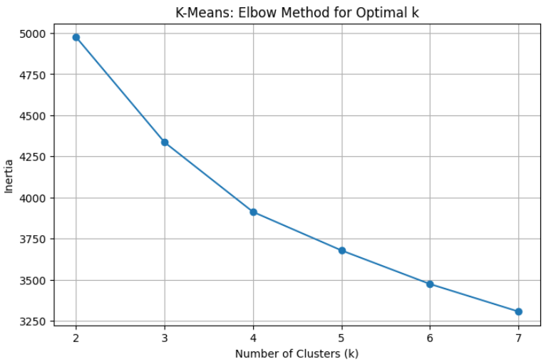
Elbow Method Plot showing Inertia vs Number of Clusters
5.3 Final Clustering Results (k=3)
Cluster Distribution:
- Cluster 0: 216 samples (28.1%)
- Cluster 1: 337 samples (43.9%)
- Cluster 2: 215 samples (28.0%)
Cluster Characteristics:
Final K-Means Clustering (k=3)
Cluster distribution:
Cluster 0: 248 samples
Cluster 1: 335 samples
Cluster 2: 185 samples
Cluster Centers:
Cluster 0: [ 1.0470787 0.30028055 0.49869482 0.10381752 -0.01203346 0.05147404
-0.04537878 1.08907535]
Cluster 1: [-0.46459069 -0.49428384 -0.4651046 -0.5579768 -0.31670965 -0.57583692
-0.18276281 -0.62093654]
Cluster 2: [-0.56236561 0.49251627 0.17369582 0.87121882 0.58963261 0.97372869
0.39178096 -0.33555105]
Inertia: 4335.74
5.4 Clustering vs True Labels Comparison
Cluster Composition Analysis:
Cluster | Total Samples | Non-diabetic | Diabetic | Diabetic %
0 | 216 | 106 (49.1%) | 110(50.9%) | 50.9%
1 | 337 | 287(85.2%) | 50(14.8%) | 14.8%
2 | 215 | 107(49.8%) | 108(50.2%) | 50.2%

Adjusted Rand Index (k=3): 0.1219
5.5 Clustering Discussion
Findings:
- Cluster 1 appears to represent the "healthy" group with 85.2% non-diabetic patients
- Clusters 0 and 2 show mixed populations with approximately equal diabetic/non-diabetic distributions
- Low ARI (0.1219) indicates clustering doesn't perfectly align with true diabetes labels
Interpretation:
- K-means clustering identifies natural groupings in the data that partially correspond to diabetes status
- The algorithm discovers patterns beyond simple diabetic/non-diabetic classification
- Clinical significance: Clusters may represent different risk profiles or disease subtypes

- Critical Discussion
6.1 Model Performance Analysis
Best Performing Classifier: Neural Network
- Achieved highest accuracy (74.46%) and F1-score (63.80%)
- Benefits from non-linear activation functions and multiple hidden layers
- Capable of learning complex feature interactions
Comparison Insights:
- Linear models (Perceptron) showed lower performance, suggesting non-linear relationships in data
- k-NN performed well, indicating local neighborhood patterns are informative
- Decision Tree moderate performance but provides interpretable rules
6.2 Feature Selection Impact
Key Insights:
- Glucose level emerges as the strongest predictor across all methods
- Feature reduction to 4 variables improved performance, suggesting some features add noise
- Clinical features (BMI, age) more predictive than demographic features
Methodological Considerations:
- Multiple feature selection approaches provide consistent rankings
- Cross-validation essential to avoid overfitting to feature subsets
6.3 Clustering Analysis
Limitations:
- Unsupervised clustering doesn't perfectly align with supervised labels (ARI=0.12)
- K-means assumes spherical clusters, which may not match data structure
- Clinical interpretation requires domain expertise
Strengths:
- Identifies meaningful patient subgroups
- Cluster 1 represents clear low-risk population
- Could inform personalized treatment strategies
6.4 Methodological Strengths
- Proper data preprocessing: Handling of missing values and feature scaling
- Comprehensive evaluation: Multiple algorithms and evaluation metrics
- Cross-validation: LOOCV provides robust performance estimates
- Feature analysis: Systematic approach to feature selection
- Reproducibility: Fixed random states ensure consistent results

- Conclusions
7.1 Key Findings
- Neural networks achieved best classification performance (74.46% accuracy)
- Feature selection improved performance: 4 features optimal (75.76% accuracy)
- Glucose level is the most important predictor across all analyses
- K-means clustering identified meaningful patient subgroups with partial correspondence to diabetes status
- LOOCV confirmed k-NN as the most stable classifier
7.2 Practical Implications
- Clinical screening: Focus on glucose, BMI, age, and insulin for diabetes prediction
- Resource allocation: 4-feature model could enable simplified screening protocols
- Patient stratification: Clustering reveals distinct risk profiles for personalized care
7.3 Technical Achievements
- Successfully implemented and compared 4 different classification algorithms
- Demonstrated systematic feature selection methodology
- Applied unsupervised learning to discover data patterns
- Provided comprehensive evaluation using multiple metrics and cross-validation

This analysis demonstrates the effectiveness of machine learning approaches for diabetes prediction and patient stratification, with practical implications for clinical decision-making.

