OperaHouse Step 2 Plan
RabbitMQ publishing design before implementation
Step 2 goal
After a booking is saved as Pending, the Booking API publishes a durable BookingCreated event to RabbitMQ using bare RabbitMQ.Client. The worker consume side is shown for context, but should remain the next implementation step unless you choose to combine them.

1. What Step 2 adds
Step 1 gave us the API, database persistence, performance seed data, Swagger, and a clean Booking service/repository slice. Step 2 introduces the first messaging behavior: publishing booking.created after a successful booking save.
- Define the BookingCreated integration event in OperaHouse.Contracts.
- Add simple RabbitMQ configuration to the API: host, port, username, password, exchange name, and routing key.
- Add RabbitMQ.Client 7.x to OperaHouse.Messaging and create a readable publisher wrapper.
- Add one small application port named IBookingEventPublisher so Application does not reference RabbitMQ.Client directly.
- Implement that port in Infrastructure, translating a saved Booking into a BookingCreated event.
- Publish after the database save succeeds, then return the booking response as before.

2. Design principles for this step
Principle | Meaning in code
Keep RabbitMQ visible | The wrapper should not hide the learning concepts. Exchange, routing key, durable declaration, persistent message, publish, and connection/channel should be obvious in the code.
Keep the Application clean | BookingService should express the business flow, not RabbitMQ.Client mechanics. One clear port is enough; no mediator, no bus abstraction framework, no MassTransit.
Do not solve future reliability yet | Publishing after DB save can fail. That is a real distributed-systems problem, but the outbox pattern belongs in a later phase after the basic RabbitMQ mechanics are understood.
Producer and consumer responsibilities stay separate | The producer should know the exchange and routing key. The consumer will own the queue and binding in the next step. This keeps coupling low.

3. Architecture picture
The important separation is that Booking.Application depends on a small publishing port, while Infrastructure and Messaging contain the RabbitMQ details.
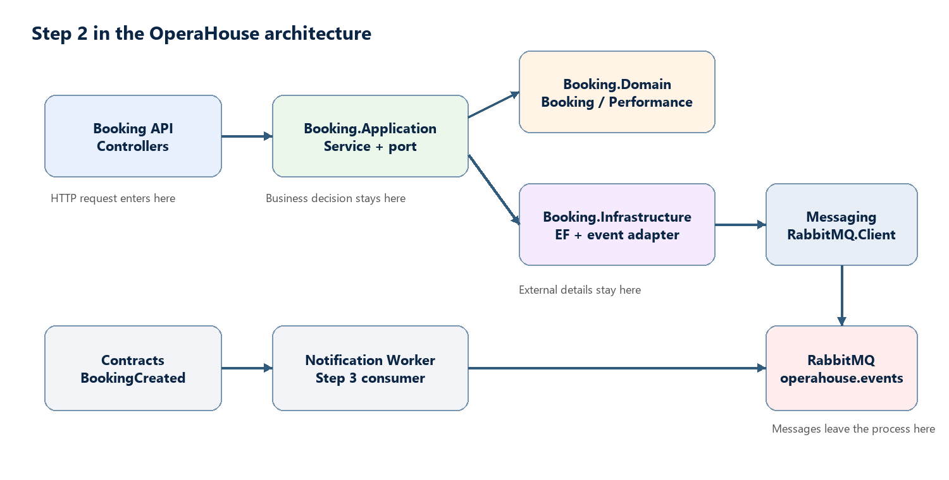

4. Publish flow
This is the exact runtime path after Swagger calls POST /bookings. The event is created only after the booking exists in Postgres.
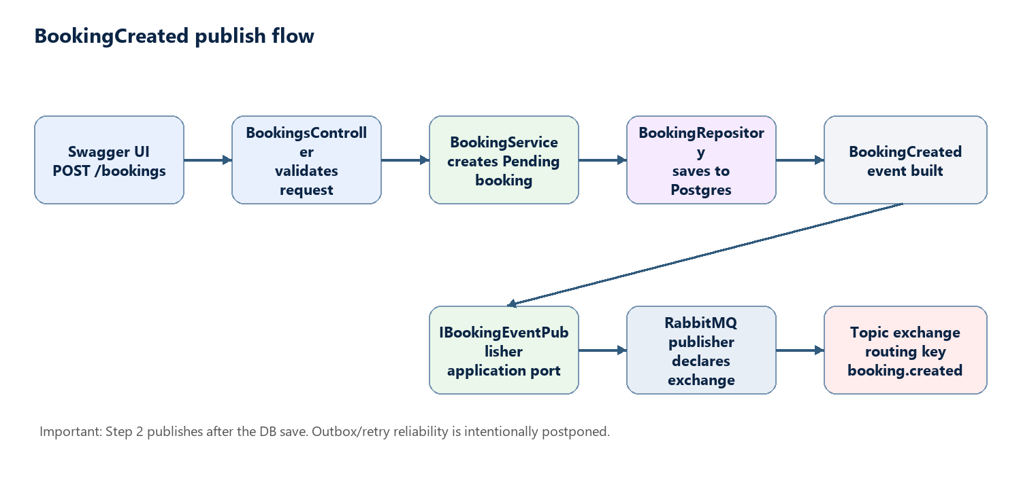

5. RabbitMQ topology
Phase 1 uses a durable topic exchange named operahouse.events. The routing key for this event is booking.created. The notification queue and binding are shown here because they complete the mental model, but the worker side can be implemented in the next step.
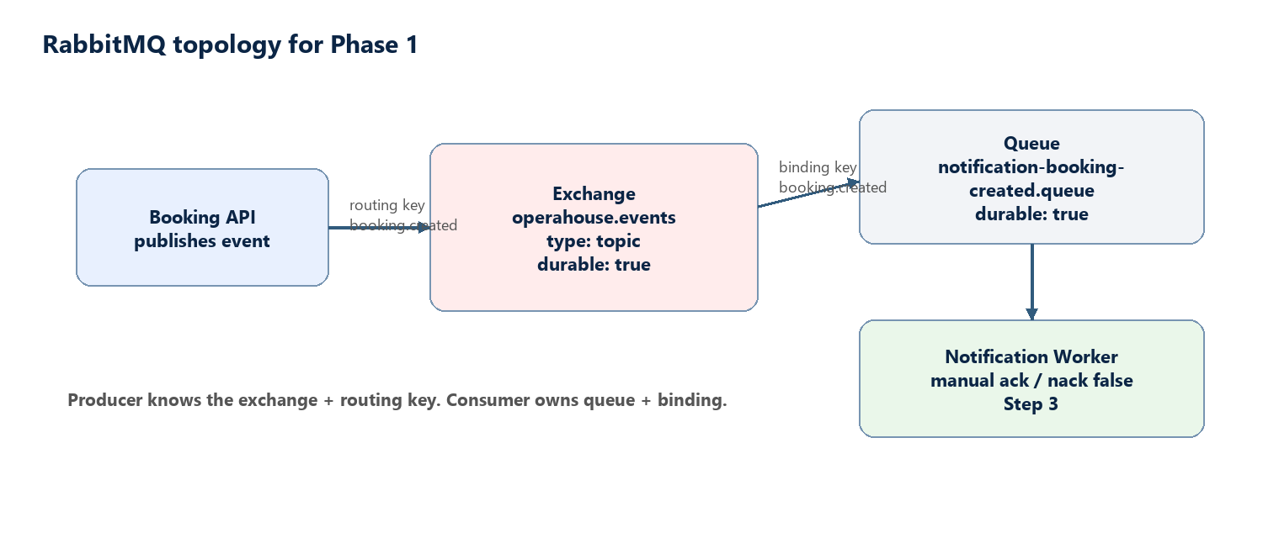

6. Files to add or change
Project | Change | Why it belongs there
OperaHouse.Contracts | Add BookingCreated event contract. | Shared message shape used by publisher and worker.
OperaHouse.Messaging | Add RabbitMQ settings and publisher. | Owns RabbitMQ.Client usage and keeps it readable.
OperaHouse.Booking.Application | Add IBookingEventPublisher and inject it into BookingService. | Application asks for an event to be published without knowing RabbitMQ mechanics.
OperaHouse.Booking.Infrastructure | Add RabbitMqBookingEventPublisher. | Builds the contract event from the saved booking and calls Messaging.
OperaHouse.Booking.Api | Add RabbitMQ config and DI registrations. | Composition root wires the concrete publisher into the app.
docker-compose.yml | No expected change. | RabbitMQ management container is already present.

7. Proposed event shape
BookingCreated should live in Contracts because it is not an EF entity and not an API request. It is the public message other processes consume.
Field | Type | Purpose
MessageId | Guid | Unique identity of this message.
CorrelationId | Guid | Connects logs across API and worker. Initially generated per request.
BookingId | Guid | The booking that was just created.
PerformanceId | Guid | The performance being booked.
CustomerEmail | string | Recipient for the later fake email.
Seats | int | Number of seats requested.
OccurredAt | DateTimeOffset | When the event happened in UTC.

8. Implementation sequence
- Add the BookingCreated contract record.
- Add RabbitMQ settings to appsettings.json under a RabbitMq section.
- Install RabbitMQ.Client 7.x in OperaHouse.Messaging.
- Create a simple RabbitMqPublisher that declares the topic exchange and publishes persistent JSON messages.
- Add IBookingEventPublisher in Application.
- Add RabbitMqBookingEventPublisher in Infrastructure.
- Inject IBookingEventPublisher into BookingService and publish after AddAsync succeeds.
- Register settings and services in Program.cs.
- Run Docker, restart the API, POST a booking from Swagger, and verify RabbitMQ connection/publish behavior.

9. What we intentionally do not add yet
- No MassTransit or messaging framework.
- No payment, ticketing, invoice, or admin module behavior.
- No outbox table yet; this comes later when we discuss reliable messaging.
- No generic enterprise event bus with many layers.
- No worker ACK/NACK code in Step 2 unless you explicitly decide to combine Step 2 and Step 3.

10. Step 3 preview: worker consume side
The next step completes Phase 1 by binding notification-booking-created.queue to booking.created, consuming with AsyncEventingBasicConsumer, logging the fake email, ACKing on success, and NACKing with requeue false on failure.
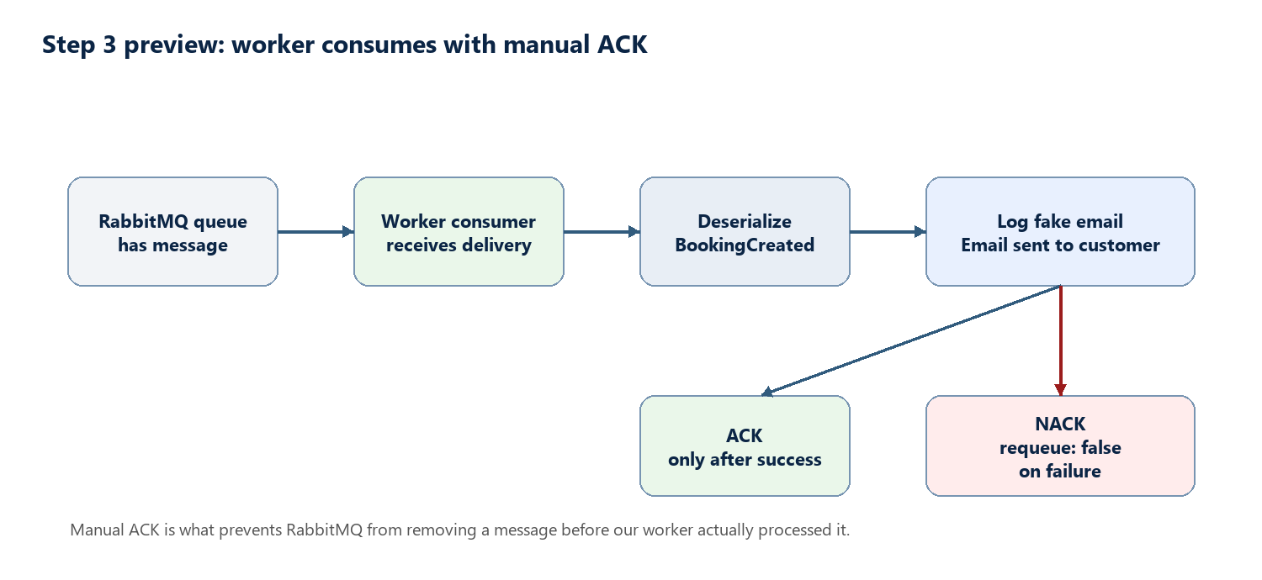

11. Testing checklist for Step 2
- docker compose ps shows RabbitMQ running on ports 5672 and 15672.
- Swagger UI can create a booking with POST /bookings.
- Booking still appears with GET /bookings/{id}.
- The API logs should clearly say when a BookingCreated event was published.
- RabbitMQ Management should show the operahouse.events exchange after the publish path runs.
- If no queue is bound yet, RabbitMQ may route the message to no consumer. That is expected until Step 3 unless we create a temporary test queue.
Recommended next coding move
Implement Step 2 as publish-only first. Once that is clear and working, implement the worker in Step 3. This keeps the learning loop tight: first understand publish, then understand consume/ack/nack.

