OPERA HOUSE

Phase 1 Architecture Design
  - A learning-first RabbitMQ ticket-booking platform on .NET 10
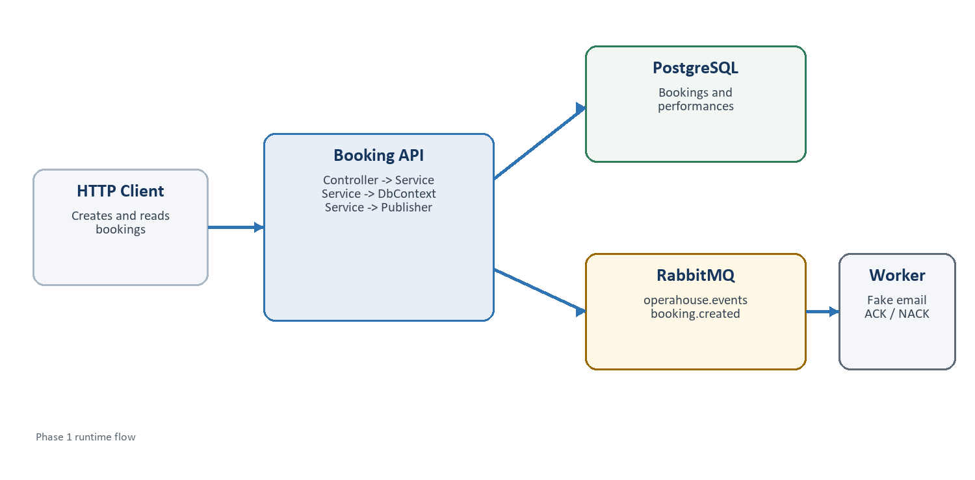
Design intent Keep business logic out of controllers, make RabbitMQ mechanics visible, and introduce abstractions only where they clarify a real boundary.
Scope: booking.created publication and notification consumption only

1. Design goals and boundaries
OperaHouse is intentionally small in Phase 1. The design separates HTTP concerns, application logic, persistence, integration contracts, and RabbitMQ transport while keeping each part easy to trace in a debugger.

Guiding principles
- Thin controllers: map HTTP requests and responses, then delegate work.
- Application services own use-case logic and orchestration.
- EF Core DbContext is the persistence abstraction; do not add a repository layer until it provides real value.
- Integration events are independent from API DTOs and database entities.
- RabbitMQ code stays explicit enough to teach exchanges, queues, bindings, publishing, consuming, ACK, and NACK.
- Interfaces are used at meaningful boundaries, not around every class.

Phase 1 scope
Included | Deferred
Performance reads | Ticket issuance
Booking creation and lookup | Payments
booking.created publication | Invoices
Notification worker and fake email log | Dead-letter and retry policies

Deliberate learning constraint MassTransit is not used. RabbitMQ.Client 7.x is called directly so broker concepts remain observable.

2. Solution map
Project | Role | Owns
OperaHouse.Booking.Api | HTTP application | Bookings, performances, use cases, database
OperaHouse.Notification.Worker | Background consumer | Notification processing and delivery acknowledgement
OperaHouse.Contracts | Shared integration schema | BookingCreated event
OperaHouse.Messaging | RabbitMQ transport | Connection options, topology names, publishing mechanics

3. Booking API architecture
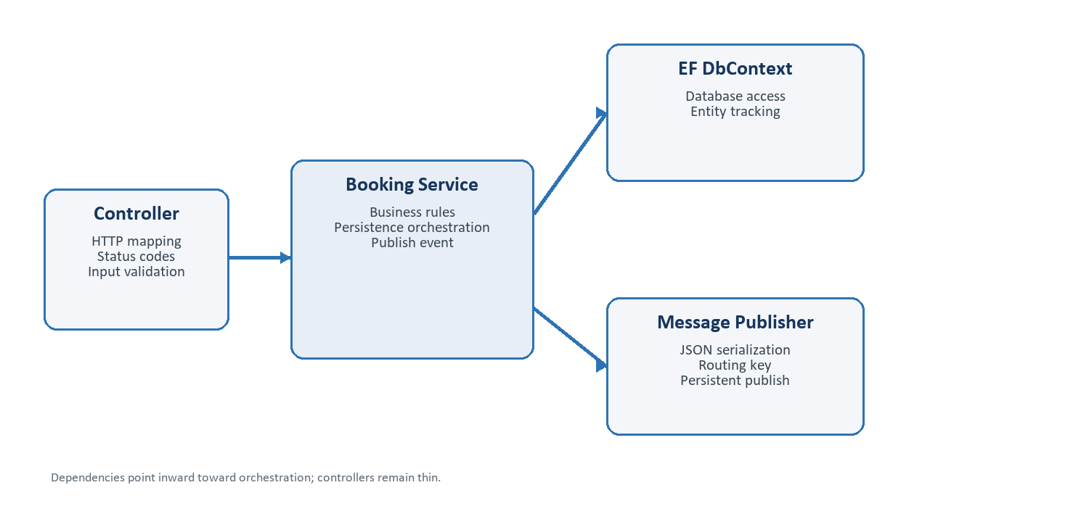
The service layer is the application boundary. Controllers know how to speak HTTP; services know how a booking use case works.

Proposed folder structure
Folder | Purpose
Controllers | Endpoints, request binding, response mapping, HTTP status codes
Services | Booking and performance use cases, validation, orchestration
Data | BookingDbContext and EF Core configuration
Entities | Booking and Performance persistence models
DTOs | API requests and responses; never published directly
Configuration | Options binding and application setup where useful

Controller responsibilities
- Accept and validate the HTTP shape of a request.
- Call IBookingService or IPerformanceService.
- Translate service outcomes into HTTP responses.
- Contain no EF Core queries and no RabbitMQ publishing code.

Service responsibilities
- Enforce booking rules such as positive seat count and known performance.
- Create a Pending booking and save it through BookingDbContext.
- Create BookingCreated from the saved entity.
- Publish through IMessagePublisher after persistence succeeds.
- Return an application result that the controller maps to a response.
Coupling choice The service depends on BookingDbContext and IMessagePublisher. This is explicit and testable without adding a generic repository or a large mediator framework.

4. Module responsibilities

OperaHouse.Booking.Api
Owns booking and performance behavior. It is the only Phase 1 application that reads or writes PostgreSQL. Its public surface is HTTP; its outgoing integration surface is BookingCreated.

OperaHouse.Notification.Worker
Owns the notification consumer. It declares the queue and binding, consumes asynchronously, logs the simulated email, ACKs only after successful processing, and NACKs failures with requeue set to false.

OperaHouse.Contracts
Contains stable messages shared across process boundaries. It has no dependency on ASP.NET Core, EF Core, or RabbitMQ.Client.
BookingCreated field | Reason
MessageId | Unique identity for deduplication and diagnostics
CorrelationId | Connects logs and operations belonging to one request
BookingId | Identifies the source booking
PerformanceId | Identifies the booked performance
CustomerEmail | Provides the worker everything needed for Phase 1
Seats | Describes the booking quantity
OccurredAt | Records when the event happened in UTC

OperaHouse.Messaging
Contains small, transport-focused components such as RabbitMqOptions, RabbitMqTopology, IMessagePublisher, and RabbitMqPublisher. It must not contain booking rules.
Boundary rule Contracts describe what happened. Messaging describes how it travels. The API decides when it should happen.

5. Project dependencies
From | May reference | Must not reference
Booking.Api | Contracts, Messaging | Notification.Worker
Notification.Worker | Contracts, Messaging | Booking.Api or its database
Messaging | Preferably no business project | Booking.Api, Worker
Contracts | Nothing | EF Core, ASP.NET Core, RabbitMQ.Client

6. Booking request flow
- POST /bookings binds CreateBookingRequest in BookingsController.
- The controller calls IBookingService.CreateAsync.
- BookingService validates the performance and requested seat count.
- The service creates a Pending Booking and saves it through BookingDbContext.
- The service maps the saved booking to BookingCreated.
- IMessagePublisher serializes the event and publishes it using booking.created.
- The service returns the booking ID and status; the controller returns the HTTP response.
Ordering matters Persistence happens before publication so an event never announces a booking that was not saved. Phase 1 still has a reliability gap if publication fails afterward.

7. RabbitMQ topology
Element | Value | Why
Exchange | operahouse.events | Single entry point for domain events
Exchange type | topic | Routes events using descriptive keys
Routing key | booking.created | Describes the event category
Queue | notification-booking-created.queue | Consumer-purpose ownership
Binding | booking.created | Routes matching events to notification
Durability | Exchange and queue durable | Survives broker restart
Delivery mode | Persistent | Requests message persistence

Consumer acknowledgement
Outcome | RabbitMQ action | Meaning
Fake email logged | ACK | Processing completed; remove the delivery
Processing throws | NACK, requeue=false | Do not create an infinite poison-message loop

A later phase should attach a dead-letter exchange and queue so failed messages remain inspectable instead of being discarded.

8. Data and API design

Persistence entities
Entity | Fields
Booking | Id, PerformanceId, CustomerEmail, Seats, Status, CreatedAt
Performance | Id, Title, Venue, StartsAt, AvailableSeats

Endpoints
Method | Route | Service call | Purpose
GET | /performances | IPerformanceService.GetAllAsync | List available performances
POST | /bookings | IBookingService.CreateAsync | Create and publish a booking
GET | /bookings/{id} | IBookingService.GetByIdAsync | Read one booking

DTO separation
CreateBookingRequest represents client input. BookingResponse represents the HTTP result. Booking is the database entity. BookingCreated is the integration event. Keeping them separate prevents an HTTP or database change from silently changing the message contract.

9. Reliability and lifecycle decisions
Decision | Phase 1 | Later improvement
Database + publish atomicity | Save, then publish | Transactional outbox
Failed consumption | NACK without requeue | Dead-letter exchange and queue
Duplicate delivery | Accept possibility | Idempotent consumer / inbox
Connection recovery | RabbitMQ.Client recovery settings | Operational monitoring
Schema evolution | Single event version | Compatibility policy and versioning

Why begin simply? The first implementation should expose the reliability problem clearly. The outbox and idempotency patterns are easier to understand after observing the failure modes they solve.

10. Recommended implementation sequence
Step | Outcome
Infrastructure | Add Docker Compose for RabbitMQ Management and PostgreSQL.
Persistence | Add EF Core packages, entities, DbContext, migrations, and seed performances.
HTTP use cases | Add DTOs, service interfaces, service implementations, and thin controllers.
Contract | Add BookingCreated to OperaHouse.Contracts.
Publisher | Add explicit RabbitMQ connection, exchange declaration, JSON publish, and persistence settings.
Consumer | Declare exchange, queue, binding, AsyncEventingBasicConsumer, manual ACK, and NACK.
End-to-end test | Create a booking, inspect RabbitMQ, observe the worker log, and verify the database row.
Failure experiments | Stop the worker or broker and observe delivery and publication behavior.

Definition of done for Phase 1
- All projects target .NET 10 and build successfully.
- POST /bookings persists a Pending booking and publishes BookingCreated.
- The notification queue is durable and bound to booking.created.
- The worker logs the fake email and ACKs only after success.
- Failures are NACKed with requeue=false and are visible in logs.
- Controllers contain HTTP coordination, while services contain use-case logic.
- No ticketing, payment, invoice, MassTransit, or premature framework abstractions are introduced.

Proposed Booking API tree
OperaHouse.Booking.Api/
|-- Controllers/
| |-- BookingsController.cs
| `-- PerformancesController.cs
|-- Services/
| |-- IBookingService.cs
| |-- BookingService.cs
| |-- IPerformanceService.cs
| `-- PerformanceService.cs
|-- Data/BookingDbContext.cs
|-- Entities/Booking.cs, Performance.cs
|-- DTOs/Bookings/, Performances/
|-- Configuration/
`-- Program.cs

