LEARNING PROJECT REFERENCE

OperaHouse Use Cases
  - Current behavior, future capabilities, and phased learning roadmap
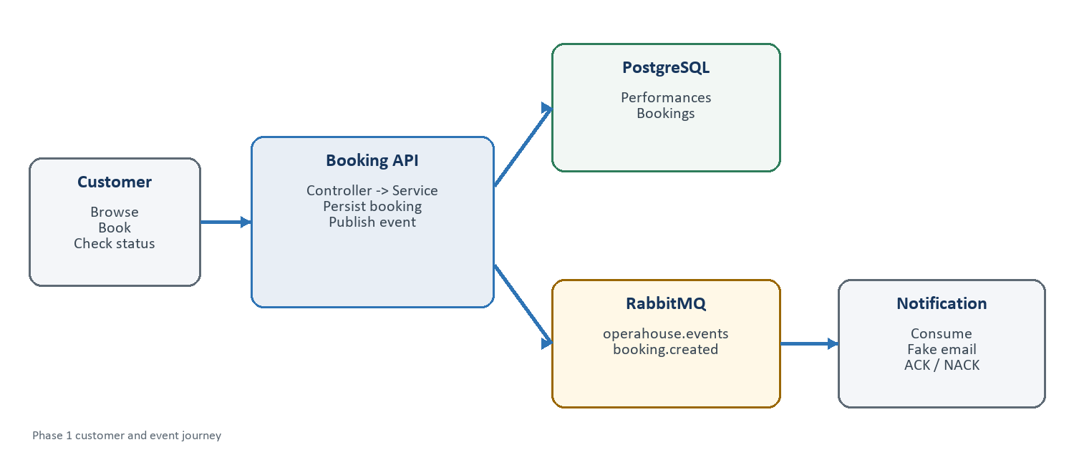
Reading rule Phase 1 items are implementation requirements. Phases 2-9 are planned learning increments and should not be implemented early.
Platform target: .NET 10 | Messaging: RabbitMQ.Client 7.x | No MassTransit

1. Product purpose and actors
OperaHouse is an opera and concert ticketing platform used to learn RabbitMQ through realistic business workflows. The first release remains deliberately narrow: browse seeded performances, create and read bookings, publish an event, and process a simulated notification.

Actors
Actor | Current role | Future role
Customer | Browses and creates bookings | Pays, receives tickets, cancels, requests refunds
Administrator | No interactive role; data is seeded | Manages performances, venues, schedules, capacity
Booking API | Owns booking use cases and persistence | Coordinates inventory and payment state
RabbitMQ | Routes booking.created | Routes lifecycle events across services
Notification Worker | Logs a simulated email | Sends transactional messages with retry policies
Operations | Observes logs and RabbitMQ UI | Monitors, replays, audits, and responds to incidents

Use-case boundaries
- HTTP use cases belong to controllers and application services in Booking.Api.
- Database entities remain private to the application that owns them.
- Integration events describe completed business facts and live in Contracts.
- RabbitMQ transport details live in Messaging or in the consuming worker.
- Future capabilities enter only when their learning phase begins.

2. Phase map
Phase | Theme | Core learning outcome
1 | Booking event | Publish, route, consume, ACK, and NACK
2 | Messaging reliability | Retries, dead letters, confirms, idempotency
3 | Seat inventory | Concurrency, reservation expiry, event-driven consistency
4 | Payments | Distributed workflows and compensation
5 | Ticketing | Event-driven fulfillment
6 | Administration | Authorized performance lifecycle management
7 | Cancellation and refunds | Reverse workflows and compensating actions
8 | Invoicing and reporting | Audit trails, projections, and reporting
9 | Production hardening | Security, observability, scale, and recovery

3. Phase 1 detailed use cases
Phase 1 goal Complete one understandable end-to-end RabbitMQ path without introducing payment, ticketing, invoicing, or administration.

UC-01 - Browse performances
Primary actor: Customer
Goal: See performances that may be booked.
Preconditions: Seeded performance records exist.
Trigger: The customer requests GET /performances.
Main flow
- PerformancesController receives the request.
- IPerformanceService retrieves performances from PostgreSQL.
- The controller returns performance DTOs including available seats.
Alternative and failure flows: If no performances exist, return an empty collection. Database failures produce an error response and log entry.
Result: The customer receives the current performance catalogue.
Events produced: None

UC-02 - Create a booking
Primary actor: Customer
Goal: Create a pending booking for a performance.
Preconditions: The performance exists; the request contains a valid email and a positive seat count.
Trigger: The customer submits POST /bookings.
Main flow
- BookingsController binds and validates CreateBookingRequest.
- IBookingService validates the requested performance and seats.
- BookingService creates a Booking with Pending status.
- BookingDbContext saves the booking.
- BookingService creates and publishes BookingCreated.
- The controller returns the booking ID and Pending status.
Alternative and failure flows: Invalid input is rejected. An unknown performance returns not found. A database failure prevents publication. A publish failure is logged and exposes the Phase 1 save-then-publish reliability gap.
Result: A Pending booking exists and its creation event is published.
Events produced: booking.created

UC-03 - View a booking
Primary actor: Customer
Goal: Retrieve the current booking state.
Preconditions: A booking ID is available.
Trigger: The customer requests GET /bookings/{id}.
Main flow
- BookingsController passes the ID to IBookingService.
- The service queries BookingDbContext.
- The controller maps the entity to BookingResponse.
Alternative and failure flows: If the booking does not exist, return 404 Not Found.
Result: The customer receives the booking data and status.
Events produced: None

UC-04 - Publish booking-created event
Primary actor: Booking API
Goal: Notify interested systems that a booking was created.
Preconditions: The booking has been saved successfully; RabbitMQ configuration is available.
Trigger: BookingService asks IMessagePublisher to publish BookingCreated.
Main flow
- The publisher obtains a RabbitMQ channel.
- It declares the durable topic exchange operahouse.events.
- It serializes BookingCreated as JSON.
- It marks the message persistent.
- It publishes with routing key booking.created.
Alternative and failure flows: Serialization or broker failures are logged and returned to the calling service. Phase 2 adds publisher confirms and reliable recovery.
Result: RabbitMQ accepts the event for routing.
Events produced: booking.created

UC-05 - Process booking notification
Primary actor: Notification Worker
Goal: React to a new booking and simulate an email.
Preconditions: RabbitMQ is available; the event is valid JSON.
Trigger: RabbitMQ delivers a message from notification-booking-created.queue.
Main flow
- The worker declares the durable exchange and queue.
- It binds the queue with booking.created.
- AsyncEventingBasicConsumer receives the delivery.
- The worker deserializes BookingCreated.
- It logs: Email sent to {CustomerEmail}: booking received.
- It manually ACKs the delivery.
Alternative and failure flows: If deserialization or processing fails, the worker logs the failure and NACKs with requeue=false.
Result: Successful deliveries are removed from the queue after ACK.
Events produced: None

UC-06 - Seed learning performances
Primary actor: Application startup / developer
Goal: Provide predictable data without an administration module.
Preconditions: The database exists and migrations can run.
Trigger: The application database is initialized for development.
Main flow
- EF Core applies or uses the configured seed data.
- Known performance records are inserted by migration.
- GET /performances exposes the seeded records.
Alternative and failure flows: Seeding must not duplicate rows on each startup. Changing seed data requires an intentional migration.
Result: Phase 1 can exercise booking flows without admin CRUD.
Events produced: None

4. Phase 2 - Messaging reliability
Phase 2 keeps the same business scope but deliberately makes message delivery safer and more observable.
Use case | Actor | Outcome
Confirm publication | Booking API | Know whether RabbitMQ accepted a published event
Dead-letter failed delivery | RabbitMQ | Preserve poison messages for inspection
Retry transient failure | Notification Worker | Retry temporary failures with limits and delay
Ignore duplicate event | Notification Worker | Process the same MessageId only once
Trace correlated work | Operations | Follow one request across API, broker, and worker logs
Recover unpublished booking | Booking API | Introduce the transactional outbox pattern

Recommended teaching order Dead-lettering -> retry -> publisher confirms -> idempotency -> transactional outbox. Each addition answers a failure mode visible in Phase 1.

5. Phase 3 - Seat inventory
- Reserve seats when a booking attempt begins.
- Reject a request when insufficient seats remain.
- Prevent concurrent requests from overselling a performance.
- Expire an unpaid reservation after a defined period.
- Release seats when a reservation expires or a booking is cancelled.
- Publish seat-reserved, reservation-expired, and seats-released events.
Likely module Introduce a dedicated Inventory component only when Phase 3 begins. Until then, AvailableSeats can remain simple seeded/read data.

6. Phase 4 - Payments
- Request payment for a reserved booking.
- Record payment success or failure.
- Move booking status through Pending, Confirmed, or Failed.
- Release seats when payment fails or times out.
- Handle duplicate payment-provider callbacks safely.
- Publish payment-completed and payment-failed events.

7. Phase 5 - Ticketing
- Issue tickets only after payment succeeds.
- Generate a unique ticket identity for each seat or admission unit.
- Retrieve issued tickets for a booking.
- Deliver ticket information asynchronously.
- Prevent duplicate tickets when events are redelivered.

8. Phase 6 - Administration
Administration arrives after the customer and messaging flows are stable. It requires authentication and role-based authorization rather than simply exposing public CRUD endpoints.
Use case | Key rule
Create performance | Require venue, title, start time, and capacity
Update performance | Protect fields that would invalidate existing bookings
Cancel performance | Start customer notification and refund workflows
Manage venue | Maintain venue details and capacity constraints
Manage schedule | Prevent invalid or conflicting performance times
View booking overview | Expose operational data without leaking customer details

9. Phase 7 - Cancellations and refunds
- Allow eligible customer booking cancellation.
- Release reserved or sold inventory according to policy.
- Request and record a refund when money was captured.
- Invalidate issued tickets.
- Notify the customer about cancellation and refund progress.
- Handle administrator-initiated performance cancellation as a bulk workflow.

10. Phase 8 - Invoicing and reporting
- Generate an invoice from a completed payment.
- Retrieve invoices by booking or customer reference.
- Maintain an immutable audit history of important state changes.
- Build reporting projections from events without querying operational services directly.
- Report sales, occupancy, cancellations, failures, and queue health.

11. Phase 9 - Production hardening
Area | Use cases
Security | Authenticate users, authorize administrators, rotate secrets, protect personal data
Observability | Metrics, structured logs, traces, alerts, queue-depth dashboards
Operations | Replay dead letters, pause consumers, diagnose stuck workflows
Scaling | Run competing consumers, tune prefetch, handle back pressure
Compatibility | Evolve event schemas without breaking existing consumers
Recovery | Back up data, restore services, rehearse broker and database failures

12. Module ownership across the roadmap
Module | Owns | Does not own
Booking.Api | Booking use cases and booking state | Email delivery, payment processing, ticket generation
Notification.Worker | Notification consumption and delivery outcome | Booking database or booking decisions
Contracts | Shared event schemas | Business logic or RabbitMQ connections
Messaging | RabbitMQ transport mechanics | Booking rules or HTTP behavior
Future Inventory | Seat reservations and availability | Payments or customer communication
Future Payment | Payment attempts and outcomes | Ticket issuance
Future Ticketing | Issued tickets and validity | Performance administration
Future Admin | Performance and venue management | Customer booking workflow

13. Scope guardrails
- Finish and test one phase before implementing the next.
- Do not create a service merely because it might exist eventually.
- Use events for facts that other modules need, not for every internal method call.
- Keep controllers thin and application services responsible for use-case orchestration.
- Prefer visible RabbitMQ.Client code while learning; abstract only repeated technical mechanics.
- Treat failure handling as part of a use case, not as an afterthought.
Current stopping point Implement only Phase 1 next. Phase 2 begins after the basic event can be published, inspected in RabbitMQ, consumed, ACKed, and deliberately failed.

