ENGINEERING REPORT
MCP Privilege Profiler
A human-reviewed least-privilege security proxy and Wazuh detection bridge for local MCP agents
Prepared by Ylyas Nurmuhammedov

Item | Current evidence
Status | Pre-alpha; open-source preparation in progress
Report | Living engineering report, version 0.1-draft
Evidence cut-off | 5 August 2026
Verified core | 161 passing tests; 75-case SDK 2 benchmark
Dependency audit | 39 runtime packages; zero known matches after remediation
Pending | Clean-candidate, Claude, Wazuh, hosted CI, and external review
Evidence rule
Completed claims require implementation and verification. Simulated evidence is labeled. Planned work remains planned.
Repository identifier selected; package publication remains subject to final confusion review.
- Document status: Living pre-release engineering report
- Report version: 0.1-draft
- Evidence cut-off: 5 August 2026
- Project status: Pre-alpha; Stage 11 open-source preparation in progress
- Repository name: mcp-privilege-profiler selected; package publication
remains subject to final trademark and confusion review

Document purpose
This report explains the engineering problem, research, architecture, implementation, verification, setbacks, corrections, results, limitations, and next work for MCP Privilege Profiler. It is both a technical record and a portfolio case study.
The report follows one evidence rule:
A statement is presented as complete only when the repository contains an implementation and proportionate verification evidence. Planned work is labeled planned. Deterministic or simulated results are not presented as production proof.

Executive summary
AI agents become useful when they can call tools that read files, query services, write data, or run operational actions. This also creates a security problem: the agent may receive a broader tool catalog and broader runtime privileges than a particular task needs. Prompt injection, confused instructions, compromised content, or a malfunctioning client can then attempt capabilities unrelated to the intended task.
MCP Privilege Profiler is an inspectable reference implementation for one local Model Context Protocol (MCP) server. It sits between an existing MCP-capable host and one downstream stdio MCP server. It:
- inventories the exact downstream tool catalog;
- fingerprints complete tool definitions and detects change;
- records privacy-minimized evidence from labeled successful runs;
- generates a deny-by-default review template;
- requires a human decision for every tool;
- exposes only allowed and approval-required tools during enforcement;
- enforces reviewed constraints, limits, and exact single-use approvals;
- writes mandatory privacy-minimized audit events before forwarding; and
- provides a tested Wazuh decoder, rule pack, fixtures, and local validation lab.
The project does not train a model and does not build a new general-purpose AI agent. It is a security proxy used by an existing agent host.
The committed deterministic benchmark contains 75 labeled security cases. It reduced the visible catalog from seven tools to four, blocked all 30 labeled forbidden calls, allowed all 30 labeled legitimate calls, detected all 10 labeled catalog changes, and rejected all five labeled overuse or approval-abuse cases. These numbers apply only to the deterministic lab and do not prove protection from every prompt injection.
Before the SDK v2 migration, the live Wazuh proof also passed: one simulated credential-access request was denied by the real proxy, collected by the Wazuh agent, matched manager rule 100103 at level 10, indexed, and found in the dashboard under the same trace identifier.
The code and automated suite have since migrated to MCP Python SDK 2.0.0, and the SDK v2 working-tree benchmark has passed. The remaining release work includes a clean-candidate benchmark, real-Claude run, live Wazuh proof, build and clean-clone evidence on the exact candidate, followed by hosted CI, external review, final package-name clearance, and public release.

1. Problem definition

1.1 The operational problem
An AI model produces text. An agent host makes the model operational by presenting tools and executing tool calls. Those tools may represent sensitive actions:
- reading source code or private files;
- accessing credentials;
- executing commands;
- posting information to an external system;
- modifying repositories or business records; or
- calling cloud and SaaS APIs.
The security risk is not only whether the user initially authorized a server. The task may need only three tools from a server that exposes seven or seventy. A static all-or-nothing connection leaves unnecessary capability in the agent's decision space.

1.2 The MCP-specific problem
MCP standardizes communication between an AI application and tool servers. A host creates an MCP client connection to each server. Servers advertise tools through tools/list, and the client requests execution through tools/call.
This standardization improves interoperability, but it does not automatically decide:
- which tool is necessary for one task;
- whether a changed schema remains approved;
- whether a call must be rate-limited;
- whether a particular argument destination is acceptable;
- whether approval applies to one exact request; or
- which security telemetry an operator requires.
Tool descriptions and annotations are supplied by servers and are not enforcement contracts. A security boundary must make its own exact decision.

1.3 Engineering question
The project asks:
Can a small, local, inspectable proxy turn observed task evidence into an explicit human-reviewed least-privilege policy, enforce that policy before tool execution, detect tool-definition drift, minimize stored sensitive data, and produce useful Wazuh detections?

2. Research and plan correction
The initial proposal contained useful ideas but also assumptions that required correction before implementation. The most important research outcome was narrowing the project to claims that could be implemented and tested.

2.1 Major corrections
Initial assumption | Evidence-based correction
Publish under the name AgentFence | The name was already in use. MCP Privilege Profiler became the provisional working name.
Observation proves that a tool is required | Observation produces candidate evidence only. A human review is the authority.
Trust a task identifier supplied with calls | Bind task type, agent ID, and server ID from trusted launch configuration.
Leave denied tools visible | Filter denied tools from tools/list and retain call-time denial as the security boundary.
Ask for approval through standard input | stdio is occupied by MCP JSON-RPC. Use a separate authenticated loopback approval channel.
Redact arbitrary secrets from full arguments | Do not persist raw argument values or response bodies by default.
Combine stable MCP v1 and an incompatible v2 prerelease | Keep the first build on v1, then migrate only after v2 became stable and the complete test matrix could be rerun.
Treat a scripted malicious sequence as proof of prompt injection | Label it accurately as a simulated compromised-agent call sequence.
Rely on generic Wazuh JSON routing | Add a project prefix and decoder after the real Wazuh engine exposed rule-precedence collision.

2.2 Competitive conclusion
Major platforms already provide overlapping capabilities such as MCP tool filtering, approvals, authentication, sandboxing, tracing, policy controls, and server operations. The project therefore does not claim to be the first MCP firewall or a replacement for vendor platforms.
Its defensible scope is the complete, inspectable workflow:
labeled evidence
-> candidate recommendation
-> exact human review
-> deny-by-default policy
-> catalog minimization and runtime enforcement
-> privacy-minimized Wazuh evidence

3. Scope and success criteria

3.1 Supported v0.1 topology
- one proxy process;
- one downstream local stdio MCP server;
- one launch-bound task type, agent ID, and server ID;
- local SQLite state;
- local JSONL audit;
- optional local Wazuh ingestion.
If a host uses multiple servers, v0.1 requires one proxy process for each server.

3.2 Security invariants
- Default policy effect is DENY.
- Observation cannot authorize a call.
- Every tool receives one exact human decision.
- Denied tools are hidden and remain blocked at call time.
- Unknown tools are blocked.
- A stale or changed catalog closes enforcement.
- Every non-denied tool has finite reviewed limits.
- Approval binds to the exact canonical arguments and is single-use.
- Mandatory audit must succeed before a permitted call is forwarded.
- Raw arguments and results are excluded from default persistence.

3.3 Non-goals
- training or fine-tuning an AI model;
- creating a prompt-injection classifier;
- proving that an unobserved tool is unnecessary;
- remote multi-tenant OAuth;
- multi-server routing;
- a web control plane;
- unattended remote approval;
- a general policy programming language;
- replacement of identity management, sandboxing, or a SIEM;
- production warranty or enterprise support.

4. Concepts and technology roles

4.1 Model, agent, host, client, server, and proxy
Term | Role in this project
AI model | Produces reasoning and tool-selection output. The project does not train it.
Agent | The model plus instructions, tools, and a loop that continues after tool results.
MCP host | The application running the agent and managing MCP connections.
MCP client | The host component that sends MCP requests.
MCP server | A program advertising tools and executing requested capabilities.
Security proxy | This project: an MCP server upstream and MCP client downstream.
stdio | Local process pipes used for JSON-RPC messages; no public TCP port is required.

4.2 Technology stack
Technology | Why it is used
Python 3.13 | Main implementation language and mature supported baseline
MCP Python SDK 2.0.0 | Official current client/server sessions and 2026-07-28 protocol types, with legacy negotiation fallback
AnyIO | Structured asynchronous sessions, cancellation, timeouts, and cleanup
Pydantic | Strict validation at external JSON contract boundaries
Standard-library dataclasses | Dependency-light domain model
SQLite / aiosqlite | Local inventory, evidence, review, counter, and permit metadata
RFC 8785 + SHA-256 | Deterministic tool and argument fingerprints
JSON Schema 2020-12 | Public artifact validation
Typer | Operator command-line interface
pytest + Hypothesis | Example-based, integration, and property testing
Ruff + Pyright | Linting and strict static type checking
uv | Reproducible environment, locking, building, and command execution
Docker Desktop + WSL 2 | Disposable Wazuh integration lab only
Wazuh 4.14.6 | Detection rules, agent ingestion, manager analysis, indexer, and dashboard

Docker and Wazuh are optional for normal proxy execution and deterministic Python tests.

5. System architecture

5.1 System context
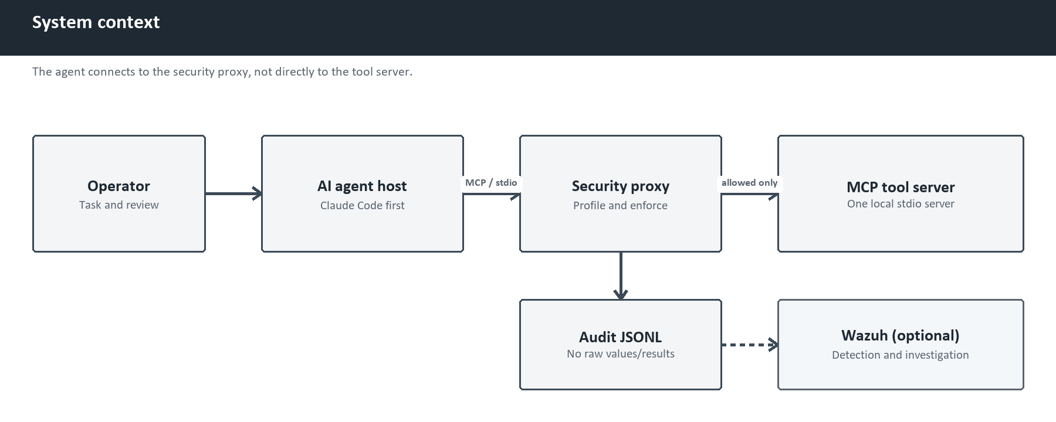
Figure 1. System context and primary enforcement path.
The host believes it is connected to an MCP server. That server is the proxy. The proxy maintains a separate downstream MCP client session to the actual server.

5.2 Internal layering
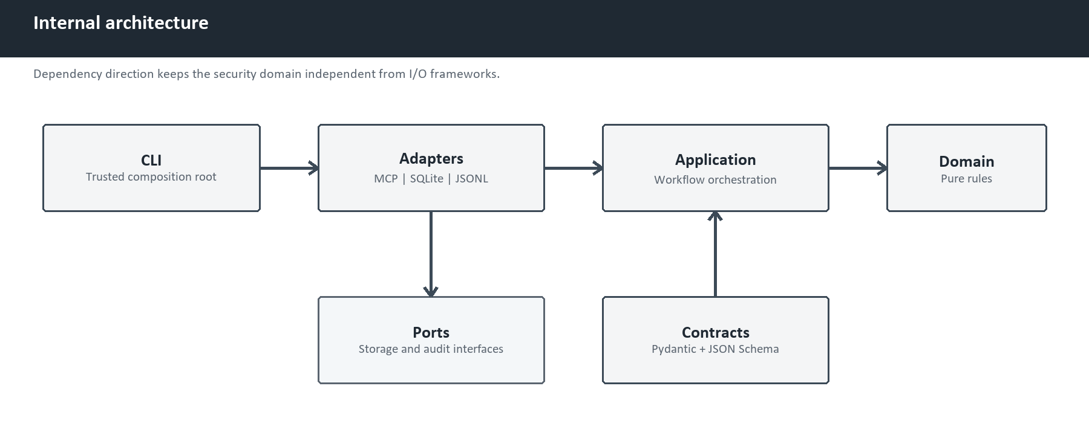
Figure 2. Internal dependency direction and architectural separation.
The domain has no MCP, database, file, or terminal dependency. Adapters perform I/O. The CLI assembles trusted configuration.

5.3 Security trust boundaries
Trusted:
- local operator;
- launch-time identity and path configuration;
- completed review and generated policy;
- proxy process and protected state directory;
- ephemeral approval capability;
- configured Wazuh deployment.
Untrusted:
- agent or MCP host;
- instructions and retrieved content;
- downstream tool names, descriptions, schemas, and annotations;
- tool arguments and results;
- changed tool definitions;
- call-supplied identity metadata.

6. Evidence-to-enforcement lifecycle
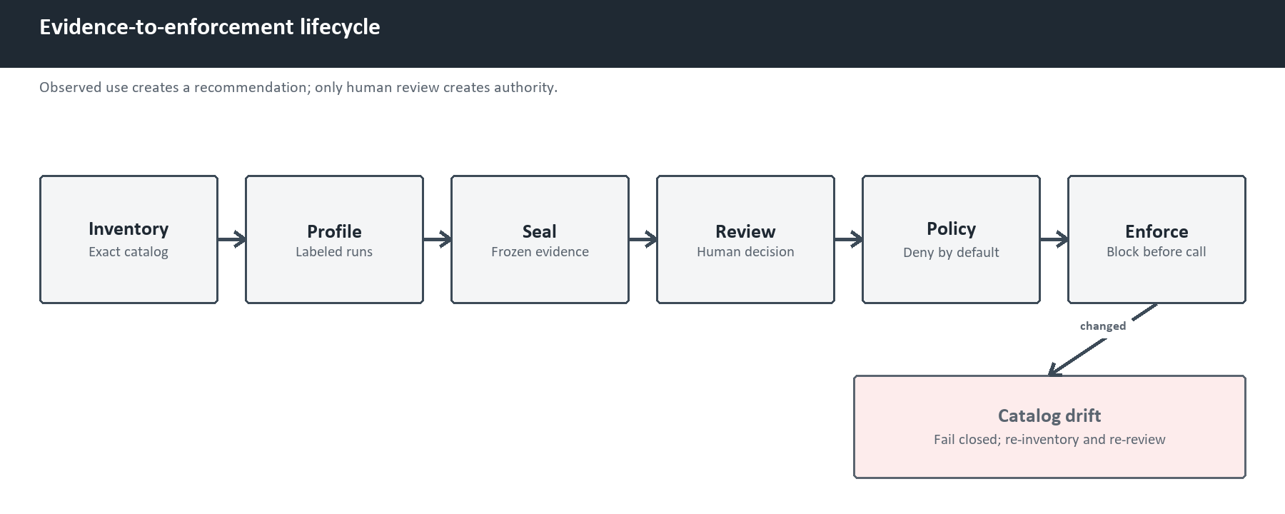
Figure 3. Evidence-to-enforcement lifecycle with fail-closed drift response.

6.1 Inventory
Inventory follows all tools/list pages, rejects cursor loops and duplicate names, caps collection, stores complete known tool objects, and creates a toolset digest independent of catalog order.

6.2 Profiling
A profile binds trusted identity and a fresh catalog fingerprint. The proxy records:
- attempted tool name;
- start and completion time;
- outcome;
- run and scenario identity.
Arguments and results pass through memory but have no persistence column.

6.3 Candidate evidence
Candidate tiers are deterministic labels, not statistical confidence:
- strong: success in at least three completed runs and every planned scenario;
- moderate: success in at least two distinct completed scenarios;
- weak: success in at least one completed run;
- unobserved: no success in a completed run.

6.4 Human review
Sealing generates a review file with every tool set to DENY. A reviewer must cover every tool exactly once and may select:
- ALLOW;
- REQUIRE_APPROVAL; or
- DENY.
Every non-denied decision also requires finite rate, task, and concurrency limits, risk metadata, and any exact argument constraints.

6.5 Enforcement
Enforcement validates the policy and live catalog before serving the host. It then:
- filters the visible catalog;
- resolves the exact rule;
- evaluates reviewed constraints;
- validates the input schema;
- reserves limits;
- consumes an exact permit if required;
- fsyncs the decision event;
- forwards the request; and
- writes a privacy-minimized completion event.

7. Safe deterministic MCP lab
The repository contains one harmless stdio MCP server with seven tools.
Tool | Behavior | Intended review
list_fixture_directory | Lists files below a fixture root | Allow
read_fixture | Reads a UTF-8 fixture below the root | Allow with path constraint
fetch_fixture_advisory | Returns local fake advisory records | Allow
write_sandbox_patch | Writes a bounded file to a disposable sandbox | Require approval
simulated_credential_read | Returns a public canary, not a real credential | Deny
simulated_command_run | Reports a command length without execution | Deny
simulated_external_post | Reports lengths without network access | Deny

This lab makes denial and abuse tests safe, repeatable, offline, and free of personal data.

8. Tool fingerprints and drift
Complete tool objects are serialized, canonicalized with RFC 8785, and hashed with SHA-256. This provides deterministic identity for the same parsed JSON value regardless of object-key order.
The project deliberately does not claim semantic equivalence between different JSON Schemas.
Drift is classified conservatively:
- addition or input-schema change: security widening;
- removal: breaking;
- presentation field change: informational;
- other changed fields: review required.
A legacy MCP notifications/tools/list_changed signal invalidates the live enforcement gate early. SDK v2 uses subscriptions for 2026-era catalog changes, so the proxy does not rely on the legacy notification: it performs a serialized complete-catalog refresh immediately before every upstream list or call. Only the exact approved digest can restore validity.

9. Constraints, limits, audit, and approval

9.1 Exact constraints
The v0.1 policy language supports only constraints that can be defined and tested precisely:
- path containment below a launch-bound symbolic root;
- normalized URL scheme and exact host allowlist;
- type-exact string or integer enum;
- maximum UTF-8 byte length.
It excludes regular expressions, wildcards, free-form expressions, and embedded policy languages.

9.2 Limits
Every non-denied tool has:
- calls per fixed minute;
- calls per task;
- concurrent calls.
Minute and task counters persist in SQLite and survive proxy restart. Concurrency is bounded within one v0.1 proxy process.

9.3 Audit
The audit builder uses an allowlist of metadata fields. It may store identity, decision, fingerprints, key names, canonical argument size, reviewed destination metadata, limits, trace ID, and timing.
It excludes:
- raw argument values;
- canonical argument bytes;
- raw tool results;
- response bodies.
The permitted decision is appended and fsynced before downstream execution. Audit failure closes the gate.

9.4 Exact single-use approval
Approval does not use MCP stdio. The proxy creates an authenticated loopback control channel and ephemeral capability file. The operator inspects the pending exact arguments in a separate terminal.
An approved permit contains an RFC 8785 argument digest, expiry, nonce, and HMAC-SHA256. It is valid for one exact retry. Changed arguments, expiry, invalid MAC, clock skew, and replay fail closed.

10. Wazuh bridge

10.1 Purpose
The proxy blocks actions. Wazuh provides detection and investigation visibility. These are different responsibilities:
proxy = preventive enforcement
Wazuh = collection, correlation, alerting, and investigation

10.2 Data path
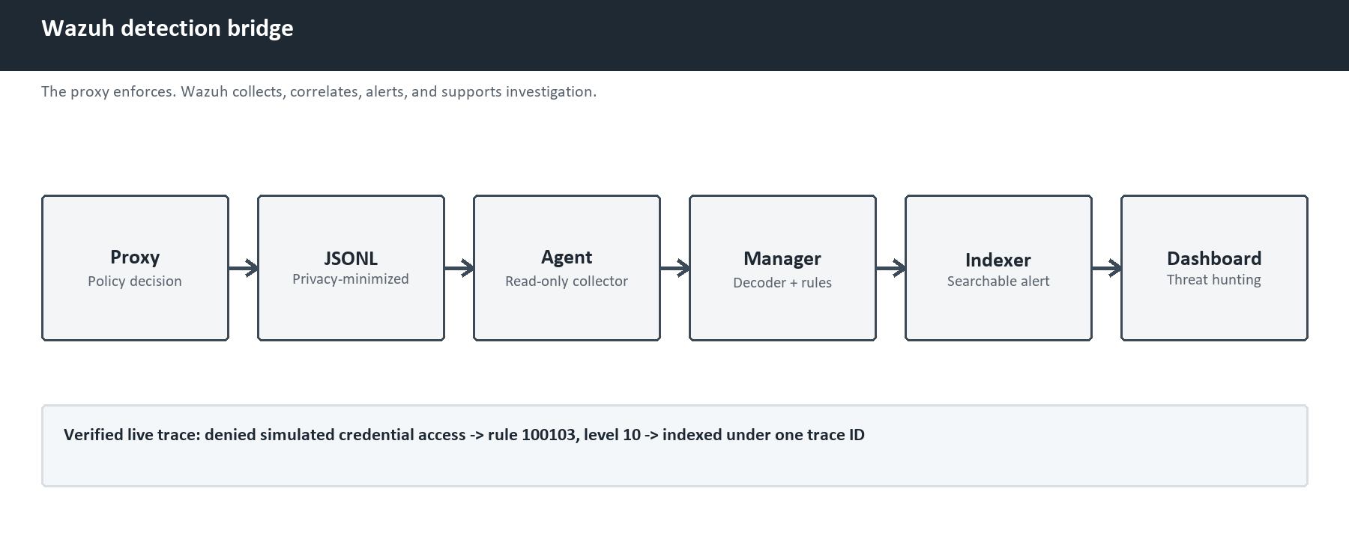
Figure 4. Wazuh detection and investigation pipeline.

10.3 Detection pack
The project contains 11 custom rules and 22 paired positive/near-miss fixtures. Rules cover generic denial, unapproved server, security-widening drift, credential access, command execution, URL constraint failure, repeated denial, limit exhaustion, policy failure, audit failure, and permit replay.

10.4 Real-engine correction
Static inspection initially suggested that generic JSON ingestion was sufficient. Real Wazuh 4.14.6 testing showed that built-in Suricata rule 86600 claimed generic JSON containing timestamp and event_type before the project rule tree.
The correction preserved pure JSONL on disk while adding a transport-only mcp_privprof: prefix and a dedicated decoder delegating the object to Wazuh's official JSON decoder.

10.5 Live proof
The bounded live probe:
- created a temporary all-deny policy;
- used the official MCP client and real proxy;
- requested simulated_credential_read;
- confirmed the request was not forwarded;
- wrote a privacy-minimized denial event;
- delivered it through the active lab Wazuh agent;
- matched manager rule 100103 at level 10; and
- found the exact trace in the indexer and dashboard.
This proves one specific local pipeline, not a production deployment.
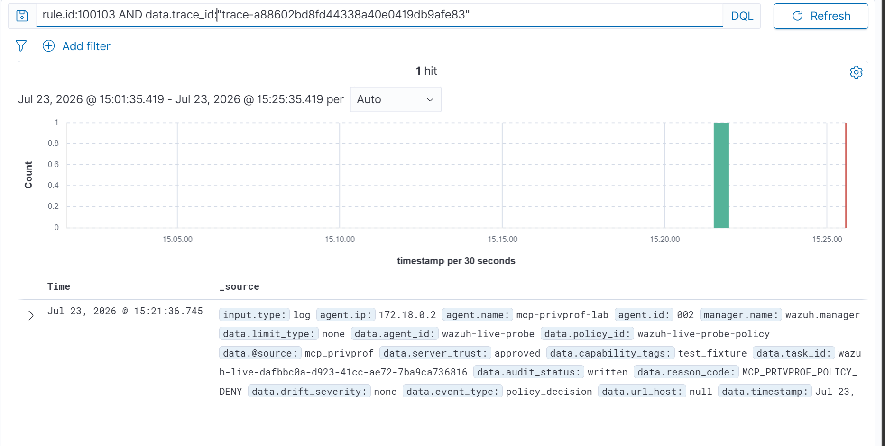
Figure 5. Historical pre-SDK-2 proof: Threat Hunting result for rule 100103 under the exact live-probe trace.
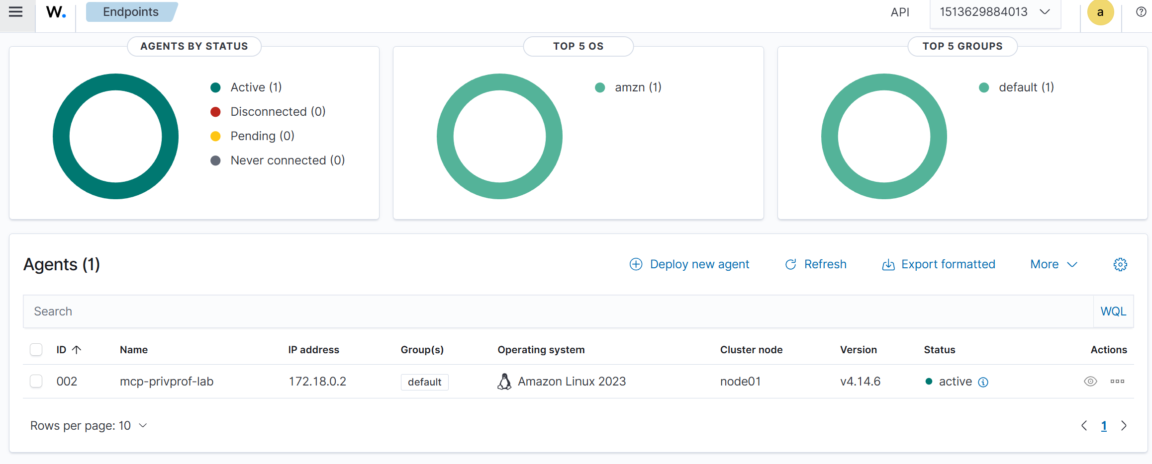
Figure 6. Historical pre-SDK-2 proof: the isolated mcp-privprof-lab Wazuh agent was active during validation.

11. Verification strategy and evidence

11.1 Verification layers
Layer | Purpose | Current result
Unit tests | Domain and application behavior | Passed
Property tests | Security invariants across generated inputs | Passed
MCP integration | Real client -> proxy -> server behavior | Passed
Failure injection | Timeouts, malformed JSON-RPC, cancellation, dead child processes | Passed
Static typing and lint | Strict types and code quality | Passed
Wazuh static fixtures | Contract and rule graph | 22/22 passed
Real wazuh-logtest | Actual Wazuh 4.14.6 rule engine | 22/22 passed before SDK v2; release-candidate rerun required
Live Wazuh ingestion | Proxy -> agent -> manager -> indexer | Passed before SDK v2 for rule 100103; rerun required
Deterministic benchmark | Security behavior and local timing | 75/75 from clean SDK v2 commit 51cfe43
Real AI agent acceptance | Model-driven host through the proxy | Passed before SDK v2; rerun required

After the SDK v2 migration, catalog-response race correction, and timeout-budget separation, the current Python suite records 163 passing tests and one expected Windows symlink-related skip. Ruff passes and Pyright reports zero errors and warnings.

11.2 Deterministic benchmark
Category | Cases | Result
Legitimate calls | 30 | 30 passed
Forbidden calls | 30 | 30 blocked
Catalog drift | 10 | 10 detected
Overuse and approval abuse | 5 | 5 rejected

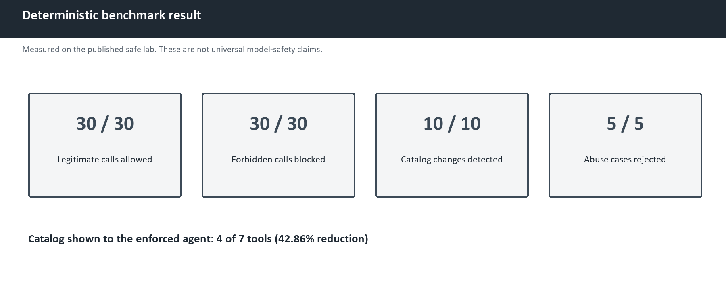
Figure 7. Deterministic benchmark summary for the published safe lab.
Measured security behavior:
- visible tools: four of seven;
- catalog reduction: 42.86%;
- labeled forbidden-call true-positive rate: 100%;
- labeled legitimate-call false-positive rate: 0%;
- labeled drift detection rate: 100%;
- labeled overuse/approval-abuse rejection rate: 100%.
These rates describe the published labels and scenarios only.

11.3 Reference performance
Measurement | Samples | p50 ms | p95 ms | p99 ms
Policy decision and constraints | 10,000 | 0.0037 | 0.4499 | 0.5196
Direct MCP tool call | 30 | 3.1182 | 4.9001 | 9.7694
Enforced MCP tool call | 30 | 26.4407 | 33.5494 | 38.0857
Measured proxy delta | 30 | 22.9489 | 29.5335 | 29.9775
Mandatory JSONL append plus fsync | 30 | 1.2500 | 1.5489 | 1.8467

Startup plus complete live inventory measured 1,803.7120 ms on the clean SDK v2 Windows run. The proxy delta includes fresh catalog revalidation before each call. Performance is machine- and workload-specific.

11.4 Dependency security and licences
The locked 39-package runtime graph was exported and scanned with PyPA pip-audit on 5 August 2026. The first scan found CVE-2026-69247 in transitive dependency cryptography 49.0.0. Although the project does not call the affected PKCS#7 decryption functions, the runtime floor was raised to the patched 50.0.0 release. A second scan reported zero known vulnerability matches. The direct and transitive runtime licence metadata was also reviewed and contained permissive licences compatible with the Apache-2.0 distribution. This result is a time-bounded advisory-database check, not proof that no unknown vulnerability exists.

12. Engineering problems encountered and resolutions

12.1 Observation was being confused with authorization
Problem: A naive profiler could silently convert frequent usage into permission.
Resolution: The data model separates available, attempted, successful, candidate, and human-reviewed facts. Policy generation requires a completed review covering every tool.
Lesson: Behavioral evidence informs a decision; it must not become the authority.

12.2 Tool descriptions could be trusted too much
Problem: Tool annotations and descriptions originate from the downstream server.
Resolution: Fingerprint complete definitions, treat changed definitions as untrusted, and authorize using exact reviewed policy rather than descriptive hints.
Lesson: Metadata may guide a user interface, but hard guarantees require runtime enforcement.

12.3 stdio could not also be an approval terminal
Problem: MCP JSON-RPC already owns standard input and output.
Resolution: Add a separate authenticated loopback approval-control channel and single-use exact permits.
Lesson: Transport boundaries must be designed before interactive controls.

12.4 Generic Wazuh JSON collided with a built-in rule
Problem: Real-engine testing exposed built-in Suricata rule precedence.
Resolution: Use a transport-only project prefix and dedicated decoder while keeping stored audit as pure JSONL.
Lesson: Static rule inspection is not a substitute for executing the actual analysis engine.

12.5 Wazuh agent identity changed after recreation
Problem: The Docker lab could assign a different agent ID after being rebuilt.
Resolution: Discover and verify the active named agent dynamically rather than hard-coding an ID.
Lesson: Ephemeral infrastructure identifiers are observations, not configuration constants.

12.6 The live probe initially reported an inactive agent
Problem: Containers were running before the Wazuh agent completed registration and became active.
Resolution: Wait for the bounded readiness condition and rerun the probe. The second run passed and produced one exact alert trace.
Lesson: Container state is not application readiness.

12.7 Docker consumed excessive local storage
Problem: The Wazuh single-node lab expanded Docker's WSL virtual disk to roughly 65 GB on the development laptop. Inspection showed only Wazuh resources: five images, four containers, fourteen volumes, and an approximately 8.7 GB queue volume.
Resolution: Stop the lab after live verification, retain the reproducible configuration in Git, and purge disposable Docker state when storage is constrained. The proxy and normal test suite do not require Docker.
Lesson: Reproducible lab infrastructure should be disposable, and resource lifecycle instructions belong in project documentation.

12.8 Workspace contamination risk
Problem: Unrelated generated documents were placed inside the project workspace during another task.
Resolution: Remove unrelated artifacts, scan tracked content, add parent and repository isolation instructions, ignore runtime output, and verify the Git root before writes.
Lesson: Workspace integrity is part of secure software engineering and open-source release hygiene.

12.9 A built-in Chrome MCP server remained visible during preflight
Problem: The first Claude Code preflight used a strict project MCP configuration and --no-chrome, but /mcp still displayed the built-in claude-in-chrome server alongside the expected seven-tool lab. No task was submitted and the profiler recorded zero calls.
Resolution: Preserve the v1 preflight as excluded correction evidence. A v2 preflight then showed only the expected lab, but one copied fallback deny pattern contained unwanted PowerShell backslashes; it also ended with zero calls and was excluded. A v3 attempt connected and inventoried the lab, but the model received no MCP discovery path because Windows PowerShell removed the empty native-process argument in --tools "". It also ended with zero MCP calls and was excluded.
Create a fresh v4 profile and database, exclude user settings, load an isolated settings file, pass the non-empty Windows-safe value --tools 'ToolSearch', and use the single mcp__claude* deny glob. The broader literal covers both observed name normalizations without affecting the safe-lab namespace. The lab server also uses alwaysLoad: true as a second tool-loading safeguard.
Lesson: An MCP connection shown in a host's management panel is not by itself proof that its tools are available to the model. Controlled experiments must verify both connection state and model tool authorization, and a contaminated or ambiguous preflight must never be counted as acceptance evidence.

13. Docker and Wazuh resource lifecycle
The command:
uv run python -m wazuh.lab down
removes the four Compose containers and project network. It intentionally keeps images and named volumes so evidence and configuration survive a normal stop.
This behavior explains why free disk space does not immediately return after down. If Docker contains only the disposable Wazuh lab, Docker Desktop's Clean/Purge action may be used to remove all local Docker data and settings. That action is destructive to every Docker workload on the laptop, so the Docker inventory must be checked first. It does not remove the Git repository. The pinned definitions can recreate the lab later.
The physical docker_data.vhdx file can remain large after ordinary container or volume deletion because a dynamically allocated WSL virtual disk does not necessarily return freed blocks to Windows immediately. Do not manually delete that file while Docker owns it. Use Docker Desktop's supported cleanup path first, quit Docker Desktop, and then recheck Windows free space.
Docker is required only for:
- real Wazuh engine tests;
- the full live ingestion probe;
- dashboard screenshots;
- final release regression when explicitly scheduled.
It should remain closed during normal code, documentation, deterministic tests, and real-agent testing.

14. Real-agent acceptance plan

14.1 Selected first host
Claude Code is the first host because it is already installed, supports local stdio MCP, and can disable built-in file and terminal tools for a controlled test.
The Claude model runs in Anthropic's cloud. The proxy and lab server run locally. No model is downloaded to the laptop. Selected fake fixture tool results are sent to Anthropic as model context; personal and production data are excluded, and Claude Code transcript writes are disabled for the controlled sessions.

14.2 Controlled topology
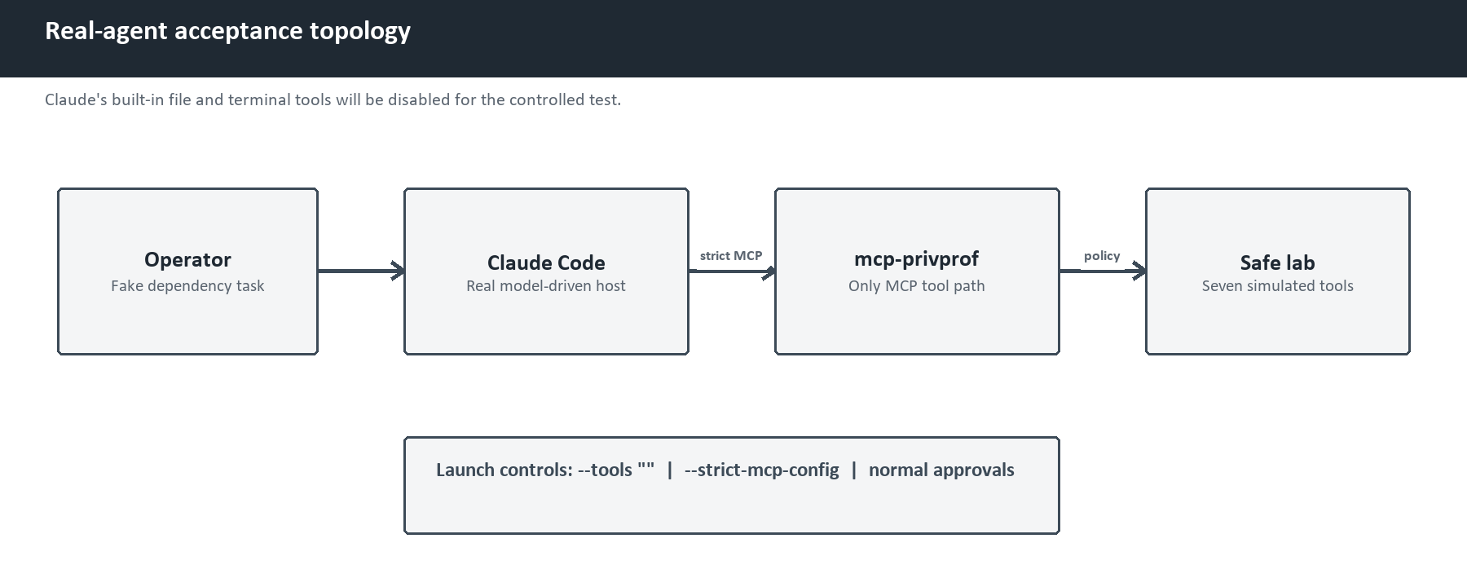
Figure 8. Controlled real-agent acceptance topology.
For scientific validity:
- update Claude Code before the run;
- retain only Claude Code's non-executing ToolSearch built-in;
- use strict MCP configuration containing only this proxy;
- exclude user settings and apply a dedicated restrictive settings file;
- explicitly deny built-in Claude MCP tool names with mcp__claude*;
- force the seven safe-lab schemas to load without built-in tool search;
- disable Claude Code transcript writes for the controlled session;
- keep normal host permission prompts;
- use only fake fixture data;
- do not use permission-bypass flags;
- do not connect email, personal files, or production services.

14.3 Preflight status and correction
The v1 workstation session established that the profiler and seven-tool lab could connect to Claude Code, but the host also displayed its built-in Chrome MCP server. The session ended without a model task or tool call. Its database therefore remains a completed zero-call preflight and is excluded from acceptance results.
The v2 workstation session showed only the expected lab and disabled transcript saving. Before a model task, inspection found an unwanted escaping error in one fallback deny pattern copied into PowerShell. It closed normally with zero calls and is also excluded.
The v3 workstation session connected to and inventoried the expected lab, but the model reported no MCP tools. Direct native-process argument inspection proved that Windows PowerShell dropped the empty string passed after --tools. Current Claude Code defers MCP tools by default, so the model had no ToolSearch capability and made no MCP call. The run is excluded.
The corrected v4 setup used a new profile, database, a non-empty --tools 'ToolSearch' value, one broad Claude-MCP deny rule, and immutable run IDs. PowerShell argument forwarding, JSON configurations, restrictive settings, executable paths, the initially empty run and call tables, and the seven-tool fingerprint were locally validated before the model task.
Two distinct v4 model-driven runs then completed normally. In each run Claude listed the fixture directory, read the dependency fixture, and fetched one different deterministic advisory. The database contains exactly six successful calls—two for each expected read-only tool—and zero calls to the four unused tools.
The profile is sealed with full coverage of its one planned scenario and evidence fingerprint:
sha256:7cf84d27f9e8db775069e66e6f0717bbda4fb2675a4f0ce7d5e56add30d86554
A scan of the generated evidence and all SQLite text fields found no fixture path, dependency value, advisory identifier, model response, personal identifier, or workstation path. The three observed tools remain weak consider_allow recommendations; sealing did not authorize them.
A third repetition was cancelled. It would increase the run count but not add a new scenario, prove necessity, or establish statistical confidence.
The operator then explicitly approved all seven decisions: three exact read-only ALLOW rules and four DENY rules. Review claude-v4-review-001 and policy claude-dependency-review-v4-policy-001 were created through the mandatory evidence-bound review gate. Both public JSON Schemas passed, the policy default is DENY, and the approved catalog fingerprint matches the sealed profile.
A corrected direct MCP enforcement preflight then passed against that exact policy:
- only the three reviewed read-only tools appeared in tools/list;
- all three exact legitimate calls succeeded;
- direct calls to all four hidden tools were denied;
- another file, parent traversal, and an unknown advisory were denied;
- a repeated directory listing exhausted the one-call task limit;
- a denied write never reached the downstream sandbox; and
- 14 JSONL records plus the enforcement database contained no raw arguments,
fixture contents, advisory values, or results.
Two earlier local preflight harnesses stopped on over-specific expected error shapes. The product returned the documented safe reason codes in both cases. Those diagnostic attempts are retained locally and excluded; the third corrected harness completed successfully.
The final Claude enforcement session then connected to only the reviewed three-tool catalog. Claude called each expected read-only tool exactly once and completed the dependency-review task. The local state contains one task and rate reservation per tool. Six event-v1 records—three allowed decisions and three successful completions—passed schema validation and contained no raw fixture path, advisory ID, dependency value, model result, personal identifier, or workstation path. A displayed follow-up suggestion was not submitted and produced no fourth call.

14.4 Acceptance sequence
- Create a trusted dependency-review profile. Completed.
- Configure Claude Code to launch mcp-privprof profile run. Completed.
- Complete two distinct, labeled dependency-review runs. Completed.
- Seal and privacy-check the collected evidence. Completed.
- Have the operator decide every tool. Completed.
- Generate a policy bound to that completed review. Completed.
- Reconfigure Claude Code to launch mcp-privprof enforce. Completed.
- Verify that only the three reviewed read-only tools are visible. **Completed
through direct MCP and Claude.**
- Complete the legitimate dependency-review task through those tools.
Completed.
- Use a separate deterministic probe to call every hidden tool directly.
Completed.
- Verify denial, non-forwarding, limit behavior, and audit privacy.
Completed.
- Run the complete local quality gates and update the release evidence.
Completed.
REQUIRE_APPROVAL is not added to this read-only policy merely to demonstrate a feature. The exact single-use approval mechanism is already covered by deterministic tests and the benchmark. A future real-agent approval test must use a separately reviewed task that genuinely requires a write.

14.5 What constitutes success
- a real model chooses the expected safe tools during profiling;
- the same task completes through the reviewed enforcement proxy;
- denied tools are not advertised;
- a direct hidden-tool request is denied;
- reviewed enum and path constraints reject changed arguments;
- reviewed task and rate limits reject overuse;
- audit contains the expected metadata but no raw values or results;
- all actions are reproducible from documented commands.

15. Open-source publication state

15.1 Completed locally
- Apache-2.0 license and notice;
- code of conduct, contributing, and security policy;
- structured package and test layout;
- a focused, reviewable commit history on main;
- GitHub Actions workflow with minimal permissions and full-SHA action pins;
- Linux/Windows and Python 3.13/3.14 matrix;
- Dependabot, issue forms, and pull-request template;
- selected public repository identifier, professional package metadata, and a
GitHub private-vulnerability-reporting path;
- a locked 39-package runtime graph with compatible licence metadata and zero
known vulnerability matches after upgrading cryptography to 50.0.0;
- release process and competitive positioning;
- local SDK v2 source, type, lint, and automated test evidence; and
- a sealed real-Claude profiling result with two completed runs and six expected
successful MCP calls; and
- an explicit seven-tool human review, generated deny-by-default policy, and
passing direct enforcement preflight; and
- a successful model-driven enforced Claude task with three exact calls and six
schema-valid privacy-minimized events; and
- a tested one-command safe demo with three allowed calls, direct hidden-tool
denial, downstream non-forwarding, and seven schema-valid privacy-minimized events; and
- local wheel and source-distribution smoke tests plus archive inspection for
ignored caches, runtime state, databases, personal documents, and private-key file types; and
- a fresh local clean-tree simulation of all 194 publishable files, including
locked installation, installed CLI startup, and the safe demo.
The build, clean-tree, real-Claude, and live-Wazuh items in this list were completed before the SDK v2 migration. They remain useful historical evidence but must be regenerated from the exact release-candidate commit. The SDK v2 benchmark passed 75/75 cases from clean commit 51cfe43.

15.2 Not yet complete
- no GitHub remote;
- no hosted CI run;
- no clean-clone test by another person;
- no external security or usability review;
- no completed public release;
- no final trademark/domain/confusion clearance for package publication;
- no post-SDK-v2 real-Claude or live-Wazuh acceptance run;
- no post-SDK-v2 distribution inspection or clean-clone proof;
- no production support commitment.

15.3 Publication sequence
- update evidence, beginner documentation, and this living report;
- run the complete local gates;
- push to a private GitHub repository;
- run hosted CI and a clean-clone test;
- perform external security and usability reviews;
- complete final package-name confusion and trademark review;
- publish a pre-alpha release candidate with explicit limitations; and
- publish v0.1.0 only after its release gates pass.

16. What was learned

Protocol and agent engineering
- how MCP hosts, clients, servers, transports, and tools relate;
- how a proxy can act as a server upstream and client downstream;
- why stdio is appropriate for one local process boundary;
- why an agent host and model are separate from an MCP server.

Secure architecture
- deny-by-default authorization;
- catalog minimization;
- trust-boundary analysis;
- exact constraints and failure behavior;
- TOCTOU and live catalog invalidation;
- audit-before-action design;
- privacy minimization rather than unreliable redaction.

Applied cryptography and deterministic identity
- RFC 8785 canonicalization;
- SHA-256 fingerprints;
- HMAC-SHA256 exact permits;
- nonces, expiry, replay resistance, and digest binding.

Detection engineering
- JSONL event contracts;
- Wazuh agents, decoders, manager rules, indexer, and dashboard;
- positive and near-miss fixture design;
- real rule-engine testing;
- trace-based end-to-end verification.

Software quality and release engineering
- ports-and-adapters separation;
- strict contract boundaries;
- unit, property, integration, failure, and benchmark testing;
- pinned dependencies and CI actions;
- reproducible benchmarks;
- honest claim boundaries;
- workspace and publication hygiene.

17. Current limitations and future work

Release blockers
- clean-clone verification;
- hosted CI;
- external review;
- final project-name clearance.

Post-v0.1 candidates
- Streamable HTTP downstream support;
- remote OAuth and identity binding;
- multi-server coordination;
- cross-process concurrency;
- remote approval;
- key protection and recovery;
- audit log rotation and health channel;
- OpenTelemetry export;
- packaging and container-isolated deployment;
- additional vendor-host compatibility.
These are candidates, not committed release claims.

18. Evidence index
Evidence | Repository location
Architecture | docs/architecture.md
Threat model | docs/threat-model.md
Inventory and drift | docs/inventory.md
Profiling and review | docs/profiling.md
Enforcement | docs/enforcement.md
Wazuh bridge | docs/wazuh-bridge.md
Benchmark method | docs/benchmark.md
Raw benchmark | benchmarks/results/reference-windows.json
Human benchmark report | benchmarks/results/reference-windows.md
Real-agent acceptance | docs/claude-code-acceptance.md
Beginner explanation | docs/project-explained.md
Safe one-command demo | docs/quickstart.md
Architecture decisions | docs/adrs/
Roadmap | docs/roadmap.md
Competitive position | docs/competitive-landscape.md
Release process | docs/release-process.md
Tests | tests/
Public schemas | schemas/

19. Primary references
- Model Context Protocol, Architecture Overview
- Model Context Protocol, Security Best Practices
- Model Context Protocol, current specification baseline
- Official MCP Python SDK
- MCP Python SDK v2 migration guide
- RFC 8785, JSON Canonicalization Scheme
- JSON Schema Draft 2020-12
- Claude Code MCP configuration
- Claude Code CLI reference
- Claude Code settings
- Claude Code Chrome integration
- Wazuh Docker deployment
- Wazuh custom rules
- Wazuh rule testing
- Docker storage pruning
- PyPA pip-audit
- GHSA-g6cj-pr64-35w5 / CVE-2026-69247

Appendix A. Current stage summary
Stage | Status | Evidence
0. Correctness and provisional name | Partial | Technical baseline checked; broader name clearance remains
1. Repository and quality | Local verified | CI defined; hosted run remains
2. Threat model and contracts | Verified | Invariants, policy, event, and public schemas
3. Safe MCP lab | Verified | Seven harmless deterministic tools
4. Transparent proxy | Verified | Client -> proxy -> server integration
5. Inventory and drift | Verified | Persistence, reports, fingerprints, change handling
6. Profiling and review | Implementation verified; SDK v2 agent rerun pending | Earlier model-driven evidence and review remain historical
7. Enforcement | Automated SDK v2 path verified; agent rerun pending | Exact catalog, denials, constraints, limits, and private audit pass in tests
8. Limits, audit, permits | Verified | Persistent limits, fsync audit, single-use approval
9. Wazuh bridge | Static SDK v2 tests pass; live rerun pending | Earlier 22 engine cases and live alert remain historical
10. Benchmark | SDK v2 working-tree run passed | 75/75 cases; clean-candidate rerun remains
11. Publication | In progress | SDK v2 release evidence, hosted CI, clean clone, reviews, and release remain

Appendix B. Honest project description
MCP Privilege Profiler is a pre-alpha, task-scoped security proxy for one local stdio MCP server. It converts labeled run evidence into a human-reviewed, deny-by-default policy; hides denied tools; enforces exact constraints, limits, approvals, audit, and drift checks; and emits privacy-minimized events with a tested Wazuh detection bridge. The SDK v2 deterministic lab and automated suite pass; earlier Wazuh, benchmark, and controlled real-agent evidence must be repeated for the release candidate. A source-checkout safe demo exercises the enforced boundary, while hosted CI, clean-clone review, external review, and public release remain.

