基于大数据的网络安全风险智能分析技术研究

摘要
针对电网信息系统中设备的异常行为、攻击行为、合规性、脆弱性的严重程度和分布情况，本文应用大数据技术对网络中的异常行为进行分析和评估，并运用机器学习以提升对网络安全风险的识别能力和评估的准确性，从而为提升电网信息系统安全性和可靠性提供强有力的保障和技术支持。

关键词: 电网; 信息系统; 机器学习;网络安全

Abstract
Aiming at the severity and distribution of abnormal behavior, attack behavior, compliance, and vulnerability of equipment in the power grid information system, this paper applies big data technology to analyze and evaluate abnormal behavior in the network, and uses machine learning to improve the network The ability to identify security risks and the accuracy of assessment provide strong guarantees and technical support for improving the security and reliability of power grid information systems.

Keywords: Power grid; information system; machine learning; network security

1 引言
随着信息时代的到来，互联网行业高速发展，海量信息的数据出现在网络之中，现如今我们正处于大数据时代，同时随着算力的提升以及机器学习算法的进一步发展，利用大数据技术对海量信息数据进行处理，对各个行业的发展都起到了促进作用。与此同时随着海量数据在互联网中的流动，对网络安全带来了更多的不稳定因素。大量数据的存在，会给黑客入侵提供一定的便利，同时也可能导致网络安全操作员操作失误等等情况。
机器学习算法广泛应用于技术及计算机视觉，自然语言处理，知识图谱等等各种方向，赋能于各行各业。包括线性回归，逻辑回归，支持向量机，决策树等，因此利用机器学习算法，对海量数据与网络的特征进行提取，再利用合适的算法对这些特征进一步进行处理，最后利用生成的模型对网络安全中设备的异常行为，攻击行为进行预测评估，可以及时发现网络中的不良行为并立即进行处理。可以实现对网络安全风险进行智能分析，加速我国的网络安全建设的脚步，实现一个网络化，安全化，智能化的信息时代国家的建设目标。

2 相关研究
近年来，国内外学者对网络安全风险评估进行了研究，并提出了一些基于不同观点的评估方法． 吴泓润等设计了基于攻击代价的网络攻击选择模型，通过对攻击代价分析，找出成功概率较大的网络攻击，并给出相应的防护措施，降低了网络安全风险，但该方法忽略了实际应用中攻击者还会考虑攻击收益． FuxiongSun等将马尔可夫链和攻击图结合对网络进行风险评估时，提出根据漏洞信息是否发布，是否有对应的攻击方法和攻击工具量化原子攻击成功概率，并在此基础上计算节点风险值；胡浩等提出将攻击图转换为吸收马尔可夫链，使用CVSS漏洞评分标准量化马尔可夫链中节点状态转移概率，进而计算各节点的概率；上述的方法具有一定的可行性，但在计算节点概率时，忽略了攻击者是智能的决策体，还会考虑攻击代价和攻击收益． 同时文献由于没有考虑网络中检测到的攻击事件对节点概率的影响，只能静态地评估网络风险，无法动态评估．
Xie 等［７］ 利用贝叶斯网络分析网络安全时，对攻击事件加以考虑，但该方法没有进一步对观察到攻击事件的节点进行后验概率的计算．Poolsappsit 等［８］将贝叶斯网络中观察到的节点状态作为攻击证据，进而计算网络中节点后验概率，从而动态评估网络风险，给网络管理员实时地掌握网络安全状况提供了便利．
陈小军等［９］利用观察到的攻击事件去对某步攻击发生的概率进行推导，但推导过程中只讨论了某节点观察到的攻击事件对该节点后验概率的影响，忽略了与该节点有关联的其它节点的后验概率会受该节点后验概率的影响；GaoNi等［１０］通过贝叶斯攻击图对网络进行风险评估时全面考虑了攻击事件对相关节点后验概率的影响，但在计算节点概率时，没有进一步分析攻击代价和攻击收益对概率的影响． 马春光等［１１］利用贝叶斯攻击图对网络进行动态评估时，从攻击压力、未知威胁等方面对节点概率进行了量化，提高了评估结果的准确性，但在计算节点概率时忽略了节点间关系为“或”的状况． 随着网络中的资源节点增加时，陈小军、GaoNiＧａｏ Ｎｉ、马春光利用贝叶斯推理计算后验概率时的时间复杂度可能会呈指数级增长，不利于及时评估网络风险．
3 Path planning modelling based on ant colony algorithm
3.1 Environment modelling
Mapping the actual terrain to a grid map with the grid method, grid identification with rectangular coordinate method. Abstract the terrain of the ancient village into network topology map G (V, E), V is a collection of nodes, E is a collection of paths. Node is divided into three categories: common node, obstacle node, and fire node.
Node V is defined as: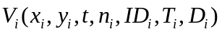.In which 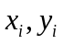 stand for two-dimensional space coordinates of nodes, they are static property, stands for time,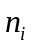 stands for the number of personnel at node V at time ,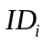 stands for safety identification at node 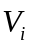, ordinary nodes represent the roadway, barrier nodes represent buildings that are obstacles to passage, fire nodes represent buildings that are breaking out of fire. ,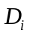 represent the temperature at node and population density respectively, they are static property.
Path set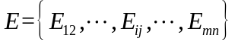, path 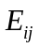 represents the escape path from node to node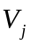. The two nodes can be passing when they are connected to each other, 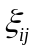 represents difficulty coefficient of roadway traffic for different paths, it is static property.
3.2 The Improvement of Ant Colony Algorithm
Ant Colony Algorithm is mentioned by Marco Dorigo^{[5]} in his doctoral dissertation. The algorithm has some characteristics, such as strong robustness, distributed computing mechanism and so on. However, there are some problems such as it takes too long to search and easy to fall into the local optimum. Adjustment pheromone volatile factor adaptively can accelerate the convergence and improve the global search ability.
In the path searching process, escape personnel choose the direction of advance based on the concentration of pheromone in the path. The tabu list 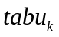 is used to represents the node set by the person k that already passed. The tabu list is adjusted dynamically in the process of the algorithm. The escape personnel determine the state transition probability according to the pheromone 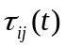 and the heuristic function 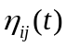 from each path.
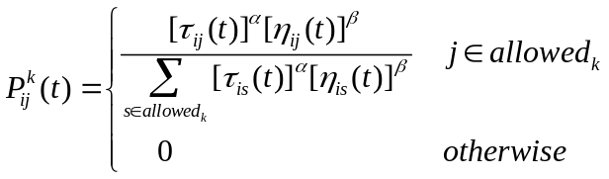 (3)
In formula (3), represents concentration of pheromone on path (i , j) at time t; is heuristic function, it represents the degree of expectation which ants from node i move to node j,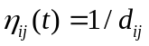,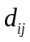 represents the geometric distance from i to j;andrepresent the importance degreeandrespectively;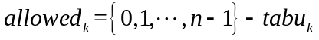represents the selectable grid collection of personnel k at present.
It can be seen from formula (3), personnel choose the path mainly rely on pheromone concentration and heuristic function. The heuristic function is related to the environment, this paper will inspire the heuristic function to make the following improvements:
It can be known that the shortest path is not necessarily the best way to escape from the above analysis, selection strategy must be changed. In this paper, the activity index of personnel 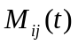 and the difficulty coefficient of roadway traffic are introduced to calculate the equivalent distance 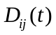^{[6]} of escape path, and then improve the heuristic function.
The activity index of personnel is calculated by the temperature influence coefficient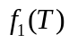and the congestion coefficient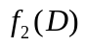from the above analysis, the expression of the personnel activity index is as follows:
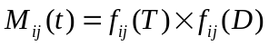 (4)
The expression of equivalent distance is as follows:
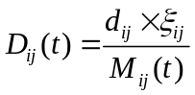 (5)
The geometric distance is replaced by the equivalent distance, the expression of heuristic function is as follows:
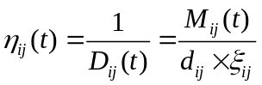 (6)
It can be seen from formula (6), and are inversely proportional to ,are in proportion to, in other words, personnel escape speed is reduced due to the impact of the environment, and the escape path also becomes longer accordingly, personnel is more inclined to choose the path of shorter equivalent distance.
Pheromone update strategy: ants update the residual information after one step or complete the traversal of n nodes. This approach is similar to the process of human brain memory which will gradually forget some of the old information after get new information. So the pheromone concentration can be reduced over time on each path. The pheromone update formula of the basic ant colony algorithm is as follows:
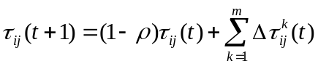 (7)
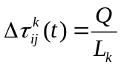 (8)
In formula (7), is called pheromone volatile coefficient,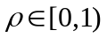, stands for the degree of reduction in pheromone; in formula (8),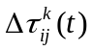 stands for the concentration of new pheromone, stands for the increase strength of pheromone,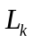 stands for the total length of the cycle is completed by ant k, that can be understood as the increase of pheromone concentration when personnel k through the path.
The value of affects the performance of the algorithm directly, the pheromone disappears quickly when the value is too large, and the global searching ability of the algorithm is restricted; the pheromone is not easy to disappear when the value is too small, and the convergence speed of the algorithm is reduced. In this paper, an adaptive method ^{[7]} to adjust the value of is proposed to solve the contradiction between the two problems mentioned above. Method setting: first set to a larger value, if the optimal solution did not change significantly after several iterations, the value of is obtained according to the following formula:
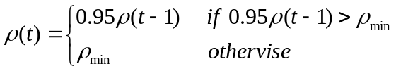 (9)
In formula (9), 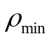 is the minimum value of, which is to prevent the value of become too small and prevent decrease the convergence rate of the algorithm.
4 Simulation steps and result
4.1 Simulation steps
In order to verify the effectiveness of the algorithm, set M=5,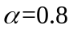,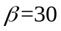,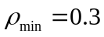,K=200,Q=1, environment is 33×33 grid, the pixels of small square is 1, the path does not participate in the path search which less than a grid. Simulating by MATLAB. The simulation steps are as follows:
Step1:Grid environment initialization, parameter initialization.
Step2:Conduct K round of iteration, selected the next node by roulette method according to the transfer probability formula.
Step3: Record the iteration path and length.
Step4: Update pheromone and empty tabu list.
Step5:If the iteration ends, output optimal path, the equivalent length, the convergence curve, the path search graph and the escape path graph; if not, go to step 2.
4.2 Simulation result
The simulation test is carried out for the single exit, set the coordinate of starting point for (16.5,21.5), set the coordinate of exit point for(28.5,1.5).
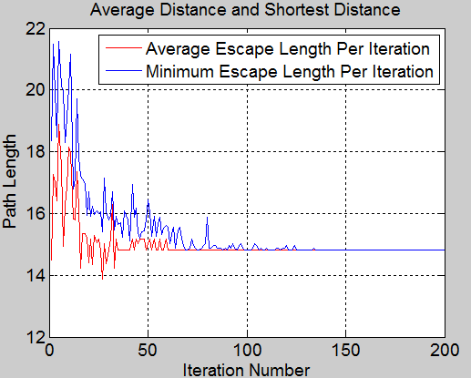
Figure 1: Path average distance and the shortest distance convergence curve
It can be known from figure 1, the shortest distance in the previous iteration is lower than the convergence value 14.4964, but the shortest distance is not necessarily the best escape distance, it is conform to the actual situation. In the 69th iteration, the average distance is equal to the shortest distance. The average distance and the shortest distance tend to converge after the 100th iteration, and remain stable, which shows that the algorithm has better convergence.
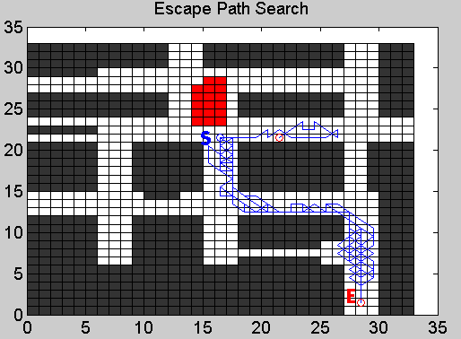
Figure 2: Single exit escape path search
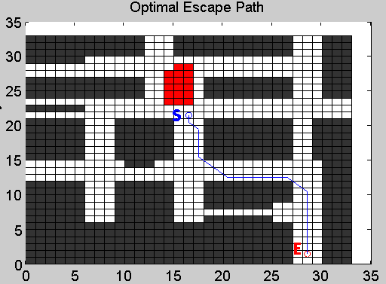
Figure 3: Single exit optimal escape path
The red part in figure 2 is the fire zone. Search path has certain randomness as can be seen from figure 2. The path in figure 3 is the final escape path given by the algorithm, the equivalent distance of this path is 14.4964, which is the shortest of all feasible paths. It shows that the algorithm has a certain ability to find the best.
Simulation results for two exits are shown by figure 4, figure 5 and figure 6.Set the coordinate of the starting point for (16.5, 21.5), set the coordinate of exit point 1 for (28.5, 1.5), set the coordinate of exit point for (28.5, 32.5).
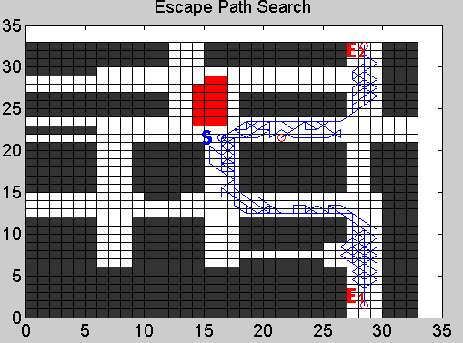
Figure 4: Two exit escape path search
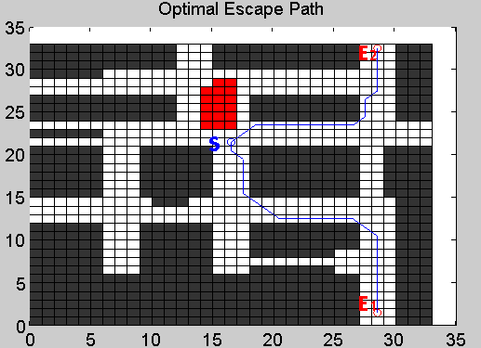
Figure 5: Two exit optimal escape path
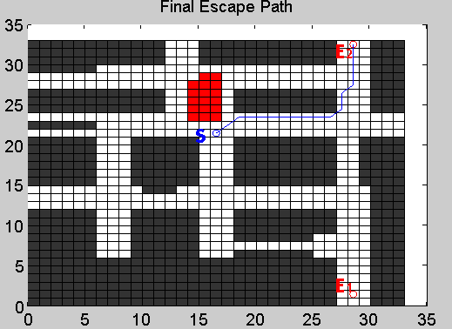
Figure 6: Final escape path
Figure 4 is a path search map with two exits, it can be seen that the search ability is better. The path in figure 5 is the optimal escape path for each exit, the equivalent distance to exit 1 is 14.4964, and the equivalent distance to exit 2 is 11.6711. The fire has little effect in the early stage of the fire. The final escape path is given by figure 6 which the equivalent distance is the shortest; it shows that the algorithm has a good ability to find the best.
Assuming the fire spread trend is in order to verify the dynamic searching ability of the algorithm, and set the exit position to simulate. The coordinate of the starting point is (16.5, 21.5), the coordinate of the exit point 1 is (28.5, 1.5), the coordinate of the exit point 2 is (28.5, 32.5).
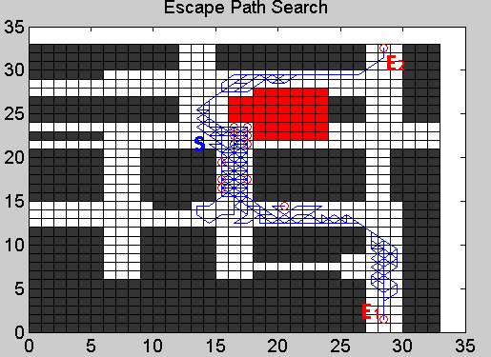
Figure 7: Fire spread escape path search
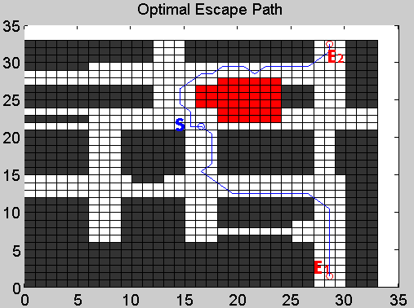
Figure 8: Fire spread optimal escape path
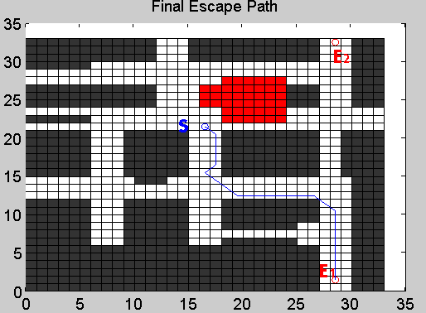
Figure 9: Fire spread final escape path
It can be seen that the fire is spreading to exit 2 from figure 7.Compared with figure 4, there is only one grid can be used in the original path as a search path due to the impact of the fire, therefore it is not choose as an escape path. Figure 8 shows the optimal escape path S1 and S2 for each exit after the fire spread, the geometric distance of S2 is less than S1, but the equivalent distance to exit 1 is 14.4964 due to the impact of the fire spread, the equivalent distance to exit 2 is 16.1230. Figure 9 shows the final escape path, the path with the shortest equivalent distance. The algorithm can adapt to the environment and can search the path dynamically.
5 Conclusions
This paper introduces the ant colony algorithm to select escape path quickly in the complex terrain environment in the ancient village when under fire. In the fire environment, the factors that affect the human traffic are convert factors into functions and then introduced into the transition probability, which can improve the adaptability and searching ability of the algorithm. The convergence of the algorithm is improved by pheromone update strategy. Simulation results show that the method can adapt to the environment, adjusting the search path dynamically, and improve the efficiency of personnel escape.
Acknowledgements
This work was supported by National Science and technology support program (Grant No.2012BAJ08B01) ,Key projects of natural science research in Anhui(Grant No.KJ2013A066), Doctoral Fund Project of Anhui Jianzhu University(Project name: Research on Key Technologies of construction safety prediction and evaluation).
Reference:
- Droid Detector:Android Malware Characterization and Detection Using Deep Learning[J]. Zhenlong Yuan,Yongqiang Lu,Yibo Xue. Tsinghua Science and Technology. 2016(01)
- FlowDroid[J].StevenArzt,SiegfriedRasthofer,Christian Fritz,Eric Bodden,Alexandre Bartel,Jacques Klein,Yves Le Traon,Damien Octeau,Patrick McDaniel. ACM SIGPLAN Notices . 2014 (6)
- [3]TaintDroid[J] . William Enck,Peter Gilbert,Seungyeop Han,Vasant Tendulkar,Byung-Gon Chun,Landon P. Cox,Jaeyeon Jung,Patrick McDaniel,Anmol N. Sheth. ACM Transactions on Computer Systems (TOCS) . 2014 (2)
- [3]“Andromaly”: a behavioral malware detection framework for android devices[J] . Asaf Shabtai,Uri Kanonov,Yuval Elovici,Chanan Glezer,Yael Weiss. Journal of Intelligent Information Systems . 2012 (1)

- Yong Liu. Research on optimal path of emergency rescue based on ant colony algorithm [D]. China University of Geosciences,2010.
- QingQuan Chen, DongNan Zhang, YongPing Zhang. Simulation of dynamic personnel evacuation based on ant colony algorithm [J]. Micro computer information,2012,10:424-426.
- Milke JA. Evaluating the early development of smoke hazard from fires in large spaces[J]. TRANSACTIONS-AMERICAN SOCIETY OF HEATING REFRIGERATING AND AIR CONDITIONING ENGINEERS, 2000, 106(1): 627-636.
- Dorigo M, Maniezzo V, Colorni A. Ant system: optimization by a colony of cooperating agents[J].IEEE Transactions on Systems Man & Cybernetics Part B Cybernetics A Publication of the IEEESystems Man & Cybernetics Society, 1996, 26(1):29-41.
- ChunYing Lei. Optimization of fire evacuation route based on improved ant colony algorithm [D]. WuHan University of Technology,2014.
- LiJun Zhu, ZhongQiu Yang. An ant colony algorithm for the adaptive mechanism of the lower and upper bounds of pheromone [J]. Journal of Shenyang Institute of Chemical Technology,2009,01:65-68.
- Zheng Xiang, Ming Xu, FoDe Wen. Simulation of evacuation in fire based on ant colony algorithm [J]. Security technology,2010,03:52-54+63.
- Dorigo B M, Vittorio. Maniezzo and Alberto Colorini: The Ant System: Optimization by a colony of cooperating agents[C]// IEEE Transactions on Systems, Man & Cybernetics. 2015.

