CS 330 Final Project Review
Neo Huynh
SNHU CS-330
Professor Aaziz
This is my picture: 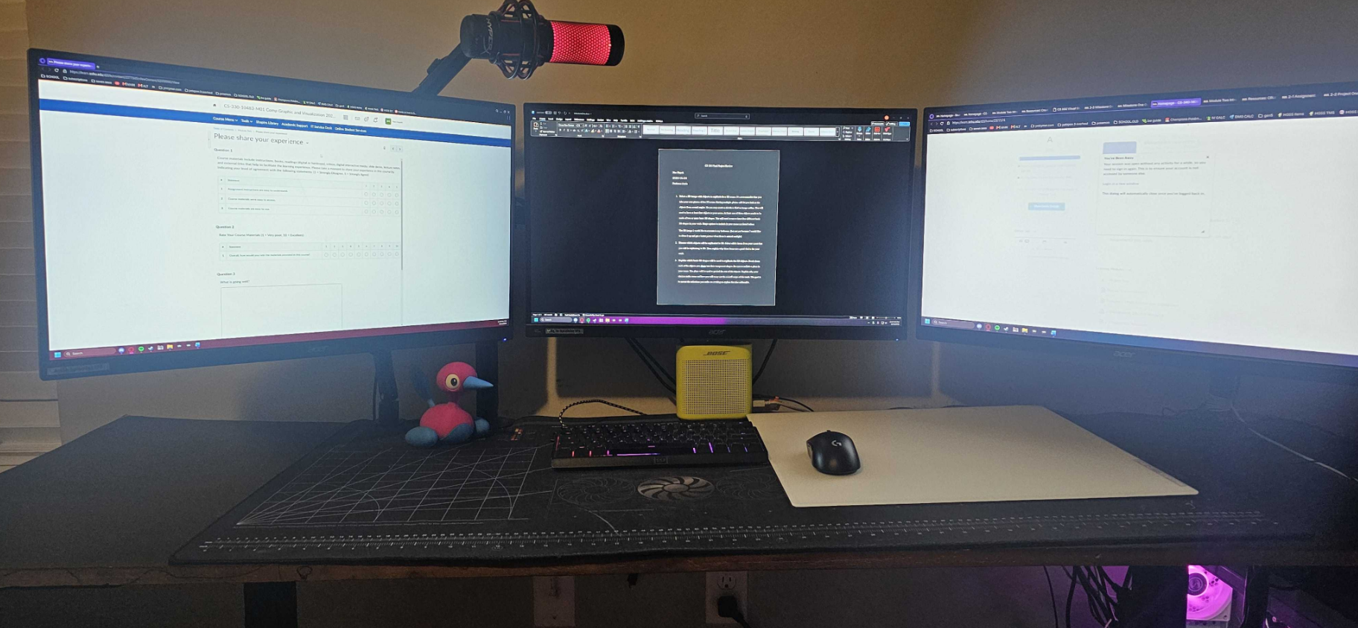This is my project recreation image:
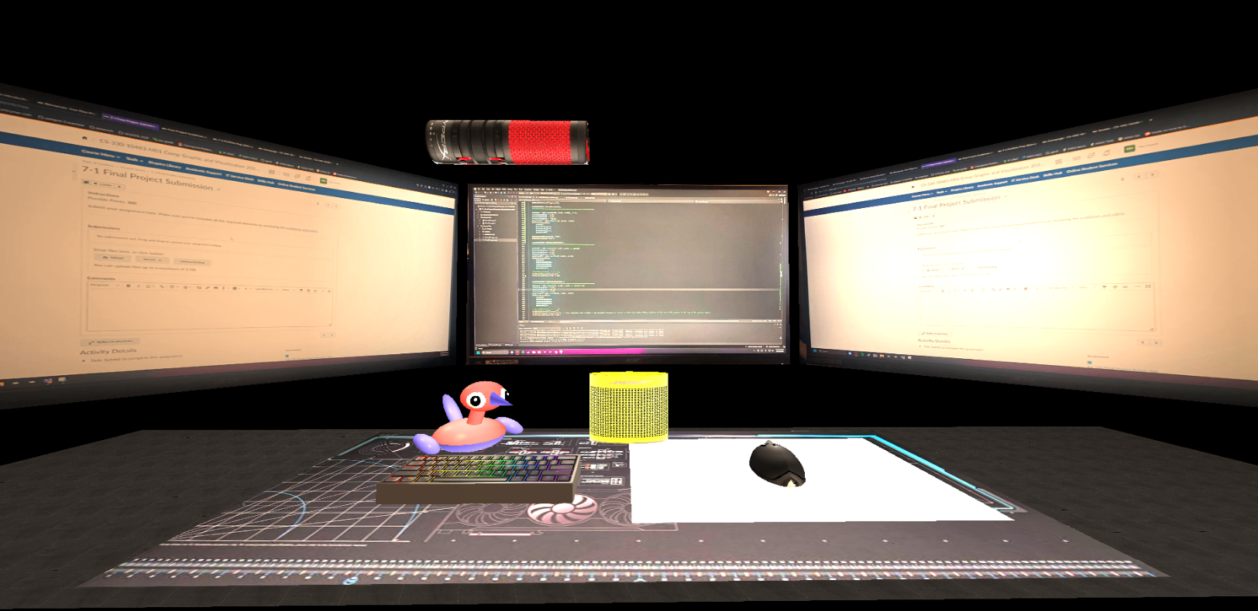
- Justify development choices for your 3D scene. Think about why you chose your selected objects. Also consider how you were able to program for the required functionality.
I originally had a lot more objects in the scene but decided against so many objects so that the project becomes redundant. I did end up keeping my Porygon2 figure in the background because I found that it was an easier challenge to create because of its simple design but also complicated for a beginner like me. I did end up incorporating two values that adjust the size and the rotation of the Porygon2 because I created the Porygon2 before the rest of the design and needed to adjust for size and rotation issues. I met the required functionalities by following the resources in every module and using them to model my designs and objects. For example, I struggled originally with understanding and applying the texturing but after re-reviewing the module resources, I was able to understand that the textures are almost always square to account for stretching and if you use a long image, it can be cut off.
- Explain how a user can navigate your 3D scene. Explain how you set up to control the virtual camera for your 3D scene using different input devices.
A user can use WASD controls to navigate throughout the scene, as well as Q to go up and E to go down, while the scroll wheel is used to adjust the movement speed of the camera. I also included the options to view in 2D (orthographic) and 3D (perspective) with the O and P keys respectively.
- Explain the custom functions in your program that you are using to make your code more modular and organized. Ask yourself, what does the function you developed do and how is it reusable?
I created multiple functions in my program to make it more modular and reusable through many different applications. For example, I used void SceneManager::LoadSceneTextures() to set up and load the textures for my scene, while using void SceneManager::SetupSceneLights() to set up the lights. My favorite modular and organized code segment is the use of a glm::vec4 matrix that controlled the rotation of my Porygon2 figure. I had to do this because I found it simpler to just make it modular in case I wanted to move my figuring and rotate it, but ran into the issue that simply rotating the pieces does not adjust for the distance traveled, meaning I had to rotate around an axis. By using the matrix, I was able to rotate around said axis and multiply against the positionXYZ value, and thus rotate the entire model together using a single value porygonRotation.

