Name: Igor Volodimir Vons Vons

Phone: +34 603 64 22 37

Email: igorvons3@gmail.com

This document is a condensed collection of various projects, more or less notable, that I have carried out. It aims to provide a general overview of the knowledge and experience gained through their completion. It also offers a summary of future ideas that I plan or intend to develop in the short or medium term.

Contents

Projects 2

Academic 2

Amazon web scraping and predictor training (2022) 2

Dataset regularization and machine learning model comparison (2023) 2

Image processing and classification (2022) 3

Dataset analysis and model training (2022) 3

“Cell conquest/tower defense” game (2022) 3

Madrid bus lines web (2023) 4

Art sales website (2023) 5

Personal 6

Translationof Qt examples from C++ to Python (2022) 6

Project Caelus (2020) 6

Others 7

Collaboration grant/Thesis (2022-2024) 7

Back-end/front-end development + Kronis APIs (2023-2024) 7

RoboArm (2023) 8

In progress 9

Numismatics project 9

Mountain Shelters Website 9

Future 10

Further studies (AI Master’s degree) 10

## Projects

### Academic

### Amazon web scraping and predictor training (2022)

The work involved several phases. First, a script was designed to collect as many comments as possible from various Amazon products. We had to handle website pagination and headers in requests (particularly user-agent) to bypass page controls. Once obtained, a dataset was created based on embeddings, and after proper data processing, it was used to train various models capable of predicting the review score based on the comment text.

FormaForma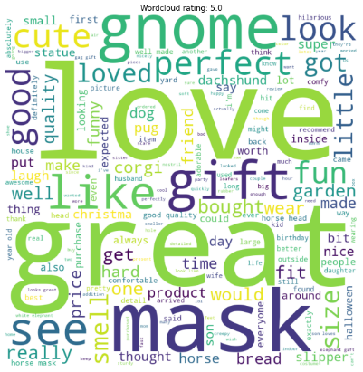

Skills: web scraping, handling headers in web requests, embedding translation and use, training and using machine learning models.

Link: <https://github.com/Yngvine/Small-projects/tree/83bfe35b37556bbed4a6303d688e5abb41c6b7e1/Review_classification>

### Dataset regularization and machine learning model comparison (2023)

An incomplete dataset was used, containing economic information about several companies labeled as bankrupt or not. Various treatments were applied to the dataset to fill missing values, determine key attributes, balance class ratios, etc. Finally, the dataset was used to train several models and evaluate their performance.

Skills: analysis and treatment of defective datasets, training and using machine learning models.

Links: <https://github.com/Yngvine/Small-projects/tree/83bfe35b37556bbed4a6303d688e5abb41c6b7e1/Dataset_regularization>, <https://www.kaggle.com/datasets/fedesoriano/company-bankruptcy-prediction>

### Image processing and classification (2022)

A simple project involving the processing and vectorization of an image dataset of dogs and cats to train and evaluate the performance of several machine learning models. Three different strategies were implemented for encoding the images to compare their effectiveness.



Skills: image processing and vectorization, training and using machine learning models.

Link: <https://github.com/Yngvine/Small-projects/tree/83bfe35b37556bbed4a6303d688e5abb41c6b7e1/Image_classification>

### Dataset analysis and model training (2022)

A project involving the selection of a dataset, studying the relationship between attribute values and the classes to which each example belonged, and training and evaluating a series of models on this dataset.

Skills: dataset analysis, training and using machine learning models.

Links: <https://github.com/Yngvine/Small-projects/tree/83bfe35b37556bbed4a6303d688e5abb41c6b7e1/Dataset_study>, <https://www.kaggle.com/datasets/muratkokludataset/acoustic-extinguisher-fire-dataset>

### “Cell conquest/tower defense” game (2022)

A real-time multiplayer game developed in Java that replicates the typical "cell conquest/tower defense" games, but in this case on a world map, making it somewhat reminiscent of a basic strategy game. It allows the connection of several players, each assigned a random country. From there, with units generated over time, they can expand their territory, with the last player standing winning.

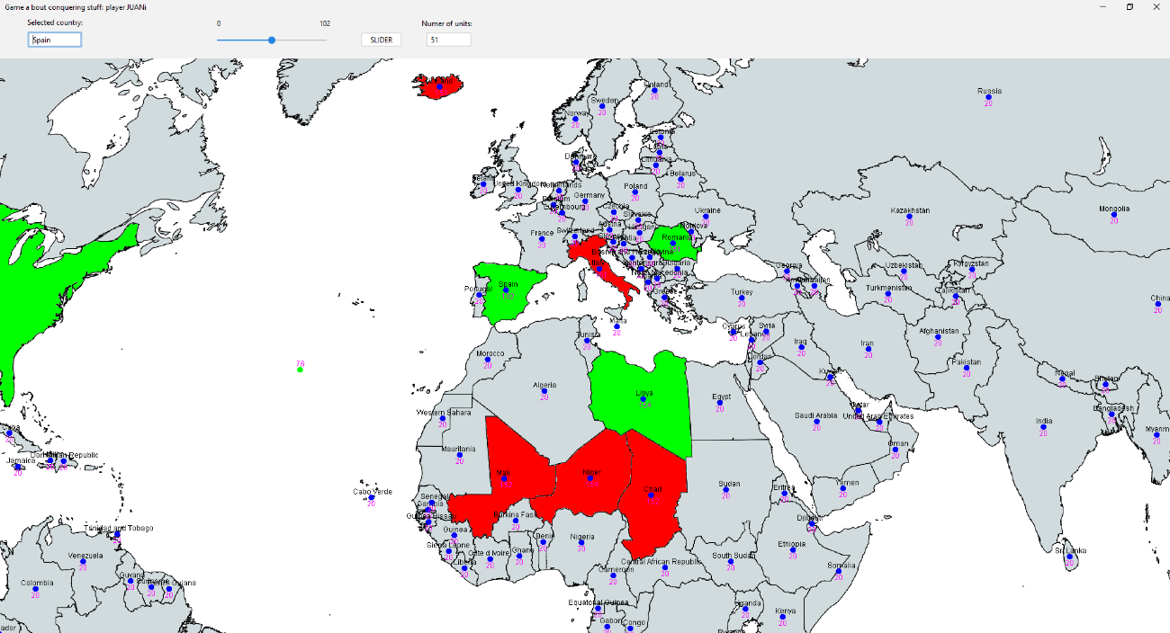

Skills: Java programming, asynchronous event handling, network communication, Java interface implementation.

Link: <https://github.com/Yngvine/Small-projects/tree/83bfe35b37556bbed4a6303d688e5abb41c6b7e1/Cell_conquest_game>

### Madrid bus lines web (2023)

First web development project. It involved using the public EMT API of Madrid to create a page displaying part of the available content. In our case, we implemented a visualization of the city’s public transport lines using Leaflet. Users could consult the lines and change the direction, modifying the route. Additionally, if registered and logged in, they could view the stops for each route, check the lines passing through each stop, and save the information as a CSV or PDF file.



The project code was lost due to server resets by UPNA.

Skills: web development with HTML, JS, and PHP without a framework, API communication, phpMyAdmin for database management, user access control, file generation and download, Postman.

API Link: <https://apidocs.emtmadrid.es>

### Art sales website (2023)

A project where we developed a simple sales website from scratch. The page includes a main page with pagination and content filter options. Each item leads to an individual article page, and if the user is registered and logged in, they can add items to their cart. Once items are in the cart, they can proceed with a mock purchase, recording the status change of the item in the database to prevent further sales. It also features an assistant connected to an AI service for users to ask questions about products. The site had admin users with access to a special view to manage users, grant/revoke privileges, modify the inventory, and download event logs and inventory reports. The project was developed as a complement to studying and applying agile Scrum development techniques.

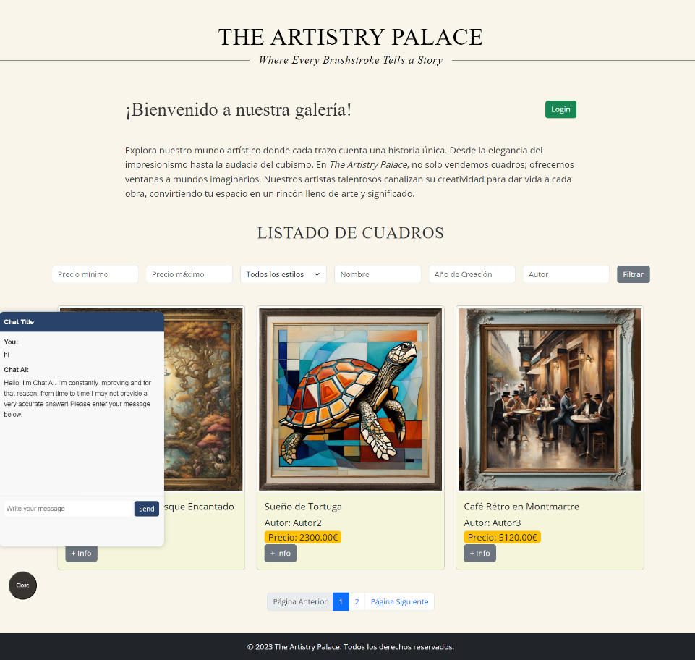

Skills: Xampp, HTML, JS, PHP, MySQL, Scrum, Git/GitLab, user access control, inventory management, file generation, and download.

Link: <https://github.com/Yngvine/AIshoppingweb>

## Personal

### Translationof Qt examples from C++ to Python (2022)

A self-initiated project to get better acquainted with PySide, a Python library that serves as a wrapper for the C++ Qt library used for software interface development. I helped translate some functional examples and implemented a simple interface to test the library's features. Specifically, I implemented a simple calculator using the PySide library.



Skills: Python/C++ programming and translation, PySide, PyQt, and Qt for interface development.

Links: <https://github.com/Yngvine/QTSvg_Example_Python>, <https://github.com/Yngvine/Calculator>

### Project Caelus (2020)

The registered group name for the 2020 edition of CanSat Navarra, a competition where participants design a mini satellite the size of a soda can, equipped with sensors to collect data during descent, a transmitter to send data to a ground device, and a system to control the descent (in our case, a parachute). The satellites are launched in groups within rockets that reach about 2 km altitude before releasing the mini satellites for descent.

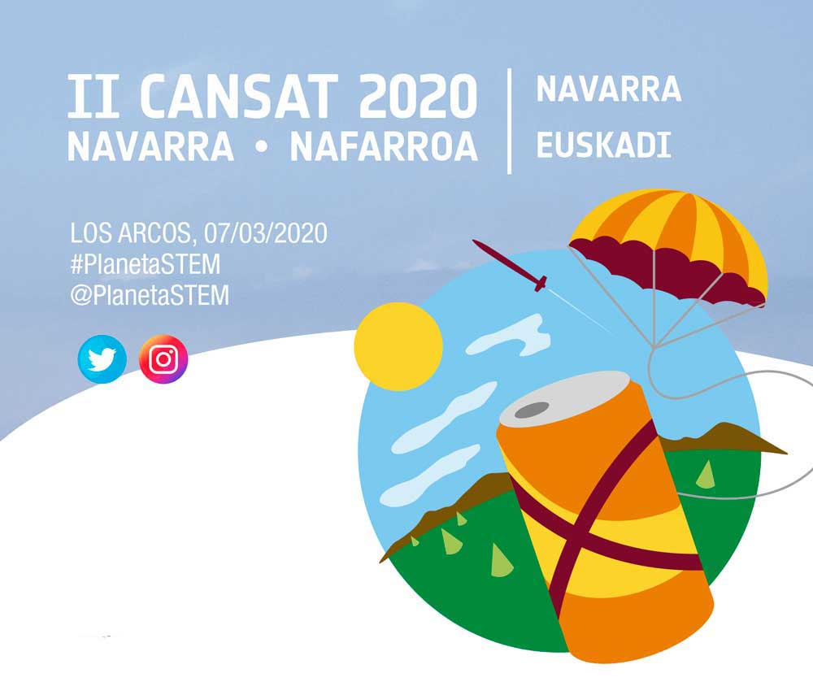

Skills: 3D modeling (FreeCad), 3D printing, Arduino, basic aerodynamics.

Link: <https://www.instagram.com/caelusproject/?hl=es>

## Others

### Collaboration grant/Thesis (2022-2024)

This project started as a collaboration grant with UPNA in the 2022-23 academic year and evolved into a full thesis during the following school year. The work involved implementing a physical and reactive interface for interacting with generative image models. The interface was a sand-filled box with a distance sensor and a projector. Using the captured camera data and a text prompt, an image was generated and projected onto the sand surface. Communication between the device and the computer running Stable Diffusion was network-based to keep the structure independent. The idea was that the generated image would respond based on how the user modified the sand surface. Several conditioning methodologies, such as Control-Net and LoRA, were tested. The initial idea focused on generating landscape images that matched the sand surface's relief, but other shapes were also tested.

 

Skills: knowledge and use of new AI generative technologies (particularly local execution), switch-based communication, Azure Kinect framework use, 3D modeling (Blender), image processing.

Link: <https://github.com/Yngvine/Small-projects/tree/21e1e4aa40bea68cc2d3b71e2cb50242217588cf/Sand_Difussion>

### Back-end/front-end development + Kronis APIs (2023-2024)

During my curricular internship, followed by an extension as a freelance worker, I participated in the development of the Kronis web application for Sploro. I had the opportunity to contribute to various parts of the project, creating tests, refactoring code, implementing new functionalities, front-end development, working with Django, and implementing an API intended to migrate the interface to React and provide it to app users for personal use.

**Skills**: implementation of Django models/views, Django migrations, Postman, Scrum/Kanban, Ajax requests, CSS/XPATH selectors, Git/GitHub, Pycharm, custom API implementation, Selenium.

Link: <https://kronis.app>

### RoboArm (2023)

A project involving the design and construction of a physical robotic arm connected to an Arduino that would record its position at all times. This information was transmitted to a connected computer, where a simulated version of the arm was displayed. A button at its end allowed the user to perform actions in the simulation, in our case, lifting and moving a cube with basic collision and gravity physics.

**Skills**: piece design and laser cutting, Processing programming, Arduino, electronic component assembly.

Link: <https://github.com/Ninjalice/ROBOARM>

## In progress

### Numismatics project

A personal interest project where I plan to delve deeper into 3D design (particularly precise modeling) and 3D printing. My intention is to create an alternative preservation system to classic numismatic plastic albums and potentially implement tools that facilitate the project's scalability and replicability if others are interested. The proyect is being developed in Python, supported by PySide6, VTK and CadQuery.

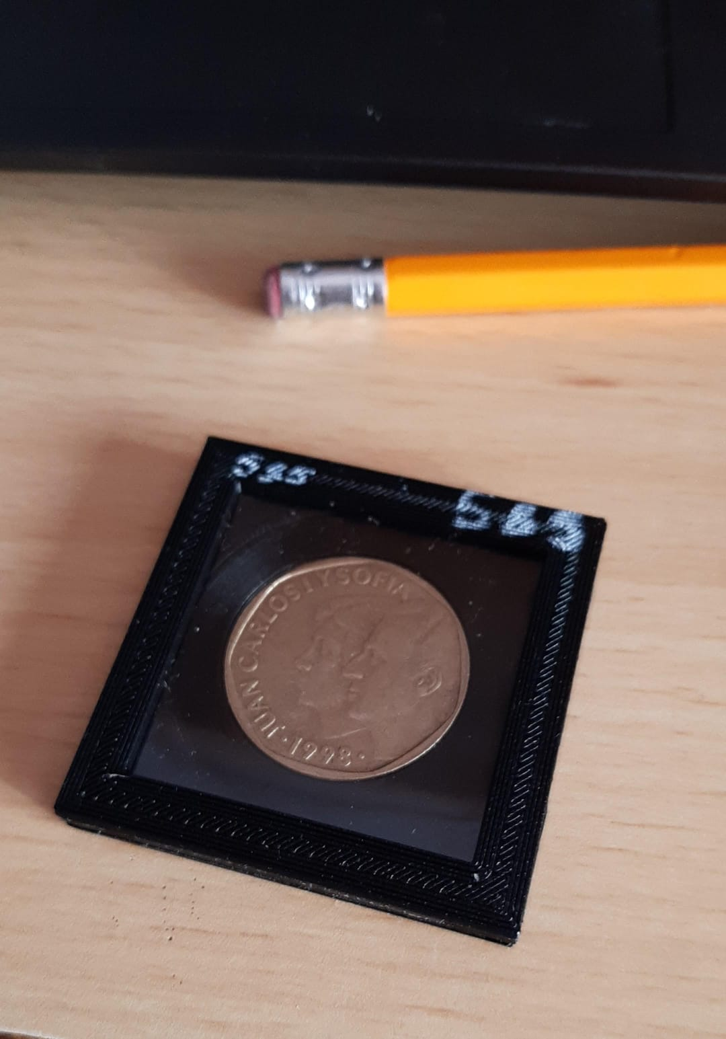

Link: <https://github.com/Yngvine/CoinChipApp>

### Mountain Shelters Website

A project developed in collaboration with former classmates, aimed at creating a website that centralizes information about mountain shelters, displaying currently registered shelters and allowing interested users to actively contribute to the database. It started as an introductory project for .NET technologies, specifically implementing an ASP.NET web API connected to a React front end. Currently, it is not deployed.

Links: <https://github.com/Ninjalice/BE-OpenCabins>, <https://github.com/Ninjalice/FE-OpenCabins>

## Future

Personal website

Create a website to showcase my resume, displaying the projects I've developed so far or providing links to view them. It would serve a similar purpose to this document but be more accessible through a simple link.

### Further studies (AI Master’s degree)

Unless there are significant changes, my intention is to pursue the new AI master's degree offered by UPNA for the 2025-2026 academic year. It would be a one-year master's with a sequential curriculum that I believe would provide essential tools for working with new AI technologies, particularly large-scale Deep Learning models.