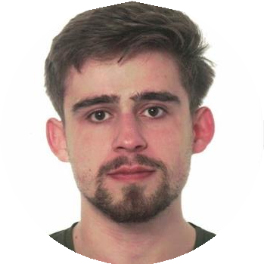Igor Volodimir Vons Vons

|  |  |
| --- | --- |
| Personal information | |
| Name | Igor Volodimir Vons Vons |
| Address | c/Comunidad de Extremadura 4, 1ºA, Barañain, Navarra, Spain |
| Phone number | +34 603 64 22 37 |
| Email | [igorvons3@gmail.com](mailto:igorvons3@gmail.com) |
| Date of birth | 12/11/2002 |
| Place of birth | Pamplona, Navarra |
| Nationality | Spain |
| Gender | Male |
| Driving license | B |
| LinkedIn | <https://www.linkedin.com/in/igor-vons-960449156/> |
| GitHub | <https://github.com/Yngvine> |

|  |  |
| --- | --- |
| Working experience | |
| Programmer/Developer  *Splorotech S.L., Pamplona*  Junior Developer on the web software tool Kronis | Sep 2023 – Jun 2024 |

|  |  |
| --- | --- |
| Education and Cualification | |
| Secondary Compulsory Education (ESO)  *IES Barañain, Barañain* | Sep 2014 – Jun 2018 |
| High School (Bachillerato) in modality of Science & Engineering  *IES Barañain, Barañain* | Sep 2018 – Jul 2020 |
| Erasmus+ Program  *Zespół Szkół Urszulańskich w Rybniku (Ursulines School Complex in Rybnik), Rybnik* | Mar 2018 |
| Bachelor’s degree in Computer Science/Informatics Engineering  *Public University of Navarre (UPNA), Pamplona* | Sep 2020- Jun 2024 |
| Erasmus+ Program  *Blekinge Tekniska Högskola (Blekinge Institute of Technology), Karlskrona* | Jan2024- Jun 2024 |

|  |
| --- |
| Personal Interests |
| IA driven development, Cartography, Art/Music, Game development. |

|  |  |
| --- | --- |
| Aptitudes | |
| Python | *Advanced* |
| Django | *Intermediate* |
| C/C++ | *Intermediate* |
| C#/.NET | *Basic* |
| JavaScript | *Intermediate* |
| Java | *Basic* |
| SQL | *Intermediate* |
| Git | *Advanced* |

|  |  |
| --- | --- |
| Languages | |
| Español | Mother tongue |
| Ucraniano | Mother tongue |
| Inglés | C2 |
| Ruso | Good working knowledge |