1. Who are the five best customers?

SELECT TOP 5

C.CustomerID,

C.CompanyName,

C.CustFirstName,

C.CustLastName,

SUM(SLI.UnitPrice \* SLI.OrderQuantity) AS TotalPurchases

FROM Customer C

JOIN SalesOrder SO ON C.CustomerID = SO.CustomerID

JOIN SalesLineItems SLI ON SO.OrderID = SLI.OrderID

GROUP BY C.CustomerID, C.CompanyName, C.CustFirstName, C.CustLastName

ORDER BY TotalPurchases DESC;

1. Which year did the company sell the most chicken coops?

SELECT TOP 1

I.PartNumber,

I.PartDescription,

I.StockPrice,

SUM(SLI.OrderQuantity) AS TotalSoldQuantity

FROM Inventory I

JOIN SalesLineItems SLI ON I.PartNumber = SLI.PartNumber

GROUP BY I.PartNumber, I.PartDescription, I.StockPrice

ORDER BY SUM(SLI.OrderQuantity) DESC, I.StockPrice DESC;

c. What items in inventory are in need of reorder?

SELECT PartNumber, PartDescription, StockLevel, ReorderLevel

FROM Inventory

WHERE StockLevel < ReorderLevel;

d. What is the most expensive item presently in inventory?

SELECT TOP 1 PartNumber, PartDescription, StockPrice

FROM Inventory

ORDER BY StockPrice DESC;

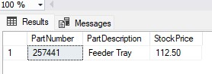

e. Which is the most expensive item the company has ever sold?

SELECT TOP 1 PartNumber, UnitPrice

FROM SalesLineItems

ORDER BY UnitPrice DESC;

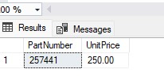

f. What are the names of the employees that work in the design department?

SELECT LastName, FirstName

FROM EmployeeInformation

WHERE JobTitle = 'Design';

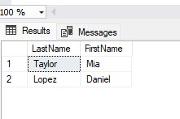

g. What are the names of former employees, and when were they let go?

SELECT LastName, FirstName, ReleaseDate

FROM EmployeeInformation

WHERE ReleaseDate IS NOT NULL;

h. What is the best-selling item?

SELECT TOP 1

PartNumber,

SUM(OrderQuantity) AS TotalSold

FROM SalesLineItems

GROUP BY PartNumber

ORDER BY TotalSold DESC;

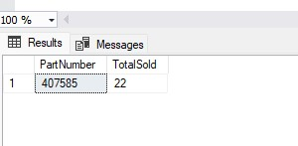

1. What items do not sell well?

SELECT PartNumber, SUM(OrderQuantity) AS TotalSold

FROM SalesLineItems

GROUP BY PartNumber

HAVING SUM(OrderQuantity) < 10;

