Chiranjeev Gurukul CRM Enhancement
Process Flow Diagrams (BPMN-style)
Version 1.0 | Aug 2025

Table of Contents
Table of Contents 2
Purpose 3
1. Lead-to-Opportunity (Sales) 4
Walkthrough 6
2. Quote & Discount Approval (Sales) 7
Walkthrough 9
3. Support Ticket Lifecycle & SLA Escalation 10
Walkthrough 12
4. Campaign-to-Lead Nurturing (Marketing) 13
Walkthrough 15

Purpose
These diagrams visualize the four core end-to-end flows behind the Chiranjeev Gurukul’s CRM Enhancement, so stakeholders can walk through the process rather than read it as prose. Notation: rounded boxes are activities, diamonds are decision gateways, circles are start/end events (green = start, red = end). Each swimlane represents the actor/system responsible for that step.

1. Lead-to-Opportunity (Sales)
Covers FR-003, FR-004, FR-005, BR-001 to BR-006, BR-014, from initial lead capture through to an active sales opportunity.

Walkthrough
- A lead enters through a web form, referral, or manual entry and is checked for duplicates against BR-001/BR-002 before anything else happens.
- Duplicates are merged into the existing record rather than creating a new one; clean leads are auto-assigned to a Sales Executive per BR-003.
- Unqualified leads are marked Lost or routed into a Marketing nurture sequence (FR-020) instead of being abandoned.
- Qualified leads convert to a Contact and Opportunity in the same step, then move through pipeline stages to quoting and close.
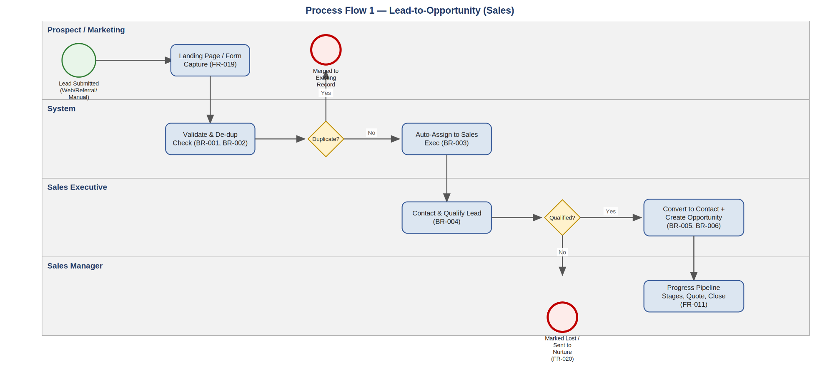

2. Quote & Discount Approval (Sales)
Covers FR-011 and BR-008 — the discount-approval control that prevents unauthorized margin erosion.
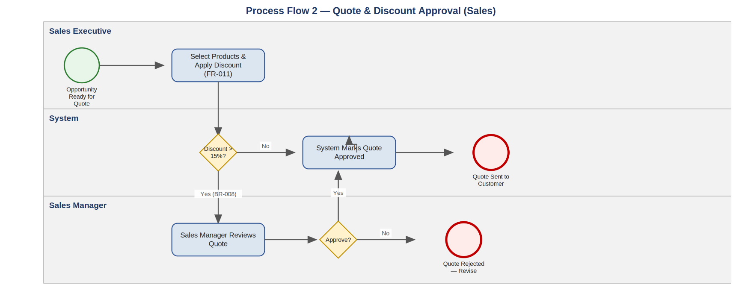

Walkthrough
- Any discount at or below 15% is auto-approved and the quote goes straight to the customer.
- Anything above 15% is routed to the Sales Manager before it can be sent — the system enforces this; it isn't left to individual judgment.
- A rejected quote returns to the Sales Executive for revision rather than being silently blocked with no path forward.

3. Support Ticket Lifecycle & SLA Escalation
Covers FR-022 to FR-025 and BR-010 — from ticket creation through SLA-driven escalation to closure.
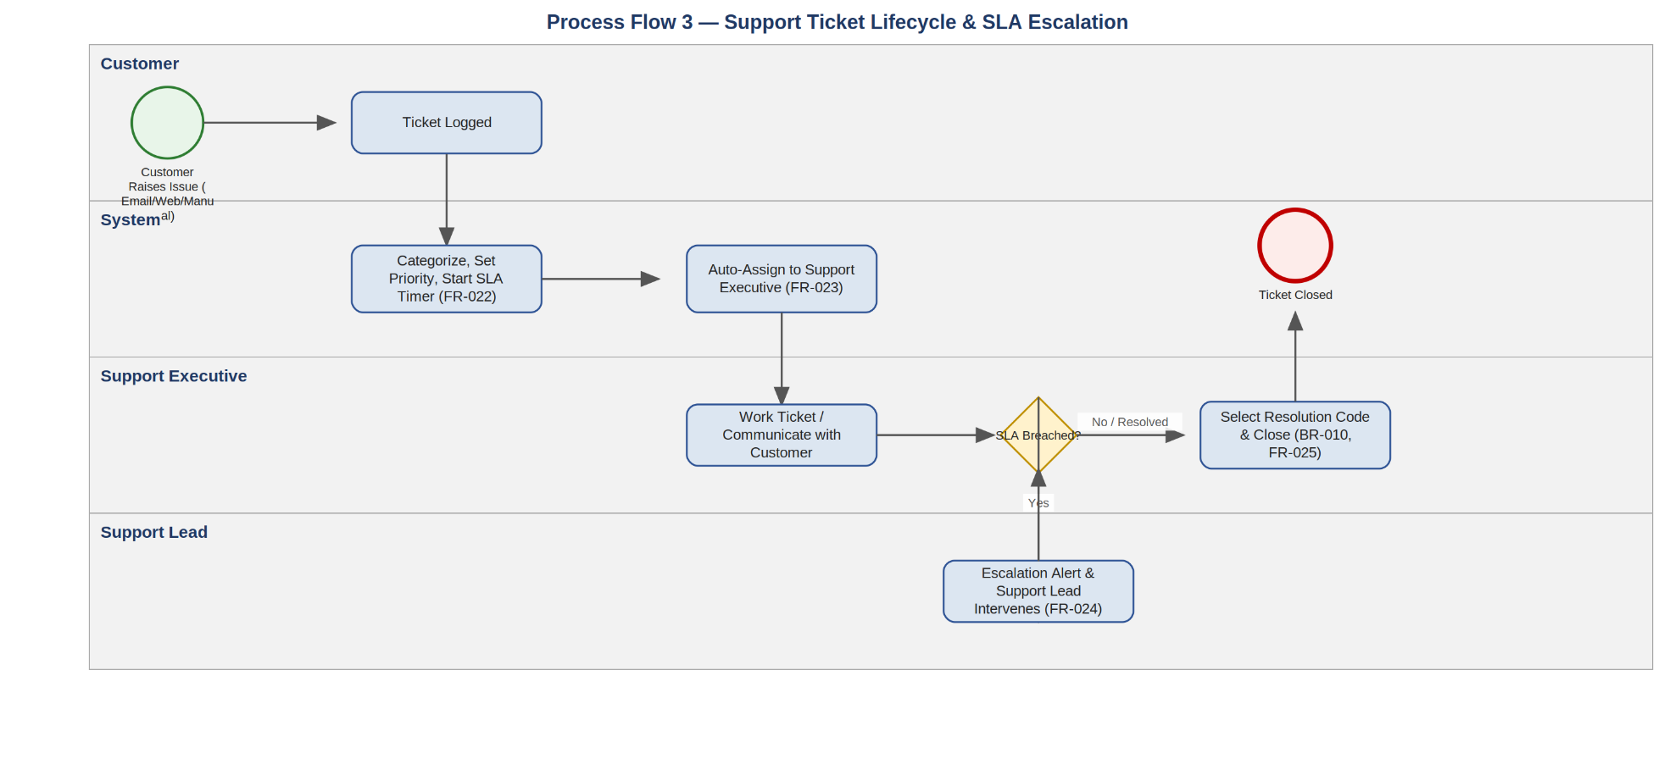

Walkthrough
- Every ticket is categorized and prioritized at creation, which starts its SLA timer immediately (FR-022).
- Assignment is automatic based on category/priority rules (FR-023), removing the manual triage step.
- If a ticket breaches its SLA before resolution, the Support Lead is alerted and pulled in — this is the loop back into active work, not a dead end.
- Closure is blocked until a Resolution Code is selected (BR-010), which is what keeps the Support Ticket Report meaningful.

4. Campaign-to-Lead Nurturing (Marketing)
Covers FR-016, FR-017, FR-019, FR-020, FR-003 — how a Marketing-sourced prospect becomes a Sales-ready lead.
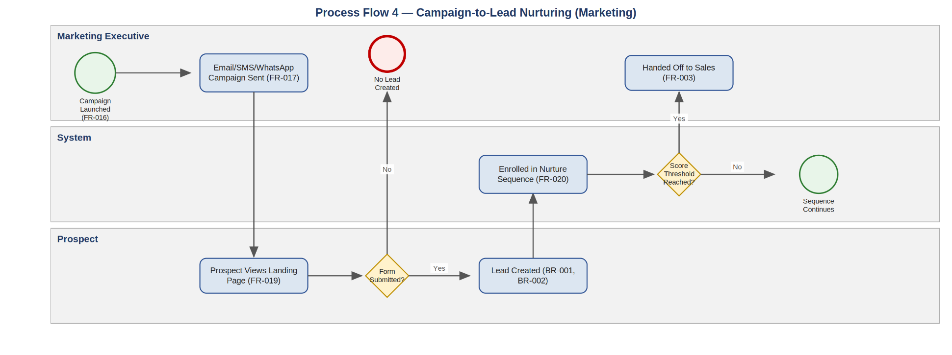

Walkthrough
- A campaign drives traffic to a landing page; only a form submission creates a Lead record (subject to the same BR-001/BR-002 rules as any other lead source).
- New leads enter a nurture sequence rather than going straight to Sales, so Marketing has a chance to warm them up.
- Lead Score is recalculated as the sequence runs; once it crosses the configured threshold, the lead is handed off to Sales (feeds directly into Diagram 1).
- Leads that don't hit the threshold stay in nurture rather than being dropped — this is the loop marketing uses to keep working a slow-moving prospect.

