Laboratory work 3

Task:
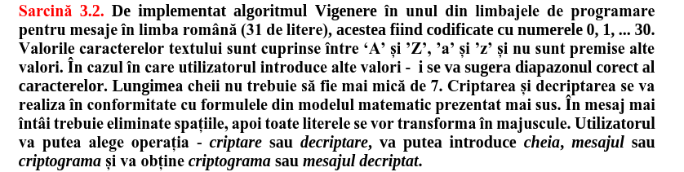
Code:
import sys

# Romanian alphabet of 31 letters
ALPHABET = [
'A', 'B', 'C', 'D', 'E', 'F', 'G', 'H', 'I', 'J', 'K', 'L', 'M',
'N', 'O', 'P', 'Q', 'R', 'S', 'T', 'U', 'V', 'W', 'X', 'Y', 'Z',
'Ă', 'Â', 'Î', 'Ș', 'Ț'
]
ALPHABET_MAP = {ch: idx for idx, ch in enumerate(ALPHABET)}

def clean_message(msg):
msg = msg.replace(' ', '').upper()
for ch in msg:
if ch not in ALPHABET_MAP:
print("The message must contain only Romanian letters (A-Z, Ă, Â, Î, Ș, Ț).")
sys.exit(1)
return msg

def clean_key(key):
key = key.replace(' ', '').upper()
if len(key) < 7:
print("The key must contain at least 7 characters.")
sys.exit(1)
for ch in key:
if ch not in ALPHABET_MAP:
print("The key must contain only Romanian letters (A-Z, Ă, Â, Î, Ș, Ț).")
sys.exit(1)
return key

def vigenere_encrypt(msg, key):
encrypted = []
key_len = len(key)
for i, ch in enumerate(msg):
m_idx = ALPHABET_MAP[ch]
k_idx = ALPHABET_MAP[key[i % key_len]]
c_idx = (m_idx + k_idx) % 31
encrypted.append(ALPHABET[c_idx])
return ''.join(encrypted)

def vigenere_decrypt(cipher, key):
decrypted = []
key_len = len(key)
for i, ch in enumerate(cipher):
c_idx = ALPHABET_MAP[ch]
k_idx = ALPHABET_MAP[key[i % key_len]]
m_idx = (c_idx - k_idx + 31) % 31
decrypted.append(ALPHABET[m_idx])
return ''.join(decrypted)

def main():
op = input("Choose operation (c for encrypt, d for decrypt): ").strip().lower()
key = clean_key(input("Enter the key: "))
if op == 'c':
msg = clean_message(input("Enter the message: "))
print("Ciphertext:", vigenere_encrypt(msg, key))
elif op == 'd':
cipher = clean_message(input("Enter the ciphertext: "))
print("Decrypted message:", vigenere_decrypt(cipher, key))
else:
print("Invalid operation. Choose 'c' to encrypt or 'd' to decrypt.")

if __name__ == "__main__":
main()

result:

