Intro (3D Object Detection – Problem Statement)

State of the art of the project (Why the project is important, what will it allow)

Tasks, concept and results (Chapter: Methodology, i.e. Machine Learning approaches from dataset to network choice to results and evaluation, include the workflow machine learning diagram with yes forward and no back to a previous step, Chapter: literature project specific information, pointnet diags) (following up the methodology with the results Chapter)

Short summary and outlook (chapter results and future)

**Chapter 1: Introduction**

**Introduction**

The problem of object detection and classification is an inherent issue in Computer Vision. IBM defines Computer Vision as “a field of artificial intelligence (AI) that enables computers and systems to derive meaningful information from digital images, videos and other visual inputs, and based on those inputs, it can take action.” [IBM]

To address this problem, earlier approaches included feature extraction to identify objects, which are time consuming and highly manual. A later approach that emerged is CNNs (Convolutional Neural Networks) which is a more scalable approach that leverages methods from Linear Algebra, such as Matrix Multiplication to identify patterns in an image.

Within the standard 2D object detection, the information and the features used include edges and RGB colors [IBM] which abstracts the features (corners and edges as well as RGB channels). To position these objects, which is a task under the umbrella of object detection, a bounding box is regressed, as follows up, an image would be an input and the output if a box or a box coordinates that are around or correspond to this object (a car in an image for example) [MaxPlank].

**3D Object Detection:**

Recently, higher level applications like scene understanding and object positioning require a richer form of information such as Point Clouds, in which the regression 3D box provides not only viewpoint information, but also information about the position of the object in the 3D space [MaxPlank].

3D information is available as a set of vectors containing the x, y and z pairs representing the vertices that make up the point cloud. As the data in the pointcloud is random, and is hard to learn from, many proposals preprocess the points to voxel grids as views before network consumption which renders the data voluminous as well as introducing transformations that may change the original data [PointNet]. [VoxelNet] is an example of such approaches. Other appraches include working on the 2D images using CNNs to extract features, as the work with 2D images has been far more extensive than working with point clouds. After that, a 2D box is regressed to give the object’s position, which is further relayed to obtain the box’s 3D coordinates or the object’s z position, an example would be the works of [MobileNetSSD with Realsense Repo][MobileNetSSD repo]

Other approaches propose working directly on the pointcloud, feeding it to the network and performing the classification and/or the detection task [PointNet][PointNet++][VoteNet][BoxNet]. Though the nature of the pointcloud is random and lacks order, these approaches, almost all of them, make use of learning the pointcloud features with a modification in the network, specifically, incorporating symmetrical functions to preprocess the data for learning allowing for the learning to take place from directly consuming the pointcloud [Pointnet][Pointnet++] and they oftentimes employ the architecture of pointnet++ as a backbone to the actual network [H3DNet] [PointNet++][VoteNet][BoxNet].

**Overview of the report:**

In chapter 2 the main problem will be discussed as well as the issues related to 3D object detection in general, chapter 3 will go through project specific literature, adapted proposals and current state of the art. In chapter 4 the proposed methodology will be discussed and chapter 5 will conclude the report with the results discussion and future work.

Online REFS:

[IBM] <https://www.ibm.com/cloud/learn/convolutional-neural-networks#toc-types-of-c-yL2bT7qZ>

[MaxPlank] <https://www.mpi-inf.mpg.de/news/spotlights/understanding-images-videos/3d-object-detection/>

**Chapter 2: Problem Statement**

**Problem Description:**

The main goal is to detect and localize 3D structures (KLTs) such that the information is available to a robot manipulator equipped with a gripper and a 3D Stereo-camera. The structures are set upon one another and have different categories depending on the objects inside, in which case the objects vary from C-Parts (fittings, screws, etc.) to dampers and other automotive parts. End goal is to develop a proof of concept, utilizing tools such as deep learning and 3D object detection to confirm the validity of the approach and culminate an in-house knowledge about the approaches available and their viability.

**Setting:**

The setting incorporates a manipulator, an end-effector with a greifer and an intel RealSense D435, the information from the camera are extracted, processed by a computer which throws out data fed to the Universal Robot manipulator as commands, which after receiving the position and class information acts accordingly. Fig. () shows the robot manipulator and Fig. () shows the Intel RealSense Depth (stereo-vision) camera.

**Manipulator + Greifer (Pictures)**

**Intel RealSense D4 depth camera**

**Targeted Detection Pipeline:**

The detection pipeline includes gathering the data, investigating the state-of-the-art, passing the state of the art to the data gathered, such that the targeted Network is able to learn from this data:

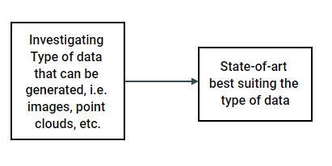

**Data à Network à Training**

After training the network, and for the purpose of testing the employed the state-of-the-art, testing data is prepared in a similar manner as the training data and the necessary code refactoring and edits to the code are carried out, proper metrics are then set, such that in the end, weakness points are determined, and necessary improvements carried out.

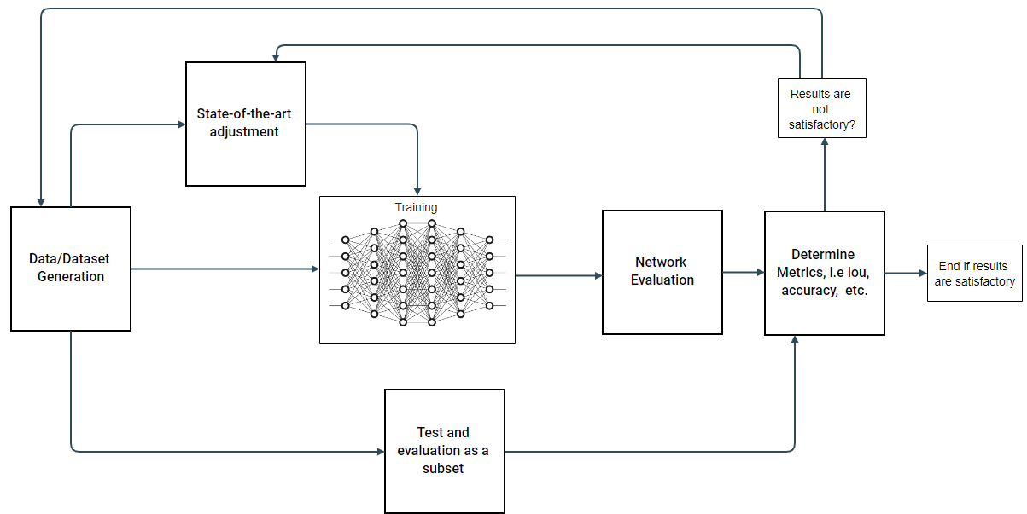

**Testing à Network Training Checkpoint à Inference**

After the training has been carried out, the checkpoint where the network has stopped training, i.e. the last training epoch, is saved and an inference is carried out using new novel data. Additionally the network, is the state-the-art allows it, can be tested in real-time

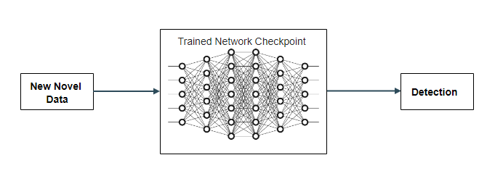

Chapter: Implemented States of the art: votenet – etc

**Chapter 3: State-of-the-art , deep learning and transfer learning**

**MobileNets:**

MobileNets employ a set of depth-wise separable convolutions, with the main point of reducing the computation in the first few layers [MobileNets]. The structure is mainly depthwise separable convolutions, except for the first layer which is a full convolutional network. This structure is carried out to ensure the networks ability to be employed on mobile and embedded devices carrying out inference/realtime inference on the spot, considering the limited set of computational and memory available in such devices. [MobileNets]. Fig. () is an example of vanilla convolutions.

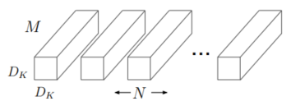

Fig. () [MobileNets]

In MobileNets the depthwise seperable convolutions are applied in 2 steps [MobileNets]:

1. A single Dk xDk x 1 input filter to each channel [MobileNets], as illustrated by Fig. (2)

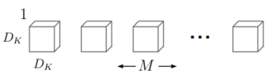

Fig. (2) [MobileNets]

1. A pointwise M x 1x 1 convolution to combine the outputs of the previous filter [MobileNets]

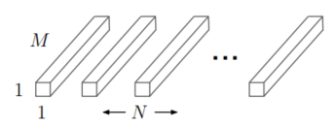

Fig. (3) [MobileNets]

MobileNets which apply 3x3 depthwise seperable convolutions use 8-9 times less computational power, comprated to regular convolutions with a slight reduction in accuracy [MobileNets].

The work of MobileNets is based on [Xception], which introduces the depthwise seperable convolutions, Fig. (4) illustrates the general structure applying both depthwise and pointwise convs.

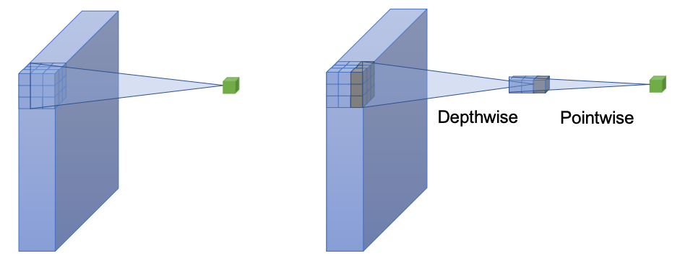

Fig. (4) [Xception]

Fig. (5) demonstrates the architecture of MobileNetV1 according to [MobileNetV1-Figure-Paper; see lit in praktikum stuffs for reference pdf]

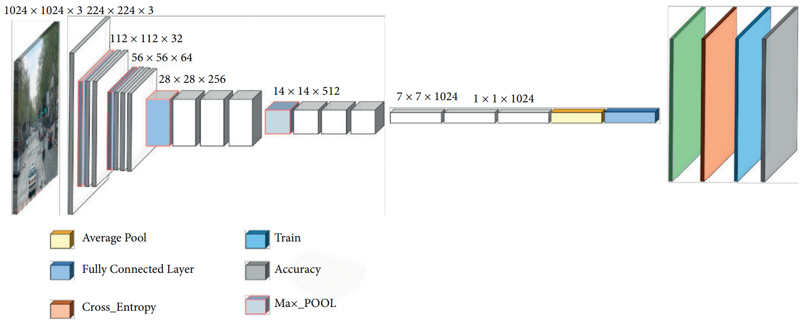

Fig. (5) [MobileNetV1-Figure-Paper; see lit in praktikum stuffs for reference pdf]

MobilenetV1:

MobilenetV2:

*is based on an inverted residual structure where the shortcut connections are between the thin bottleneck layers. The intermediate expansion layer uses lightweight depthwise convolutions to filter features as a source of non-linearity. Additionally, we find that it is important to remove non-linearities in the narrow layers in order to maintain representational power*

The structure of MobileNetV2 differs from that of MobileNetV1. It is based on the concept of inverted residuals, where a shortcut connection is established between bottleneck layers. Bottleneck layers, known as projection layers, and as the name suggests, reduce multi-layer tensors. An intermediate layer is also introduced, it uses the lightweight depthwise convolutions to filter features as a source of non-linearity. Additionally, the authors remove non-linearities in the narrow layers and the reasoning behind it is to maintain the features that are representative [MobileNetV2].

Fig. (6) demonstrated the general architecture of MobileNetV2 according to [https://machinethink.net/blog/mobilenet-v2/]

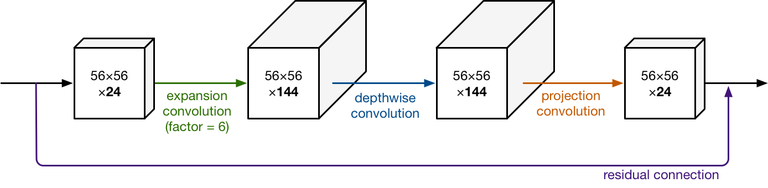

Fig. (6) MobileNetV2 general architecture according to [<https://machinethink.net/blog/mobilenet-v2/>]

Online REFs:

[MobileNetV2 Fig.] <https://machinethink.net/blog/mobilenet-v2/>

VoteNet:

1. Hough Voting and the Hough Transform:

Introduced in the late 1950s, it is originally used to detect patterns in a set of points in some arbitrary coordinate system, but extends this pattern detection to peak detection in the parametric space.

It achieves this by finding the parameters that correspond to these patterns [JIllingeorth-ASurveyoftheHoughTransform]. The patters are transformed into another space in which the derived features will be mapped in a compact way [JIllingeorth-ASurveyoftheHoughTransform]. Hence the HT transforms the detection problem into a space where they can more easily solved problem of peak detection [JIllingeorth-ASurveyoftheHoughTransform].

Furthermore, in the context of object detection the Hough Voting or the Hough Transform is used to detect abnormal or complex objects in image patches. [24] introduced implicit shape methods, other work used it for plane extraction from 3D point clouds and pose estimation [VoteNet]. Hough Voting has also been combined with learning techniques . (all paragraph [VoteNet], cite it everywhere outside of the part with [24] and [JIllingeorth-ASurveyoftheHoughTransform]).

[24] Bastian Leibe, Ales Leonardis, and Bernt Schiele. Robust object detection with interleaved categorization and segmentation. International journal of computer vision, 77(1- 3):259–289, 2008. 2, 3

1. Pointnet:

PointNet is a unified approach that consumes point clouds directly as inputs and outputs labels and/semantic labels, labels are generated per point in the point set. The authors of pointnet argue that it has a simple architecture. Each point is processed individually as a coordinate (*x; y; z*), the paper leverages the use of symmetric functions, such as max pool, and including an MLP (Multi Layer Perceptron). The network then learns special relationships between interesting points in the given input set, the selection grounds are embedded in the network parameters. The final layers are fully connected layers that aggregate the learned features into a ‘global’ descriptor for the shapes in the case of shape classification and the point labels in the case of segmentation. [PointNet]

Fig. (7) illustrates the architecture of PointNet according to [PointNet]

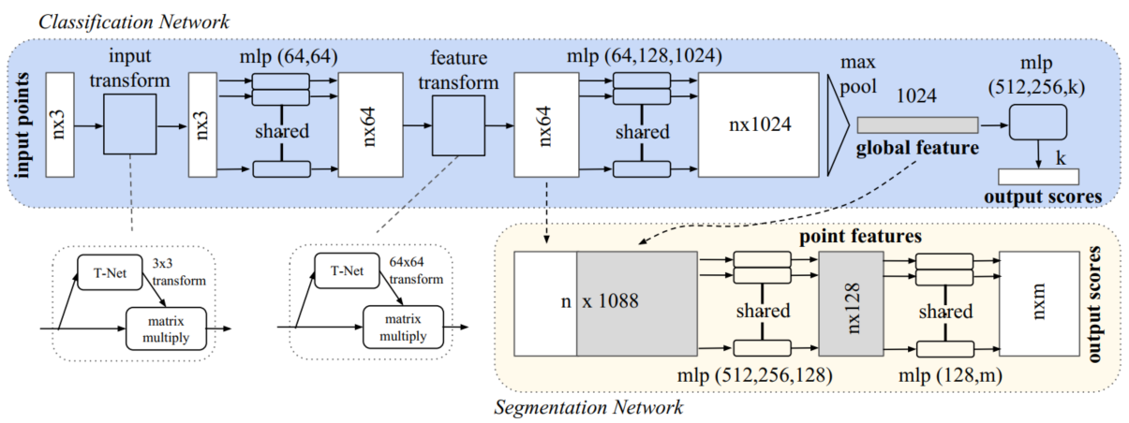

Fig. (8): Architecture of PointNet

1. PoiNet++:

One of the problems that lead to the inception of PointNet++ is that PointNet does not capture local structures into features, it rather constructs the relationship function based on the whole consumed point cloud, regardless of the individual and distinct geometries embedded within the point cloud. CNNs takes datapoints in grid-like shapes and is able to capture features in different scales and among different resolutions. The field receptivity of the neurons are proportional to weather the levels are low or high, the authors of PointNet++ argue that abstracting local patterns in a more explicit way allows for better generalization regarding the network parameters when the network is shown net data. [PointNet++]

PoitNet++ hence processes points hierarchically, the points are partitioned according to a defined distance metric, and the features are extracted from these points in a manner similar to that of CNNs, these features are then aggregated further into a larger point feature hierarchy, and so on the process is undertaken from the bottom up until the whole point cloud is enveloped in-whole. [PointNet++]

The generation of the overlapping in the point set is first by selecting centroids of the areas of interest with the aid of the FPS (Farthest Point Sampling) algorithm. [PointNet++]

Fig. (9) demonstrated the architecture of PointNet++ according to [PointNet++]

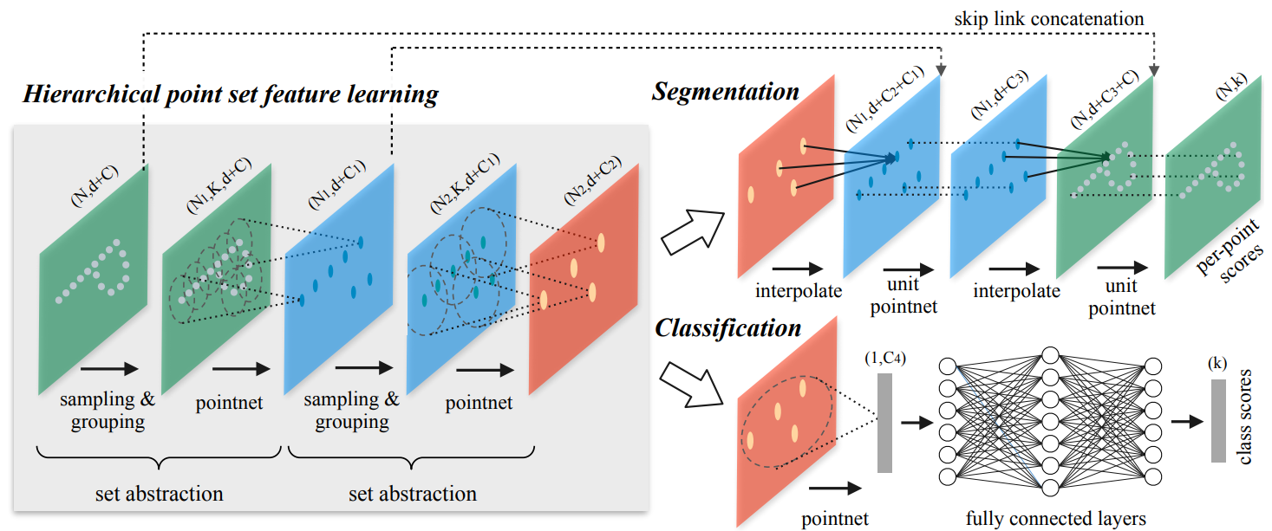

Fig. (9) Architecture of PointNet++

----Talk about the Fig. (9) in detail and possible include additional figs

VoteNet:

VoteNet leverages PointNet++, as PointNet++ processes the point cloud as it is and learns features in the point cloud structures without having to covert it to regular structures. This consequently indicates that the information is taken as is, rather then partly losing information in the conversion process.

A standard approach to apply PointNet++ is to propose 3D bounding boxes is to follow suit with the standard box proposal methods by proposing the boxes that has dense objects within. This approach is not favourable in 3D proposals for a few reasons, firstly, the inherent sparsity in point clouds and secondly, depth sensors tend to capture only the surface of the objects in the scene, so the centers of the objects are usually spatially in a void place in that point cloud. Herein comes VoteNet to leverage Hough Voting and customize to establish a relationship between the centers and the points, which after aggregation are used to generate bounding box proposals.

The input is first sampled through the backbone network a set of seed points is sampled, from which feature are derived and votes are generated. The votes, as aforementioned are targeted to indicate an object’s bounding box’s center location and to generate the bounding box proposals they are clustered and aggregated through a learning module.

Chapter 4: Implementation, tools and data type as well as preparation

Chapter 5: Results, would be short I think