基于softcast算法的无线视频传输发送端基带系统设计规格与定点算法说明书

I. 功能概述
本文描述了基于softcast算法的无线视频传输发送端基带系统的设计。为了适应视频广播场景需求，发送端采用了伪模拟的方案，即DCT变换后的图像数据不经过任何编码、调制，直接经过OFDM的IFFT变换后发送。为了使接收端可以最佳恢复出原始发送的图像数据，DCT变换后的数据要经过功率重分配以压缩数据量并保证最佳接收恢复效果。

定点数表示约定
后续文中所有定点数表示约定如下：（u/s, 总位宽, 小数部分位宽），其中u/s表示有符号数还是无符号数，u表示无符号数，s表示有符号数。文中所有的截位处理，如未做特别声明均以round（四舍五入）方式实现。
例子
1）(u,8,0)表示8位无符号数，其中小数部分位宽为0（即8位全部是整数部分）
2）(s,16,10)表示16位有符号数，其中小数部分10位，符号位1位，其余即为整数部分位宽

(Algorithm overview and description; missions and tasks of the module)

II. 模块微架构

发送端的模块微架构如下图所示：

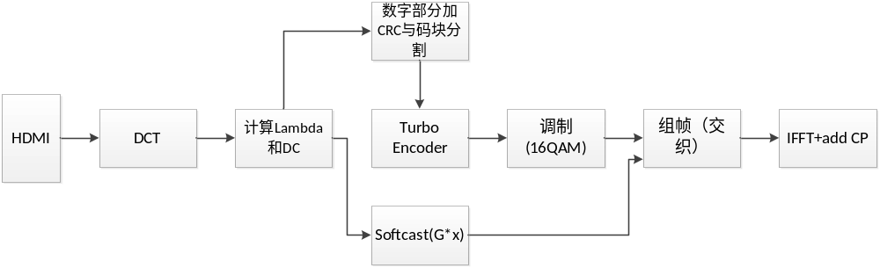

整个发送端得流程如下：
1）从HDMI口以32x32像素分块输入的8bit数据位宽的图像数据经过2D-DCT变换得到每块32x32的DCT系数；
2）将变换后的32x32的DCT结果以L型chunk分为15块分别求取每块平均功率lambda后再将一行所有DCT块（960x640分辨率下每行有30=960/32个DCT块）对应的lambda分别求取平均得到每行15个lambda值；
3）根据lambda计算每块的功率分配系数gi，并对DCT变换结果进行softcast调制（S=G*x）；
同时，4）将每行15个平均lambda以及每行所有块的DC（直流）系数定点取整数部分拼接后按预设的码块长度进行分割并添加CRC；
5）添加CRC后的码块经过1/3码率的turbo编码后进行16QAM调制；
6）调制后lambda值和DC系数与softcast软值一同组帧、进行交织并添加导频和preamble；
7）最后经过4096点的IFFT并添加循环前缀（CP）后输出，完成发送端的处理。

III. 设计需求规格

(A)无线系统规格
基本规格
传输带宽：40MHz
采样率：61.44MHz
OFDM子载波数：4096
子载波间隔：15kHz = 61.44M/4096
有效子载波数：2520 ~= 4096*40/61.44
CP（循环前缀）长度：128样点
符号长度：68.75us = (4096+128)/61.44MHz

帧格式
无线帧长度：30符号 = 2062.5us
导频间隔：每6子载波，每3符号，导频分布如下图所示：
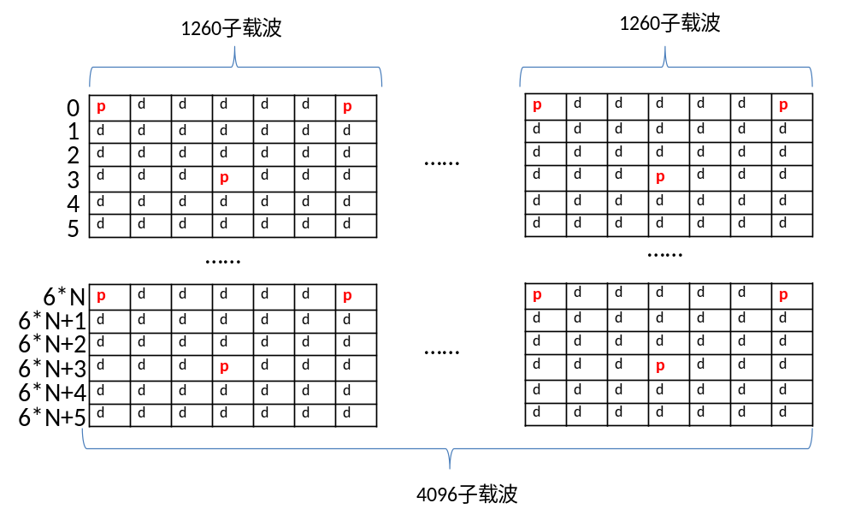
同步序列：同步序列位于每个无线帧的第2和第3个符号，每个符号中占512个子载波，如下图所示：

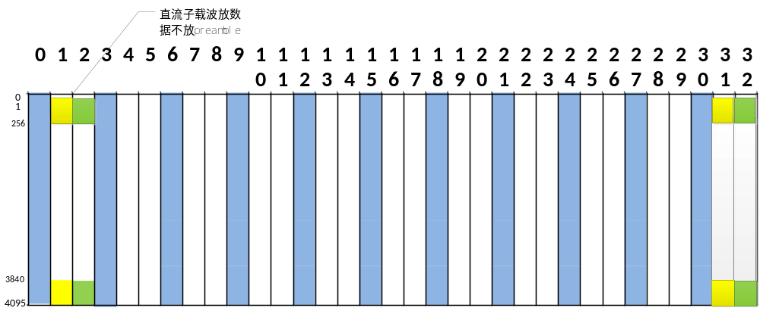

注意：每个symbol的第0个子载波(直流载波)放数据，不放preamble序列

每无线帧总共可用载波数：70376 = 30*2520 – 1024(preamble) – 420*10（导频）

(B)图像传输需求
色度格式：YUV 4:2:0
Y分辨率：960x640
UV分辨率：480x320
帧率：30fps x 2路(VR)

(C)系统需求满足度估算
估算前提
数字部分：16QAM调制、1/3码率、码块长度200、CRC长度16、每32行图像数字部分编3个码块
伪模拟部分：每两个像素的伪模拟值组成一个I/Q符号
估算每32行图像占用子载波数
数字部分：495ca = ((200+16)*3+12)/4*3block
模拟部分：15360ca = 30*512
每32行图像总共占用子载波数：15855 = 495 + 15360
每帧图像总共需要占用子载波数：951300 = (20+10)*2*15855
所需无线帧数：14帧 = 951300 / 70376
可达帧率：34fps = 1s/14*2062.5us

IV.子模块定点算法说明
(A)DCT
DCT模块对HDMI按行输入的YUV数据先分成32x32的块(block)，再对每个块进行二维DCT变换。
DCT变换与离散傅里叶变换类似，是离散余弦变换（Discrete Cosine Transform）的缩写。即采用一组DCT系数来表示原始序列的方法，离散余弦变换是在数据压缩中常用的一种变换。
DCT的定义如下式所示：
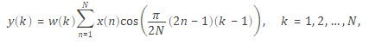
其中
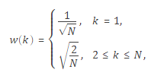
N为x序列的长度。
定点说明：
DCT输入x为32x32的矩阵，矩阵每个元素为位宽8bit，范围[0,255]的无符号数表示为x(32,32)—(u,8,0)。
首先对输入矩阵所有元素-128，得到范围[-128，127]的有符号数x(32,32)—(s,8,0)。
然后，对x矩阵进行2维DCT变化，定点方案采用定点化后的变换矩阵A分别左乘和右乘输入矩阵x实现，即Y = AxA^{T}。
其中变换矩阵A的定点表示为(s,8,6)，x经过2次矩阵乘之后得到Y—(s,34,12)。
最后要截掉小数位，并且根据公式，变化后的系数要乘1/N（k不为1时的跟号2已经乘到变换矩阵中去了），此处N=32。因此，总体将Y右移17位，并且饱和到16bit得到Y—(s,16,0)。

(B)Lambda计算
Lambda计算模块将变换后的32x32的DCT结果以L型chunk分为15块分别求取每块平均功率，L型chunk划分如下图所示：
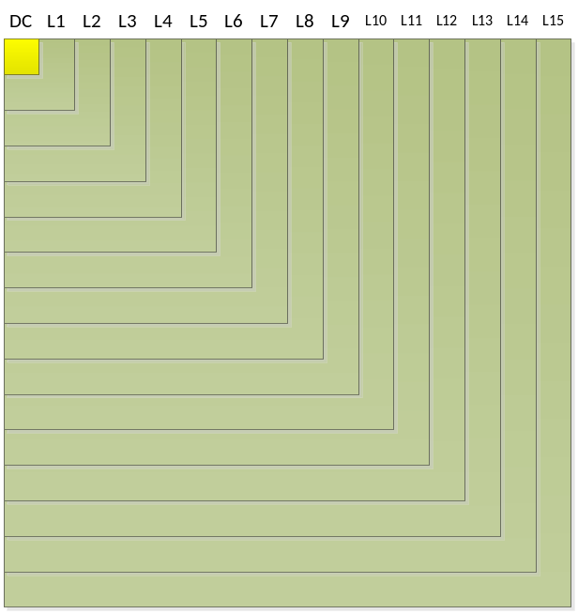

其中，每块chunk的行、列分界点可用向量[1,3:2:29,32]表示。每个block的第1行第1列Y(1,1)为DC分量，Y(2:3,2:3)元素组成的L型chunk用于计算Lambda1；Y(4:5,4:5)元素组成的L型chunk用于计算Lambda2，依此类推。最后一个chunk由Y(30:32,30:32)组成，用于计算chunk15。
每个Lambda的计算公式为Lambda(i)=mean(|Y(chunk(i))|²)，即，将每个lambda对应chunk内的元素平方后在chunk内求平均。
定点方案：
输入DCT变换后Y—(s,16,0)，平方后得到(u,32,0)，中间不饱和，一个chunk内最多183个元素加和得到(u,40,0)，加和结果求平均需要除以183，转化为乘2865后右移19bit，饱和得到(u,24,0)。再将30个块的15个lambda分别求平均结果依然为(u,24,0)。
(C)Softcast
Softcast模块根据lambda计算每块的功率分配系数gi，并对DCT变换结果进行softcast调制（S=G*Y）。每块的功率分配系数gi的计算公式如下：
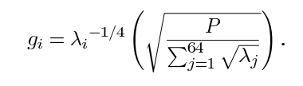
定点方案：
输入Lambda—(u,24,0)。
1、先用cordic算法（cordic的Q值设为20）对每个Lambda求平方根，得到(u,12,0)。
2、再对得到的根号Lambda按每个lambda对应chunk的元素个数加权求和，得到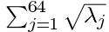—(u,22,0)。用计算根号lambda同样的cordic算法对西格玛开根，得到(u,11,0)。
3、计算lambda的4次根，对前面计算得到的根号lambda—(u,12,0)继续用cordic算法开根，得到(u,6,0)
4、用除去DC系数的block平均功率sqrt(1023)—(u,21,16)除以2、3步骤结果的乘积(u,17,0)，并保留16位小数得到gi—(u,16,16)
5、最后，用gi—(u,16,16)乘上前面DCT变换得到的Y—(s,16,0)，得到S—(s,32,16)，并饱和截位到(s,16,9)。

(D)数字部分CRC与码块分割
数字部分取前面每行15个平均lambda—(u,24,0)以及每行所有块的DC（直流）系数，DC系数—(s,16,0)。先进行位宽压缩，然后进行拼接。根据matlab仿真统计数字部分的动态范围，15个lambda的压缩位宽分别设为[18 15 14 13 14 15 13 12 13 14 16 12 11 10 10]，DC系数位宽设为13bit。这样整个一行的数字部分拼接后的位宽为200+30*13=590bit。补10个0到为600bit后分割成3个码块，每个码块200bit。再对每个码块添加16bit CRC校验位后得到3个216bit码块。CRC采用生成多项式为g(z)=z^16 + z^15 + z^2 + 1的多项式生成。

(E)Turbo编码
添加CRC后的码块经过1/3码率的turbo编码输出编码后码块长度为216*3+12（尾比特）= 660bits，turbo编码采用的卷积码生成多项式和交织索引参见matlab仿真代码。

(F)16QAM调制
将编码后得数字部分码块按归一化后的能量进行16QAM星座点调制，星座点采用格雷码方式映射，详见matlab仿真代码。调制后每个码块占用660/4=165子载波。
定点方案
为了在IFFT计算时和模拟部分保持一致，数字调制的结果采用和softcast输出同样的定点方案—(s,16,9)

(G)组帧
调制后的数字部分与softcast输出的伪模拟信号一起按行进行组帧。伪模拟输出为实数，在组帧模块中，每2个伪模拟数据组成一个复数信号占用一个OFDM子载波。一行30个block的伪模拟数据共占用30*512=15360个子载波。调制后的数字部分共有3码块，每码块占165个子载波，与伪模拟部分拼接后共占15855个子载波。为了数字部分码块对抗频率选择性衰落，拼接后的前2520子载波进行一次行列交织，交织行列分别选择为15行x 168列，如下图所示。
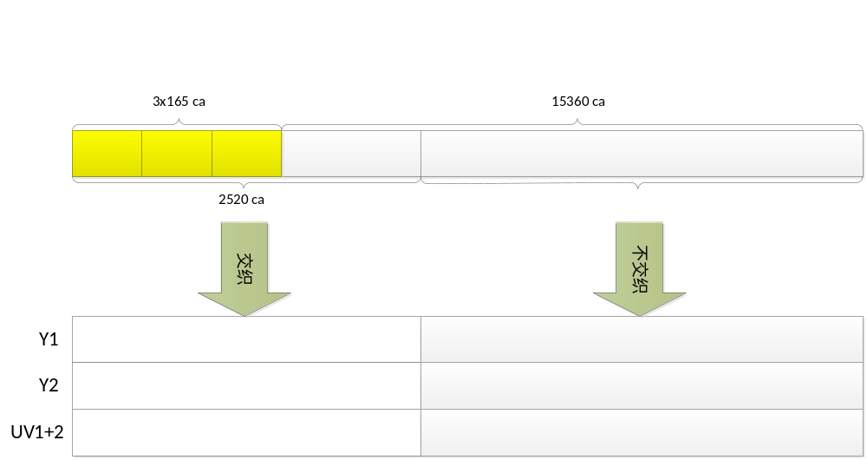

组完的子载波数据按照2行Y分量1行UV分量的顺序装入无线帧中（需跳过导频和preamble子载波）。一个无线帧只装入4行组帧数据，剩余子载波保留用于未来音频等数据传输。一个图像帧总共需要60/4=15帧无线帧进行传输。

(H)IFFT
对组帧后得数据进行4096点的IFFT变换转换到时域，并将最后128样点作为循环前缀，放置到4096样点之前组成4224样点数据送往中射频板，完成整个发送端处理。

定点方案：待定。

V.定点测试向量抽取说明
基于定点仿真平台的测试向量的抽取说明如下：
所有测试向量按照图像帧分开存放，每抽取点上每图像帧测试向量存成一个.txt文件。各抽取点说明如下：
Dct_in_y：DCT输入y分量像素值，每图像帧32x32x600元素。
Dct_in_uv：DCT输入uv分量像素值，每图像帧32x32x300元素。
Dct_out_y：DCT输出y分量DCT系数，每图像帧32x32x600元素。
Dct_out_uv：DCT输出uv分量DCT系数，每图像帧32x32x300元素。
Lambda_y：y分量每图像块15个lambda值，每图像帧15x600元素。
Lambda_uv：uv分量每图像块15个lambda值，每图像帧15x300元素。
Lambda_y_avg：y分量每块行15个平均lambda值，每图像帧15x20元素。
Lambda_uv_avg：uv分量每块行15个平均lambda值，每图像帧15x10元素。
Codedata_y：Y分量每块行数字部分编码前数据，每图像帧600x20bits。
Codedata_uv：UV分量每块行数字部分编码前数据，每图像帧600x10bits。
crcdata_y：Y分量每块行数字部分编码前添加CRC后数据，每图像帧216x60bits。
crcdata_uv：UV分量每块行数字部分编码前添加CRC后数据，每图像帧216x30bits。
encodedata_y：Y分量每块行数字部分Turbo编码后数据，每图像帧660x60bits。
encodedata_uv：UV分量每块行数字部分Trubo编码后数据，每图像帧660x30bits。
moddata_y：Y分量每块行数字部分16QAM调制后数据，每图像帧495x20元素。
moddata_uv：UV分量每块行数字部分16QAM调制后数据，每图像帧496x10元素。
s_y：Y分量能量分配后的伪模拟数据，每图像帧32x32x600元素。
s_uv：UV分量能量分配后的伪模拟数据，每图像帧32x32x300元素。
s_y_complex：Y分量能量分配后的伪模拟数据两两组成复数，每图像帧15360x20元素。
s_uv_complex：UV分量能量分配后的伪模拟数据两两组成复数，每图像帧15360x10元素。
Gi：每图像块15个功率分配系数，每图像帧15x900个元素。
Ifft_in：组帧后送给ifft的数据（混合了y/uv），每图像帧4096x240个元素（8个无线帧）。
Ifft_out：ifft输出数据，每图像帧4096x240个元素（8个无线帧）。
Ifft_cp：ifft输出加循环前缀数据，每图像帧4224x240个元素（8个无线帧）。

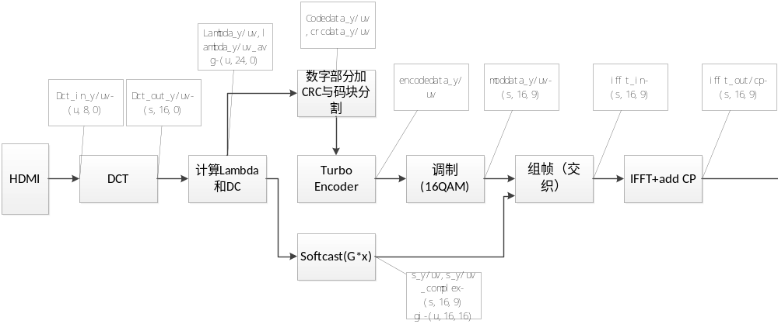
(B) Block Diagrams and Description

(Block diagram – in hierarchical form for complicate designs)
(Describe what each block does; and the thoughts how and why it is micro-architected so)

(C) State Machine Diagram and description

(Major state diagrams in your design, and describe/explain the states and branch conditions associated with them)

III. Register Map

(A) Address Range

(B) Register Description

IV. File Structure and Module Hierarchy

(Tabulate modules in each .v file and sub-smodule dependency for module hierarchy.) (Brief description of each module – what the module does.)

V. Top I/O Ports and Description

(A) Inputs

(Input pins including bit width and brief description)

(B) Outputs

(Output pins including bit width and brief description)

VI. Macrocell List and Flip-Flop Registers

(A list of all SRAM, RF, ROM cells, including information pertinent to the cells)
(A list of all IPs licensed from outside, including information pertinent to the IPs)
(Total number of flip-flop registers in each clock domain)

VII. Timing Diagram

VIII. Functional Verification

(How is the test bench set up? – including how to clone external components used with your design in verification)
(What test cases need be verified? Description of test cases and verification status)
(What is supposed to be verified and is not verified? Why?)

IX. Performance Related

(For example, how many cycles to process I, P, B frames? …. etc.)
(Clock requirements: how fast is the clock?)
(Combinational, noncombinational, memory area report from synthesis – including synthesis library and environment setup)

Appendix A: Asynchronous design

(if applicable)

Appendix B: Built-in test logic

(if applicable)

Example

I. Functional Description

I2S is a synchronous data transmission scheme for audio PCM. Each I2S channel carries 2 channels of audio data. The I2S signal is shown in Fig. I.1. It consists of 3 pins: bit clock, word clock, and data bit. Each bit clock cycle represents a data bit, and each word clock cycle signals two words each of which represents the PCM value of an audio channel.

The purpose of the module i2s is to capture the audio PCM data from the I2S input ports, and write the captured data to external SDRAM via an internal SDRAM controller. It will also interrupt an on-chip CPU every time when a programmable number of audio samples are captured. In addition to compliant I2S signaling (in Figure 1), the module i2s can also capture pseudo-I2S signal where word clock is deviated from the nominal by 1 bit clock cycle and/or data bit order is reversed (least significant bit first).

……….

II. Module Micro-architecture

(A) Design Requirement

The audio sampling rate ranges from 32 kHz to 192 kHz, and the number of bits per sample (word) from 12 bits to 32 bits. Therefore the bit clock is as high as 192k x 32 x 2 = 12.288 MHz, and as low as 32k x 12 x 2 = 768 kHz. The i2s module is required to deal with all cases.

To facilitate audio processing after audio samples are captured, the audio samples are stored in separate left and right buffers in SDRAM where each sample (word) is 32 bits/word.

The module is required to begin to capture the next available complete left channel sample after it is notified by CPU. No incomplete audio sample is allowed to store in SDRAM.

………..

(B) Block Diagram and Description

The top-level block diagram is illustrated in Figure II.1. The i2s_capture is a block that captures the audio PCM data by using bit clock as the capturing clock and creates a control signal when a word is completely captured. The i2s_control is a block that performs cross clock domain synchronization of the control signal from i2s_capture and …….

The i2s_capture is described in Figure II.2. …………

The i2s_control is illustrated in Figure II.3 …………

…………….

(C) State Machine Diagram and Description

Shown in Figure II.4 is the state diagram used for audio sample capture. The state is increased by 1 after capturing a bit. When the channel transition strobe is asserted, the state is back to initial state. …….

In module i2s_control, the state diagram that is used to process the SDRAM services into left and right channel buffers of the SDRAM is shown in Figure II.5. The state is out of idle state when the number of audio samples in the internal SRAM buffer reaches to ½ full………..

…………….

III. Register Map

(A) Address Range: 32’h00000000 – 32’h00000007 (8 addresses)

(B) Register Description

Address | Register | Bit Field | Description | Specification | Default
32’h00000000 | reg0 | [31:30] | Input type | 2’d0=I2S, 2’d1=P0-I2S,  2’d2=P1-I2S, 2d3=P2-I2S | 2’d0
 |  | [29:24] | …. | ….. | …..
 |  | [23:0] | reserved |  | 24’h111111
32’h00000001 | reg1 | [31:0] | CPU interrupt duration | Interrupt every (reg1+1) samples | 32’d2047
…. | …. | …. | …… | ….. | …..
32’h00000005 |  |  | reserved
32’h00000006 |  |  | reserved
32’h00000007 |  |  | reserved

IV. File Structure and Module Hierarchy

The design consists of 7 files which contain the modules as follows:

i2s_top.v: i2s_top
i2s_capture.v: i2s_capture
i2s_control.v: i2s_control
i2s_ramctl.v: i2s_ramrdctl
i2s_ramwrctl
i2s_ram.v: i2s_ram_wrap
RF2SH16x64
i2s_umacreq.v: i2s_umacreq
i2s_cpuint.v: i2s_cpuint

The module i2s_top is the top module that instantiate all modules in the table as follows. The module i2s_capture captures the audio PCM data for both left and right channels. A bit is captured at the positive edge of the bit clock. When the number of audio samples reaches to a preset value, a signal flag is raised and passed to i2s_control for further processing in the system clock domain. The module i2s_control controls …….

The module hierarchy is shown in the following table:

1st level  Module name | 2nd level  Instance name  (module name) | 3rd level  Instance name  (Module name)
i2s_top | i2s_capture_000  (i2s_capture)
 | i2s_ram_wrap_000  (i2s_ram_wrap) | i2s_ram_000  (RF2SH16x64)
 | i2s_ram_wrap_111  (i2s_ram_wrap) | i2s_ram_000  (RF2SH16x64)
 | i2s_control_000  (i2s_control) | i2s_umacreq_000  (i2s_umacreq)
i2s_ramrdctl_000
(i2s_ramrdctl)
i2s_ramwrctl_000
(i2s_ramwrctl)
i2s_cpuint_000
(i2s_cpuint)

V. Top I/O Ports and Description

(A) Inputs

clk // system clock
reset_ // hard reset; low assertion
bitclk // audio bit clock
adatain // audio data bit
wdclk // audio word clock
[31:0] regaddr // address for registers
[31:0] regdatain // data input from register bus
regwen // write enable for registers
umac_i2s_ack // acknowledgement from umac to i2s for DDR2 service
cpu_i2s_ack // acknowledgement from cpu to i2s for interrupt service
……………

(B) Outputs

i2s_cpu_interrupt // interrupt signaling from i2s to cpu
[63:0] i2s_dram_data // write data from i2s to DDR2
i2s_umac_req // DDR2 service request from i2s to umac
…………

VI. Macrocell list and Flip-Flop Registers

(A) Macrocells

Cell type | Port type | Y | X | Mask | Instances
Register file | 2-port | 16 | 64 | byte | 2

(B) Flip-Flop Registers

bitclk: 208
clk: 1099

VII. Timing Diagrams

(Paste from your simulation waveforms)

VIII. Functional Verification

The test bench contains an instance of module i2s_top and a clone (i2s_master) of ADC that outputs bit clock, word clock, and data bit. Parameters can be set in the i2s_master to output various audio sampling frequencies, bits per word, and signal types for maximum verification coverage. A mechanism that automatically checks the audio PCM values when those samples are outputted to DDR2 data bus is built in. Necessary data files for verification are generated beforehand using a C-program. The testbench then reads the data files, creats input signals to i2s_top, and checks against the outputs from i2s_top at the appropriate cycle timings.

Test cases from all possible combinations of 12, 16, 20, 24, 32 bits/sample, 32, 44.1, 48, 96, 192 kHz sampling rate are created, resulting in a total of 50 cases. In each test case, the number of samples is equal to 2**min{bits/sample, 24} for each left and right channels. The values in the adjacent samples are incremented or decremented in a systematic way. The simulation results show that the design can deal with all these test cases correctly; there is no mismatch at the check points.

In the test bench, the register values which suppose to be set by CPU are forced to desired ones. The true interface functions with CPU are not verified until it is integrated with CPU and firmware. Nevertheless, a simple separate test shows that the read and write mechanism functions correctly when register address values over the register address bus belong to the module.

………………

IX. Performance Related

From the simulation, the cycle count (based on the clk) per capture of 8 samples is xxx.

The design is synthesized with clk=250 MHz, bitclk=500 kHz, clk uncertainty=0.2 ns, bitclk uncertainty=5ns, using the UMC 90 nm library XXXXX and ARM memory compiler YYYY. The resulting combinational and non-combinational areas are xxxx and yyyy, respectively. The memory area for the two register files in the design is zzzz.
…….

Appendix A: Asynchronous design

There are two clocks in the design; one is bitclk and the other clk. A control signal xxxx is created based on bitclk in the i2s_capture module. The control signal is then synchronized with 3 stages of flip-flops in clk domain. A one clk cycle long strobe yyyy is then created and used for all functions in clk domain as shown in Figure A.1.

……….

Appendix B: Built-in test logic

