Tema 4

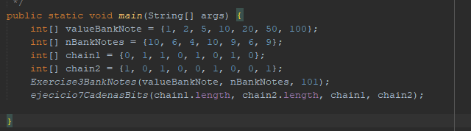

Exercise 3:
Biggest bank note is taken and if I can, I pay with it until it reaches to 0 or I run out of bank notes.
If 0 -> I was able to pay, if not -> it wasnt possible.
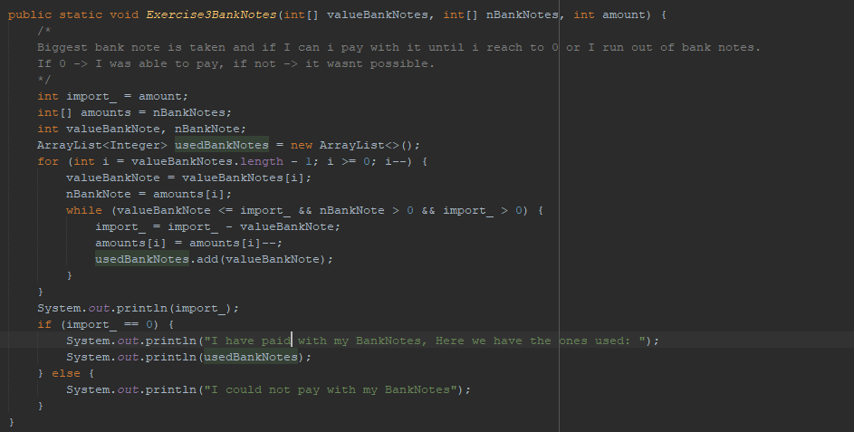

Exercise 7:
We nee to create a table with size equal to the chains, and keep updating it with the length expression.
Once maximum length has been obtained, we need to go over the table.for adding to an empty variable the bits in which we had add 1(the ones that would be part of the chain).

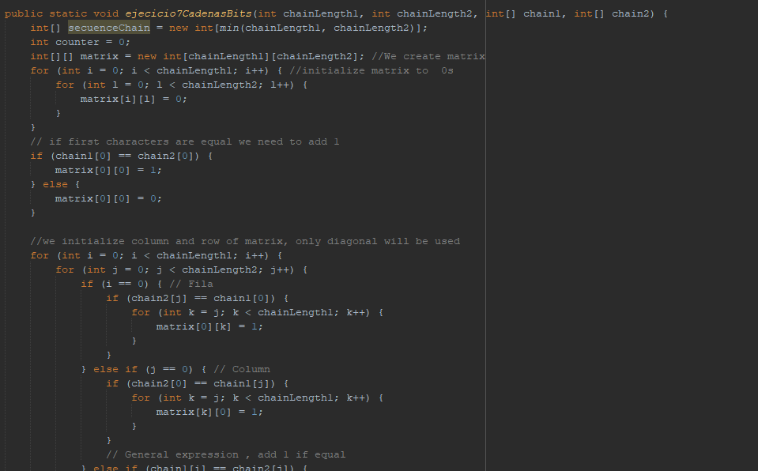

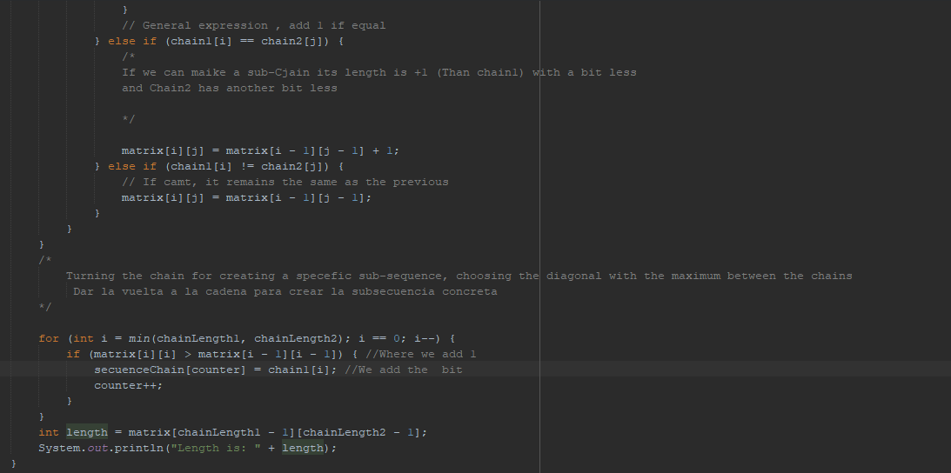

Execution Result for both:
