

*MAHARASHTRA STATE BOARD OF TECHNICAL EDUCATION, MUMBAI*

**GOVERNMENT POLYTECHNIC OSMANABAD**

**CERTIFICATE**

**GOVERNMENT POLYTECHNIC OSMANABAD**

**CERTIFICATE**

This is to certify that the micro project entitled-

**Implementing C program to show Animation of Hot Air Ballon**

Submitted by :-

Roll no:-in third semester of diploma in computer engineering has completed micro project satisfactorily in the course **Computer Graphics (22318)** academic year 2022-2023 as prescribed in the curriculum.

Place: Osmanabad Enrollment No-

Date: / /2022 Exam Seat No-

Subject Teacher Head of the Department principle

Seal of

Institution

*MAHARASHTRA STATE BOARD OF TECHNICAL EDUCATION, MUMBAI*



**GOVERNMENT POLYTECHNIC OSMANABAD**

**CERTIFICATE**

Micro project title :- **Implementing C program to show Animation of Hot Air Ballon**

Submitted by :-

|  |  |  |  |
| --- | --- | --- | --- |
| Roll No | Name of student | Enrollment no | Seat no |
|  |  |  |  |
|  |  |  |  |
|  |  |  |  |

**UNDER THE GUIDANCE MR. SIR**

**ACKNOWLADGEMENT**

I am grateful to Almighty God for giving me the strength, knowledge and understanding to complete this project. His love has been more than sufficient to keep and sustain me.

My profound gratitude goes to my wonderful supervisor, Mr R.V.Munde sir for him invaluable support, patience, time and guidance in seeing me to the completion of this research work. Also, my gratitude goes to my head of department Mr. P.J. Bansode sir who patiently saw me to the completion of this research work.

I extend gratitude and appreciation to my lecturers Mr R.V. Munde sir in department who have taught me at one point or the other. May God continue to bless, protect and guide you all.

I also wish to acknowledge the great support of my parents, siblings who have been a source of inspiration towards my academic pursuit. God bless you all.

I will not cease to acknowledge the support of my friend : Kshirsagar Yogesh. God bless you .

Computer eng.

**Index**

|  |  |  |
| --- | --- | --- |
| **SR.NO** | **Title** | **Page No** |
| 1 | Acknowledgement | 1 |
| 2 | Introduction to computer Graphics | 2 |
| 3 | Need of Computer Graphics | 2 |
| 4 | Rationale | 3 |
| 5 | Aim of project | 3 |
| 6 | Course Outcomes | 3 |
| 7 | Literature Review | 3 |
| 8 | Functions Used In Program | 4 |
| 9 | Code | 8 |
| 10 | Output | 14 |
| 11 | Applications of Computer Graphics | 16 |
| 12 | Advantages of Computer Graphics | 16 |
| 13 | Resources Used | 17 |
| 14 | References | 17 |

**INTRODUCTION TO COMPUTER GRAPHICS**

## Computer Graphics involves technology to access. The Process transforms and presents information in a visual form. The role of computer graphics insensible. In today life, computer graphics has now become a common element in user interfaces, T.V. commercial motion pictures.

Computer Graphics is the creation of pictures with the help of a computer. The end product of the computer graphics is a picture it may be a business graph, drawing, and engineering.

In computer graphics, two or three-dimensional pictures can be created that are used for research. Many hardware devices algorithm has been developing for improving the speed of picture generation with the passes of time. It includes the creation storage of models and image of objects. These models for various fields like engineering, mathematical and so on.

Today computer graphics is entirely different from the earlier one. It is not possible. It is an interactive user can control the structure of an object of various input devices.

It is the use of computers to create and manipulate pictures on a display device. It comprises of software techniques to create, store, modify, represents pictures.

**Need Of Computer Graphics:**

Suppose a shoe manufacturing company want to show the sale of shoes for five years. For this vast amount of information is to store. So a lot of time and memory will be needed. This method will be tough to understand by a common man. In this situation graphics is a better alternative. Graphics tools are charts and graphs. Using graphs, data can be represented in pictorial form. A picture can be understood easily just with a single look.

Interactive computer graphics work using the concept of two-way communication between computer users. The computer will receive signals from the input device, and the picture is modified accordingly. Picture will be changed quickly when we apply command

**Rationale:**

The implementation of the hot air balloon can be done by the programming languages which supports the concept of POP . In this project we implement the hot air balloon with the c language by using computer graphics .

This is maybe a proper implementation of the hot air balloon Because in this project I use the best implementation of POP. In future this will become easy to implement any real life problem method because of the artificial development.

My project questions that I am answering are "How to implement the real life problem?" and "What is the concept of POP?" and “What is the concept of computer graphics and its functions ?” . These questions helps me to completing my project.

**Aim of project :**

To implement simple c program of Hot air balloon by using computer graphics functions

**Course outcomes achieved :**

* + - Develop a c program for Implementing C program to show Animation of Hot Air Ballon
    - Understanding translaction , polygon filling etc .

**Literature Review :**

The project is implemented due to creating animation of the hot air ballon. I collect the information of creating this project from Books , web pages and more. From books I know more about the translation , polygon filling and from websites I get whole information about the polygon fillling.

**Some function which are used in program :**

**1] flood fill :**

In this method, a point or seed which is inside region is selected. This point is called a seed point. Then four connected approaches or eight connected approaches is used to fill with specified color.

The flood fill algorithm has many characters similar to boundary fill. But this method is more suitable for filling multiple colors boundary. When boundary is of many colors and interior is to be filled with one color we use this algorithm.

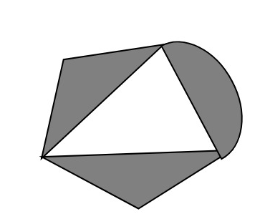

In fill algorithm, we start from a specified interior point (x, y) and reassign all pixel values are currently set to a given interior color with the desired color. Using either a 4-connected or 8-connected approaches, we then step through pixel positions until all interior points have been repainted.

**Disadvantage:**

1. Very slow algorithm
2. May be fail for large polygons
3. Initial pixel required more knowledge about surrounding pixels.

**Algorithm:**

1. Procedure floodfill (x, y,fill_ color, old_color: integer)
2. If (getpixel (x, y)=old_color)
3. {
4. setpixel (x, y, fill_color);
5. fill (x+1, y, fill_color, old_color);
6. fill (x-1, y, fill_color, old_color);
7. fill (x, y+1, fill_color, old_color);
8. fill (x, y-1, fill_color, old_color);
9. }
10. }

**Syntax for flood fill :**

Void flood_fill (int x, int y, int border_color);

**2] Set fill style :**

What is set fill style?

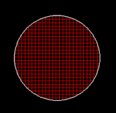

What is set fill style?

Setfillstyle() and floodfill() in C.h contains setfillstyle() function which sets the current fill pattern and fill color. floodfill() function is used to fill an enclosed area. Current fill pattern and fill color is used to fill the area.

# **3] setcolor function in C**

The header file graphics.h contain setcolor() which is used to set the current drawing color to the new color.

Syntax :

void setcolor(int color);

**Explanation :**

In Graphics, each color is assigned a number. Total number of colors available are 16. Number of available colors depends on current graphics mode and driver. For example, setcolor(RED) or setcolor(4) changes the current drawing color to RED. Remember that default drawing color is WHITE. The Colors table is given below.

**COLOR** **INT VALUES**

-------------------------------

BLACK 0

BLUE 1

GREEN 2

CYAN 3

RED 4

MAGENTA 5

BROWN 6

LIGHTGRAY 7

DARKGRAY 8

LIGHTBLUE 9

LIGHTGREEN 10

LIGHTCYAN 11

LIGHTRED 12

LIGHTMAGENTA 13

YELLOW 14

WHITE 15

**4] Arc () :**

The header file graphics.h contains **arc()** function which draws an arc with center at (x, y) and given radius. start_angle is the starting point of angle and end_angle is the ending point of the angle. The value of the angle can vary from 0 to 360 degree

syntax for arc :

void arc(int x, int y, int start_angle, int end_angle, int radius);



**CODE**

#include <stdio.h>

#include <conio.h>

#include <graphics.h>

void main()

{

    int gd = DETECT, gm, i;

    initgraph(&gd, &gm, "C:\\TURBOC3\\BGI");

    settextstyle(10, 0, 5);

    setcolor(4);

    outtextxy(35, 150, "HOT AIR BALLON");

    settextstyle(1, 0, 1);

    setcolor(3);

    outtextxy(400, 350, "CREATED BY-->");

    setcolor(2);

    outtextxy(450, 380, "* ARE VAISHNAVI");

    outtextxy(450, 410, "* ASMITA MULE");

    outtextxy(450, 440, "* SHREYA KULKARNI");

    getch();

    cleardevice();

    line(0, 430, 800, 430); // bottom horizontal line

    setfillstyle(1, 2);

    floodfill(1, 431, 15);

    setfillstyle(1, 9);

    floodfill(30, 30, 15);

    setcolor(3);

    rectangle(50, 390, 120, 433); // brown rectangle

    setfillstyle(1, 6);

    floodfill(51, 391, 3);

    setcolor(12);

    rectangle(50, 390, 120, 433); // brown rectangle

    setcolor(15);

    rectangle(70, 360, 100, 380); // black rectangle

    setfillstyle(1, 0);

    floodfill(71, 361, 15);

    arc(85, 360, 0, 180, 10); // small arc

    setfillstyle(1, 6);

    floodfill(84, 359, 15);

    line(50, 390, 30, 340);

    line(120, 390, 140, 340);

    arc(85, 340, 0, 180, 55);

    line(30, 340, 140, 340);

    setfillstyle(1, 4);

    floodfill(31, 339, 15);

    setcolor(4);

    arc(85, 340, 0, 180, 55);

    line(30, 340, 140, 340);

    setcolor(15);

    arc(300, 100, 50, 200, 30);

    arc(350, 82, 50, 170, 30);

    arc(397, 70, 50, 160, 30);

    arc(300, 100, 180, 300, 30);

    arc(343, 115, 200, 340, 30);

    arc(400, 120, 190, 340, 30);

    arc(455, 125, 190, 340, 30);

    arc(483, 105, 270, 90, 30);

    arc(455, 75, 0, 100, 30);

    arc(430, 65, 40, 140, 30);

    setfillstyle(1, 15);

    floodfill(350, 120, 15);

    setcolor(0);

    arc(520, 120, 0, 50, 30);    // first bird

    arc(580, 120, 130, 180, 30); // first bird

    arc(519, 120, 0, 50, 30);    // first bird

    arc(579, 120, 130, 180, 30); // first bird

    arc(550, 120, 0, 50, 30);    // second bird

    arc(610, 120, 130, 180, 30); // second bird

    arc(549, 120, 0, 50, 30);    // second bird

    arc(609, 120, 130, 180, 30); // second bird

    setcolor(15);

    line(0, 430, 800, 430); // bottom horizontal line

    setfillstyle(1, 2);

    floodfill(1, 431, 15);

    getch();

    cleardevice();

    setcolor(15);

    arc(300, 100, 50, 200, 30);

    arc(350, 82, 50, 170, 30);

    arc(397, 70, 50, 160, 30);

    arc(300, 100, 180, 300, 30);

    arc(343, 115, 200, 340, 30);

    arc(400, 120, 190, 340, 30);

    arc(455, 125, 190, 340, 30);

    arc(483, 105, 270, 90, 30);

    arc(455, 75, 0, 100, 30);

    arc(430, 65, 40, 140, 30);

    setfillstyle(1, 15);

    floodfill(350, 120, 15);

    setcolor(0);

    arc(520, 120, 0, 50, 30);    // first bird

    arc(580, 120, 130, 180, 30); // first bird

    arc(519, 120, 0, 50, 30);    // first bird

    arc(579, 120, 130, 180, 30); // first bird

    arc(550, 120, 0, 50, 30);    // second bird

    arc(610, 120, 130, 180, 30); // second bird

    arc(549, 120, 0, 50, 30);    // second bird

    arc(609, 120, 130, 180, 30); // second bird

    setcolor(15);

    for (i = 0; i < 300; i++)

    {

        delay(20);

        settextstyle(1, 0, 1);

        setcolor(15);

        outtextxy(1 + i + i, 441, "PRESS ANY KEY FOR EXIT");

        delay(20);

        if (kbhit())

        {

            exit(0);

        }

        setcolor(0);

        arc(520, 120, 0, 50, 30);    // first bird

        arc(580, 120, 130, 180, 30); // first bird

        arc(519, 120, 0, 50, 30);    // first bird

        arc(579, 120, 130, 180, 30); // first bird

        arc(550, 120, 0, 50, 30);    // second bird

        arc(610, 120, 130, 180, 30); // second bird

        arc(549, 120, 0, 50, 30);    // second bird

        arc(609, 120, 130, 180, 30); // second bird

        setcolor(15);

        line(0, 430, 800, 430); // bottom horizontal line

        setfillstyle(1, 2);

        floodfill(1, 431, 15);

        setfillstyle(1, 9);

        floodfill(30, 30, 15);

        setcolor(3);

        rectangle(50, 390 - i + 1, 120, 433 - i + 1); // brown rectangle

        setfillstyle(1, 9);

        floodfill(51, 392 - i + 1, 3);

        setcolor(9);

        rectangle(50, 390 - i + 1, 120, 433 - i + 1); // brown rectangle

        delay(10);

        setcolor(3);

        rectangle(50, 390 - i, 120, 433 - i); // brown rectangle

        setfillstyle(1, 6);

        floodfill(51, 391 - i, 3);

        setcolor(15);

        rectangle(50, 390 - i, 120, 433 - i); // brown rectangle

        delay(20);

        setcolor(15);

        rectangle(70, 360 - i + 1, 100, 380 - i + 1); // black rectangle

        setfillstyle(1, 9);

        floodfill(71, 361 - i + 1, 15);

        setcolor(9);

        rectangle(70, 360 - i + 1, 100, 380 - i + 1); // black rectangle

        delay(10);

        setcolor(15);

        rectangle(70, 360 - i, 100, 380 - i); // black rectangle

        setfillstyle(1, 0);

        floodfill(71, 361 - i, 15);

        delay(20);

        arc(85, 360 - i + 1, 0, 180, 10); // small arc

        setfillstyle(1, 9);

        floodfill(84, 359 - i + 1, 15);

        setcolor(9);

        arc(85, 360 - i + 1, 0, 180, 10); // small arc

        delay(10);

        setcolor(15);

        arc(85, 360 - i, 0, 180, 10); // small arc

        setfillstyle(1, 6);

        floodfill(84, 359 - i, 15);

        delay(20);

        setcolor(9);

        line(50, 390 - i + 1, 30, 340 - i + 1);

        line(120, 390 - i + 1, 140, 340 - i + 1);

        delay(10);

        setcolor(15);

        line(50, 390 - i, 30, 340 - i);

        line(120, 390 - i, 140, 340 - i);

        delay(20);

        setcolor(9);

        arc(85, 340 - i + 1, 0, 180, 55);

        line(30, 340 - i + 1, 140, 340 - i + 1);

        setfillstyle(1, 9);

        floodfill(31, 339 - i + 1, 15);

        delay(10);

        setcolor(15);

        arc(85, 340 - i, 0, 180, 55);

        line(30, 340 - i, 140, 340 - i);

        setfillstyle(1, 4);

        floodfill(31, 339 - i, 15);

        delay(20);

        setcolor(2);

        outtextxy(1 + i + i, 441, "PRESS ANY KEY FOR EXIT");

    }

    getch();

    closegraph();

}

**OUTPUT**

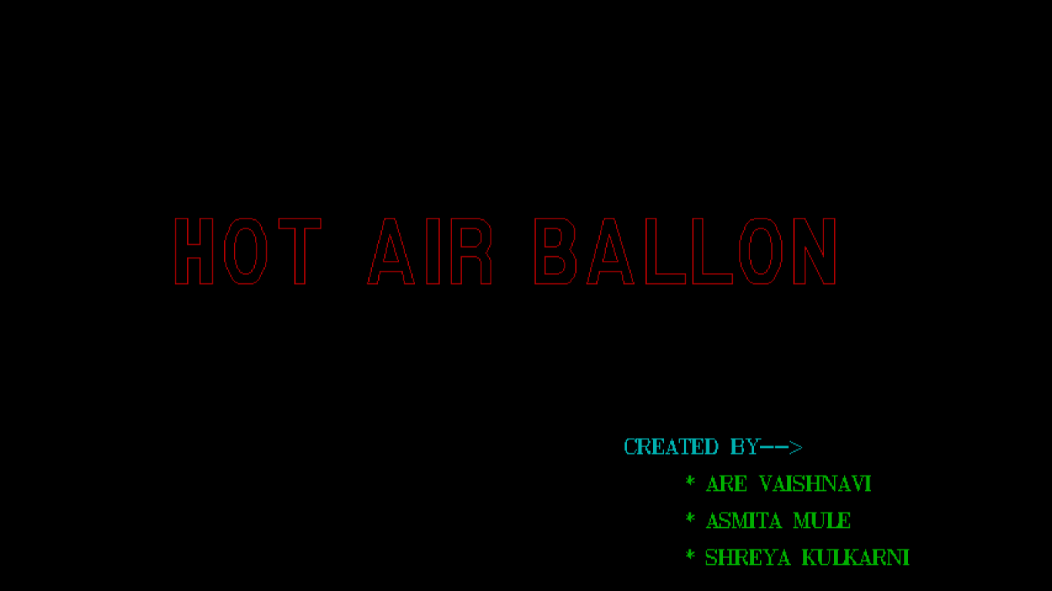

**FRONT PAGE**

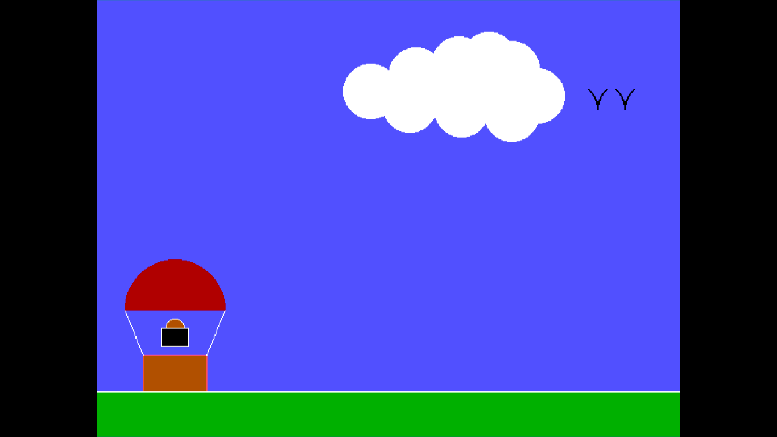

**MAIN PAGE**

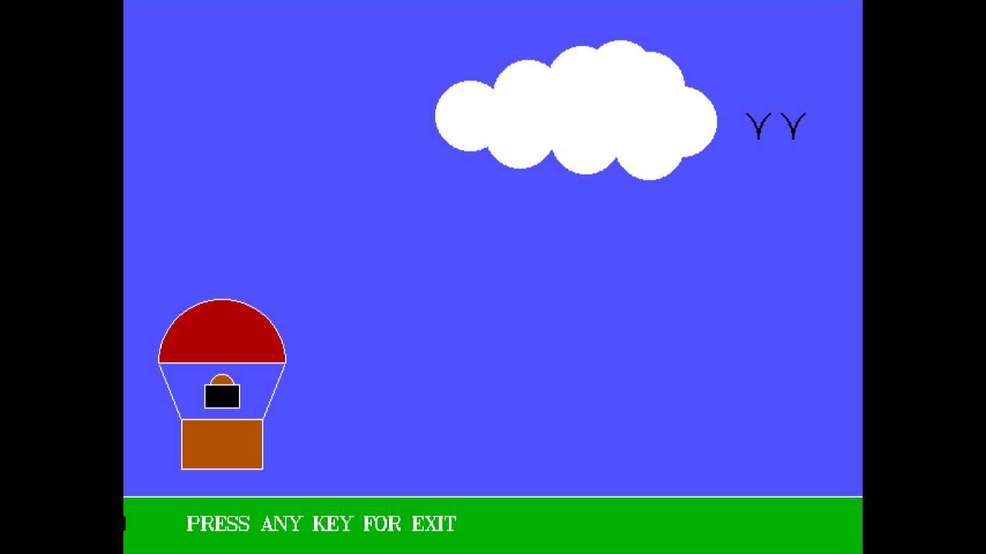

**Moving Hot Air Ballon**

* **Applications**

Computer graphics may be used in the following :

1. Computer-aided design
2. Design
3. Digital art
4. Education
5. Graphic design
6. Video game

* **Advantages Of Computer Graphics :**

1. Increases Usability
2. Product Development and Research
3. Employment Opportunitie
4. Designin
5. Teaching Learning activities becomes easy

**Actual resources used**

|  |  |  |  |
| --- | --- | --- | --- |
| **Sr No.** | **Name Of Resource** | **Specification** | **Quantity** |
| 1. | Laptop | RAM-8 GB,  Processor-Intel Core i5 | 1 |
| 2 | System type | 64-bit operating system (windows) | 1 |
| 3 | Software | Visual studio code | 1 |

**Reference:**

*1]*

[https://www.geeksforgeeks.org](https://www.geeksforgeeks.org )

*2]*

[https://www.tutorialspoint.com](https://www.tutorialspoint.com )

3]

[https://www.quora.com](https://www.quora.com )

*4]* <https://www.msbtemicroproject.tech>

*5]* <https://edu-mate.com>

We have used all of the above references for getting information about computer graphics and its functions for using it in our project .