

*MAHARASHTRA STATE BOARD OF TECHNICAL EDUCATION, MUMBAI*

**GOVERNMENT POLYTECHNIC OSMANABAD**

**CERTIFICATE**

**GOVERNMENT POLYTECHNIC OSMANABAD**

**CERTIFICATE**

This is to certify that the micro project entitled-

**Implementing** **a ALP program to check given number is palindrome or not**

Submitted by :- **Samarth Vishnu Joshi**

**Yogesh Dattatraya Kshirsagar**

**Yash Sanjay Patil**

Roll no:- **21,29,45** in third semester of diploma in computer engineering has completed micro project satisfactorily in the course **Microprocessors (22415)** academic year 2022-2023 as prescribed in the curriculum.

Place: Osmanabad Enrollment No-2101180269

2101180277

2101180354

Date: / /2022 Exam Seat No- 396409

396417

396434

Subject Teacher Head of the Department Principal

Seal of

Institution

*MAHARASHTRA STATE BOARD OF TECHNICAL EDUCATION, MUMBAI*



**GOVERNMENT POLYTECHNIC OSMANABAD**

**CERTIFICATE**

**Micro project title** :- **Implementing** **a ALP program to check given number is palindrome or not**

Submitted by :-

|  |  |  |  |
| --- | --- | --- | --- |
| Roll No | Name of student | Enrollment no | Seat no |
| 21. | Samarth Vishnu Joshi | 2101180352 | 396409 |
| 29. | Yogesh Dattatraya Kshirsagar | 2101180277 | 396417 |
| 45. | Patil Yash Sanjay | 21011802354 | 396434 |

UNDER THE GUIDANCE MR.B.R.CHAUHAN

ACKNOWLEGEMENT

I am grateful to Almighty God for giving me the strength, knowledge and understanding to complete this project. His love has been more than sufficient to keep and sustain me.

I extend gratitude and appreciation to my lecturers in **Mr**.**B.R.CHAUHAN SIR** department who have taught me at one point or the other. May God continue to bless, protect and guide you all.

I also wish to acknowledge the great support of my parents, siblings who have been a source of inspiration towards my academic pursuit. God bless you all.

I will not cease to acknowledge the support of my friends:

Om, Purushottam God bless you all

SAMARTH VISHNU JOSHI

YOGESH DATTATRAYA KSHIRSAGAR PATIL YASH

COMPUTER ENG.

**INDEX**

|  |  |  |
| --- | --- | --- |
| Sr no. | Title | Page no |
| 1 | Acknowlegement | 1 |
| 2 | rationale | 1 |
| 3 | Aim of Project | 1 |
| 4 | Course outcome achieved | 1 |
| 5 | Literature Review | 1 |
| 6 | Introduction to assembly language | 2 |
| 7 | Components of assembly language | 3 |
| 8 | Advantages and Disadvantages of assembly language | 4 |
| 9 | Algorithm | 5 |
| 10 | Flowchart | 6 |
| 11 | Code | 7 |
| 12 | Output | 8 |
| 13 | Actual Resources used | 9 |
| 14 | Conclusion | 9 |
| 15 | References | 10 |

1. **Rationale:**

This microproject contains various concept of assembly language programming like class and object. It is used to check whether the number is palindrome or not if it is palindrome then it shows number is palindrome otherwise number is not palindrome.

1. **Aim of project :**

To develop a simple program of palindrome number checking using various concepts of the assembly language programming.

1. **Course** **outcomes** **achieved** :
   * + Develop assembly language program using classes and object
     + Implement a project by using 8086 concept
     + Develop 8086 program to check palindrome number
2. **Literature Review :**

Assembly language programming is a programming language which is used to program the processor. Its is an low level programming language that is intended to communicate directly with a computers hardware.

**INTRODUCTION TO ASSEMBLY LANGUAGE**

* An assembly language is a type of programming language that translates high level languages into machine language.
* It is necessary bridge between the software programs and their underlying hardware platforms.
* Assembly language relies on language syntax, labels, operators and directives to convert code into usable machine instruction.
* Assembly language may pass through single pass or multi pass assemblers, each with specific uses and benefits.
* Today assembly language are rarely written directly although they are still used in some niche applications such as when performance requirements are particularly high.

**COMPONENTS OF ASSEMBLY LANGUAGE**

1. **Syntax:-**

When writing any code in any program language there is an observable specific order of rules that must be followed to allow a compiler to execute the code without error.

1. **Label**:-

A label is a symbol that represents the address where an instruction or data is stored. Its purpose is to act as the destination when referenced in a statement. Labels can be used anywhere an address can be used in assembly languages.

1. **Operators:-**

Also referred to as commands operators are logical expressions that occur after the label field. In addition, it must be preceded by at least one white space character. Operators can be either opcode or directive.

1. **Directives:-**

Directives are the instructions to the assembler that tell what actions must take place during the assembly process. Directives have the importance of declaring or reserving memory for variables; this variables can be recalled later in the processes to perform more dynamic function .

1. **Macro:-**

An assembly macro is template shoe format presents a series or pattern pf statements this sequence of assembly language statement s might be common to multiple different programs . A macro facility is used to interpret macro definitions while a macro call is inserted into the source code where normal assembly code would have gone instead of the macro sets of then statements.

**ADVANTAGES AND DISADVANTAGES OF ASSEMBLY LANGUAGE**

**ADVANTAGES**

1. Assembly language can usually be executed faster than high level languages.
2. Its relatively easy to insert of delete components of assembly language code.
3. An assembly language usually requires fewer instructions to complete a task when compared against other types of languages.
4. Assembly language are also often used by programmers wanting greater control over their computers.
5. Because of its speed and importance some programmes are specifically written using assembly language code.

**DISADVNTAGES**

1. Long programmes written using assembly language usually requires high system it cannot be run in small computers.
2. The syntax of assembly language is more difficult to remember as it is complex.
3. The assembly language is usually not portable between different computers.
4. Programming maybe more challenging to compared high llevel languages.

Algorithm

1. Initialize data segment
2. Load 4 in cx and num1 in ax
3. Div by 10
4. Store result of division in temporary variable

* Tempque – quotient – ax
* Temprem – reminder – dx

1. Load num1 in ax and multiply by 10
2. Add ax and temprem and load ax in num2
3. Load tempque in ax
4. Is cx = 0 then go to step 9 else go to step 3
5. Compare num1 and num2
6. Is num1= num2 then go to step 11 else go to step 12
7. Display number is palindrome on screen
8. Go to step 13
9. Display number is not palindrome on screen
10. stop

**FLOW-CHART**

Start

Initialize Data Segment

Load 4 in CX and num1 in AX

Is CX =0

Divide by 0

Store result of division in temporary variable

Tempque🡪quotient🡪ax

Temprem 🡪reminder🡪 dx

Load num1 in ax and multiply by 10

Add ax and temprem and load ax in num2

Load tempque in ax

Compare num1 and num2

**F**

Display number is not palindrome on screen

If num1= num2

**T**

Display number is palindrome on screen

Stop

**CODE**

**;ALP Program For Checking The Given Number Is Palindrome Or Not**

.model small

.data

    num1 dw 3332d

    num2 dw 0

    tempque dw 0

    temprem dw 0

    ten dw 0010d

    str1 db 'Number is Palindrome$'

    str2 db 'Number is not Palindrome$'

.code

    mov ax,@data

    mov ds,ax

    mov cx,4

     mov ax,num1

  up:

    div ten

    mov tempque,ax

    mov temprem,dx

    mov ax,num2

    mul ten

    add ax,temprem

    mov num2,ax

    mov ax,tempque

    loop up

    mov ax,num1

    mov bx,num2

    cmp ax,bx

    je down

       mov ah,09h

       lea dx,str2

       int 21h

       jmp end

  down:

       mov ah,09h

       lea dx,str1

       int 21h

  end:

       mov ah,4ch

       int 21h

ends

end

**Output**

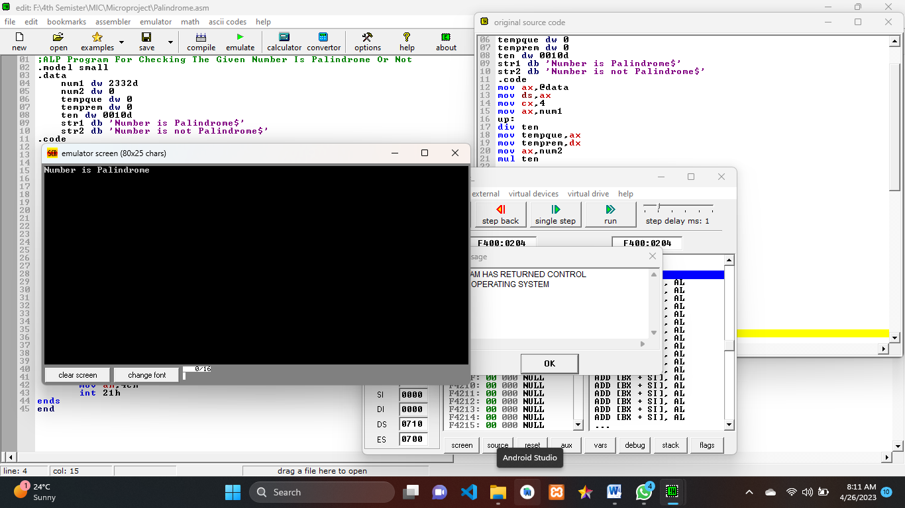

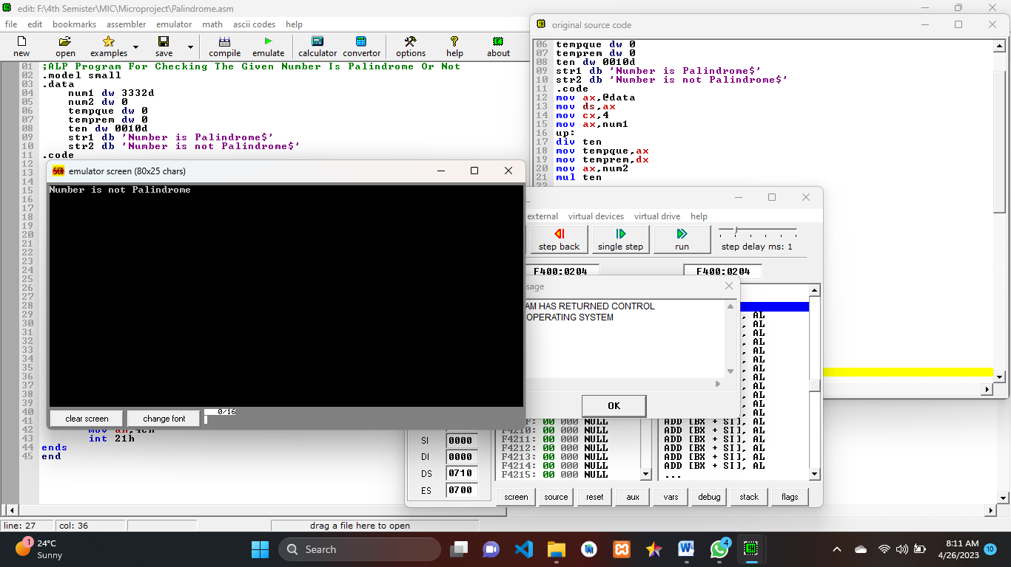

**ACTUAL RESOURCES USED**

|  |  |  |  |
| --- | --- | --- | --- |
| Sr No. | Name Of Resource | Specification | Quantity |
| 1. | Laptop | RAM-8 GB,  Processor-Intel Core i5 | 1 |
| 2 | System type | 64-bit operating system (windows) | 1 |
| 3 | Software | EMU 8086 | 1 |

**CONCLUSION :**

In this project we learn about ALP program to How to find the given number is palindrome or not

**REFERENCE:**

* <https://www.tutorialpoint.com> .
* <https://www.>javatpoint.com
* <https://www.geeksforgeeks.org>