Find out the purpose of the following commands and execute them on your system
with different parameters.
ls, cd, pwd, mkdir, rmdir, rm , cp, mv, touch
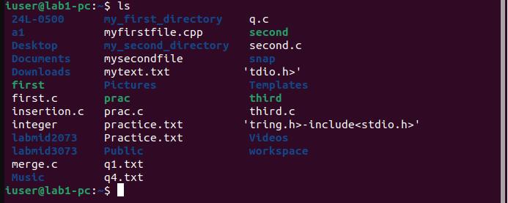



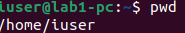

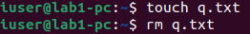

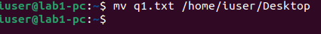

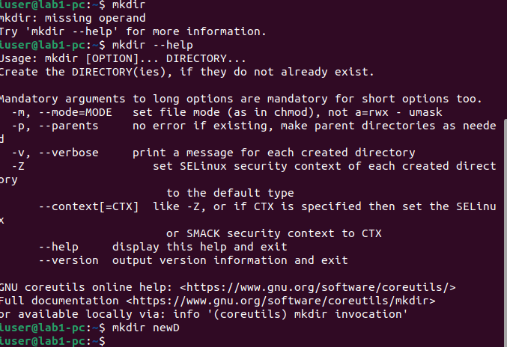

Some commands may be new for most of you. Practice these terms on your own:

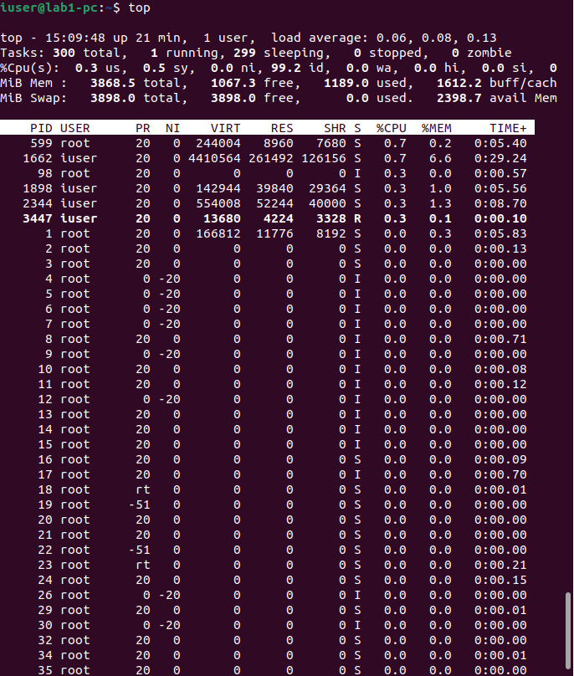
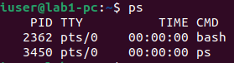
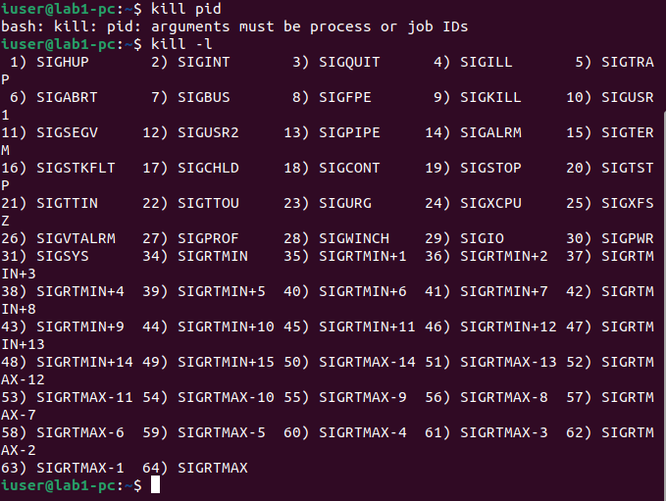
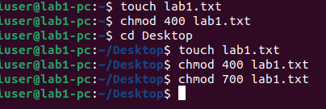
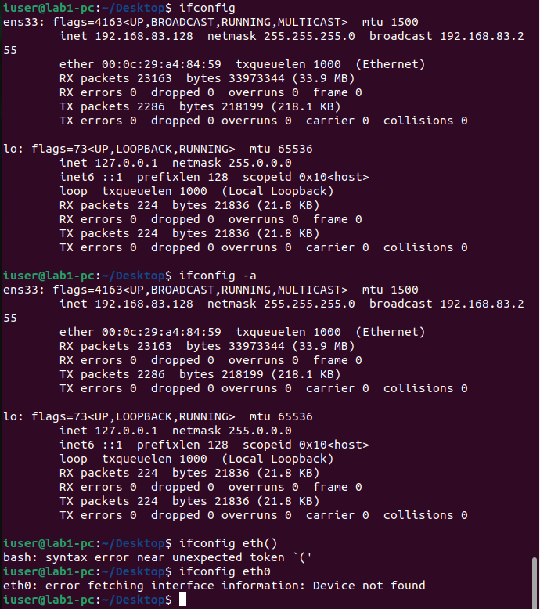
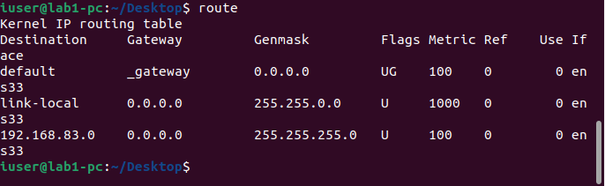
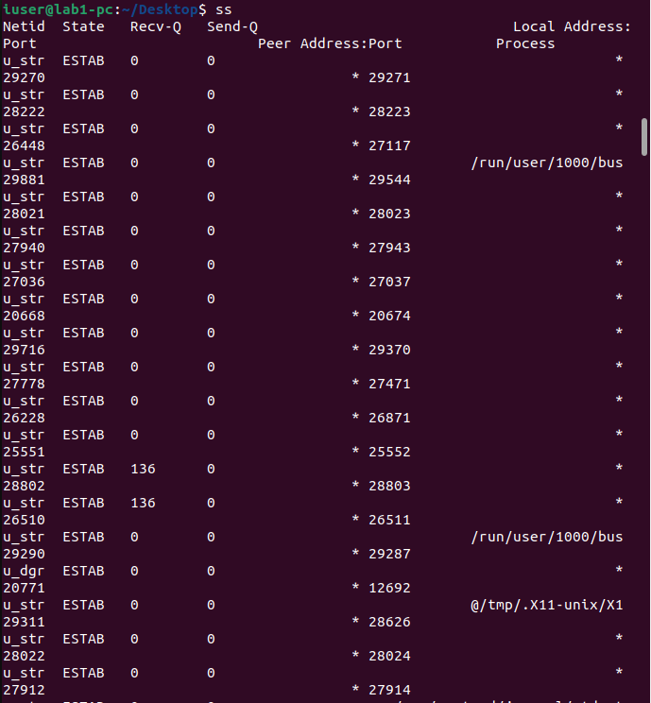
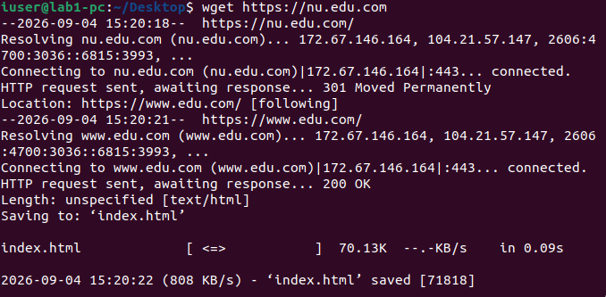
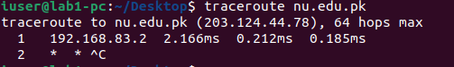
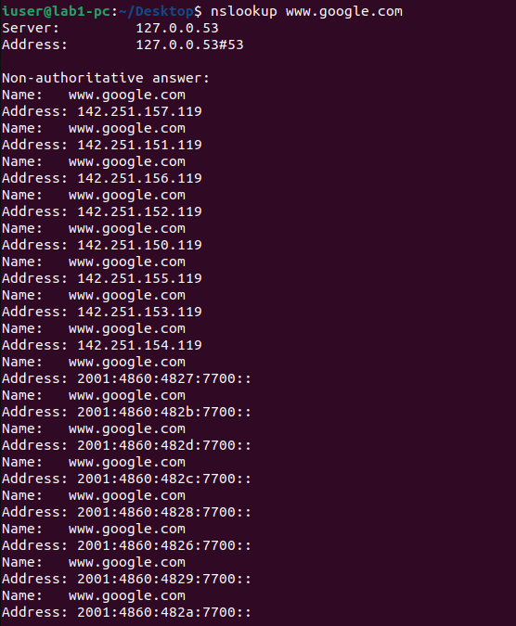

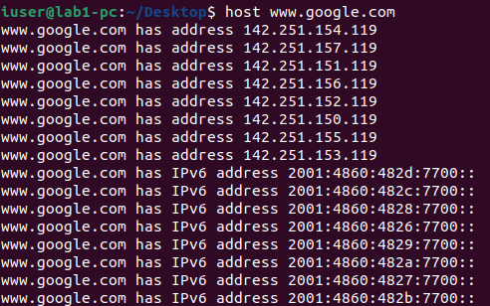

Ping command: [5]
Use the ping command to test connectivity to at least five reachable hosts/IP addresses,
including the loopback address 127.0.0.1. Record the average round-trip time (RTT)
reported by ping and compare the results.

Syntax for Pinging is:
ping [other network’s ID (Domain/IP Address)]
Question - You are required to ping at least 5 other networks (including your own
address i.e. 127.0.0.1) and compare the latency rate of all networks.

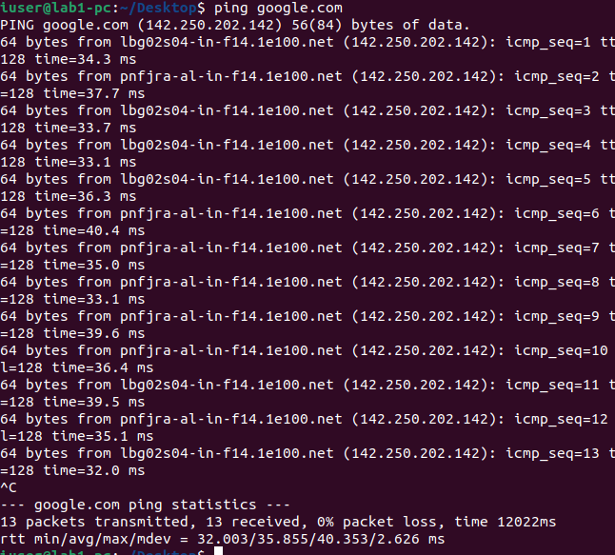
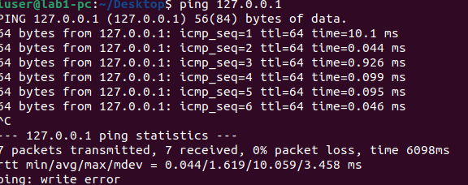
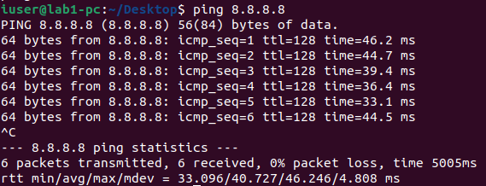
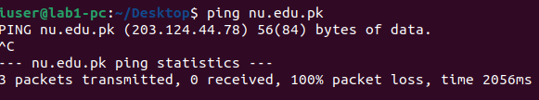
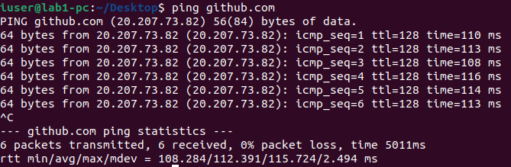

WireShark
1.
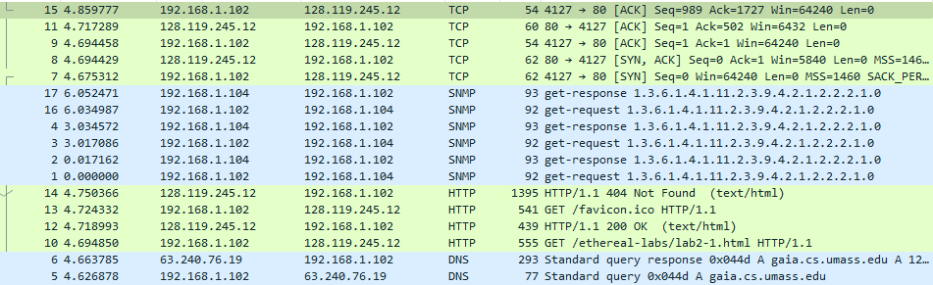
TCP, SNMP, HTTP, DNS

2.
Packet 10 (GET) was sent at time 4.694850
Packet 12 (response) arrived at time 4.718993
Difference: 4.718993 − 4.694850 = 0.024143 seconds ≈ 24.1 milliseconds
3.
No, it was not successful. We can tell because the response status code is 404 Not Found — this means the server searched for the file favicon.ico but couldn't find it
4.
Http version is 1.1

5.
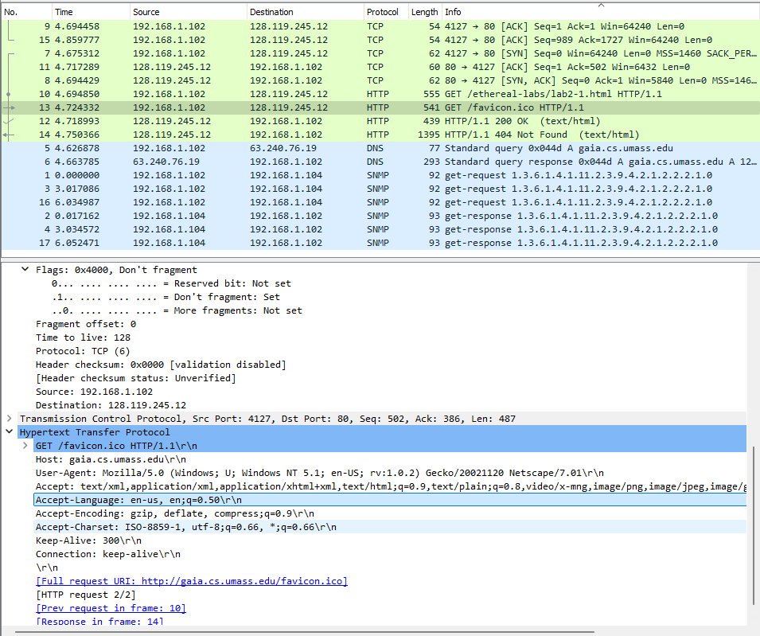
Accept-Language: en-us, en;q=0.50\r\n
6.
our computer: 192.168.1.102
gaia.cs.umass.edu server: 128.119.245.12

7.
Source: Dell_4f:36:23 (00:08:74:4f:36:23)
Destination: LinksysG_da:af:73 (00:06:25:da:af:73)
Source MAC (00:08:74:4f:36:23) = the physical network card (NIC) address of your computer (a Dell machine, based on the vendor prefix).
Destination MAC (00:06:25:da:af:73) = the physical address of your home router/gateway (a Linksys device) — not the actual gaia.cs.umass.edu server.
8.
Src Port: 4127, Dst Port: 80
Source port: 4127 — a random, temporary ("ephemeral") port your OS assigned just for this one connection.
Destination port: 80 — this is the standard, well-known port for HTTP. The server listens on port 80 specifically for web traffic, so your browser always sends HTTP requests there.
9.
OK

10.
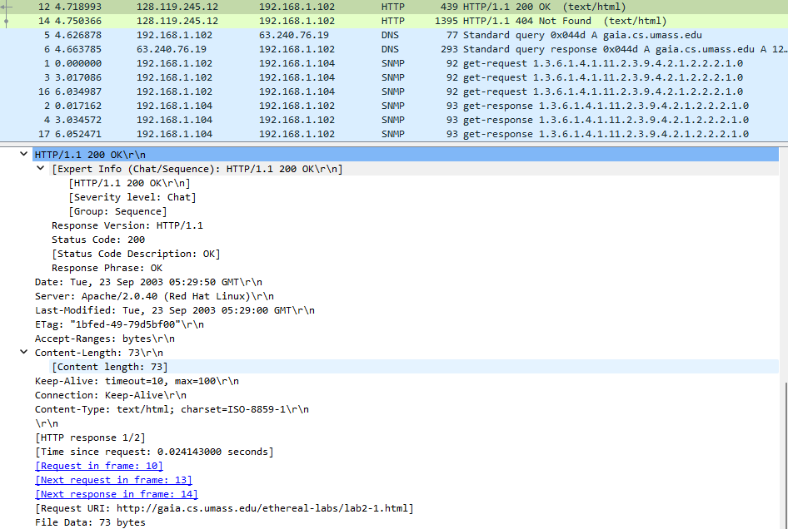
Last modified is:
Last-Modified: Tue, 23 Sep 2003 05:29:00 GMT
11.
Content Size is:
File Data: 73 bytes

12.
If-Modified-Since: Tue, 23 Sep 2003 05:35:00 GMT
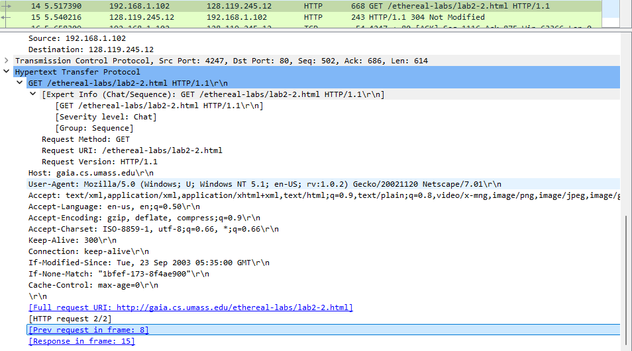
13.
HTTP/1.1 304 Not Modified
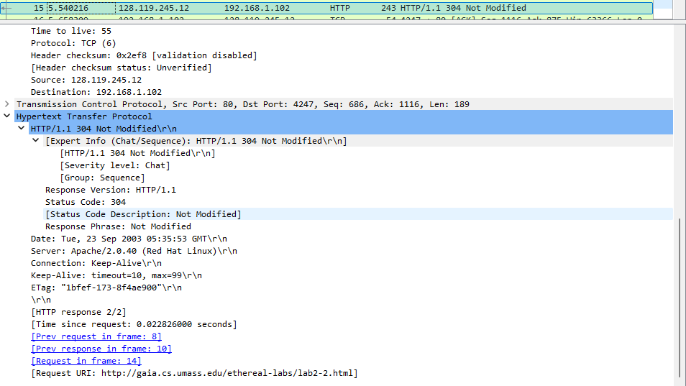
14.
No, the object was not returned. You can confirm this two ways. The status code itself, 304 Not Modified, specifically means "the file hasn't changed since the time you gave me, so I'm not going to resend it." Looking at the packet, there's no HTML body/content after the headers , the response just ends after the header block (no Content-Length with actual data, no entity body). The packet length is also very small (only 243 bytes total), consistent with headers only, not an HTML file
15.
The first GET (packet 8) has no If-Modified-Since or If-None-Match headers, it's a normal, "fresh" request since the browser has nothing cached yet. The server responds with a full 200 OK and the entire HTML content.
The second GET (packet 14) includes:
If-Modified-Since: Tue, 23 Sep 2003 05:35:00 GMT
If-None-Match: "1bfef-173-8f4ae900"

POST LAB
1.
Packet 8: GET /ethereal-labs/lab2-3.html HTTP/1.1
So the answer is 1
2.
Packet 8, this is the GET request for lab2-3.html, which is the Bill of Rights page for this trace.
3.
Packet 14, this is the one showing HTTP/1.1 200 OK (text/html) in the Protocol/Info column
4.
200 OK
5.
4 data-containing segments: packets 10, 11, 13, and 14.
6.
The total data was broken down into smaller chunks mostly 1460*3 and the last chunk covering the remaining bits that why the last chunk 120 is smaller compared to the other chunks.

