LAB STATEMENT 1:

1.
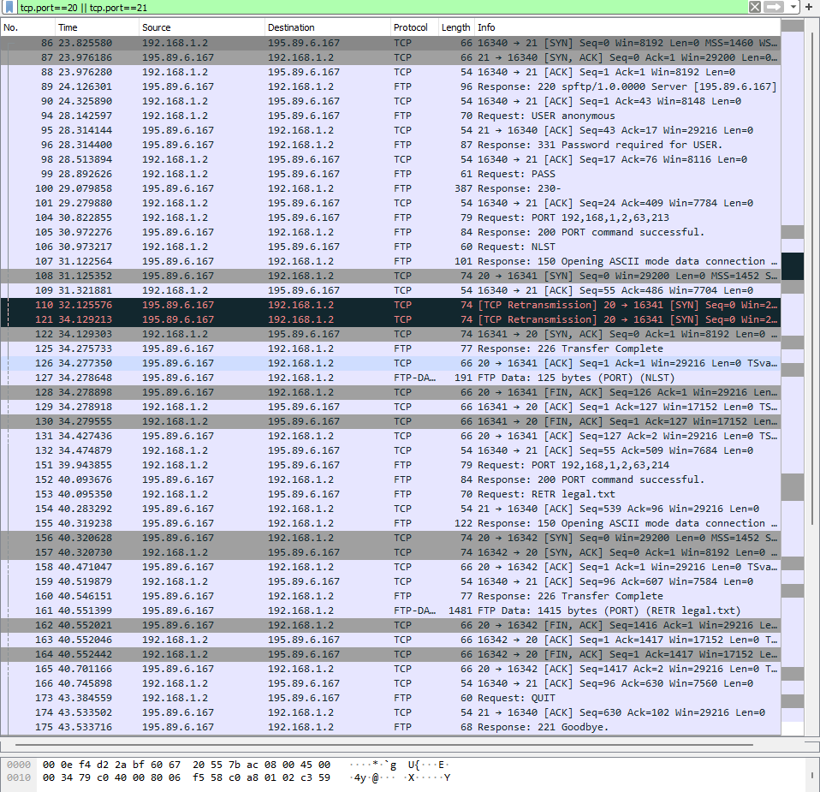
Port 21 = control connection. It carries all the FTP commands and their numeric responses for the entire session.
Port 20 = data connection, the server initiates a connection from port 20 back to the client (active mode), because the client told it where to connect using the PORT command.
Data connection port numbers: the client specified them via PORT command:
192,168,1,2,63,213 port = 63×256+213 = 16341 (used for the file listing)
192,168,1,2,63,214 port = 63×256+214 = 16342 (used for downloading legal.txt)
So yes, the data connection ports are different each time (16341, then 16342); a fresh ephemeral port is negotiated for every data transfer, while the server side always originates from port 20.

2.
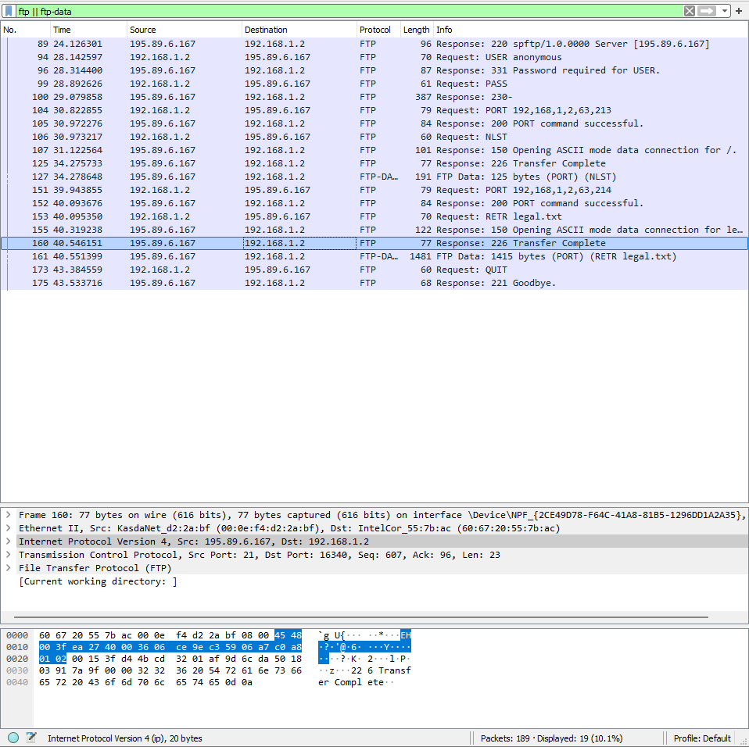

Packet No. | Response Code | Response Argument | Purpose
89 | 220 | spftp/1.0.0000 Server [195.89.6.167] | Server welcome banner sent upon client connection
94 |  |  | Client sends username (USER anonymous)
96 | 331 | Password required for USER. | Server requests password
99 |  |  | Client sends password (PASS)
100 | 230 | - | Server confirms successful login
104 |  |  | Client requests server to use port 192,168,1,2,63,213 for data connection (PORT)
105 | 200 | PORT command successful. | Server acknowledges the PORT command
106 |  |  | Client requests a name list of files (NLST)
107 | 150 | Opening ASCII mode data connection for /. | Server about to send directory listing over data connection
125 | 226 | Transfer Complete | Server confirms directory listing transfer finished
127 |  |  | FTP-DATA: Actual directory listing data (125 bytes) sent over data connection (NLST)
151 |  |  | Client requests server to use port 192,168,1,2,63,214 for next data connection (PORT)
152 | 200 | PORT command successful. | Server acknowledges the new PORT command
153 |  |  | Client requests download of legal.txt (RETR legal.txt)
155 | 150 | Opening ASCII mode data connection for legal.txt. | Server about to send file contents over data connection
160 | 226 | Transfer Complete | Server confirms file transfer finished
161 |  |  | FTP-DATA: Actual contents of legal.txt (1415 bytes) sent over data connection (RETR legal.txt)
173 |  |  | Client ends the session (QUIT)
175 | 221 | Goodbye. | Server closes the control connection

LAB STATEMENT 2:
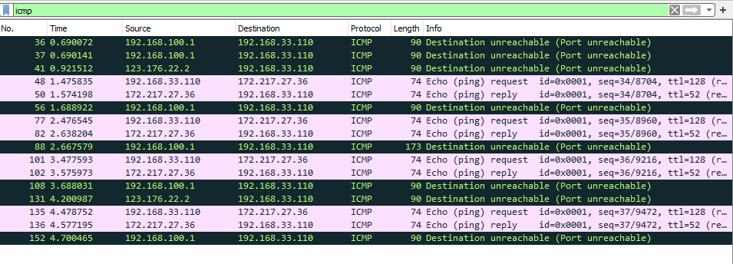

1.
ICMP messages are not sent using either TCP or UDP. ICMP works directly on top of IP (it is encapsulated inside an IP packet), so it does not use any transport layer protocol. This can also be verified from the capture, since Wireshark directly labels the protocol column as "ICMP" without showing any TCP or UDP layer.

2.
The source MAC address is 60:67:20:55:7b:ac (registered to Intel Corporate, shown as IntelCor_55:7b:ac). This is the MAC address of the host that sent the ping request (192.168.33.110).
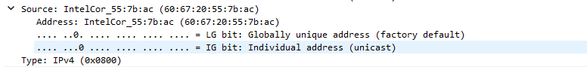

3.
The host is sending Echo (ping) Request messages. This is visible in the Info column, which clearly states "Echo (ping) request" for packets like 48, 77, 101 and 135. The ICMP Type value for an Echo Request is Type 8.

4.
Looking at the capture, there are 4 Echo Request messages sent by the source host, seen in packets 48, 77, 101 and 135, having sequence numbers 34, 35, 36 and 37 respectively

5.
In the Echo Request packets (e.g. packet 48), the source IP address is 192.168.33.110 and the destination IP address is 172.217.27.36.

6.
Port numbers are used at the transport layer so that data can be delivered to the correct application or process running on a device. ICMP, however, works at the network layer and is used for diagnostic/control purposes between IP stacks, not between specific applications. Since ICMP messages are handled directly by the operating system's network layer rather than being delivered to any particular application, there is no need for source or destination port numbers.

7.
The main field that differs between the two is the Type field. An Echo Request has Type = 8, while an Echo Reply has Type = 0. Both have Code = 0. The Identifier and Sequence Number fields remain the same in a matching request-reply pair (e.g. id=0x0001, seq=34 in both packet 48 and packet 50), which is what allows them to be matched together.
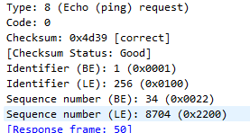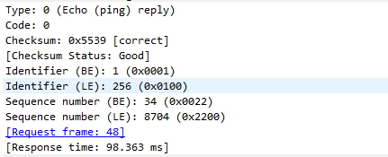

8.
Taking packet 48 as an example, the Type is 8 and Code is 0. Along with Type and Code, the ICMP header also contains a Checksum, Identifier, and Sequence Number field, followed by the data/payload. The Checksum field is 2 bytes, the Identifier field is 2 bytes, and the Sequence Number field is also 2 bytes.

9.
Taking packet 50 as an example, the Type is 0 and Code is 0. The header contains the same fields as the request: Checksum, Identifier, and Sequence Number, followed by the data. Similarly, the Checksum is 2 bytes, Identifier is 2 bytes, and Sequence Number is 2 bytes.

10.
Packet 56 is a Destination Unreachable message (192.168.100.1 -> 192.168.33.110), specifically a Port Unreachable error. So the Type is 3 and the Code is 3.
The reason this ICMP message contains the original IP header and TCP/UDP header is because ICMP error messages don't have any way (like ports) to directly tell the sender which packet or connection caused the problem. So instead, the router or host generating the error message copies the original IP header along with the first 8 bytes of the original transport header (which includes the source and destination port numbers) back into the ICMP message. This way, when the message reaches back the original sender, its OS can match this error to the exact packet/connection that caused it and inform the correct application.
