Successful voter authentication:
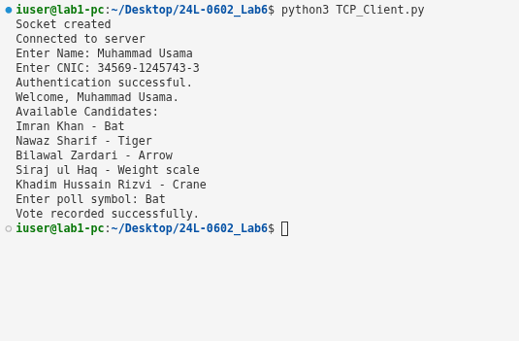

Candidate list displayed with poll symbols:
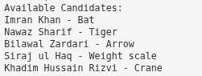

Successful vote casting:

Invalid voter authentication:
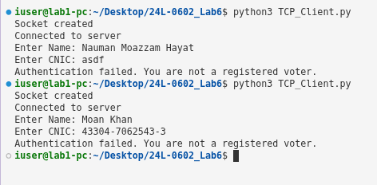

Invalid poll symbol handling:
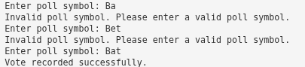

Duplicate vote rejection:
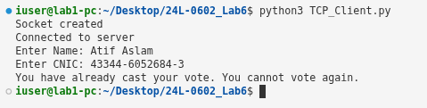

Multiple threads running:

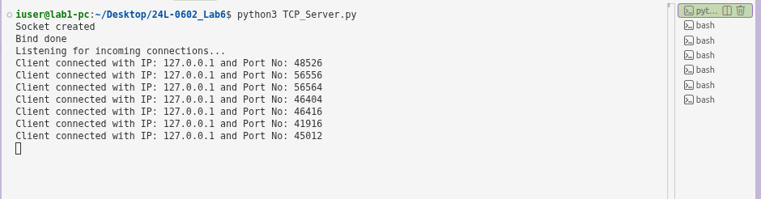

Server remaining active while handling multiple clients:

Votes.txt containing successfully recorded votes:
