FINAL PROJECT REPORT

Python-Based Private Blockchain with Proof of Work, REST API and Consensus
Mehmet Şamil ARAT
211401002
Project Repo URL: https://github.com/YoSoyNep/BlockChain

1. Introduction
Blockchain technology has become a fundamental component of modern distributed systems due to its ability to ensure data integrity, immutability, and decentralized consensus. While public blockchains such as Bitcoin and Ethereum focus on large-scale, permissionless environments, private blockchains are widely used in enterprise and academic contexts where controlled participation and lightweight consensus mechanisms are preferred.
This project is the continuation and practical implementation of the previously submitted Project Technical Documentation. The aim of this final phase is to transform the theoretical design into a fully working private blockchain system, demonstrate its correctness through experiments, and document all implementation details with code and visual evidence.
The developed system is a Python-based private blockchain that supports:
- Proof of Work (PoW)
- Transaction integrity
- RESTful API access
- Multi-node operation
- Consensus using the longest valid chain rule

2. System Overview
The implemented blockchain system consists of independent nodes that communicate over HTTP using a REST API. Each node maintains its own copy of the blockchain, performs mining, validates blocks, and resolves conflicts through consensus.

Key Components
- Blockchain Core: Block structure, hashing, PoW, validation
- Flask API: External interaction with the blockchain
- Multi-node Network: Nodes running on different ports
- Consensus Mechanism: Longest valid chain selection
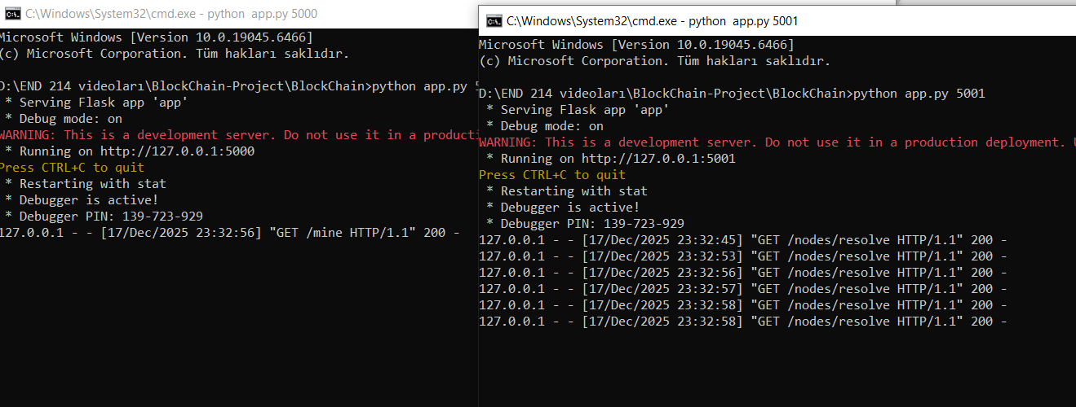

3. Data Structures

3.1 Block Structure
Each block in the blockchain contains the following fields:
- index: Position of the block in the chain
- timestamp: UTC time when the block is created
- transactions: List of transactions included in the block
- proof: Proof of Work nonce
- previous_hash: SHA-256 hash of the previous block
@dataclass
class Block:
index: int
timestamp: str
transactions: List[Dict[str, Any]]
proof: int
previous_hash: str
This structure ensures that each block is cryptographically linked to the previous one, forming an immutable chain.
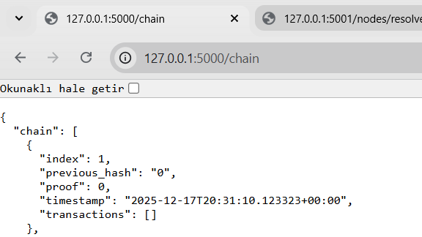

3.2 Transaction Structure
Transactions are stored as dictionaries with the following fields:
- sender
- recipient
- amount
Transactions are temporarily stored in a mempool (current_transactions) and are permanently recorded once a new block is mined.

4. Hashing and Immutability
The system uses the SHA-256 hashing algorithm to generate cryptographic hashes for blocks.
def hash(self, block: Block) -> str:
return sha256(block.to_ordered_json())
Any modification in a block’s content results in a completely different hash value. Because each block stores the hash of the previous block, tampering with any block invalidates the entire chain after it.
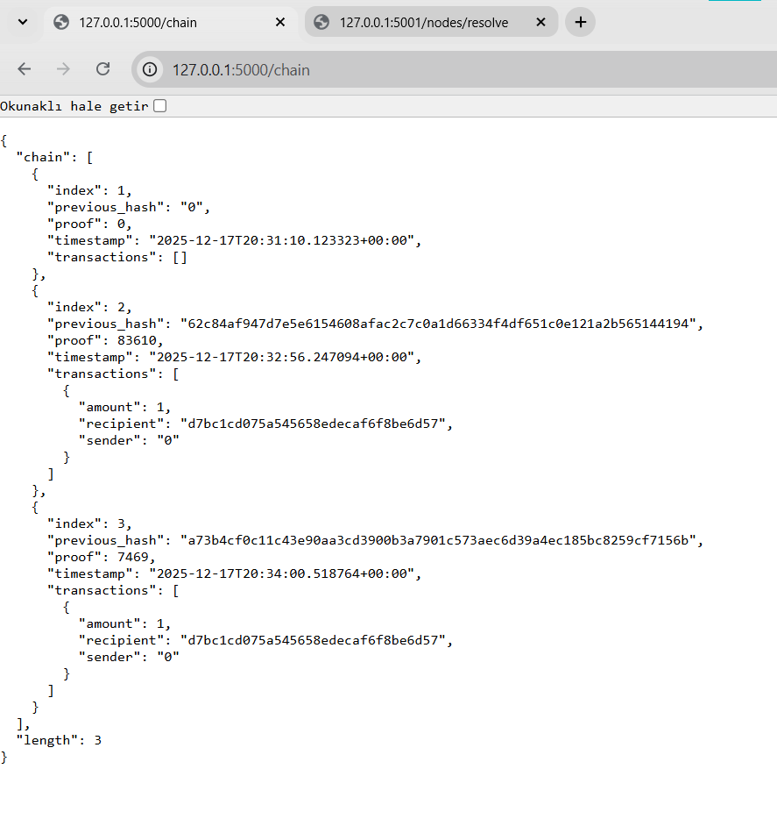

5. Proof of Work (PoW)

5.1 PoW Algorithm
The Proof of Work mechanism requires finding a nonce (proof) such that the resulting hash starts with a predefined difficulty prefix (e.g., "0000").
def valid_proof(self, last_proof, proof, last_hash, transactions):
tx_str = json.dumps(transactions, sort_keys=True)
guess = f"{last_proof}{last_hash}{tx_str}{proof}"
return sha256(guess).startswith(self.difficulty_prefix)

5.2 Transaction-Dependent PoW
Unlike naive implementations, this system includes transactions in the PoW calculation. As a result:
- Any change in transaction data invalidates the PoW
- Block tampering is reliably detected
This significantly strengthens data integrity.

6. Mining and Reward Mechanism
Each successful mining operation creates a new block and includes a coinbase (reward) transaction.
bc.new_transaction(sender="0", recipient=node_id, amount=1)
- sender = "0" represents the system
- recipient = node_id identifies the miner
- amount = 1 is the mining reward
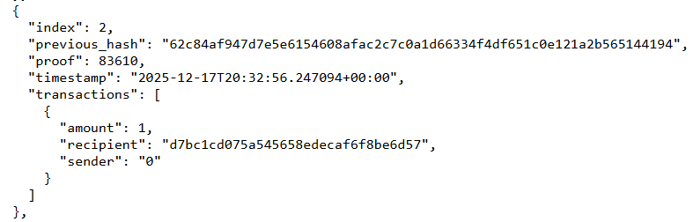

7. REST API Design
The blockchain is accessed and controlled using a RESTful API built with Flask.

7.1 Implemented Endpoints
Endpoint | Method | Description
/chain | GET | Returns the full blockchain
/transactions/new | POST | Adds a new transaction
/mine | GET | Mines a new block
/nodes/register | POST | Registers peer nodes
/nodes/resolve | GET | Resolves conflicts via consensus
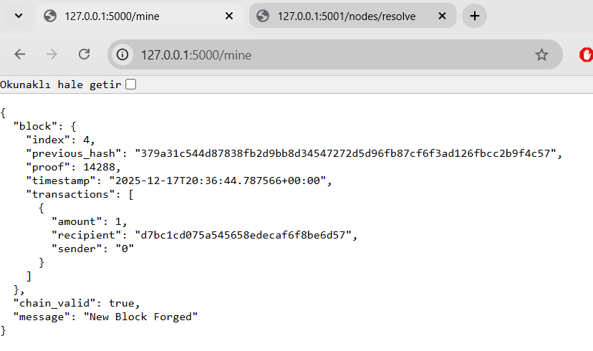

8. Multi-Node Architecture
Multiple blockchain nodes are run on different ports (e.g., 5000 and 5001). Each node:
- Maintains its own blockchain
- Mines blocks independently
- Communicates with peers via HTTP
Nodes are registered using /nodes/register and stored in a node list.

9. Consensus Algorithm

9.1 Longest Chain Rule
When conflicts occur (forks), nodes resolve them using the longest valid chain rule:
- All registered nodes are queried
- The longest valid chain replaces the local chain
if length > max_length and bc.valid_chain(chain):
new_chain = chain

9.2 Consensus Demonstration
In experiments:
- Node 5000 mines multiple blocks
- Node 5001 mines fewer blocks
- Node 5001 executes /nodes/resolve
- Node 5001 adopts Node 5000’s longer chain

10. Experimental Results and Validation

10.1 Normal Mining
- New blocks are added correctly
- Chain length increases as expected

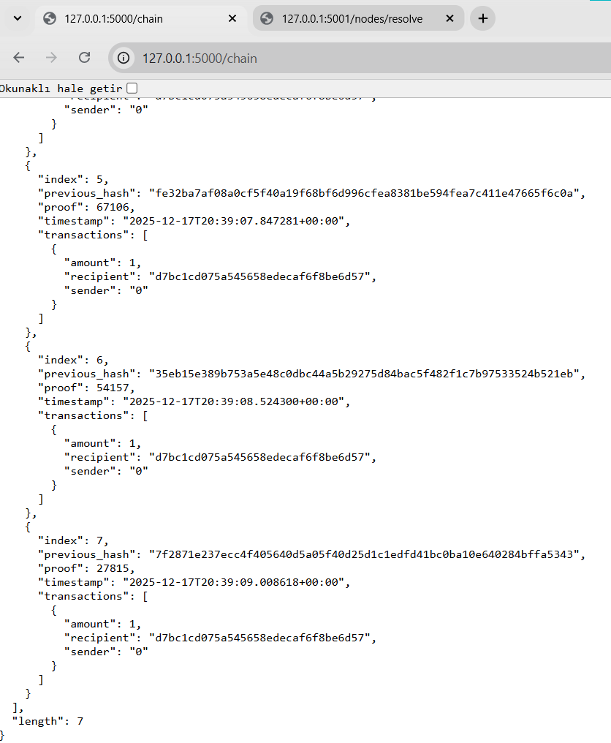

10.2 Tampering Detection
- Manual modification of transaction data
- valid_chain() returns false

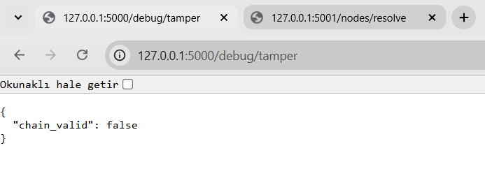

10.3 Consensus Validation
- Fork resolution works correctly
- Network consistency is preserved

11. Limitations
- No persistent storage (in-memory only)
- No digital signatures for transactions
- No peer discovery mechanism
- Fixed difficulty level
These limitations are acceptable given the project’s academic and demonstrative nature.

12. Future Work
Possible extensions include:
- Persistent storage (database or file-based)
- Public/private key cryptography
- Dynamic difficulty adjustment
- Smart contract support
- Web-based UI dashboard

13. Conclusion
This project successfully implements a fully functional private blockchain system using Python. All core blockchain concepts—hash chaining, Proof of Work, transaction integrity, REST APIs, multi-node operation, and consensus—have been practically demonstrated.
The system validates the theoretical concepts presented in the Project Technical Documentation and provides a strong foundation for further blockchain research and development.

