Oil Market Weekly Update
13 August 2026 · Data as of 11:10 Paris time
Risk premium returns as Hormuz talks stall, while a large inventory build caps the rally.

Macro & oil market
The previous week, Brent front-month futures fell sharply from a July 31 close of $90.12/b to an Aug. 7 close of $83.55/b, a 7.3% decline. Investors reduced the geopolitical risk premium as Iran and Oman appeared closer to an arrangement that could facilitate traffic through the Strait of Hormuz. This optimism outweighed the continuing disruption to physical oil flows.
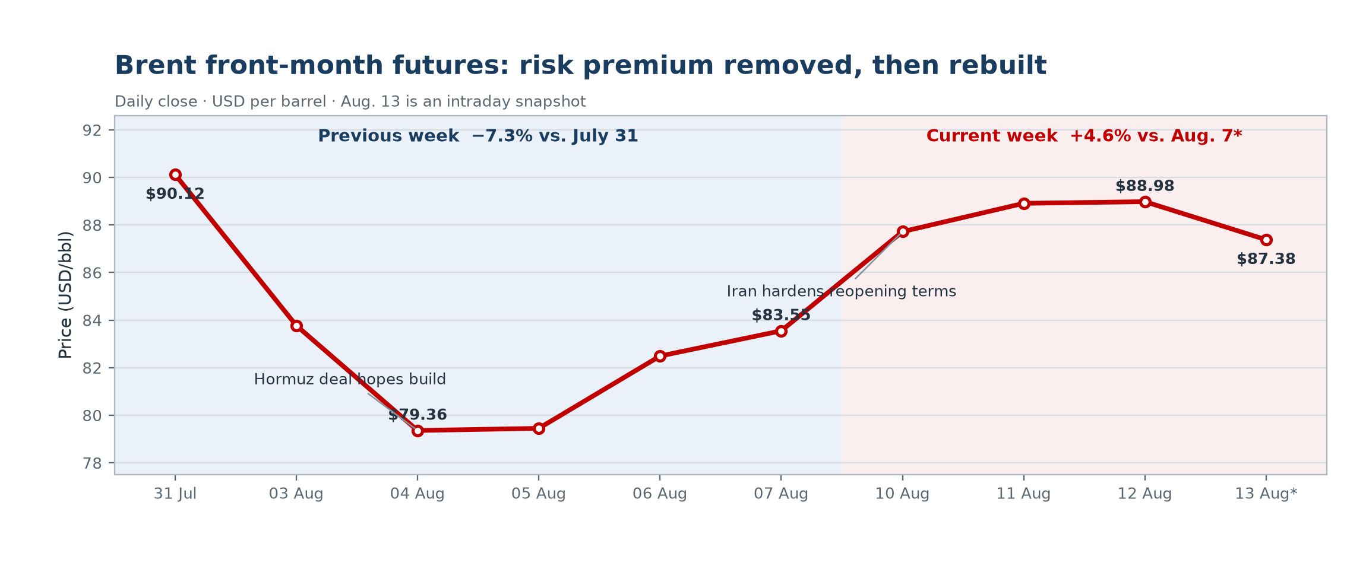
Figure 1 · Brent front-month futures. Daily close in USD/bbl; Aug. 13 is an intraday snapshot. Source: Yahoo Finance (BZ=F).

Macro & oil market · continued
However, sentiment reversed quickly this week. The stringent conditions set by Iran for reopening Hormuz, combined with renewed attacks on vessels and Saudi energy infrastructure, revived supply concerns. Brent consequently closed at $88.98/b on Aug. 12, 6.5% above the previous Friday’s close. Against this backdrop, the IEA estimates that the global oil market deficit could reach 1.8 mb/d in the third quarter.
Nevertheless, the rally lost momentum this Thursday Aug. 13, with Brent trading around $87.38/b intraday. A 17.4 mb increase in US commercial crude inventories, together with downward revisions to 2026 demand from OPEC and the IEA, capped the upside. Investors are now monitoring US–Iran negotiations and actual traffic through Hormuz: a credible agreement would weigh on prices, while a prolonged closure would preserve a substantial geopolitical premium.
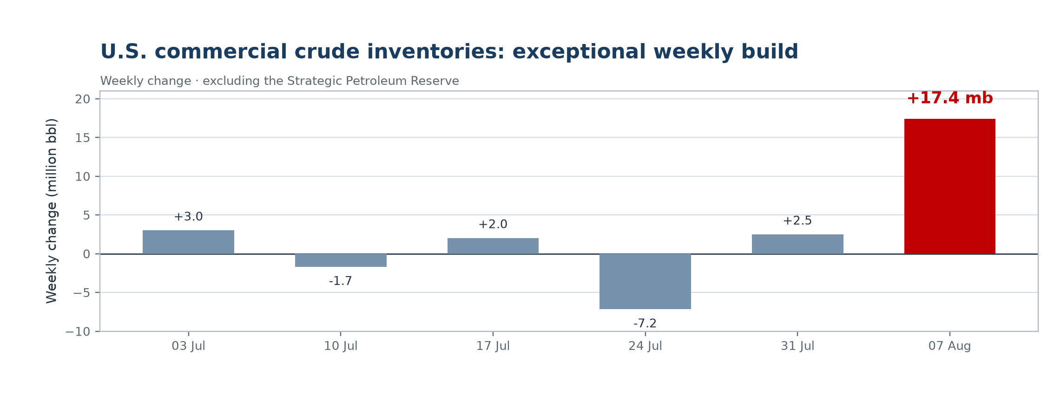
Figure 2 · Weekly change in U.S. commercial crude inventories, excluding the Strategic Petroleum Reserve. Source: U.S. EIA, released Aug. 12, 2026.

Sources
Yahoo Finance · Brent Crude Oil Last Day Financial (BZ=F), historical data
Oil & Gas Journal · Crude falls on possible Hormuz arrangement · Aug. 7, 2026
OilPrice.com · Oil Prices Rise as Iran Hardens Hormuz Demands · Aug. 10, 2026
U.S. EIA · Weekly U.S. commercial crude inventories excluding SPR
Oil & Gas Journal · IEA revises down 2026 oil demand forecast · Aug. 12, 2026
OilPrice.com · Oil Prices Fall as OPEC and IEA Slash 2026 Demand Outlooks · Aug. 13, 2026

