| Песен | Can You Hear Me | Knives | As Above, So Below | Chemical Shore | Ich hasse Kinder |
| --- | --- | --- | --- | --- | --- |
| Изпълнител | Korn | Bullet For My Valentine | In This Moment | HYPOCRISY | Till Lindemann |
| Албум | The Nothing | Knives | Mother | WORSHIP |  |
| Гледания до момента | 5 159 433 | 1 802 241 | 3 195 557 | 734 448 | 14 732 372 |
| Дата на качване | 20.03.2020 г. | 18.06.2021 г | 28.10.2020 г. | 10.09.2021 г. | 1.06.2021 г. |

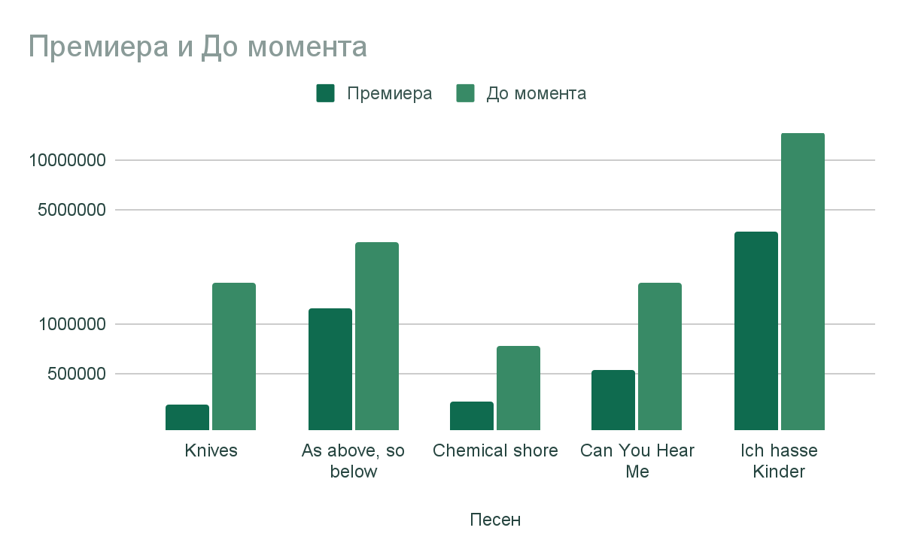

| Дата/Песен | Knives | As above, so below | Chemical shore | Can You Hear Me | Ich hasse Kinder |
| --- | --- | --- | --- | --- | --- |
| 19.10.2021г. | 1 795 642 | 3 152 756 | 730 175 | 5 155 227 | 14 710 573 |
| 20.10.2021г. | 1 798 000 | 3 155 345 | 730 799 | 5 155 775 | 14 714 135 |
| 21.10.2021г. | 1 798 752 | 3 156 941 | 731 427 | 5 156 762 | 14 716 500 |
| 22.10.2021г. | 1 799 897 | 3 158 580 | 731 885 | 5 157 420 | 14 723 098 |
| 23.10.2021г. | 1 800 679 | 3 160 069 | 732 670 | 5 158 077 | 14 725 787 |
| 24.10.2021г. | 1 801 575 | 3 163 558 | 733 569 | 5 158 545 | 14 730 683 |
| 25.10.2021г. | 1 802 241 | 3 195 557 | 734 448 | 5 159 433 | 14 732 372 |

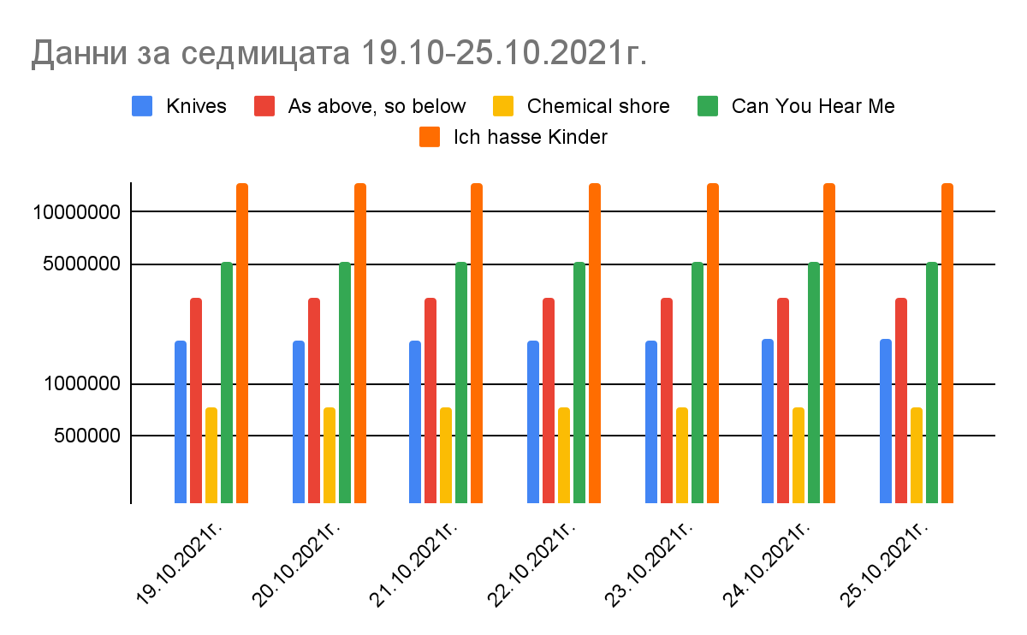

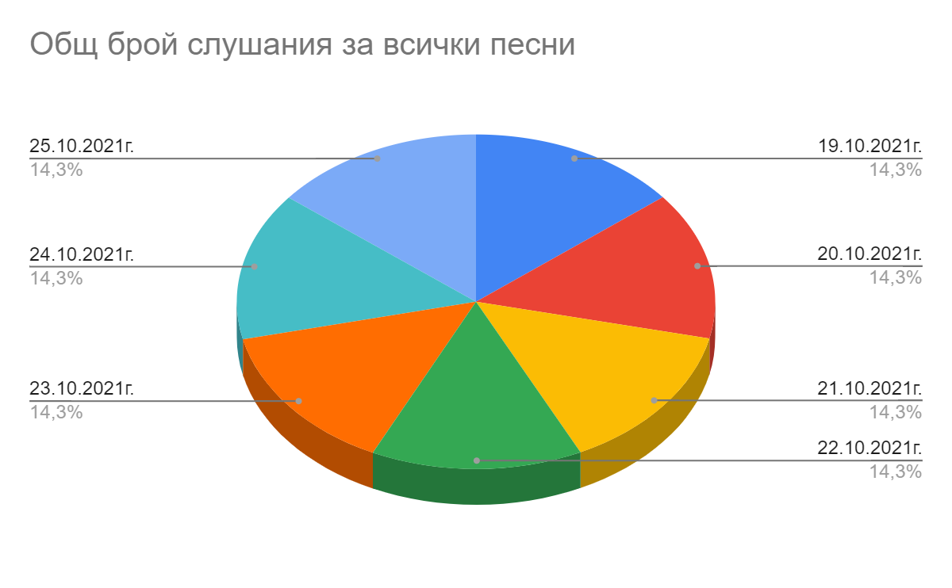

Credits:

Songs:In This Moment - "As Above, So Below" -<https://youtu.be/RZYzcPwQN-8>

Bullet For My Valentine - Knives-<https://youtu.be/gEhek9yusks>

Korn - Can You Hear Me - <https://youtu.be/Dgs2SYBPKMI>

HYPOCRISY - Chemical shore-<https://www.youtube.com/watch?v=uJRUq90EC_A>

Till Lindemann - Ich hasse Kinder -<https://youtu.be/GbfeH6Q8PzY>