

INTRODUCTION TO MOBILE APPLICATION DEVELOPMENT
IMAD5112
Semester 1 –2026
Practicum Exam

Student name :Yoane Sebastião
Student number :ST10543853
Programme :Higher Certificate in Mobile Application and web development

Table of Contents
1. Project Overview 3
2. Main Features 3
3. Technologies Used 3
4. Sample Weekly Budget 3
5. Programming Logic and Implementation 3
5.1 Parallel Arrays 3
5.2 Loops 4
5.3 Budget Calculations 4
5.4 Screen Navigation 4
6. Application Screenshots 5
6.1 Splash Screen 5
6.2 Main Screen 6
6.3 View All Spending 7
6.4 Budget Calculation 8
7. How to Run the Project 8
8. Source Code Repository 8
References 9

SPENDING TRACKER
Android Application – Project Documentation

1. Project Overview
Spending Tracker is an Android application developed in Kotlin using Jetpack Compose. It helps users review a seven-day spending plan by displaying each day's budget, amount spent, comments, and remaining balance.

2. Main Features
- Splash screen introducing the Spending Tracker application.
- Main screen displaying the total weekly budget and navigation options.
- View All Spending screen showing the daily budget, spending amount, and comment for each of seven days.
- Budget Calculation screen calculating the remaining amount for each day.
- Visual indication of remaining balances: green for zero or positive balances and red when spending exceeds the daily budget.
- Weekly remaining balance calculated from the daily balances.

3. Technologies Used
- Programming language: Kotlin
- Development environment: Android Studio
- User interface: Jetpack Compose
- Build system: Gradle

4. Sample Weekly Budget
The current sample data contains seven daily budgets and spending amounts. The total weekly budget displayed by the application is R2,550. The calculated total weekly remaining balance is R880.

5. Programming Logic and Implementation

5.1 Parallel Arrays
The application uses four parallel arrays, each containing seven elements:
- dates stores the dates of the spending records.
- dailyBudget stores the budget allocated for each day.
- dailySpent stores the amount spent each day.
- comments stores descriptions of the daily expenses.
The arrays are parallel because the elements at the same index position belong to the same spending record. For example, index 0 represents the first day's date, budget, spending and comment.

5.2 Loops
The application uses a for loop with dates.indices to access all seven records.
The loop uses the same index to retrieve information from the four arrays and display each daily spending record.
Another loop is used to calculate the remaining budget for each day.

5.3 Budget Calculations
The remaining daily budget is calculated by subtracting the amount spent from the allocated daily budget.
Formula:
Remaining Budget = Daily Budget - Daily Spent
The application also adds the daily remaining balances to calculate the total weekly remaining budget.
For example:
- Total Weekly Budget: R2,550
- Total Weekly Spending: R1,670
- Total Weekly Remaining: R880
If the remaining balance is negative, the application displays it in red to indicate that the daily budget was exceeded. Positive or zero balances are displayed in green.

5.4 Screen Navigation
The application uses Jetpack Compose to display its screens.
The main screen provides buttons that allow users to navigate to the View All Spending screen and Budget Calculation screen.
A back button allows users to return to the main screen. The Exit button closes the application.

6. Application Screenshots

6.1 Splash Screen
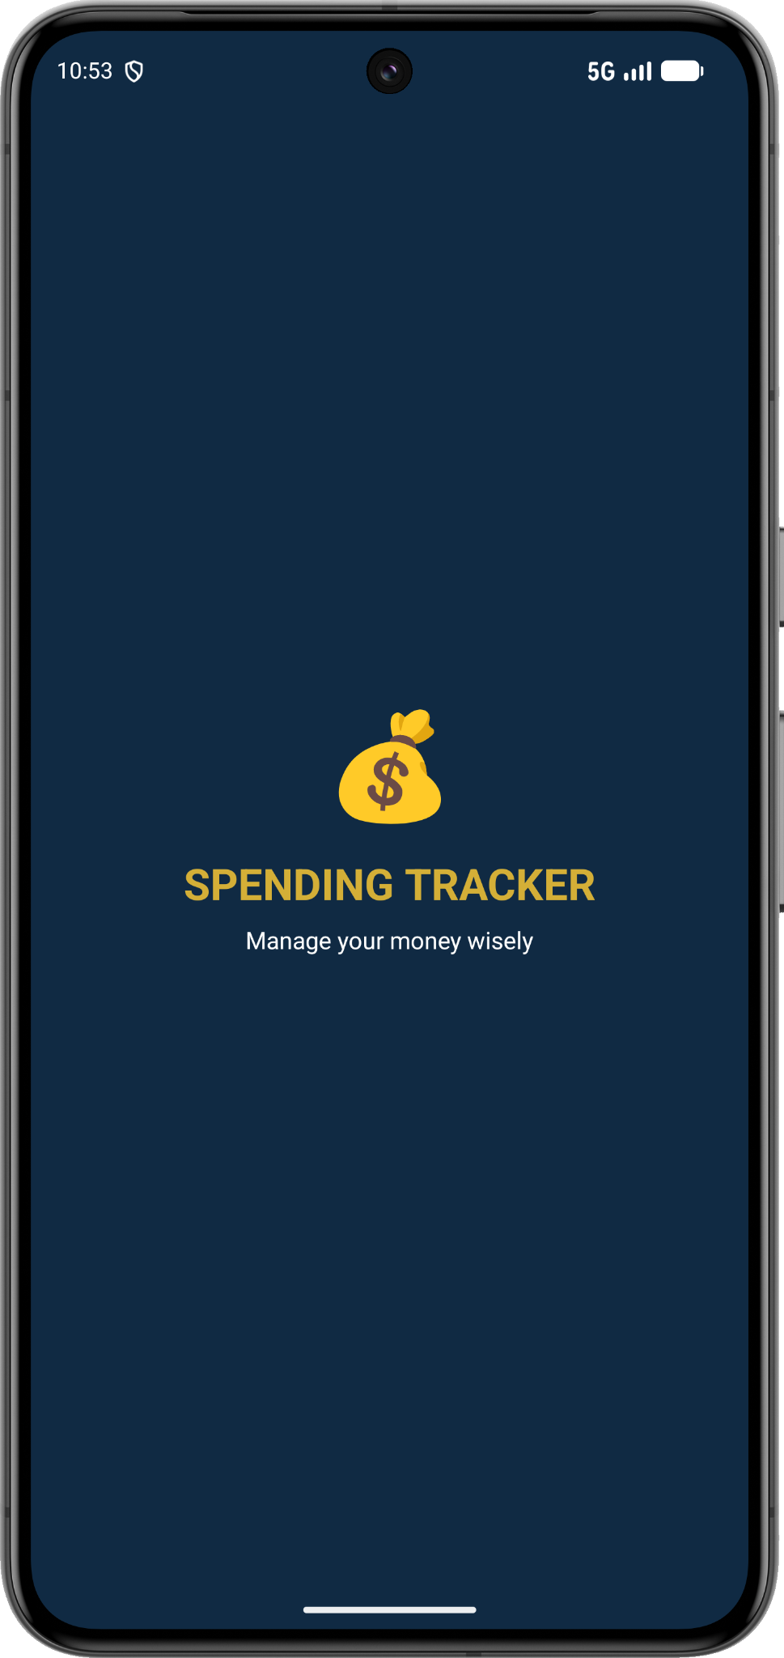
The opening screen displays the application name and the message “Manage your money wisely.”

6.2 Main Screen
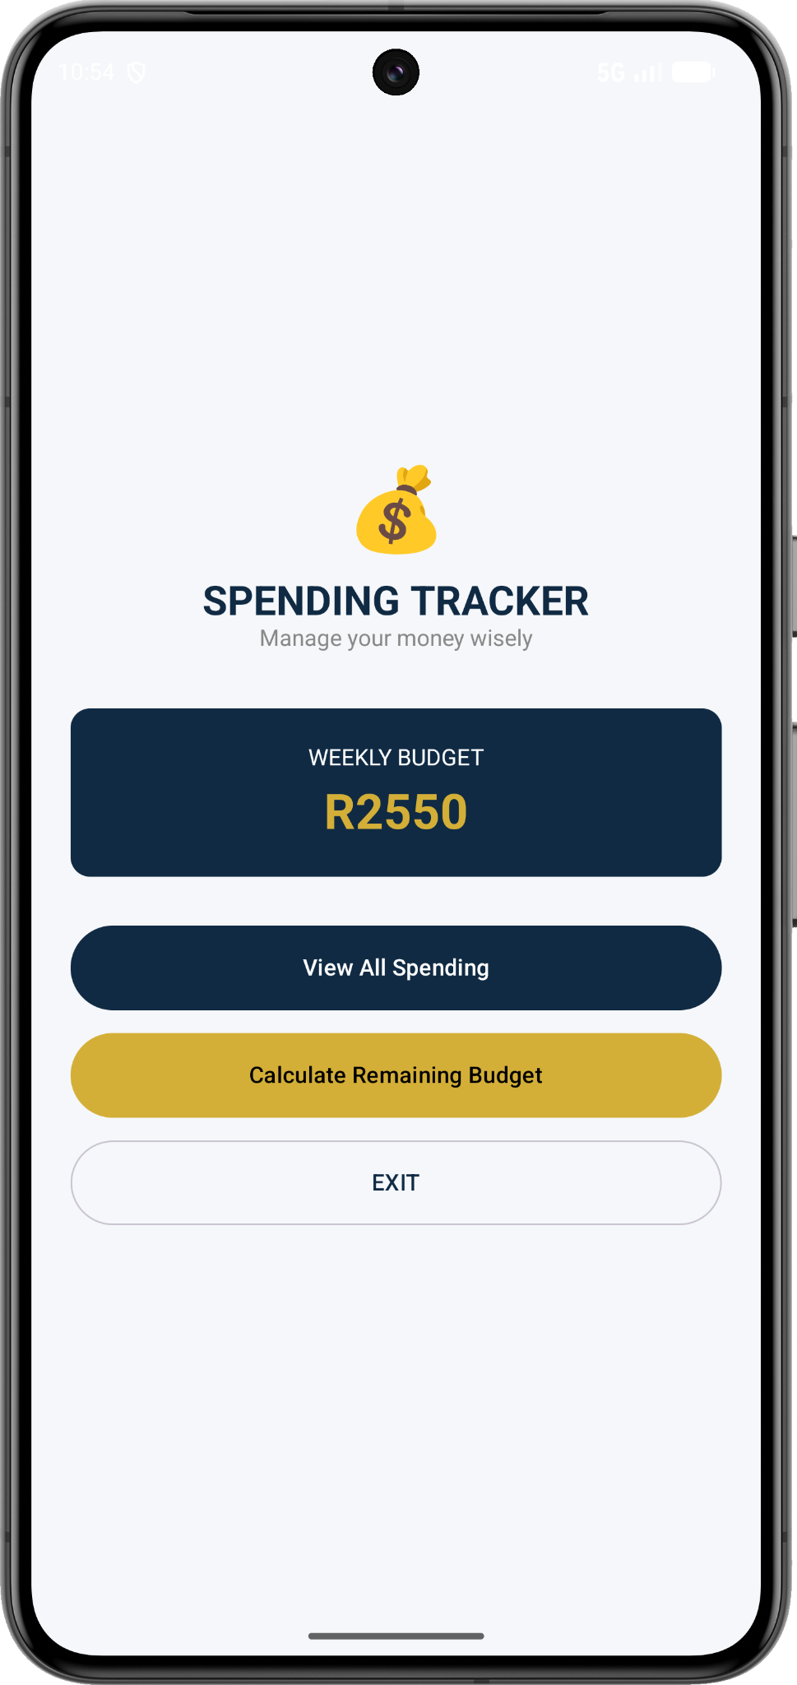
The main screen displays the weekly budget and provides navigation to the spending list and budget calculation.

6.3 View All Spending
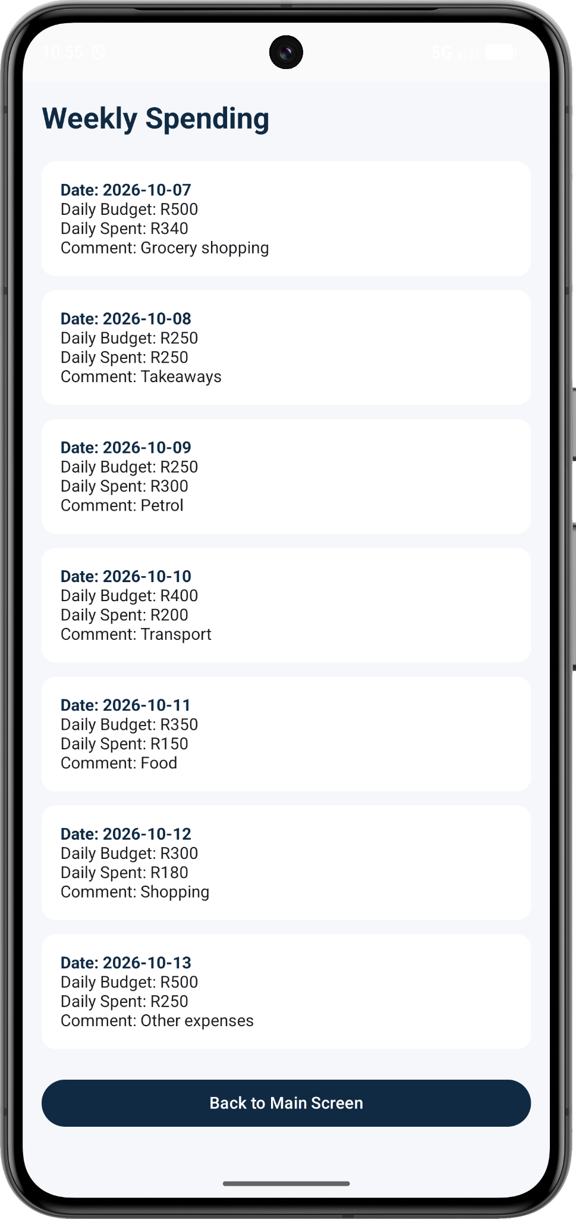
This screen lists the seven days with each date, daily budget, daily spending, and comment.

6.4 Budget Calculation
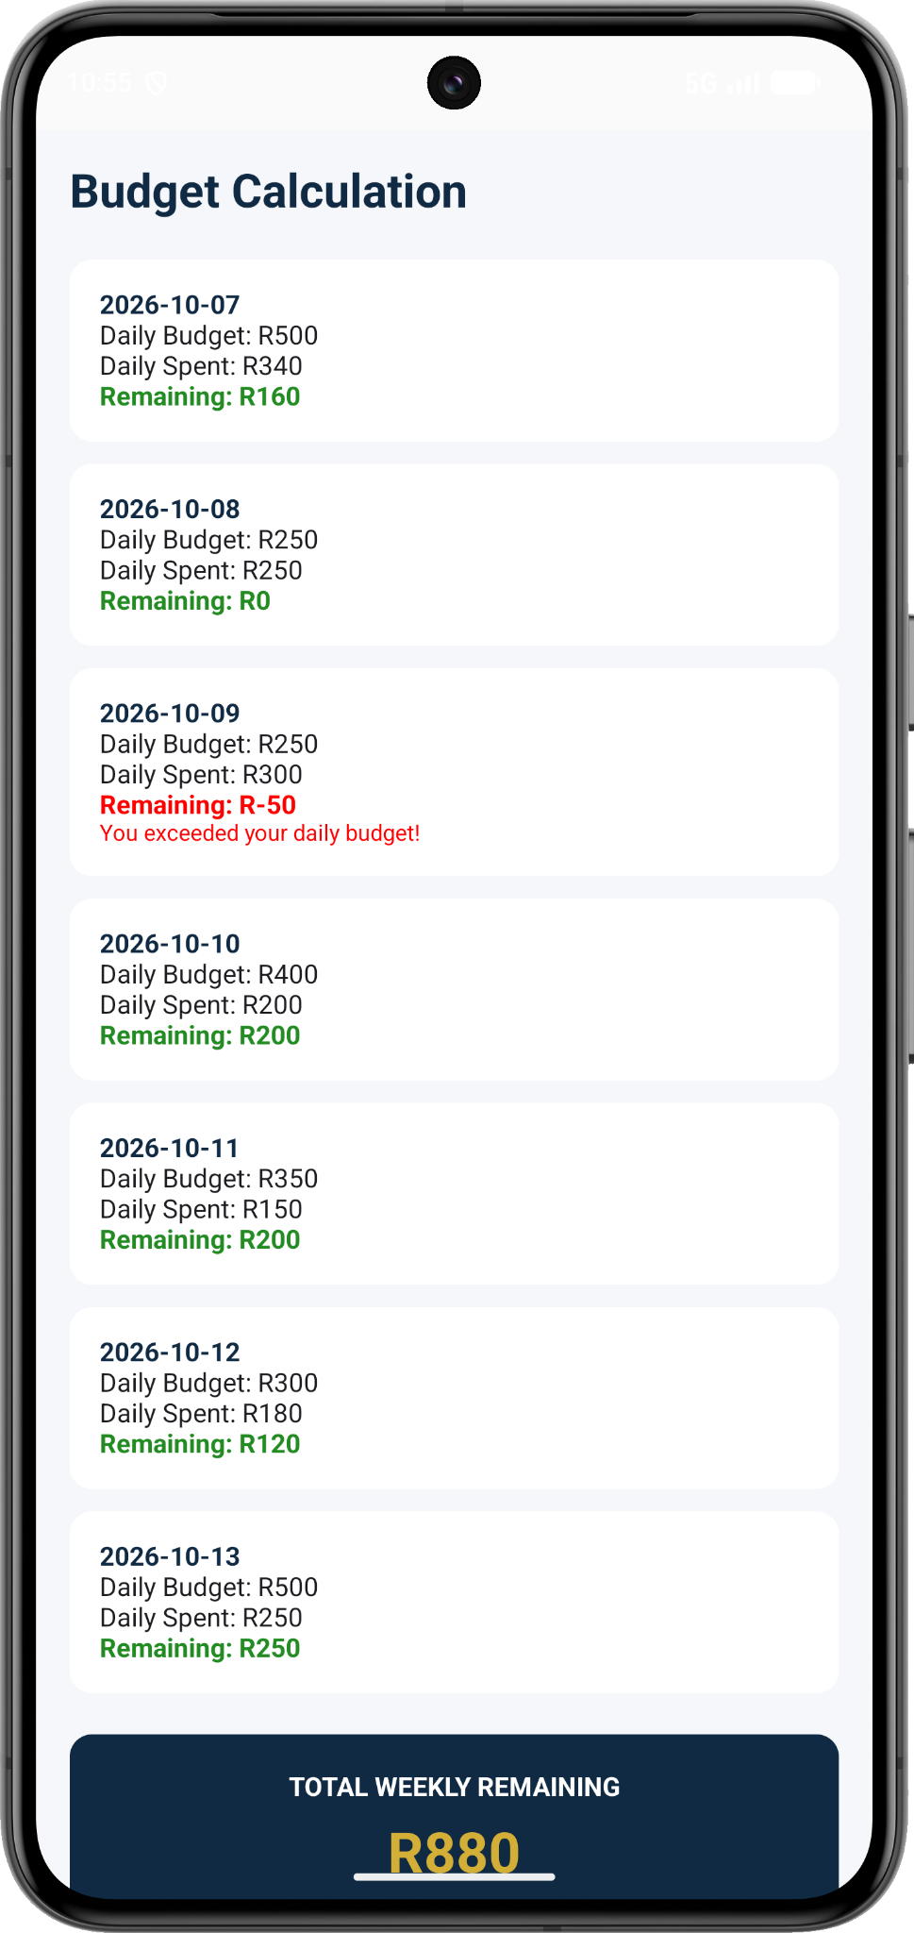
This screen displays each day's remaining balance and the total weekly remaining balance of R880.

7. How to Run the Project
- Open Android Studio.
- Select Open and choose the SpendingTracker project folder.
- Allow Gradle to sync and finish downloading any required dependencies.
- Start an Android emulator or connect an Android device with USB debugging enabled.
- Select the app run configuration and click Run.

8. Source Code Repository
GitHub: https://github.com/YoaneSebastiao/SpendingTracker
Note: The application screenshots show the current sample data used for demonstration. The weekly figures shown are based on that sample data.

References
Google (n.d.) Kotlin documentation. Available at: https://kotlinlang.org/docs/home.html (Accessed: 9 November 2026).
Google (n.d.) Jetpack Compose documentation. Available at: https://developer.android.com/compose (Accessed: 9 November 2026).

