

Alarm Incident Management System (SIGIAL).

Author:
- Yoangel Rondón Bolúa.

Professor: Dr. Omar Ali Zatarain Durán.
Class: Software Configuration Management.
Career: Master's Degree in Software Engineering.
Edition: 2025A.

Table of Contents
FORMAL DEFINITION OF THE SYSTEM (BASELINE). 1
SHORT DESCRIPTION OF THE PROJECT. 1
SYSTEM SCOPE. 1
SYSTEM ACTORS. 2
SYSTEM MODULES (SIGIAL). 2
M1. User Management and Security. 2
M2. Account and Company Management. 3
M3. Alarm Management. 3
M4. Incident Management. 3
M5. Incident Monitoring and Control. 4
M6. Communication and Notifications. 4
M7. Reporting and Auditing. 4
FUNCTIONAL REQUIREMENTS (GENERAL STRUCTURE ). 5
Module M1 – User Management and Security. (RF-01 to RF-06) 5
Module M2 – Account and Company Management. (RF-07 to RF-10) 6
M3 Module – Alarm Management. (RF-11 to RF-15) 6
Module M4 – Incident Management. (RF-16 to RF-20) 6
Module M5 – Incident Tracking and Control. (RF-21 to RF-32) 6
M6 Module – Communication and Notifications. (RF-33 to RF-40) 7
Module M7 – Reports and Audits. (RF-41 to RF-50) 7
NON-FUNCTIONAL REQUIREMENTS (GENERAL STRUCTURE ). 8
Security. (RNF-01 to RNF-05) 8
Performance. (RNF-06 to RNF-09) 9
Availability. (RNF-10 to RNF-12) 9
Traceability and Auditing. (RNF-13 to RNF-15) 9
Usability. (RNF-16 to RNF-17) 9
Maintainability and Scalability. (RNF-18 to RNF-20) 9
REQUIREMENTS ANALYSIS 10
Classification of requirements. 10
Prioritization of requirements. 10
Dependencies between Requirements. 11
ASSUMPTIONS AND RESTRICTIONS: 12
Assumptions. 12
Restrictions. 12
SYSTEM DESIGN 12
1. Presentation Layer (Web). 13
2. Service Layer / Business Logic. 13
3. Integration Layer with Alarm Systems. 14
4. Persistence Layer. 14
5. Transversals infrastructure services. 15
CONFIGURATION ORGANIZATION AND MANAGEMENT 18
Project Organizational Structure. 18
SIGIAL Project Activity Schedule 20

Tabla 1. The Funtional Requirements for Modules. 5
Tabla 2. The Non-funcional Requirements. 8

Figura 1. The System Modules. 2
Figura 2. The System Modules Relation. 5
Figura 3. The Architecture View. 16

FORMAL DEFINITION OF THE SYSTEM (BASELINE).

System Name: Alarm Incident Management System (SIGIAL).

SHORT DESCRIPTION OF THE PROJECT.
The Alarm Incident Management System (SIGIAL) is a platform designed to support an alarm monitoring center in the administration, tracking and control of incidents generated by alarms belonging to the company and those subcontracted by other companies.
The system allows recording incidents associated with false activations, technical failures or operational problems detected during alarm monitoring, providing complete traceability of the actions taken, communications with account managers and the resolution status of each incident.
SIGIAL is designed to operate in high-load operational environments, with more than a thousand active accounts, guaranteeing control, order, history and visibility of the incident handling process, reducing operational errors and improving coordination between the monitoring center and subcontracted companies.

SYSTEM SCOPE.
The system covers:
- Management of own and subcontracted accounts.
- Recording and classification of alarm incidents.
- Incident lifecycle monitoring.
- Record of communications and actions.
- Generation of operational and audit reports.

The system does not include:
- Physical control of alarm devices.
- Direct intervention on the hardware.
- Billing or commercial contracts.

SYSTEM ACTORS.
Clearly identified actors:
- System administrator.
- Monitoring center operator.
- Supervisor of the monitoring center.
- Representative of subcontracted company.
- Softguard . Alarm monitoring system (external actor).

SYSTEM MODULES (SIGIAL).
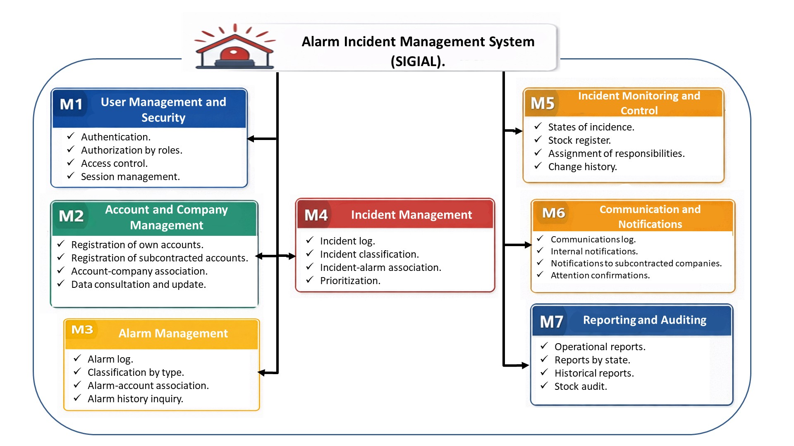
Figura 1. The System Modules.

M1. User Management and Security. (Responsible for controlling who enters and what they can do.)
Key functions:
- Authentication.
- Authorization by roles.
- Access control.
- Session management.
Actors: Administrator, Operator, Supervisor
Impact: Security, audit, compliance

M2. Account and Company Management. (Manages alarm accounts and their relationship with third parties.)
Key functions:
- Registration of own accounts.
- Registration of subcontracted accounts.
- Account-company association.
- Data consultation and update.
Actors: Administrator, Supervisor.
Impact: Scalability and domain organization.

M3. Alarm Management. (Centralizes information from monitored alarms. )
Key functions:
- Alarm log.
- Classification by type.
- Alarm-account association.
- Alarm history inquiry.
Actors: Operator, External System.
Impact: System operational basis.

M4. Incident Management. (Core of the system. Center of the problem we solve. )
Key functions:
- Incident log.
- Incident classification.
- Incident-alarm association.
- Prioritization.
Actors: Operator, Supervisor.
Impact: Operational control and traceability.

M5. Incident Monitoring and Control. (It allows control of the entire life cycle. )
Key functions:
- States of incidence.
- Stock register.
- Assignment of responsibilities.
- Change history.
Actors: Operator, Supervisor.
Impact: Traceability and auditing.

M6. Communication and Notifications. (Supports interaction with third parties. )
Key functions:
- Communications log.
- Internal notifications.
- Notifications to subcontracted companies.
- Attention confirmations.
Actors: Operator, Subcontracted company.
Impact: Coordination and error reduction.

M7. Reporting and Auditing. (Control and continuous improvement layer.)
Key functions:
- Operational reports.
- Reports by state.
- Historical reports.
- Stock audit.
Actors: Supervisor, Administrator.
Impact: Decision-making and control.

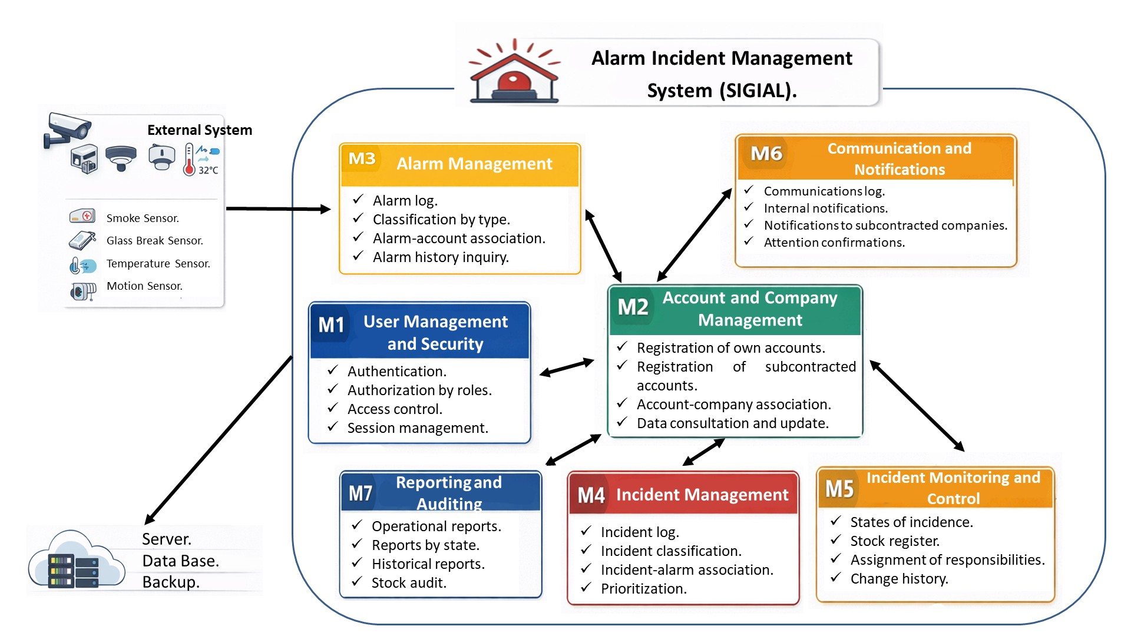
Figura 2. The System Modules Relation.

FUNCTIONAL REQUIREMENTS (GENERAL STRUCTURE ).
Tabla 1. The Funtional Requirements for Modules.
Module | Description | RF
M1 | User Management and Security | RF-01 to RF-06
M2 | Account and Business Management | RF-07 to RF-10
M3 | Alarm Management​ | RF-11 to RF-15
M4 | Incident Management​ | RF-16 to RF-20
M5 | Incident Tracking and Control | RF-21 to RF-32
M6 | Communication and Notifications | RF-33 to RF-40
M7 | Reports and Audits | RF-41 to RF-50

Module M1 – User Management and Security. (RF-01 to RF-06)
- RF-01. The system must allow users to register with unique access credentials.
- RF-02. The system must allow assigning a defined role to each user within the system.
- RF-03. The system must allow users to be authenticated using a username and password.
- RF-04. The system must allow restricting access to functionalities according to the user's role.
- RF-05. The system must allow modification of registered user information.
- RF-06. The system must allow users to be deactivated without deleting the history of actions performed.

Module M2 – Account and Company Management. (RF-07 to RF-10)
- RF-07. The system must allow the registration of alarm accounts specific to the monitoring center.
- RF-08. The system must allow the registration of alarm accounts belonging to subcontracted companies.
- RF-09. The system must allow associating an alarm account with a subcontracted company.
- RF-10. The system must allow viewing detailed information about a registered account.

M3 Module – Alarm Management. (RF-11 to RF-15)
- RF-11. The system must allow the registration of alarms associated with an account.
- RF-12. The system must allow alarms to be classified according to their type.
- RF-13. The system must allow associating an alarm with a subcontracted company when applicable.
- RF-14. The system must allow consulting the activation history of an alarm.
- RF-15. The system must allow updating the information of a registered alarm.

Module M4 – Incident Management. (RF-16 to RF-20)
- RF-16. The system must allow recording an incident associated with a specific alarm.
- RF-17. The system must allow incidents to be classified according to their type or nature.
- RF-18. The system must allow assigning a priority level to each recorded incident.
- RF-19. The system must allow associating an incident with a specific alarm account.
- RF-20. The system must allow recording the date and time of creation of each incident.

Module M5 – Incident Tracking and Control. (RF-21 to RF-32)
- RF-21. The system must allow assigning a responsible party to each recorded incident.
- RF-22. The system must allow defining and managing the states of an incident.
- RF-23. The system must allow changing the status of an incident during its life cycle.
- RF-24. The system must allow recording the date and time of each status change of an incident.
- RF-25. The system must allow recording the actions taken on an incident.
- RF-26. The system must allow maintaining a complete history of changes to an incident.
- RF-27. The system must allow reassigning an incident to another responsible party.
- RF-28. The system must allow checking incidents according to their current status.
- RF-29. The system must allow users to check incidents according to their priority level.
- RF-30. The system must allow an incident to be closed when it has been resolved.
- RF-31. The system must allow reopening a previously closed incident.
- RF-32. The system must allow a supervisor to validate the closure of an incident.

M6 Module – Communication and Notifications. (RF-33 to RF-40)
- RF-33. The system must allow recording of communications made in the context of an incident.
- RF-34. The system must allow each communication to be associated with a specific incident.
- RF-35. The system must allow internal managers to be notified when an incident is assigned to them.
- RF-36. The system must allow subcontracted companies to be notified about incidents related to their accounts.
- RF-37. The system must allow recording the date and time of each communication sent.
- RF-38. The system must allow recording the medium used for each communication.
- RF-39. The system must allow consulting the communication history associated with an incident.
- RF-40. The system must allow confirmation of receipt of a notification by the recipient.

Module M7 – Reports and Audits. (RF-41 to RF-50)
- RF-41. The system must allow generating incident reports by time period.
- RF-42. The system must allow generating incident reports according to their status.
- RF-43. The system must allow generating incident reports by alarm account or subcontracted company.
- RF-44. The system must allow generating incident reports according to their priority level.
- RF-45. The system must allow consulting statistics on incident response times.
- RF-46. The system must allow exporting reports in standard digital formats.
- RF-47. The system must allow auditing of actions performed by system users.
- RF-48. The system must allow consulting the history of actions performed by a user.
- RF-49. The system must allow restricting access to reports according to the user's role.
- RF-50. The system must allow for the preservation of historical incident records for auditing purposes.

NON-FUNCTIONAL REQUIREMENTS (GENERAL STRUCTURE ).
In the context of the Alarm Incident Management System for Subcontracted Monitoring Centers (SIGIAL), the RNFs are grouped by quality attributes.

Tabla 2. The Non-funcional Requirements.
Quality attribute​ | RNF Code
Security | RNF-01 to RNF-05
Performance | RNF-06 to RNF-09
Availability | RNF-10 to RNF-12
Traceability and Auditing | RNF-13 to RNF-15
Usability | RNF-16 to RNF-17
Maintainability and Scalability | RNF-18 to RNF-20

Security. (RNF-01 to RNF-05)
- RNF-01. The system must guarantee that access to its functionalities is protected by mandatory authentication.
- RNF-02. The system must ensure that user credentials are stored securely.
- RNF-03. The system must restrict access to information according to the user's role.
- RNF-04. The system must record failed authentication attempts for auditing purposes.
- RNF-05. The system must guarantee the confidentiality of account information and incidents.

Performance. (RNF-06 to RNF-09)
- RNF-06. The system must allow the recording of incidents without affecting the normal operation of the monitoring.
- RNF-07. The system must respond to incident queries in a timely manner for the operation.
- RNF-08. The system must support the simultaneous management of more than a thousand alarm accounts.
- RNF-09. The system must maintain stable performance during periods of high operational load.

Availability. (RNF-10 to RNF-12)
- RNF-10. The system must be available during the operating hours of the monitoring center.
- RNF-11. The system must allow for the recovery of information in case of system failures.
- RNF-12. The system must guarantee the integrity of the information in the event of unexpected interruptions.

Traceability and Auditing. (RNF-13 to RNF-15)
- RNF-13. The system must guarantee complete traceability of incidents throughout its life cycle.
- RNF-14. The system must retain historical records of actions for subsequent audits.
- RNF-15. The system must allow the identification of the user responsible for each recorded action.

Usability. (RNF-16 to RNF-17)
- RNF-16. The system must have a clear interface that facilitates incident management by operators.
- RNF-17. The system must minimize the number of steps required to register and update an incident.

Maintainability and Scalability. (RNF-18 to RNF-20)
- RNF-18. The system must allow the incorporation of new types of alarms without affecting existing functionalities.
- RNF-19. The system must facilitate maintenance through a modular architecture.
- RNF-20. The system must allow scaling the number of managed accounts without compromising its stability.

REQUIREMENTS ANALYSIS

Classification of requirements.
The requirements of the SIGIAL system are classified into two main groups:
- Functional Requirements (FR): Define the behavior and functionalities that the system must offer.
- Non-Functional Requirements (NFR): Define quality attributes, constraints, and conditions under which the system must operate.

Prioritization of requirements.
Prioritization was performed considering operational impact, domain criticality, and functional dependencies. The following priority scale was used:
- High (A): Essential requirements for system operation.
- Media (M): Important requirements that improve or optimize operation and communication, but do not impede its basic functioning.
- Low (B): Complementary or support requirements, aimed at improving and evolving the system.
Prioritization Summary:
- High Priority:
- RF related to:
- User management and security (Module 1).
- Account and company management.
- Alarm and incident log (Module 3 and Module 4).
- Incident monitoring and control (Module 5).
- RNF related to:
- Security.
- Availability.
- Traceability and Auditing.
- Medium Priority:
- RF related to:
- Communication and notifications (Module 6).
- Basic operational reports (Module 7).
- RNF related to:
- Performance.
- Usability.
- Low Priority:
- RF related to:
- Export functionalities and historical analysis.
- RNF related to:
- Maintainability and scalability.

Dependencies between Requirements.
Clear dependencies were identified between different groups of requirements:
- The requirements of Module 5 (Incident Tracking and Control) depend on the correct implementation of:
- Alarm management (Module 3).
- Incident Management (Module 4).
- The requirements for Module 6 (Communication and Notifications) depend on:
- Existence of recorded incidents.
- Assignment of responsibilities.
- The requirements for Module 7 (Reporting and Auditing) depend on:
- Historical record of actions.
- Traceability of incidents and users.

In addition, the following risks associated with the requirements were identified during the analysis:
- Risk of operational overload.
- A high volume of accounts and incidents can affect system performance if performance and scalability RNFs are not considered.
- Risk of loss of traceability.
- The absence of detailed records of changes and actions could hinder audits and incident tracking.
- Security risk.
- Inadequate access control could expose sensitive information from monitored accounts.

These risks are mitigated by ensuring proper implementation of security, traceability, and access control requirements.

ASSUMPTIONS AND RESTRICTIONS:

Assumptions.
- The system will be used by trained personnel at the monitoring center.
- Subcontracted companies will have defined channels to receive notifications.
- The system will operate in an environment controlled by the organization.

Restrictions.
- The system does not interact directly with the alarm hardware.
- The scope of the system is limited to the management and monitoring of incidents.
- The implementation must respect the defined modular architecture.

SYSTEM DESIGN
General approach to architecture.
The SIGIAL system is designed under a distributed web architecture in the cloud, oriented to:
- High availability.
- Immediate response to alarm events.
- Horizontal scalability.
- Clear separation of responsibilities.

Type of architecture.
Layered architecture with decoupled services (enterprise web style)

High-level view.
At a macro level, the system consists of:
- Presentation Layer.
- Service Layer / Business Logic.
- Integration Layer with Alarm Systems.
- Persistence Layer.
- cross-cutting infrastructure services.

Presentation Layer (Web).
Characteristics :
- Web application accessible via browser.
- Interface geared towards central operator.
- Secure communication with the backend.
Responsibilities.
- User authentication.
- Display of alarms and incidents.
- Daily operational management.
- Report consultation.
Functional modules from the user's point of view:
- Users.
- Accounts.
- Alarms.
- Incidents.
- Follow-up.
- Reports.

Service Layer / Business Logic.
Logical services aligned to modules:
- User and Security Service (Module 1).
- Accounts and Business Service (Module 2).
- Alarm Service (Module 3).
- Incident Service (Module 4).
- Monitoring and Control Service (Module 5).
- Communications Service (Module 6).
- Reporting and Auditing Service (Module 7).
Key responsibilities:
- Business rule validation.
- Incident status control.
- Traceability of actions.
- Orchestration of operational flows.

Integration Layer with Alarm Systems.
Characteristics:
- Communication with external alarm systems.
- Near real-time event reception.
- Processing of false activations.
Conceptual mechanisms:
- Integration interfaces.
- Secure communication channels.
- Asynchronous event processing.
Important Note:
The system does not control the hardware, it only consumes and manages events, consistent with the defined scope.

Persistence Layer.
Function.
Centralized storage of:
- Users.
- Accounts.
- Alarms.
- Incidents.
- Histories.
- Audit.
Design considerations.
- critical data replicated.
- Information integrity.
- Support for operational and historical queries.

Transversals infrastructure services.
Conceptual services included:
- Load balancing.
- System monitoring.
- Fault management.
- Automatic backups.
- Scalability on demand.

The proposed design for the SIGIAL system is based on a distributed cloud-based web architecture, designed to ensure high availability, scalability, and appropriate response times for an alarm monitoring center. The separation of layers and services facilitates traceability, maintenance, and system configuration management.

System Architecture Diagram (formal description)
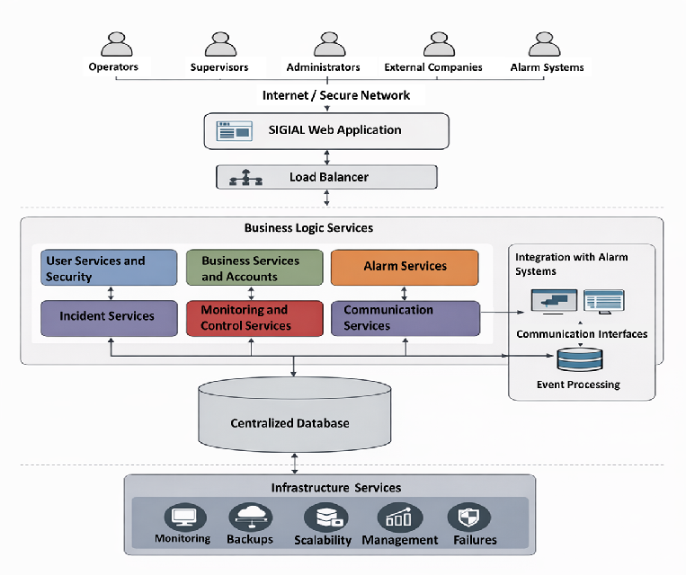
Figura 3. The Architecture View.

Overview of the architecture

The SIGIAL system is implemented as a distributed web system in the cloud, organized in layers, with decoupled services and redundant components to ensure high availability and low latency.

Main components of the diagram (from top to bottom)
1. Users / External Systems.
- Central operators.
- Supervisors.
- Administrators.
- Subcontracted companies.
- External alarm systems.
Note: They access via a secure network.

2. Presentation Layer (Web).
- SIGIAL Web Application.
- Access via browser.
- Real-time operational interface.
- User management, alarms and incidents.
Note: Secure communication (HTTPS)

3. Load Balancer.
- Distributes requests among backend instances.
- It allows for high availability.
- It supports peak loads.
Note: Redirects to available services.

4. Service Layer / Business Logic.
Decoupled logical services, aligned to the system modules:
- User and Security Service (Module 1).
- Accounts and Business Service (Module 2).
- Alarm Service (Module 3).
- Incident Service (Module 4).
- Monitoring and Control Service (Module 5).
- Communication and Notification Service (Module 6).
- Reporting and Auditing Service (Module 7).
Each service:
- Implement business rules
- Record traceability
- Manage states and flows
Note: Controlled access to data.

5. Integration Layer with Alarm Systems.
- Communication interfaces with monitoring systems.
- Near real-time alarm event reception.
- Asynchronous event processing.
Note: It does not control hardware, only events. Event persistence.

6. Persistence Layer.
- Centralized and replicated database
- Storage of:
- Users.
- Accounts.
- Alarms.
- Incidents.
- Histories.
- Audit.
Note: Designed for integrity, availability, and quick queries.

7. Cross-cutting Infrastructure Services.
- System monitoring.
- Fault management.
- Automatic backups .
- Horizontal scalability.
- Log record.

CONFIGURATION ORGANIZATION AND MANAGEMENT

Project Organizational Structure.
The team would be composed of 11 people: 3 senior, 5 semi-senior, and 3 junior.

1. Direction and Management (2 people)
- Project Manager (Senior).
- Master plan.
- Progress tracking.
- Change control.
- Baselines
- Configuration Manager / Technical PMO (Semi-Senior).
- Configuration Item (CI) control
- Internal audits
- Baseline management

2. Architecture and Design (2 people).
- Software Architect (Senior).
- Functional Analyst (Semi-Senior).

3. Backend Development (3 people).
- Backend Developer (Senior)
- API design
- Service architecture
- Event processing
- Backend security
- Backend Developer (Semi-Senior)
- Implementation of modul 1.
- Implementation of modul 4.
- Backend Developer (Junior)
- Implementation of simple endpoints
- Testing support
- Technical documentation

4. Frontend Development (2 people)
- Frontend Developer (Semi-Senior)
- Operational UX design
- Monitoring dashboards
- API integration
- Frontend Developer (Junior)
- Forms
- Basic components
- Visual adjustments

5. QA and Testing (2 people)
- QA Engineer (Senior)
- Test plan
- Performance testing strategy
- Integration testing
- NFR validation
- QA Engineer (Junior)
- Functional testing
- Defect logging
- Test cases.

SIGIAL Project Activity Schedule
Estimated duration: 22 weeks.

1. Project Initiation.
Activities:
• Scope definition.
• Stakeholder identification.
• Role definition.
• Configuration management plan development.
• Versioning strategy definition.

Deliverables:
• Scope document.
• Configuration plan.
• Risk management plan.
• Communication plan.
• Initial baseline v0.1.

2. Requirements Engineering.
Activities:
• Gathering information on the current process.
• Identifying stakeholders.
• Defining requirements.
• Defining non-required requirements (NRBs).
• Validation with stakeholders.
• Analysis and prioritization.
• Approval and freezing of baseline v1.0.

Deliverables:
• Requirements document.
• Traceability matrix.
• Approved baseline.

3. System Design.
Activities:
• High-level architectural design.
• Module definition.
• Alarm system interaction design.
• Database design.
• Integration API design.
• Technical design review.
• Design approval.

Deliverables:
• Design document.
• UML diagrams.
• Complete data model.
• Security model.
• Integration specification.

4. Environment Setup.
Activities:
• Code repository setup.
• Branch definition.
• Development environment setup.
• Testing environment setup.

Deliverables:
• Structured repository.
• Version control document.

5. Development.
It is recommended to divide the development into modules.
5.1 Backend Development.
• Implementation Module 1.
• Implementation Module 2.
• Implementation Module 3.
• Implementation Module 4.
• Implementation Module 5.
• Implementation Module 6.
• Implementation Module 7.

5.2 Frontend Development.
• Operational Interfaces.
• Monitoring Screens.
• Reports.

5.3 Integration with Alarm System
• API/Webhook Implementation.
• Event Processing Implementation.
• Error and Retry Handling.

Deliverables:
• Versioned Code.
• Incremental Versions.

Development is iterative:
Iteration 1.
• Module 1 and Module 2.
• Base API Structure.
• Authentication.

Iteration 2.
• Module 3 and Module 4.
• Event Processing.

Iteration 3.
• Module 5 and Module 6.
• Notification System.

Iteration 4.
• Module 7.
• Reports.
• Integration Adjustments.

6. Testing.
Activities:
• Unit testing.
• Integration testing.
• Performance testing.
• Security testing.
• Availability testing.
• Acceptance testing.

Deliverables:
• Test report.
• Documented fixes.

7. Change Management.
(Cross-cutting activity throughout the project)
• Change request log.
• Impact assessment.
• Approval.
• Baseline update.
• Version control.

8. Final Documentation.
Activities:
• Technical manual.
• User manual.
• API documentation.
• Version control.
• Final configuration document.

9. Deployment.
Activities:
• Production environment preparation.
• Cloud infrastructure configuration.
• Monitoring configuration.
• Controlled deployment.
• Post-deployment validation.

10. Project Closure.
• Results evaluation.
• Requirements compliance review.
• Formal version closure.
• Lessons learned.

Salary Estimates by Role and Level

Technology salaries in Guadalajara vary depending on experience and specialization, but typical ranges in the local market can be grouped as follows:

👑 Senior Level (Mid–High)

• Senior Software Architect / Project Manager
• Senior Backend or Frontend Engineers

Estimated range: MXN $50,000 – $80,000 per month depending on experience and role.

This range corresponds to leadership profiles with strong professional experience.

💼 Semi-Senior Level (Mid-Level)

• Functional Analysts
• Developers with several years of experience

Estimated range: MXN $30,000 – $50,000 per month.

This range is slightly above the local average but competitive for experienced professionals.

🧑‍💻 Junior Level (Entry-Level)

• Junior Developers
• Junior QA Engineers

Estimated range: MXN $15,000 – $30,000 per month.

This range is similar to the average salaries offered in the Guadalajara job market.

Summary of Monthly Salaries by Role (Approx.)
Role Level Monthly Range
Software Architect / Project Manager Senior $60,000 – $80,000
Backend / Frontend Developer Senior $50,000 – $70,000
Backend / Frontend Developer Semi-Senior $35,000 – $50,000
Functional Analyst Semi-Senior $30,000 – $45,000
QA Engineer Senior $45,000 – $60,000
QA Engineer Junior $15,000 – $30,000
Junior Developer Junior $15,000 – $28,000

➡️ These figures represent local market averages, adjusted to the regional context. Actual salaries may vary depending on each professional’s specialization and experience.

2. Office Space Rental in Guadalajara

Office rental costs depend largely on size and location, but the following ranges are representative of the local market.

📊 Monthly Rental Options

• Small office (~30 m²): approximately $18,000 – $30,000 per month for a compact team of about 10 people.

• Medium office (~100–200 m²): approximately $30,000 – $60,000 per month depending on location and services.

• Large office (~300 m²+): approximately $60,000 – $100,000+ per month for larger facilities.

💡 General market reference:
Commercial office space typically ranges between MXN $332 and $498 per m² per month, depending on location and equipment.

📍 For a team of 10–12 people, a space of 150–200 m² is considered reasonable.

👉 Quick estimation:

Estimated monthly rent for 150–200 m²:
MXN $45,000 – $70,000 per month

3. Electricity and Utility Costs per Month

For a medium-sized office (150–200 m²) occupied by approximately 10–12 people, including:

• computers
• servers and routers
• air conditioning
• lighting
• peripheral equipment

👉 Estimated electricity cost: MXN $6,000 – $12,000 per month

(This amount may increase if servers run continuously or if air conditioning usage is intensive, but it represents a reasonable estimate.)

4. Other Necessary Operational Costs

In addition to salaries, rent, and electricity, a project of this type typically requires other operational expenses.

📌 Infrastructure and Technology

• High-speed business internet: $1,000 – $3,000 per month
• Servers / cloud hosting: depending on usage, approximately $3,000 – $20,000 per month or more depending on system load and SLA requirements
• Office equipment: desks, ergonomic chairs, monitors, laptops or desktop computers (initial investment)

🧾 Public Services and Maintenance

• Water, telephone services, cleaning, and security
• Property insurance and liability insurance

🧑‍💼 Human Resources and Administration

• Legal employee benefits: Christmas bonus, vacation benefits, social security (IMSS)
• Training and professional certifications

📊 Software Licenses and Tools

• Collaboration platforms: Slack, Jira, Confluence, premium repositories
• Development and testing tools
• Corporate antivirus and security solutions

🚗 Logistics and Mobility (if applicable)

• Staff transportation
• Travel expenses for meetings or client events

Monthly Project Cost (Operational Estimate)

🧑‍💼 1. Salaries (Monthly)
Role | Quantity | Monthly Range | Monthly Subtotal
Project Manager (Senior) | 1 | $70,000 | $70,000
Configuration Manager (Semi-Senior) | 1 | $40,000 | $40,000
Software Architect (Senior) | 1 | $70,000 | $70,000
Functional Analyst (Semi-Senior) | 1 | $40,000 | $40,000
Backend Developer (Senior) | 1 | $65,000 | $65,000
Backend Developer (Semi-Senior) | 1 | $45,000 | $45,000
Backend Developer (Junior) | 1 | $22,000 | $22,000
Frontend Developer (Semi-Senior) | 1 | $40,000 | $40,000
Frontend Developer (Junior) | 1 | $22,000 | $22,000
QA Engineer (Senior) | 1 | $55,000 | $55,000
QA Engineer (Junior) | 1 | $20,000 | $20,000
Estimated total monthly salary cost:
MXN $469,000
💡 This calculation considers a mix of mid-to-high-level professionals and junior profiles, aligned with local market competitiveness.

2. Office Rent
Estimated cost for an office space of approximately 180 m²:
• MXN $55,000 per month

3. Basic Utilities
Type | Monthly Estimate
Electricity | $10,000
Business Internet | $2,000
Water and other utilities | $1,500
Telephony | $1,500
Total utilities:
MXN $15,000 per month

4. Technology Infrastructure
Cloud / hosting / managed services (AWS, Azure, or GCP)
Service | Estimate
Servers and load balancers | $10,000
Managed database | $8,000
Monitoring and backup | $4,000
Total monthly infrastructure cost:
MXN $22,000
These figures represent conservative estimates for a medium-load cloud-based system with high availability requirements.

5. Tools and Licenses
Type | Monthly Estimate
Collaboration tools (Jira, Confluence, Slack) | $5,000
Development software licenses | $3,000
Antivirus / security tools | $2,000
Total licenses:
MXN $10,000 per month

6. Administrative and Legal Expenses
Type | Monthly Estimate
Accounting / payroll services | $5,000
Human resources services | $3,000
Office maintenance | $4,000
Total administrative costs:
MXN $12,000 per month

Total Estimated Monthly Cost
• Salaries: $469,000
• Office rent: $55,000
• Utilities: $15,000
• Infrastructure: $22,000
• Licenses: $10,000
• Administration: $12,000
📌 Estimated total monthly cost:
≈ MXN $583,000

B) Total Project Cost (22 Weeks ≈ 5.5 Months)
Total project cost estimate:
5.5 months × $583,000 = MXN $3,206,500
This amount includes salaries and operational costs, but does not include full legal employee benefits such as IMSS contributions, which can increase labor costs by approximately 30%.

C) Adjustment for Employee Benefits (Mandatory in Mexico)
In Mexico, salaries include additional mandatory social benefits such as:
• IMSS (Social Security)
• INFONAVIT
• Vacation benefits
• Christmas bonus (Aguinaldo)
These benefits typically add approximately 30% to base salary costs.
Concept | Calculation | Total
Base monthly salaries | $469,000
Employee benefits (+30%) | $140,700
Salary + benefits |  | $609,700
Recalculating the total monthly cost:
Adjusted monthly project cost ≈
$580,000 + $140,700 ≈ $720,000
For 5.5 months:
👉 Total project cost including benefits:
≈ MXN $3,960,000

D) Additional Costs Affecting the Project Estimate
Beyond the previously described elements, projects of this type may require additional expenditures.

Training and Certifications
• AWS / Azure training
• Framework specialization
• Internal skill development
Estimated cost:
$60,000 – $120,000 total

External Technical Support / Consulting
• Third-party system integration
• Testing laboratories
• Security audits
Estimated cost:
$50,000 – $150,000 total

Off-site Backup and Disaster Recovery
• Backup policies
• Geographic replication
Estimated monthly cost:
$5,000 – $10,000

Corporate Insurance
• Liability insurance
• Equipment insurance
Estimated annual cost:
$40,000 – $80,000

E) Project Market Value
When pricing or selling a project of this type to a client, there are two common approaches.

1. Cost + Margin
Using the adjusted total cost of $3,960,000:
Typical corporate software margin: 25% – 40%
Estimated client price:
• Cost + 30% margin ≈
$3,960,000 × 1.3 ≈ MXN $5,148,000
• Cost + 40% margin ≈
MXN $5,544,000
👉 Recommended project value in the market:
MXN $5,100,000 – $5,600,000
This range is appropriate for an enterprise-level system with external integration, traceability, high availability, and full documentation.

2. Value by Project Phases (Milestone-Based Payments)
A highly professional alternative is billing by project phases.
Phase | Percentage
Requirements / Design | 15%
Development | 50%
Testing | 15%
Deployment | 10%
Documentation and Closure | 10%
Using a total project value of $5,200,000:
• Requirements / Design ≈ $780,000
• Development ≈ $2,600,000
• Testing ≈ $780,000
• Deployment ≈ $520,000
• Documentation ≈ $520,000
This approach is commonly used in real contracts and helps ensure stable project cash flow.

F) Cost Scenarios
Scenario | Estimated Total Cost
Optimistic (more efficient team, lower office/cloud costs) | $3,200,000 – $3,600,000
Medium (base estimate) | $3,960,000 – $4,500,000
Pessimistic (benefits + training + consulting) | $5,000,000 – $5,800,000
📍 It is recommended to present multiple scenarios to the client in order to support risk management and financial planning.

Executive Conclusion
👉 Estimated internal project cost:
MXN $3.9M – $4.5M
👉 Estimated commercial project value:
MXN $5.1M – $5.6M

1. Configuration Items Identification
Configuration Items (CI)

In the context of Software Configuration Management, a Configuration Item (CI) is any software artifact that must be controlled, versioned, and maintained throughout the system lifecycle.

For the SIGIAL system, the following configuration items have been identified:

CI ID Configuration Item Type Description
CI-01 SIGIAL Web Application Software Main user interface for monitoring center operators and administrators.
CI-02 User and Security Service Software Manages authentication, authorization, and role-based access control.
CI-03 Account Management Service Software Handles registration and management of alarm accounts and subcontracted companies.
CI-04 Alarm Management Service Software Manages alarm information and alarm history.
CI-05 Incident Management Service Software Handles incident registration, classification, and lifecycle management.
CI-06 Monitoring and Control Service Software Manages incident states, assignments, and traceability.
CI-07 Communication and Notification Service Software Handles internal and external notifications related to incidents.
CI-08 Reporting and Auditing Service Software Generates operational reports and audit information.
CI-09 Database Schema Data Stores system entities such as users, alarms, incidents, and historical records.
CI-10 Integration Interfaces Interface Interfaces for communication with external alarm monitoring systems.
CI-11 System Documentation Documentation Includes architecture documents, requirements, and technical manuals.
CI-12 Deployment Configuration Infrastructure Configuration files and scripts required for system deployment in cloud environments.

All configuration items will be controlled through the configuration management process to ensure traceability, version control, and integrity of the system.

2. Version Control Strategy
Version Control Strategy

Version control is used to maintain the integrity and traceability of the system throughout its development lifecycle.

The SIGIAL project will use a distributed version control system (Git) to manage source code, documentation, and configuration artifacts.

Versioning Convention

The project follows a semantic versioning strategy using the following format:

Major.Minor.Patch

Example:

Version Description
v1.0.0 Initial functional baseline
v1.1.0 Addition of new functionalities
v1.1.1 Bug fixes and minor corrections
Branching Strategy

The project repository will use the following branches:

Branch Purpose
Main Stable production-ready version
Develop Integration branch for ongoing development
Feature branches Development of specific functionalities
Hotfix branches Urgent corrections in production

This strategy ensures that the system can evolve while maintaining stability and traceability of changes.

3. Change Control Board (CCB)
Change Control Board (CCB)

The Change Control Board (CCB) is responsible for evaluating, approving, or rejecting change requests that may impact the system baseline.

The CCB ensures that all modifications are properly analyzed and controlled to prevent uncontrolled scope changes or system instability.

CCB Composition
Role Responsibility
Project Manager Approves or rejects change requests and ensures alignment with project objectives.
Configuration Manager Maintains configuration control and ensures proper documentation of changes.
Software Architect Evaluates the technical impact of proposed changes.
QA Lead Assesses the impact of changes on system quality and testing processes.
Functional Analyst Evaluates the impact of changes on business requirements and system functionality.

All change requests must be formally documented and evaluated before being incorporated into the system baseline.

4. Change Management Process
Change Management Process

To ensure controlled evolution of the system, SIGIAL follows a structured change management process.

The process includes the following steps:

1. Change Request Submission

A stakeholder submits a formal Change Request (CR) describing the proposed modification and its justification.

2. Impact Analysis

The configuration management team performs an analysis to determine the potential impact of the change on:

system architecture

configuration items

project schedule

project cost

3. Change Control Board Evaluation

The Change Control Board reviews the change request and the impact analysis to determine whether the change should be approved.

4. Decision

The CCB may issue one of the following decisions:

Approved

Rejected

Approved with modifications

5. Implementation

If approved, the change is implemented according to the project development process.

6. Baseline Update

Once implemented and validated, the system baseline is updated to include the approved modification.

This process ensures that all changes are controlled, documented, and traceable.

5. Configuration Audit
Configuration Audit

Configuration audits are performed to verify that the system components correspond to the approved baseline and that all configuration items are properly controlled.

Two types of audits are defined for the SIGIAL project.

Functional Configuration Audit (FCA)

The Functional Configuration Audit verifies that the system satisfies the approved functional and non-functional requirements defined in the baseline documentation.

The objective of this audit is to ensure that the system behaves according to the approved specifications.

Physical Configuration Audit (PCA)

The Physical Configuration Audit verifies that all configuration items correspond to the approved system baseline and that the correct versions of each component are included in the system release.

This audit confirms that:

configuration items are properly identified

version control has been correctly applied

documentation matches the implemented system

These audits help ensure the consistency, integrity, and traceability of the system configuration.

