[](https://github.com/BoykoPetevBoev/JS-Applications-October-2019/blob/master/JSApplications.jpg)

**За курса**

In the "JS Applications" course you will learn what HTTP requests are and how to use them. You will learn about REST Services, what databases are and how to work with them, what asynchronous code means, what Templating and Routing are. You will learn what the architecture of an application is and how to properly structure your applications. At the end of the course you will create your own Single Page App, on which you will be evaluated.

**Skills**

• What is HTTP and how to make requests

• Working with non-relational databases

• Create simple Single Page applications

• Work with REST API

• Work with templates and routing

• Asynchronous programming

**Themes**

* This
* Object Composition
* Prototypes and Inheritance
* REST Services and AJAX
* Asynchronous Programming
* Remote Databases
* Templating
* Routing and Architecture
* Design Patterns and Best Practices
* WebPack

**Certificate**

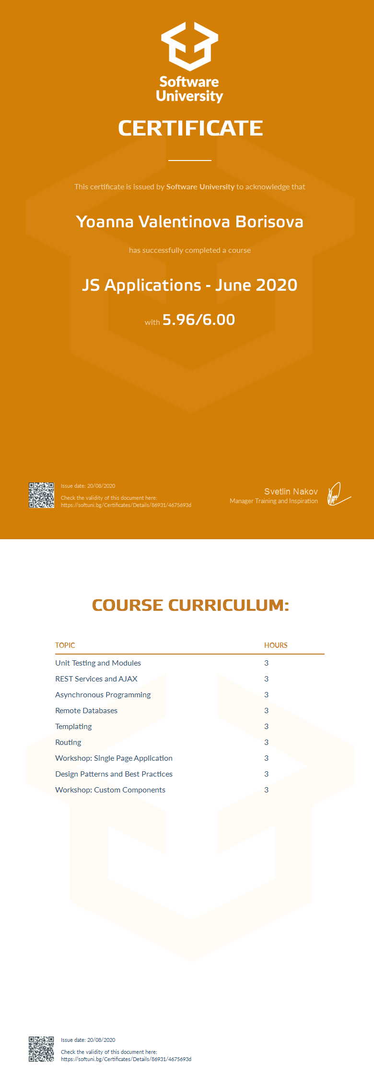



**Links**

* SoftUni [https://softuni.bg](https://softuni.bg/)
* SoftUni Judge [https://judge.softuni.bg](https://judge.softuni.bg/)
* Kinvey - Progress Software <https://console.kinvey.com/apps>
* Postman [https://www.getpostman-beta.com](https://www.getpostman-beta.com/)
* Handlebars [https://handlebarsjs.com](https://handlebarsjs.com/)
* Chai [https://www.chaijs.com](https://www.chaijs.com/)
* Mocha [https://mochajs.org](https://mochajs.org/)