Predicting ICU Length of Stay after Cervical Spinal Cord Injury
Case Study Report | October 2026

Summary
This study tested whether information collected during the first day in intensive care can predict ICU length of stay (LOS) for adults with a cervical spinal cord injury. MIMIC-IV was the main dataset; the CareVue part of MIMIC-III was analyzed separately. In the primary MIMIC-IV analysis, Random Forest achieved an R² of 0.071 for log(1 + LOS) and 0.028 for LOS in days. Its apparent advantage over the median baseline and an APACHE-II-based comparison was uncertain. The results do not show that the machine-learning model reliably predicts individual ICU stays better than APACHE-II.

1. Question and purpose
The case-study question was whether a model could improve prediction of ICU length of stay for patients with cervical spinal cord injury, compared with a simple baseline and a severity score comparison. The primary questions were:
- How well can first-day ICU information predict total ICU stay in this defined cohort?
- Does the best-performing model clearly outperform a median prediction or the APACHE-II comparison?
- Do the findings change when the stay rule or observation window is varied?
The assignment mentioned APACHE-IV as a possible comparator. This analysis does not claim to reproduce APACHE-IV. It uses an explicitly labeled APACHE-II approximation because faithful APACHE-IV reproduction requires its specific diagnosis mapping and model details, which are not directly usable from the available tables.

2. Data and study group
The analysis used MIMIC-IV version 2.2 as the primary dataset and the CareVue subset of MIMIC-III version 1.4 as a secondary, separate analysis. Both databases contain de-identified ICU records from Beth Israel Deaconess Medical Center. The two datasets were not pooled. Because patient identities cannot be matched across these versions, the MIMIC-III analysis is not described as independent external validation.
Admissions were selected using ICD-9 cervical spinal cord injury code 806.0x and, in MIMIC-IV, ICD-10 S14.1xxA (initial encounter). The first ICU stay per qualifying hospital admission was kept. The cohort was restricted to adults, and ICU LOS was calculated from ICU admission and discharge times. The main analysis required at least 24 hours in the ICU.
Cohort step | MIMIC-IV | MIMIC-III CareVue
Admissions with a qualifying diagnosis | 250 | 155
ICU stays in those admissions before dataset-specific filters | 175 | 163
CareVue stays (after CareVue restriction) | — | 103
First ICU stay per admission | 156 | 96
Adults with valid positive LOS | 156 | 94
Primary analysis: at least 24-hour stay | 139 | 88

3. Analysis
Predictors came from the first 24 hours of the ICU stay; the outcome was the full ICU stay in days. The notebook compared a median baseline, two APACHE-II linear comparisons (with and without GCS), Lasso, Random Forest, and XGBoost. The main score was R² for log(1 + LOS); R² and mean absolute error in days were also reported. An R² below zero means performance was worse than predicting the evaluation-set mean for that outcome scale.
Validation kept all admissions from a patient together in the same fold. Imputation and scaling were fitted within each training fold. Predictions were capped to the minimum and maximum LOS in that training fold; a separate paired check compared capped and uncapped predictions. Lasso used a fixed penalty (alpha = 0.01), rather than inner-fold tuning.
Four sensitivity settings were tested: retaining stays shorter than the feature window, using a 12-hour window, using a 48-hour window, and removing the 99-day MIMIC-IV stay. The short-stay setting is not a fair complete first-24-hour prediction scenario, because some included stays end before all first-day information could be observed.

4. Results
Random Forest had the highest mean R² among the machine-learning models in both primary cohorts, but its advantage over the comparator depended on dataset and was uncertain. Table 2 summarizes the primary results.
Dataset | N | Random Forest R², log scale (95% CI) | RF R², days | APACHE-II R², log scale | RF MAE, days
MIMIC-IV | 139 | 0.071 [-0.060, 0.196] | 0.028 | 0.079 | 6.59
MIMIC-III CareVue | 88 | 0.183 [0.027, 0.369] | 0.009 | 0.131 | 6.73

For MIMIC-IV, the paired patient-level bootstrap difference in log-scale R² was +0.148 for Random Forest versus the median baseline (95% CI −0.027 to 0.294) and +0.009 versus APACHE-II (95% CI −0.105 to 0.115). Both intervals include no difference. In MIMIC-III CareVue, Random Forest was distinguishable from the median baseline, but not from APACHE-II. These comparisons support a cautious interpretation, not a claim of a dependable model win.
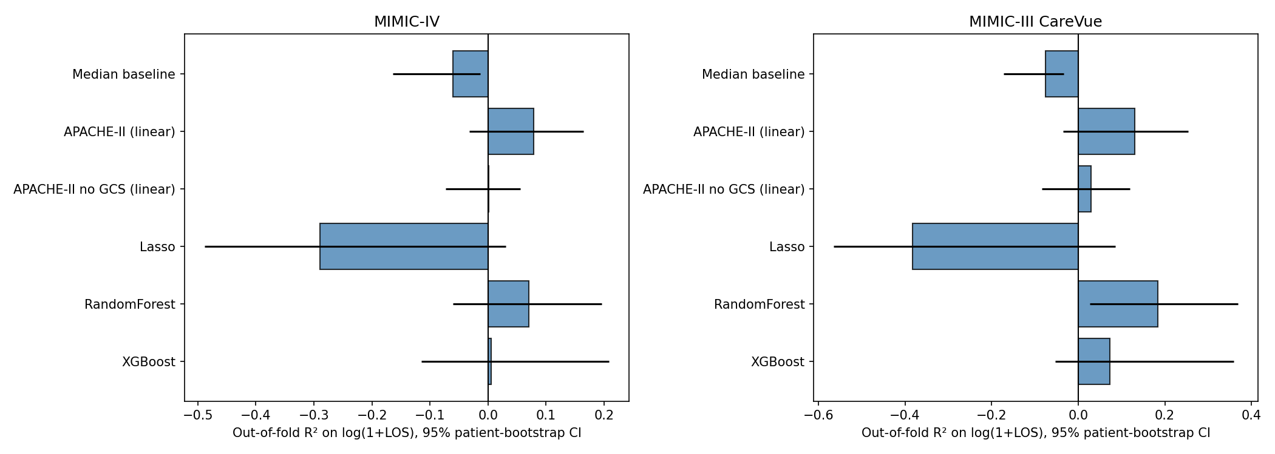
Figure 1. Out-of-fold model performance in the primary settings. Higher R² is better; negative values indicate performance below the mean-prediction reference on that scale.

Sensitivity checks
Dataset | Setting | N | Best ML log R² | Compared with APACHE-II
MIMIC-IV | Primary | 139 | 0.071 | not distinguishable
MIMIC-III CareVue | Primary | 88 | 0.183 | not distinguishable
MIMIC-IV | Shorter window | 148 | 0.107 | not distinguishable
MIMIC-III CareVue | Shorter window | 92 | 0.184 | not distinguishable
MIMIC-IV | Longer window | 117 | 0.122 | not distinguishable
MIMIC-III CareVue | Longer window | 70 | 0.085 | not distinguishable
MIMIC-IV | Drop the 99-day stay | 138 | 0.114 | not distinguishable
MIMIC-III CareVue | Drop the 99-day stay | 88 | 0.228 | not distinguishable

Across the alternative windows and the outlier check, Random Forest remained the best machine-learning model by mean log-scale R², but it was not distinguishable from APACHE-II in any of those settings. The keep-short-stays comparison is omitted from the table because those patients may leave the ICU before the full feature window is observed.
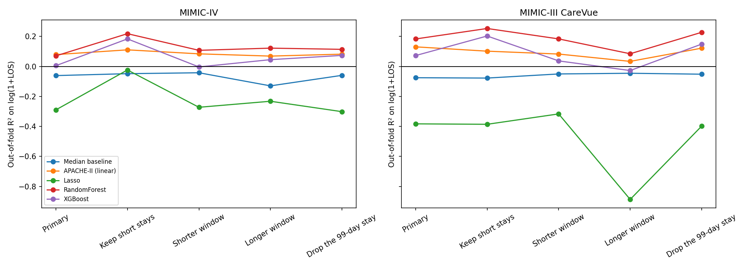
Figure 2. Random Forest performance across the five notebook settings. The short-stay setting is shown by the notebook but is not a complete 24-hour prediction comparison.
The capped-versus-uncapped check did not change the primary Random Forest R² to three decimal places in either dataset. It materially changed the CareVue Lasso result: uncapped log-scale R² was −0.669 versus −0.383 capped, and uncapped day-scale R² was −26.240 versus −0.549 capped. Lasso performed poorly in either case; the cap is disclosed because it can limit legitimate predictions outside the training range.

5. Interpretation and limitations
The results answer the assignment’s central question, but they do not produce a strong individual-level predictor. The primary MIMIC-IV Random Forest log-scale R² of 0.071 is low, and its uncertainty interval includes values below zero. The systematic review cited in the assignment also found that ICU LOS prediction is difficult across published models. Results from that broader literature use different populations and methods, so they are context, not a direct head-to-head benchmark.
Important assumptions and limitations include:
- The selected diagnosis codes are used as the operational definition of cervical spinal cord injury; code-based selection may miss or misclassify cases.
- Only adults and the first ICU stay per admission were analyzed. This makes the cohort more consistent but narrows who the results apply to.
- The first-day window assumes the prediction is made after that window. The short-stay sensitivity does not meet that timing for every patient.
- The APACHE-II implementation is an approximation. Some chronic-health flags rely on discharge diagnosis codes, information that may not have been known at hour 24. It is not APACHE-IV.
- Small cohorts lead to wide uncertainty. Both datasets come from one hospital and different eras; CareVue is not an independent external validation.
- ICU LOS is shaped by death, complications, treatment response, bed capacity, and local discharge practice. Several important spinal-injury details are not represented in the predictors.
- Prediction clipping and the fixed Lasso penalty affect results. Both choices are disclosed, and the clipping check is reported separately.
- Feature importance describes model behavior; it does not show that a feature causes a longer or shorter stay.

6. Key takeaways
- The project stayed focused on the assigned question: ICU length-of-stay prediction for a cervical spinal cord injury cohort in MIMIC data.
- The MIMIC-IV primary model showed limited explanatory performance (Random Forest R² = 0.071 on log(1 + LOS); 0.028 in days). This low score is not, by itself, evidence that the analysis failed; it reflects how difficult and uncertain individual LOS prediction is in this small cohort.
- The model did not show a reliable advantage over the APACHE-II approximation. APACHE-IV was not calculated, so no claim is made about beating APACHE-IV.
- The separate CareVue analysis gives a similar caution: a higher log-scale R² than MIMIC-IV, but no clear advantage over APACHE-II and almost no explained variation on the day scale.
- The appropriate conclusion is that first-day routine data alone were not enough to produce a dependable individual ICU-stay prediction in these cohorts.
Reproducibility note. The saved notebook has a blank execution count for its Step 8 results-summary cell, although the saved output matches results_FINAL/results_summary.csv. That cell summarizes existing model results; restart and run all once before submission to leave a clean execution record.

References
1. Johnson AEW, et al. MIMIC-IV, a freely accessible electronic health record dataset. Scientific Data. 2023;10:1. doi:10.1038/s41597-022-01899-x.
2. Johnson AEW, et al. MIMIC-III, a freely accessible critical care database. Scientific Data. 2016;3:160035. doi:10.1038/sdata.2016.35.
3. Knaus WA, Draper EA, Wagner DP, Zimmerman JE. APACHE II: a severity of disease classification system. Critical Care Medicine. 1985;13(10):818–829.
4. Verburg IWM, et al. Which models can I use to predict adult ICU length of stay? A systematic review. Critical Care Medicine. 2017;45(2):e222–e231. doi:10.1097/CCM.0000000000002054.
5. Zimmerman JE, Kramer AA, McNair DS, Malila FM. Acute Physiology and Chronic Health Evaluation (APACHE) IV: hospital mortality assessment for today's critically ill patients. Critical Care Medicine. 2006;34(5):1297–1310.

