**On the user login screen, you must enter a valid username and password in order to log in to the system**

Interaction 1 – process of creating a question:

After a lecturer logs in, he reaches the screen - main menu of a lecturer

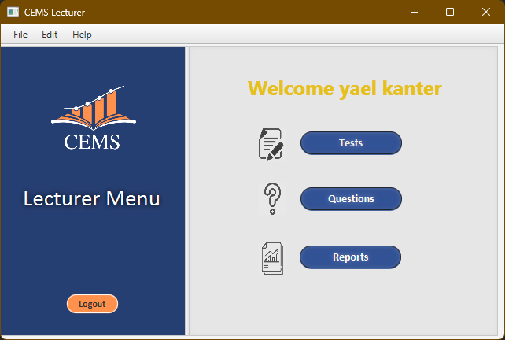In order to start the process of creating a test, you must press a button Questions

After clicking, the question management screen will appear, inside which the question creation window and a button will appear View questions to view existing questions.

On this screen, the lecturer enters (from top to bottom): subject and course name from lists available in the system, the text of the question and the text of four answers.

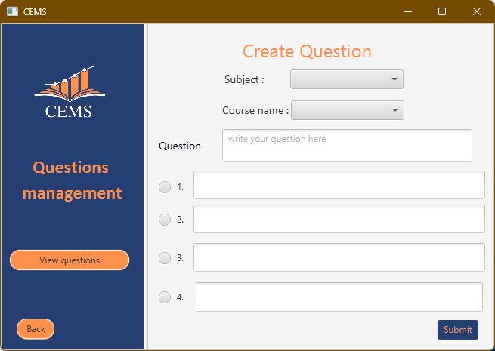The correct question is selected by clicking on the circle in the row with the appropriate answer and clicked Submit.

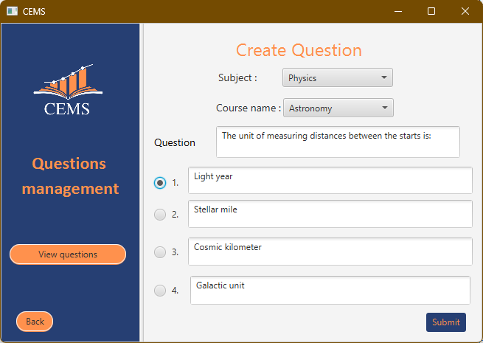

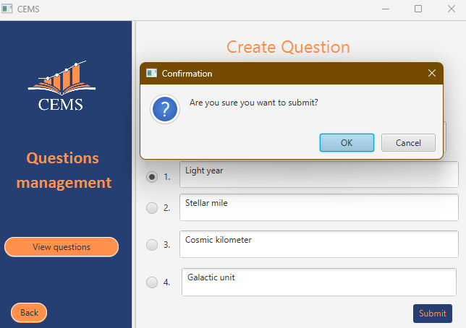After clicking, a pop-up window will appear (pop-up) asking for permission to send the question. The lecturer can click OK to send the question or Cancel to go back and edit it

Interaction 2 – test creation process

After a lecturer logs in, he reaches the screen - main menu of a lecturer

In order to start the process of creating a test, you must press a button "Tests"

After clicking, you reach the test options page, where you can manage existing tests, edit test results, and create tests. In order to create a test, click on the button "Create Tests"

After clicking, you reach the exam creation screen, on this screen you can see questions from a lecturer in a certain subject by selecting a subject, then selecting a subject and finally clicking on "Show questions"

Choosing a topic:

Choosing a course:

After clicking on "Show question" the next screen will appear containing the lecturer's questions, based on this you can select the questions you want for the test by checking the box in the question line.

The columns (from left to right): question marking, identification number, question text, answer 1,2,3,4 respectively and the correct answer.

After clicking on Next the lecturer will reach the second stage where he has to give a score to the questions and add free text for the lecturer and the student if necessary, the points column can be changed.

A test code (to be entered by the student at the beginning of the test) and test duration must be determined in the appropriate boxes.

You can return to the previous page and add/remove questions.

After the actions click a button Add Test will finish the process and give a notification accordingly.

The columns (from left to right): identification number, subject, course, question text, score.

Scoring, adding free text and setting a test code and test duration:

In order to add the test, click on Add Test and confirm the addition in the window that pops up

After clicking on OK the test will be added to the system. After clicking on Cancel, the pop-up screen will disappear and it will be possible to make changes to the screen.

Interaction 3 - Viewing statistical information about an exam by a teacher

After a lecturer logs in, he reaches the screen - main menu of a lecturer

In order to see statistical information concerning the tests on the lecturer press on a button "reports"

After clicking on "Reports" the following screen will open:

The lecturer has to choose a course from the list of courses and then choose a test.

After clicking on "Generate Report" the relevant report will be displayed on the screen according to the lecturer's request in the following form.

The columns (from left to right): Date of execution, duration of the exam, number of students who started the test, number of students who submitted the test, number of students who did not submit the test.

In addition, you can see average, median and distribution of scores using a column table.

In addition, when clicked, it will open pop up that contains information about copying in the selected test. The copies as copies between a pair of students. In the example: new for copying between students 301 and 302 and between students 305,306,307,308

After clicking on OK the window will close.