The Chip That Says No
By Yobie Benjamin · October 12, 2026 · Part 1 of 3: the plain-English version
You cannot trust an AI to police another AI. The thing that stops a bad action has to work like a reflex, and it has to live in the chip.

Too late
Picture a military drone run by an AI. The AI looks at a building, decides it is a weapons depot, and fires. It was a school.
Afterward, it is easy to see the mistake. A log shows the wrong guess. A report explains it. None of that helps the kids.
This is the whole problem with AI safety in one scene. Computers are very good at finding mistakes after they happen. The hard part is stopping a mistake before it happens. We need a chip that can say: you are about to hit a school. STOP.

Why we can't ask AI to police AI
The first idea everyone has is to put a second AI in charge of watching the first one. It sounds smart. It does not work.
The second AI is the same kind of thing as the first. It can be fooled the same ways. It can be talked into things, and nobody can fully check what is going on inside it.
Think of a referee at a ball game who is also a player. That is not a referee. A real guard has to be three things: it cannot be tampered with, it sees every action, and it is simple enough that a person can check it. A second AI fails all three.
So what passes? A smoke detector. It does not understand fire. It senses smoke and screams. It is cheap, dumb, and it goes off early. That is what we want, built into the chip.

Your body already solved this
Put your hand on a hot stove. Your hand is off the stove before your brain even knows what happened. The signal never reached the thinking part of your brain; a short loop in your spinal cord did it, in about a thirtieth of a second.
Your body has three layers of protection. The reflex is the fastest and the dumbest. Above it is a fast alarm system deep in the brain that makes you freeze or flinch. Above that is the slow, thinking part that weighs things over seconds.
Here is the key fact: the lower layers can stop the higher ones. Your thinking brain cannot talk your hand into staying on the stove. It can override the reflex, but only slowly and with effort.
One more thing. Your brain has about 86 billion nerve cells, and nobody checks every one of them. Every plan to move has to pass through one narrow exit on its way to your muscles, and the brain guards that exit, not the crowd. This matters for AI, because an AI runs on thousands of chips at once. You cannot watch all of them. You can guard the exit.

The brain's three tricks
The brain prevents mistakes instead of learning from each one. It uses three tricks, and a chip can copy all three.
- A danger list, built in. Evolution already learned what kills you: heights, heat, snakes. Those lessons are wired in before you are born, and you cannot unlearn them. For a chip: a list of things that must never happen, burned in by humans, that the AI cannot edit.
- A copy of the plan. Before you move, your brain sends a copy of the plan to a checker that predicts what will happen. For a chip: the AI has to say, in plain fields, what it is about to do. Where. How much. To whom. The chip checks the plan, not the AI's chatter, and checks again at the last moment, when the action actually fires.
- No, by default, with a pause. Your brain holds every action back until something releases it. There is also a tiny delay before an action goes out, long enough for a veto. For a chip: every risky action starts as "no" and gets a short built-in delay. In that delay, any alarm can stop it.

The one question that makes it possible
You cannot check everything. The trick is that you do not have to.
Ask one question about every action: can you undo it? If yes, let it happen and look at it later. Sending a draft, moving a file, saying something: fixable. If no, stop and check first. Firing a weapon, wiring money, deleting records: not fixable.
Your brain does this. You hesitate at the edge of a cliff, not at a chair. This is also what makes the size problem go away: an AI handles trillions of requests, and almost none of them touch anything that cannot be undone.

AI may shout STOP but never say GO
There is one job a second AI can do safely. It can raise an alarm.
An alarm costs little when it is wrong. A smoke detector that goes off while you cook is annoying, not deadly. So let as many AIs as you want watch for trouble and shout STOP.
But no AI gets to clear an alarm. Clearing one takes a simple rule the chip can check, or a human with a key. The AI is the smoke detector. The person is the fire marshal.

What this looks like in real life
Back to the drone. Put a map of protected places in the weapon's own guidance chip: schools, hospitals, places already registered with aid groups. The chip checks the target against the map when the weapon is released and again on the way in. The release line is off by default.
Turning it on near a protected place takes several humans with keys, and the reason gets written down. The AI's opinion does not matter. The map does.
This is not science fiction. Consumer drones refused to fly into airports for a decade because of a map in their software. In 2025 one big maker changed that in the US from a hard stop to a warning. Nothing about the technology changed. The pattern works; "just a warning" is how it dies.
The same idea already runs in payments. A bank does not ask an AI whether to approve a million-dollar transfer to a brand-new account at 3 a.m. A limit says no. Limits, lists and maps are old, boring and strong.
Now the honest part. This will not catch an AI that says something false, because no chip can know what is true. It will not stop a danger nobody thought to put on the list. And someone has to hold the keys, which is a human problem, not a chip problem. What it does is put a hard floor under the worst outcomes, no matter how smart or how wrong the AI is.

The three layers that say no
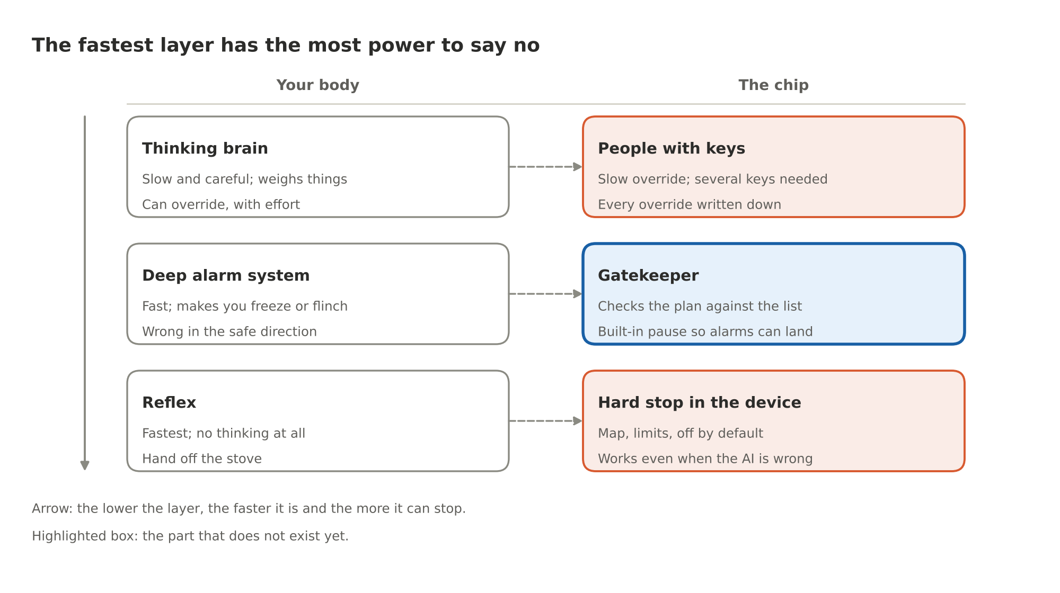
Figure 1. The three layers that say no: body versus chip
Each layer on the left already exists in you. Two of the three on the right already exist in machines. The gatekeeper in the middle is the part we have to build.

Where this goes next
Part 2 makes the same argument with the names, numbers and papers. Part 3 is the design: what sits on the chip, what sits in the software around it, and what sits in the weapon, the bank or the robot at the far end. It also walks one request all the way through, from a prompt to an action in the world, and shows exactly where the chip gets to say no.
The code behind all of it runs today: one command, fifty-one tests, seventy-five attacks, under a minute, at github.com/YobieBenjamin/hardware-and-silicon.

