**МИНИСТЕРСТВО ОБРАЗОВАНИЯ И НАУКИ РОССИЙСКОЙ ФЕДЕРАЦИИ**

**НОВОСИБИРСКИЙ ГОСУДАРСТВЕННЫЙ ТЕХНИЧЕСКИЙ УНИВЕРСИТЕТ**

**Кафедра теоретической и прикладной информатики**

**Лабораторная работа № 4**

**по дисциплине** «Базы данных и экспертные системы»

Работа с базой данных средствами встроенного SQL

Вариант задания № 2

**Факультет: ФПМИ**

**Группа: ПМИ-72**

**Бригада №7**

**Студенты: Антонов С.**

**Боброва А.**

**Преподаватели: Стасышина Т.Л.**

**Сивак М.А.**

**Новосибирск 2020**

1. **Выдать число цветов деталей, поставлявшихся поставщиками, выполнявшими поставки для изделий из Парижа.**

select count (distinct spj.n_izd)

from spj

join s on s.n_post = spj.n_post

where s.name in (select distinct s.name

from spj

join p on p.n_det= spj.n_det

join s on s.n_post = spj.n_post

where p.ves > 12

order by 1

limit 1 )



1. **Поменять местами названия деталей, стоящих первой и последней в списке, упорядоченном по весу и названию.**

update s set name = (case when s.name=(select s5.name

from s s5

order by 1

limit 1)

then (select s3.name name1

from s s3

order by 1 desc

limit 1 )

else (select s4.name name2

from s s4

order by 1

limit 1)

end )

where s.name=(select name from s order by 1 limit 1)

or

s.name=(select name from s order by 1 desc limit 1)

**До**

**После**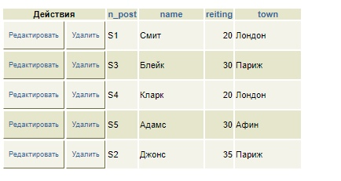

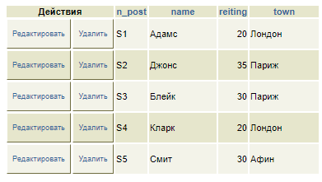

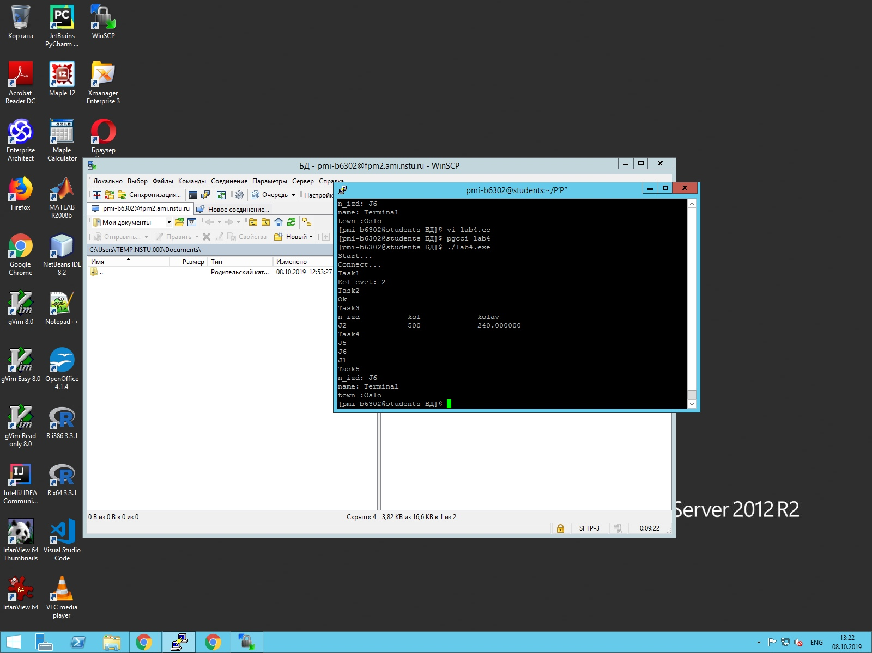

1. **Найти изделия, имеющие поставки, объем которых более чем в 2 раза превышает средний объем поставки для изделия. Вывести номер изделия, объем поставки, средний объем поставки для изделия.**

select a.n_izd, a.kol*pa.ves pves, b.mves

from spj a

join p pa on pa.n_det=a.n_det

join (select t.n_izd, min(t.kol*p.ves)mves

from spj t

join p on p.n_det=t.n_det

group by t.n_izd) b on b.n_izd=a.n_izd

where a.kol*pa.ves > 4*mves

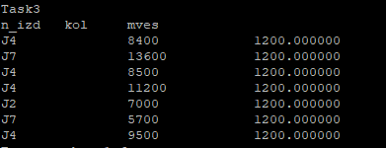

1. **Выбрать изделия, для которых не поставлялась ни одна деталь, имеющая наибольший вес.**

select s.n_post

from s

except

select spj.n_post

from spj

where spj.n_det in (select p.n_det

from p

where p.ves = (select min(p1.ves) from p p1))

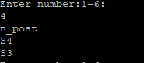

1. **Выдать полную информацию об изделиях, для которых поставлялись ТОЛЬКО детали из последнего по алфавиту города.**

select distinct s.*

from spj t

join s on s.n_post=t.n_post

where t.n_post in (select n_post

from spj

join p on p.n_det=spj.n_det

join j on j.n_izd=spj.n_izd

where p.cvet = 'Красный'

and

length(j.name)>7)

except

select distinct s.*

from spj t

join s on s.n_post=t.n_post

where not t.n_post in (select n_post

from spj

join p on p.n_det=spj.n_det

join j on j.n_izd=spj.n_izd

where p.cvet = 'Красный'

and

length(j.name)>7 )

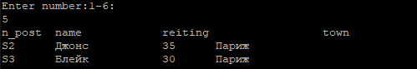

**Текст программы:**

#include <sqlca.h>

#include <stdio.h>

#include <stdlib.h>

#include <locale.h>

bool Connect()

{

EXEC SQL connect to students@fpm2.ami.nstu.ru user "pmi-b7607" using "apjafOd0";

if (sqlca.sqlcode != 0)

{

do_error("Connect to database", sqlca.sqlcode);

return;

}

EXEC SQL set search_path to pmib7607;

if (sqlca.sqlcode != 0)

{

do_error("Set database", sqlca.sqlcode);

return;

}

}

void do_error(char* st_name, int errnum)

{

printf("Error code %d at %s \n", errnum, st_name);

printf("Error message: %s\n", sqlca.sqlerrm.sqlerrmc);

return;

}

int Task1()

{

EXEC SQL begin declare section;

int n;

EXEC SQL end declare section;

printf("Task1\n");

EXEC SQL begin work;

EXEC SQL select count(distinct spj.n_izd) into:n

from spj

join s on s.n_post = spj.n_post

where s.name in(select distinct s.name

from spj

join p on p.n_det = spj.n_det

join s on s.n_post = spj.n_post

where p.ves > 12

order by 1

limit 1);

if (sqlca.sqlcode != 0)

{

do_error("Request", sqlca.sqlcode);

EXEC SQL rollback work;

return 1;

}

printf("Kol_det: %d\n", n);

EXEC SQL commit work;

return 0;

}

int Task2()

{

printf("Task2\n");

EXEC SQL begin work;

EXEC SQL update s set name = (case when s.name = (select s5.name

from s s5

order by 1

limit 1)

then(select s3.name name1

from s s3

order by 1 desc

limit 1)

else (select s4.name name2

from s s4

order by 1

limit 1)

end)

where s.name = (select name from s order by 1 limit 1)

or

s.name = (select name from s order by 1 desc limit 1);

if (sqlca.sqlcode != 0)

{

do_error("Request", sqlca.sqlcode);

EXEC SQL rollback work;

return 1;

}

printf("Ok\n");

printf("%ld lines processed\n", sqlca.sqlerrd[2]);

EXEC SQL commit work;

return 0;

}

int Task3()

{

EXEC SQL begin declare section;

char _n_izd[12];

int _kol;

float _mves;

EXEC SQL end declare section;

printf("Task3\n");

EXEC SQL DECLARE cur3 CURSOR FOR

select a.n_izd, a.kol* pa.ves pves, b.mves

from spj a

join p pa on pa.n_det = a.n_det

join(select t.n_izd, min(t.kol * p.ves)mves

from spj t

join p on p.n_det = t.n_det

group by t.n_izd) b on b.n_izd = a.n_izd

where a.kol * pa.ves > 4 * mves;

if (sqlca.sqlcode != 0)

{

do_error("Declare cursor", sqlca.sqlcode);

EXEC SQL rollback work;

return 1;

}

EXEC SQL begin work;

EXEC SQL OPEN cur3;

if (sqlca.sqlcode != 0)

{

do_error("Open cursor", sqlca.sqlcode);

EXEC SQL close cur3;

EXEC SQL rollback work;

return 1;

}

EXEC SQL FETCH NEXT FROM cur3 into : _n_izd, : _kol, : _mves;

if (sqlca.sqlcode == 100)

{

printf("No results for request\n");

EXEC SQL close cur3;

EXEC SQL commit work;

return 0;

}

else if (sqlca.sqlcode < 0)

{

do_error("Fetch", sqlca.sqlcode);

EXEC SQL close cur3;

EXEC SQL rollback work;

return 1;

}

printf("n_izd\tkol\tmves\n");

do

{

printf("%s\t\t%d\t\t%f\n", _n_izd, _kol, _mves);

EXEC SQL fetch next from cur3 into : _n_izd, : _kol, : _mves;

if (sqlca.sqlcode < 0)

{

do_error("Fetch", sqlca.sqlcode);

EXEC SQL close cur3;

EXEC SQL rollback work;

return 1;

}

} while (sqlca.sqlcode != 100);

EXEC SQL CLOSE cur3;

if (sqlca.sqlcode != 0)

{

do_error("Close cursor", sqlca.sqlcode);

EXEC SQL rollback work;

return 1;

}

EXEC SQL commit work;

}

int Task4()

{

EXEC SQL begin declare section;

char n_post[12];

EXEC SQL end declare section;

EXEC SQL declare cur4 cursor for

select s.n_post

from s

except

select spj.n_post

from spj

where spj.n_det in(select p.n_det

from p

where p.ves = (select min(p1.ves) from p p1));

if (sqlca.sqlcode != 0)

{

do_error("Declare cursor", sqlca.sqlcode);

EXEC SQL rollback work;

return 1;

}

EXEC SQL begin work;

EXEC SQL open cur4;

if (sqlca.sqlcode != 0)

{

do_error("Open cursor", sqlca.sqlcode);

EXEC SQL close cur4;

EXEC SQL rollback work;

return 1;

}

EXEC SQL fetch next from cur4 into : n_post;

if (sqlca.sqlcode == 100)

{

printf("No results for request\n");

EXEC SQL close cur4;

EXEC SQL commit work;

return 0;

}

else if (sqlca.sqlcode < 0)

{

do_error("Fetch", sqlca.sqlcode);

EXEC SQL close cur4;

EXEC SQL rollback work;

return 1;

}

printf("n_post\n");

do

{

printf("%s\n", n_post);

EXEC SQL fetch next from cur4 into : n_post;

if (sqlca.sqlcode < 0)

{

do_error("Fetch", sqlca.sqlcode);

EXEC SQL close cur4;

EXEC SQL rollback work;

return 1;

}

} while (sqlca.sqlcode != 100);

EXEC SQL close cur4;

if (sqlca.sqlcode != 0)

{

do_error("Close cursor", sqlca.sqlcode);

EXEC SQL rollback work;

return 1;

}

EXEC SQL commit work;

return 0;

}

int Task5()

{

EXEC SQL begin declare section;

char n_post[15], name1[20], town1[20];

int reiting;

EXEC SQL end declare section;

EXEC SQL declare cur5 cursor for

select distinct s.*

from spj t

join s on s.n_post = t.n_post

where t.n_post in(select n_post

from spj

join p on p.n_det = spj.n_det

join j on j.n_izd = spj.n_izd

where p.cvet = 'РљСЂР°СЃРЅС‹Р№'

and

length(j.name) > 7)

except

select distinct s.*

from spj t

join s on s.n_post = t.n_post

where not t.n_post in(select n_post

from spj

join p on p.n_det = spj.n_det

join j on j.n_izd = spj.n_izd

where p.cvet = 'РљСЂР°СЃРЅС‹Р№'

and

length(j.name) > 7);

if (sqlca.sqlcode != 0)

{

do_error("Declare cursor", sqlca.sqlcode);

EXEC SQL rollback work;

return 1;

}

EXEC SQL begin work;

EXEC SQL open cur5;

if (sqlca.sqlcode != 0)

{

do_error("Open cursor", sqlca.sqlcode);

EXEC SQL close cur5;

EXEC SQL rollback work;

return 1;

}

EXEC SQL fetch next from cur5 into : n_post, : name1, : reiting, : town1;

if (sqlca.sqlcode == 100)

{

printf("No results for request\n");

EXEC SQL close cur5;

EXEC SQL commit work;

return 0;

}

else if (sqlca.sqlcode < 0)

{

do_error("Fetch", sqlca.sqlcode);

EXEC SQL close cur5;

EXEC SQL rollback work;

return 1;

}

printf("n_post\tname\t\treiting \t\ttown\n");

do

{

printf("%s\t%s\t%d\t%s\n", n_post, name1, reiting, town1);

EXEC SQL fetch next from cur5 into : n_post, : name1, : reiting, : town1;

if (sqlca.sqlcode < 0)

{

do_error("Fetch", sqlca.sqlcode);

EXEC SQL close cur5;

EXEC SQL rollback work;

return 1;

}

} while (sqlca.sqlcode != 100);

EXEC SQL close cur5;

if (sqlca.sqlcode != 0)

{

do_error("Close cursor", sqlca.sqlcode);

EXEC SQL rollback work;

return 1;

}

EXEC SQL commit work;

}

void main()

{

setlocale(LC_ALL, "Russian");

printf("Start...\n");

if (Connect())

{

printf("Error connect\n");

return 1;

}

printf("Connect...\n");

int n, flag = 0;

do {

printf("Enter number:1-6:\n");

scanf("%d", &n);

switch (n)

{

case 1:

Task1();

break;

case 2:

Task2();

break;

case 3:

Task3();

break;

case 4:

Task4();

break;

case 5:

Task5();

break;

case 6:

flag = 1;

EXEC SQL disconnect all;

printf("Session closed\n");

break;

default:

printf("Wrong number!\n");

break;

}

} while (flag == 0);

return;

}