Министерство науки и высшего образования Российской Федерации

Федеральное государственное бюджетное

образовательное учреждение высшего образования
«Новосибирский государственный технический университет»

Кафедра прикладной математики

Расчетно-графическая работа

по дисциплине «Логическое программирование»
 | Факультет: | ПМИ
 | Группа: | ПМИ-72
 | Вариант: | 1
 | Студенты: | Антонов Сергей
 | Преподаватель: | Авдеенко Татьяна Владимировна
Новосибирск
2019

- Цель работы
Получение знаний, умений и навыков по созданию базы знаний, представляющей собой фреймовую модель представления знаний.
- Задания
1.Для заданной в соответствии с вариантом предметной области разработать фреймы в виде взаимосвязанных таблиц и сложной иерархической структуры.
2.Разработанную фреймовую структуру реализовать в системе Visual Prolog

- Frame модель
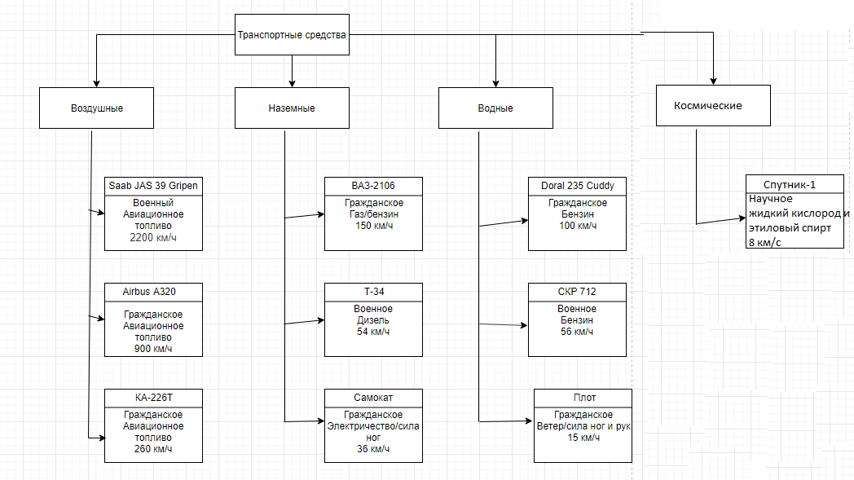

- Текст программы
domains
property = type(symbol); tip(symbol); names(symbol); skorost(integer)
name = name(symbol)
isa = isa(symbol)
names = name*
properties = property*
facts
answer(property,symbol).
database - TS
frame(name, isa, properties)
predicates
get_ans(property)
nondeterm recognition()
nondeterm recognition(isa)
nondeterm discover(properties)
nondeterm ask(property)
nondeterm isSublist(properties, properties)
nondeterm merge(properties, properties, properties)
nondeterm choice(char)
nondeterm menu
nondeterm repeat
nondeterm read_property(symbol, property)
nondeterm read_properties(properties)
nondeterm read_propertie(properties)
nondeterm read_ts()
nondeterm read_ts_system()
nondeterm get_propertie(property, name)
nondeterm get_all_properties(properties, symbol)
nondeterm member(property, properties)
clauses
ask(Q):-answer(Q,"y"),!.
ask(Q):-answer(Q,"n"),!,fail.
ask(Q):-write(Q,"?"),get_ans(Q).
recognition():- frame(name(Name), isa("TS system"), Properties), discover(Properties), !,
write("Your object is like ", Name, " - ", Properties), nl,
recognition(isa(Name)).
recognition(IsA):-frame(name(Name), IsA, Properties), discover(Properties), !,
write("Your object is like ", Name, " - ", Properties), nl.
discover([]).
discover([X|Y]):- ask(X), discover(Y).
get_ans(X):-nl, readln(Y), assert(answer(X, Y)), Y="y".
read_property(P, R) :- P=tip, readln(V), R=tip(V).
read_property(P, R) :- P=type, readln(V), R=type(V).
read_property(P, R) :- P=names, readln(V), R=names(V).
read_property(P, R) :- P=skorost, readint(V), R=skorost(V).
read_properties([H|T]):-write("Enter property name(type, names or skorost), end with epmty line"),nl,
readln(P),P<>"",!,
write("Enter property value"),nl,
read_property(P,H),
read_properties(T).
read_properties([]).
read_propertie([H|T]):-write("Enter property name(tip), end with epmty line"),nl,
readln(P),P<>"",!,
write("Enter property value"),nl,
read_property(P,H),
read_propertie(T).
read_propertie([]).
read_ts() :- write("Enter TS name"),nl,
readln(Name),
write("Enter TS system"),nl,
readln(IsA),
write("Enter TS properties"),nl,
read_properties(P),
assert(frame(name(Name), isa(IsA), P), TS).
read_ts_system() :- write("Enter TS(Vozduh, Zemlya, Voda, Kosmos)"),nl,
readln(Name),
write("Enter TS system properties"),nl,
read_propertie(P),
assert(frame(name(Name), isa("TS system"), P), TS).
member(_, []) :- fail.
member(X, [H|T]) :- X = H; member(X, T).
merge([],L,L).
merge([H|L1], L2, [H|L3]):-merge(L1,L2,L3).
isSublist([],_).
isSublist([HSub|TSub], List):-member(HSub, List),isSublist(TSub, List).
get_all_properties([], "TS system").
get_all_properties(P, Name) :- frame(name(Name), isa(Parent), P1),
get_all_properties(P2, Parent),
merge(P1, P2, P).
get_propertie(Prop, Object1) :-
frame(Object1, _, List_of_properties),
member(Prop, List_of_properties).
get_propertie(Prop, Object1) :-
frame(Object1, isa(Parent), _),
get_propertie(Prop, name(Parent)).
choice('1'):-read_ts_system(),
write("added"),nl,
save("Z:/VIP52/BIN/WIN/32/test1.txt",TS),
fail.
choice('2'):-read_ts(),
write("added"),nl,
save("Z:/VIP52/BIN/WIN/32/test1.txt",TS),
fail.
choice('3'):-write("Enter TS:"),nl,
readln(Name),
retract(frame(name(Name), isa("TS"), _),TS),
write("removed"),nl,
fail.
choice('4'):-write("Enter TS name:"),nl,
readln(Name),
retract(frame(name(Name), _, _),TS),
write("removed"),nl,
fail.
choice('5'):-frame(name(Name), isa(IsA), _),
get_all_properties(Properties, Name),
write("Name: ", Name),nl,
write("Is a: ",IsA),nl,
write("Properties: ", Properties),nl.
choice('6'):-frame(name(Name), isa("TS"), _),
get_all_properties(Properties, Name),
write("Name: ", Name),nl,
write("Properties: ", Properties),nl.
choice('7'):-frame(name(Name), isa(IsA), _),
IsA<>"TS", Name<>"TS",
get_all_properties(Properties, Name),
write("Name: ", Name),nl,
write("Is a: ",IsA),nl,
write("Properties: ", Properties),nl.
choice('8'):-read_propertie(P),
frame(name(Name), isa("TS"), Properties),
isSublist(P, Properties),
write("Name: ", Name),nl,
write("Properties: ", Properties),nl.
choice('9'):-read_properties(P),
frame(name(Name), isa(IsA), Properties),
IsA<>"TS", Name<>"TS",isSublist(P, Properties),
write("Name: ", Name),nl,
write("Is a: ",IsA),nl,
write("Properties: ", Properties),nl.
choice('a'):-write("Enter TS name"),nl,
readln(Name),
frame(name(Name), isa("TS"), Properties),
write("Name: ", Name),nl,
write("Properties: ", Properties),nl.
choice('b'):-write("Enter TS name"),nl,
readln(Name),
frame(name(Name), isa(IsA), Properties),
write("Name: ", Name),nl,
write("Is a: ",IsA),nl,
write("Properties: ", Properties),nl.
choice('c') :- retractall(answer(_,_)),
recognition(),
retractall(answer(_,_)).
choice('0'):-!.
menu :-
repeat,
write("------------------------------------"),nl,
write("1 - Add TS system"),nl,
write("2 - Add TS"),nl,
write("3 - Remove TS system"),nl,
write("4 - Remove TS"),nl,
write("5 - Show all database"),nl,
write("6 - Show TS system"),nl,
write("7 - Show TS"),nl,
write("8 - Show TS system with properties"),nl,
write("9 - Show TS with properties"),nl,
write("a - Show TS system properties"),nl,
write("b - Show TS properties"),nl,
write("c - Guess object"),nl,
write("0 - Exit"),nl,
readchar(Choice),
choice(Choice),
Choice='0'.
repeat.
repeat :- repeat.
goal
consult("Z:/VIP52/BIN/WIN/32/test1.txt",TS), menu.
Используемые правила
frame(name("Vozduh"),isa("TS"),[tip("Vozduh")])
frame(name("Zemlya"),isa("TS"),[tip("Zemlya")])
frame(name("Voda"),isa("TS"),[tip("Voda")])
frame(name("Kosmos"),isa("TS"),[tip("Kosmos")])
frame(name("Saab JAS 39 Gripen"),isa("Vozduh"),[type("Voennoe"),names("Avio Toplivo"),skorost(2200)])
frame(name("Airbus A320"),isa("Vozduh"),[type("Grazhdanskoe"),names("Avio Toplivo"),skorost(900)])
frame(name("KA-226T"),isa("Vozduh"),[type("Grazhdanskoe"),names("Avio Toplivo"),skorost(260)])
frame(name("ВАЗ-2106"),isa("Zemlya"),[type("Grazhdanskoe"),names("Gaz\Benzin"),skorost(150)])
frame(name("Т-34"),isa("Zemlya"),[type("Voennoe"),names("Dizel"),skorost(54)])
frame(name("Самокат"),isa("Zemlya"),[type("Grazhdanskoe"),names("Elektro\Nogi"),skorost(36)])
frame(name("Doral 235 Cuddy"),isa("Voda"),[type("Grazhdanskoe"),names("Benzin"),skorost(100)])
frame(name("СКР 712"),isa("Voda"),[type("Voennoe"),names("Benzin"),skorost(56)])
frame(name("Плот"),isa("Voda"),[type("Grazhdanskoe"),names("Veter\Ruki+Nogi"),skorost(15)])
frame(name("Спутник-1"),isa("Kosmos"),[type("Nauka"),names("Kosmos toplivo"),skorost(28800)])

Тесты программы:
Добавления ТС
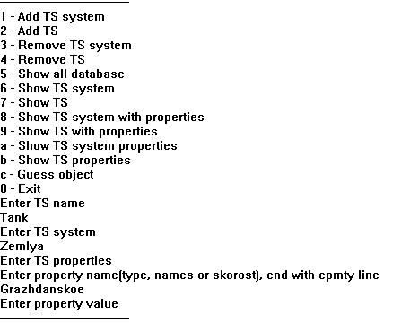
Удаление ТС
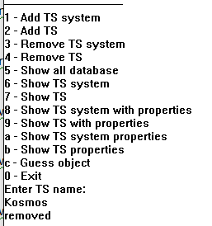

Угадываем ТС
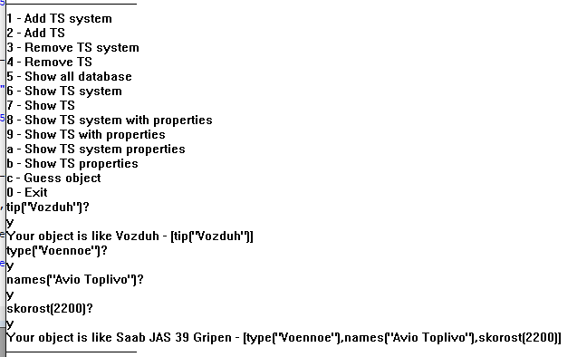

Просмотр ТС и их свойств
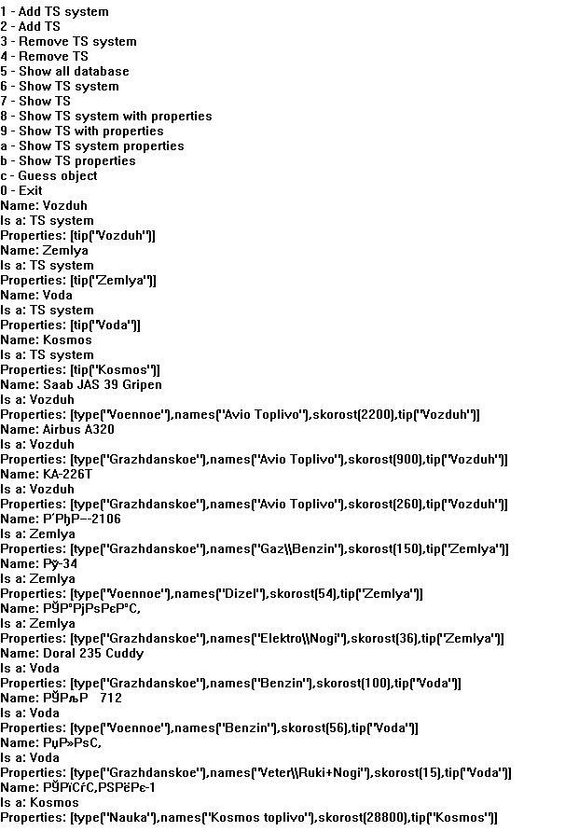

Задание вспомогательное.
Задание – вспомогательное. Исследовать работу программы GENI, сначала с базой правил, хранящейся в файле GENI.GNI, затем с базой знаний, хранящейся в файле VACATION.GNI. В первом случае путем последовательного задания уточняющих вопросов программа угадывает задуманное животное. Во втором случае программа распознает место отдыха, о котором Вы мечтаете, также предварительно задав серию вопросов.
Придумать и реализовать свою (авторскую) базу знаний для данной программы.
Дерево
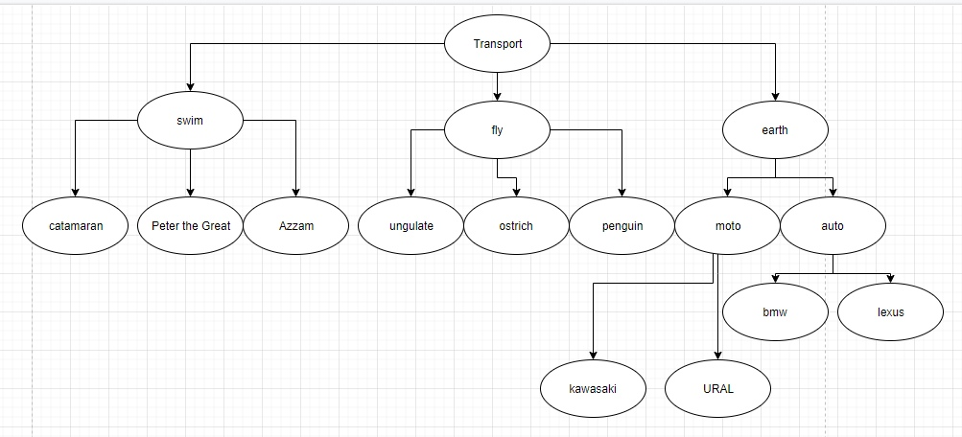
База знаний
rule(1,"transport","earth",[3])
rule(2,"transport","fly",[2])
rule(3,"transport","swim",[1])
rule(4,"fly","MIG-35",[2,5])
rule(5,"fly","Boeing 777",[2,6])
rule(6,"fly","MI-8",[2,4])
rule(7,"earth","moto",[7])
rule(8,"earth","auto",[10])
rule(9,"moto","URAL",[8])
rule(10,"moto","kawasaki",[3,7,9])
rule(11,"auto","bmw",[11])
rule(12,"auto","lexus",[12])
rule(13,"swim","catamaran",[1])
rule(14,"swim","Peter the Great",[5])
rule(15,"swim","Azzam",[13])
cond(1,"Can your transport swim")
cond(2,"Can your transport fly")
cond(3,"Can your vehicle ride on the road")
cond(4,"Does it have blades, like a helicopter")
cond(5,"can he fight")
cond(6,"Is it designed to transport people")
cond(7,"Does it have 2 wheels")
cond(8,"Is your transport made in Russia")
cond(9,"Does your vehicle race")
cond(10,"Does it have 4 wheels")
cond(11,"Is your transport made in Germany")
cond(12,"Is your transport made in Japany")
cond(13,"Does your vehicle have an engine")
topic("transport","Now I will guess the transport you are thinking about")
Тесты
