**Materialliste für Arduino-Shields (*in Bearbeitung*)**

***Temperatursensor***

 **Preis:** US $1.00/Stück

***AliExpress:*** <https://de.aliexpress.com/item/TMP36-TMP36GT9-TMP36GT9Z-TO92-IC-1pcs-lot-Free-Shipping/32749280351.html?spm=a2g0x.search0104.3.1.155f6e8aOdAyeF&ws_ab_test=searchweb0_0,searchweb201602_5_10152_10151_10065_10344_10068_10342_10325_10343_10546_10340_10548_10341_10084_10083_10618_10630_10307_10134_5722316_5711211_10313_10059_10534_100031_10629_10103_10626_10625_10624_10623_10622_10621_10620_10142,searchweb201603_1,ppcSwitch_5&algo_expid=c26ecfae-849d-4806-a103-1cea5b65dd8c-0&algo_pvid=c26ecfae-849d-4806-a103-1cea5b65dd8c&priceBeautifyAB=0>

***Abstandsensor***



**Preis:**US $0.83/Stück

***AliExpress:*** <https://de.aliexpress.com/item/Free-shiping-10PC-HC-SR04-HCSR04-to-world-Ultrasonic-Wave-Detector-Ranging-Module-HC-SR04-HC/32472332209.html?spm=a2g0x.search0104.3.15.27937e34uzi0I6&ws_ab_test=searchweb0_0,searchweb201602_5_10152_10151_10065_10344_10068_10342_10325_10343_10546_10340_10548_10341_10084_10083_10618_10630_10307_10134_5722316_5711211_10313_10059_10534_100031_10629_10103_10626_10625_10624_10623_10622_10621_10620_10142,searchweb201603_1,ppcSwitch_5&algo_expid=3a56da2e-c790-4ea5-9fec-85612e33ac74-2&algo_pvid=3a56da2e-c790-4ea5-9fec-85612e33ac74&priceBeautifyAB=0>

***Buzzer***



**Preis:** 0,59 Є/Stück

***Conrad:*** <https://www.conrad.de/de/piezo-signalgeber-rmp-serie-ohne-elektronik-710167.html>

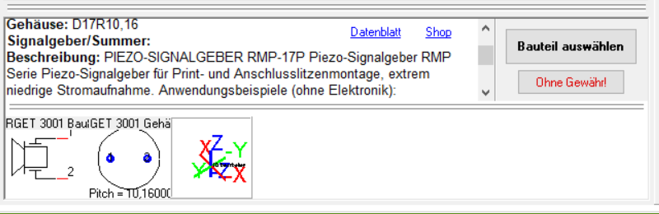

**Datenblatt:** <http://www.produktinfo.conrad.com/datenblaetter/700000-724999/710167-da-01-en-PIEZO_SIGNALGEBER_RMP_17P.pdf>

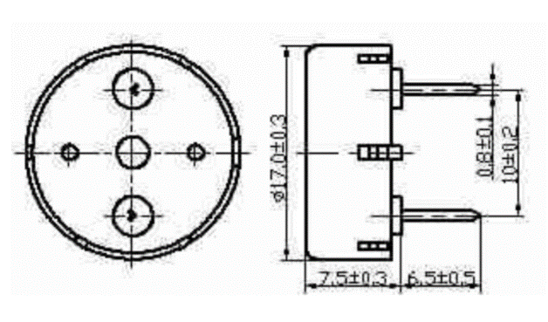

***10 Segment LED Balkenanzeige***



**Preis:** US $0.52/Stück

***AliExpress:*** <https://de.aliexpress.com/item/1Pcs-10-Segment-LED-Bargraph-Light-Display-Module-Bar-Graph-Ultra-Bright-Red-Yellow-Green-Blue/32801237126.html?spm=a2g0x.search0104.3.273.778a30ebs8DqFC&ws_ab_test=searchweb0_0,searchweb201602_5_10152_10151_10065_10344_10068_10342_10325_10343_10546_10340_10548_10341_10084_10083_10618_10630_10307_10134_5711211_5722317_10313_10059_10534_100031_10629_10103_10626_10625_10624_10623_10622_10621_10620_10142,searchweb201603_1,ppcSwitch_5&algo_expid=7625d219-3ddd-467c-abd8-7e110e065422-40&algo_pvid=7625d219-3ddd-467c-abd8-7e110e065422&priceBeautifyAB=0>

**Datasheet:** <https://www.distrelec.de/Web/Downloads/12/76/tm661276.pdf>

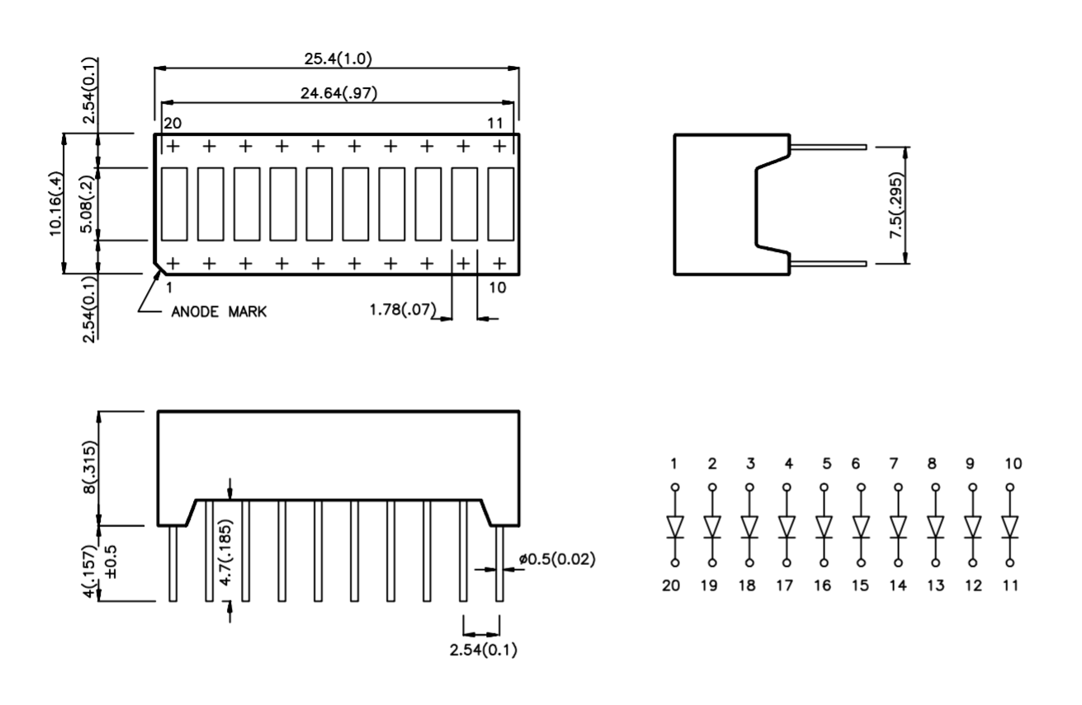

**Distrelec Preis:** 2,49 Є / Stück

<https://www.distrelec.de/de/led-balkenanzeige-gruen-rot-kingbright-dc7g3hwa/p/17502614>

***HC-SR501 Bewegungsmelder***

**Preis:** US $0.78/Stück  
***AliExpress:*** <https://de.aliexpress.com/item/Free-Shipping-HC-SR501-Adjust-Infrared-IR-Pyroelectric-Infrared-PIR-module-Motion-Sensor-Detector-Module-We/1564561530.html?spm=a2g0x.search0104.3.22.38a24a46B0luFT&ws_ab_test=searchweb0_0,searchweb201602_5_10152_10151_10065_10344_10068_10342_10325_10343_10546_10340_10548_10341_10084_10083_10618_10630_10307_10134_5711211_5722315_10313_10059_10534_100031_10103_10627_10626_10624_10623_10622_10621_10620_10142_5711312,searchweb201603_25,ppcSwitch_5&algo_expid=c4a7a0c8-e13f-4182-b129-b0872edc208c-3&algo_pvid=c4a7a0c8-e13f-4182-b129-b0872edc208c&priceBeautifyAB=0>

***Photoelektrische Fotowiderstand***

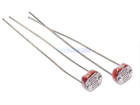

**Preis:** US $1.08/ 50 St.

***AliExpress:*** <https://de.aliexpress.com/item/50-ST-CKE-LDR-Foto-Light-Sensitive-Resistor-Photoelektrische-Fotowiderstand-5528-GL5528/32668713683.html?spm=a2g0x.search0104.3.9.1648283fxewo8l&ws_ab_test=searchweb0_0%2Csearchweb201602_5_10152_10151_10065_10344_10068_10342_10325_10343_10546_10340_10548_10341_10084_10083_10618_10630_10307_10134_5711211_5722313_10313_10059_10534_100031_10103_10627_10626_10624_10623_10622_10621_10620_5711313_10142%2Csearchweb201603_25%2CppcSwitch_5&algo_expid=900264dd-af8f-4cb1-85d6-8d455dcc0c45-1&algo_pvid=900264dd-af8f-4cb1-85d6-8d455dcc0c45&priceBeautifyAB=0>

***7-Semgnet Gemeinsame Kathode (ähnlich wie HDSP-7503)***



**Preis:** US $1.69/ 10 St.

***AliExpress:*** <https://de.aliexpress.com/item/5pcs-bag-high-red-light-digital-led-3-bit-common-cathode-0-36-inch-3461/32265316167.html?spm=a2g0x.10010108.1000023.4.4f1f4336WlamBl>

**AliExpress:**

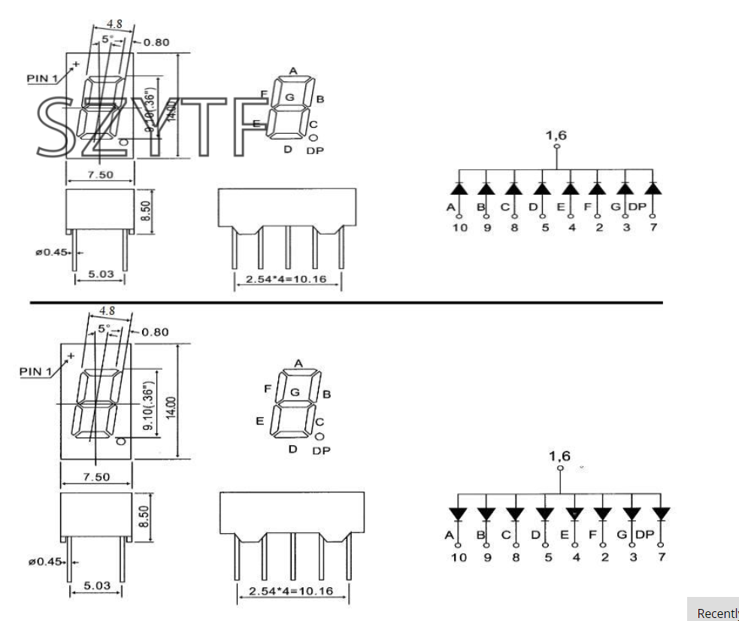

**Distrelec Preis:** 1,30 Є / Stück

**Datasheet:** <https://www.distrelec.de/Web/Downloads/11/91/tg661184-661191.pdf>

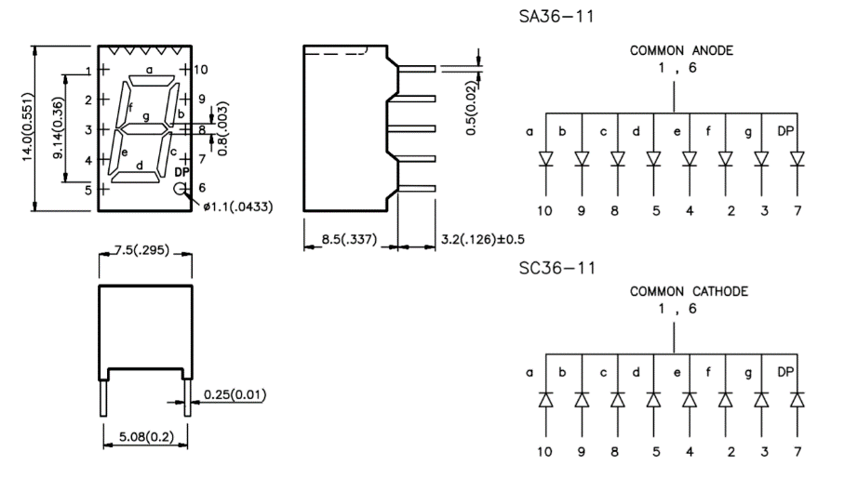

**Das Dokument befindet sich auf dem folgenden Pfad:**