**GM – iOS Assessment**

* **Requirements:**

1. Create a Network Controller class which is used to connect and fetch the JSON data from the URL.
2. The JSON data from the URL response model in data model classes.
3. For cities and states, fetch data from JSON file in the project because I can’t find an API to get all cities and states of USA. (JSON file: cityList.json).
4. With the state and the city, use them as parameters to call to weather API (aerisweather.com).

* **Additions**:
* Written in Objective-C.
* I save API Key, Client ID and Client Secret in plist file for security.
* Fetch data asynchronously:
  + Avoid blocking the main thread while fetching data.
  + Updating the view right after we have data. (update UI on main thread by DispatchQueue.main.async)
* Used MVVM Architecture:
  + Models: Struct object to parse data from JSON.
  + Views: Main view for users.
  + ViewControllers: Work directly to ViewModels (not Models), update Views.
  + ViewModels: Call Network layer to API, get data, parse data from JSON to Model Object. ViewModels works between Models and Controllers, connect them.
* Connected to API by NSURLSession.
* Parse data from JSON to Object Model.
* Use Test Drive Development. First, I write a fail test case (red) of a function. After that, I fixed the function to pass that test case (green). Lastly, I refactored the code to make it cleaner. Because I only have 1 day to code this application, so I only test one method for example.
* If you have any problems with API, feel free to contact me at [nhannguyenit.work@gmail.com](mailto:nhannguyenit.work@gmail.com). Because I’m using free API, sometimes they will change the API key or limit the quota requesting.
* **Demo:**

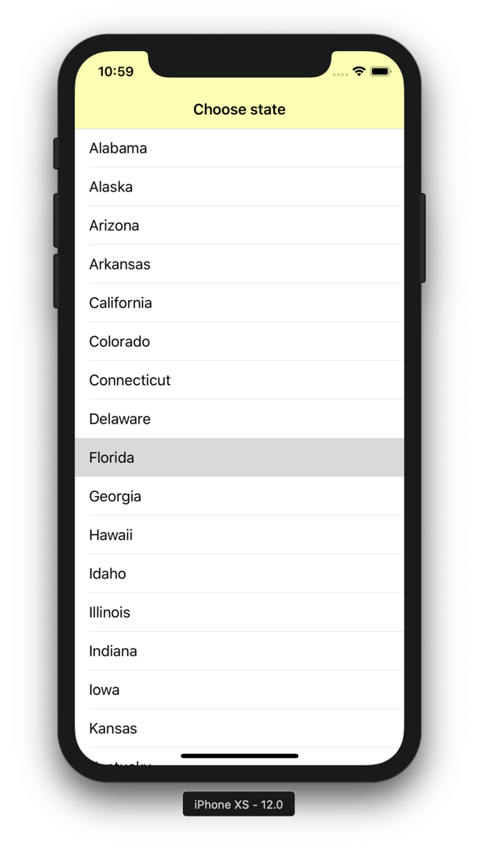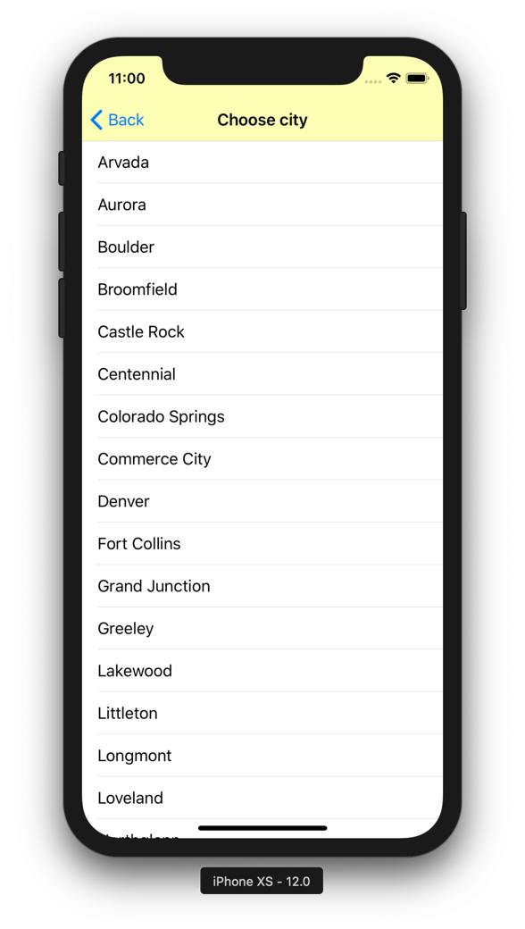

* Case 1:

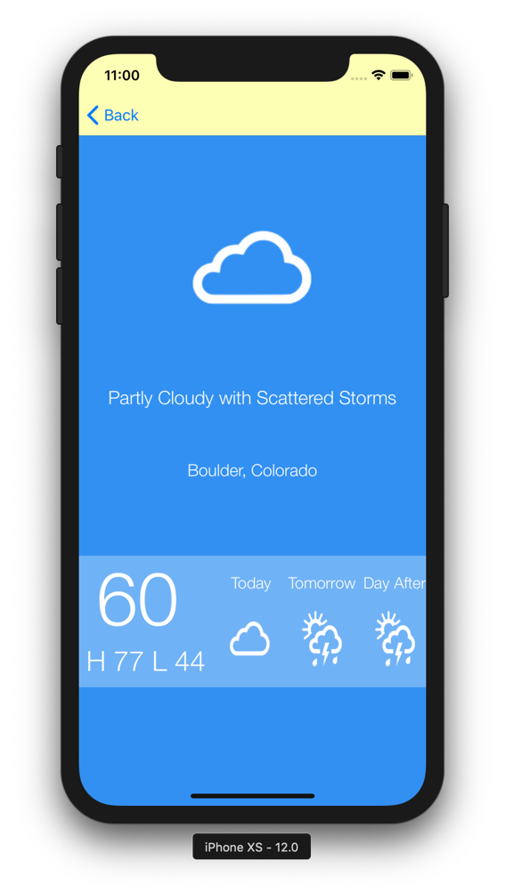

Information of weather for today, tomorrow and the day after.

The icon is button, you can click to view that day information.

City and state which user choose.

Weather information get from API.

Base on average temp, choose the icon of weather to display.

Background color will change bases on Average temp of that day.

H 77: Highest temp, get from API.

L 44: Lowest temp, get from API.

60: Average temp.

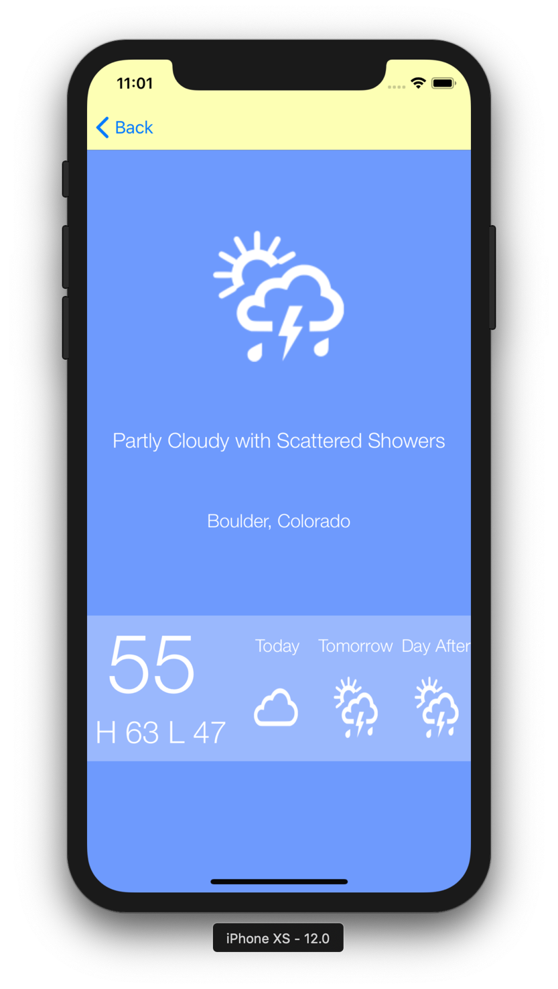

After click Tomorrow button, based on the Average temp, it will change background color, icon of weather, weather detail, average temp, highest temp and lowest temp.

* Case 2:

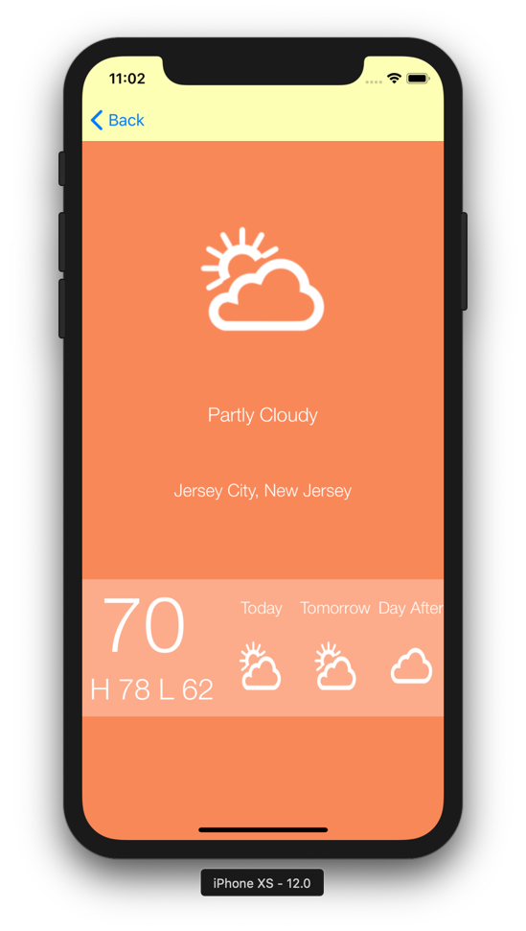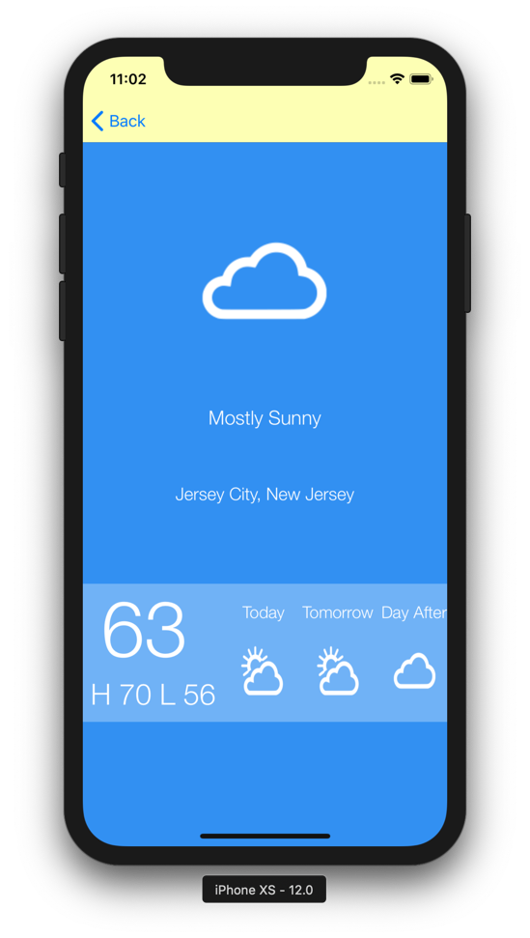

* Case 3:

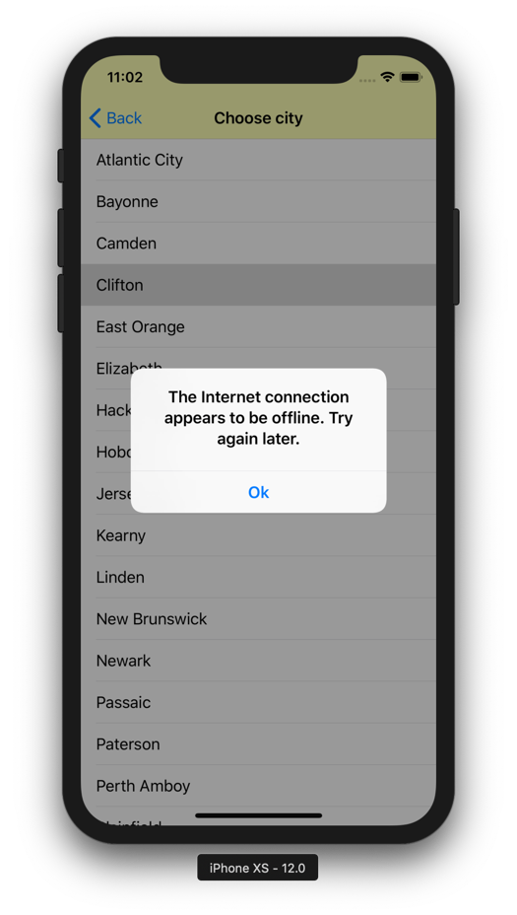

If you cannot access to the Internet, the screen will display this message