ARTICLE Manuscript draft · Research Team 7
Closing the predictive gap in subterranean urban drainage monitoring: an evidence analysis and a hydroclimate-coupled cyber-physical framework
[Parvez Hossen Badal]¹, [Md. Abir Hossain]², [Afifur Rahman Maraz]³ & [Naziur Rahman Raju]⁴ (Research Team 7)
¹[ CSE , UITS , Dhaka , Bangladesh ] e-mail: [mohammad3badol@gmail.com]
Urban waterlogging in monsoon-exposed deltaic cities disrupts economies, strands traffic and endangers lives, yet drainage networks usually remain unobserved until streets are already submerged. Internet-of-Things (IoT) drain monitors have proliferated, but it is unclear whether they have converged on predictive, safety-aware and citizen-facing operation. Here we analyse 73 records published between 2013 and 2026, of which 59 are IoT monitoring systems, against five capabilities. Gas sensing is present in 34 systems (58%), but only 12 (20%) offer a map, 9 (15%) apply machine learning and 9 (15%) use sub-GHz low-power wide-area networks. No system exceeds three of the five capabilities, none is recorded as using satellite or reanalysis climate data, and capability breadth has not increased over time (Spearman ρ = 0.07, P = 0.60). Machine learning is concentrated in offline studies that have no live telemetry. We distil six unresolved gaps and propose JOLODHAR-ML, a four-layer framework that couples under-cover LoRa telemetry with NASA POWER climate indices, LSTM forecasting, XGBoost cause attribution and civic rerouting, together with a pre-specified validation protocol.

Flooding is among the most damaging natural hazards for cities, and its burden is expected to grow with urbanization and a changing climate¹. In low-lying deltaic cities, a large share of this risk is pluvial: intense monsoon rainfall exceeds the capacity of the drainage network, water surcharges from manholes, and streets become impassable within hours. The drainage network is the last engineered barrier between rainfall and the street, yet it is among the least instrumented components of urban infrastructure. Maintenance is frequently reactive: blocked conduits are cleared after complaints, and emergency pumping is dispatched after flooding has begun.
Low-cost IoT hardware has made it feasible to place sensors inside drains and manholes, and a sizeable literature reports prototypes that measure water level, flow and gas concentration and raise local alarms. A system that merely signals a present threshold crossing, however, can only be reactive. Three further capabilities are needed to change outcomes: forecasting skill with enough lead time to act, safety monitoring for the sanitation workers who enter confined spaces, and a way to turn telemetry into decisions for people outside the municipal control room, for example drivers who could be diverted around a flooded corridor. At the same time, machine-learning methods such as long short-term memory (LSTM) networks² and gradient-boosted trees³ have shown strong skill in rainfall–runoff and flood prediction^{4,5}, and open climate reanalysis products such as NASA POWER^{6,7} provide freely accessible meteorological and soil-wetness variables. It is not clear whether the drainage-monitoring literature has joined these threads.
Here we analyse 73 records from 2013 to 2026, coded for communication technology, gas sensing, mapping, machine learning and use of external hydroclimate data. We ask what the field has converged on, where progress has stalled, and what an architecture that closes the remaining gaps would require. We then specify such an architecture, JOLODHAR-ML, and a validation protocol with explicit, falsifiable hypotheses. We do not report field performance of the proposed system; the contribution is the evidence analysis, the formulation of the gaps, and a testable design.
Results
A corpus of 73 records from 20 countries. The corpus merges the team's original matrix of 23 systems with 50 further records (Supplementary Data 1). We classified 59 records as IoT monitoring systems, 10 as model-based or data-driven studies (for example image-based sewer defect detection and process-model sulfide prediction) and 4 as reviews. Publication years span 2013 to 2026, and 61 records (84%) appeared in 2020 or later (Fig. 1a). India contributes 19 of the 59 systems (32%); 16 systems (27%) do not state a country. Bangladesh, the motivating context for this work, is represented by three systems (S15, S25 and S26), all Wi-Fi prototypes with general-purpose MQ-135 gas sensors and none with machine learning; S25 was validated only by circuit simulation.
Gas sensing is common; predictive and civic capabilities are rare. Gas sensing is present in 34 of 59 systems (58%; Fig. 1b). In contrast, 12 systems (20%) provide a map or GIS interface, 9 (15%) apply machine learning, 9 (15%) use sub-GHz LPWAN, and 2 (3%) use rainfall or hydro-meteorological inputs (S71, with simulated sequences, and S72, with local rainfall sensing). No system is recorded as using satellite or reanalysis climate data. The most common profile is gas sensing alone (22 systems, 37%), and 13 systems (22%) have none of the five capabilities (Fig. 1c). Only S21 combines gas sensing, mapping and machine learning, and it does so over NB-IoT cellular links with edge hardware whose cost and power draw are noted as limiting for battery-operated manholes.

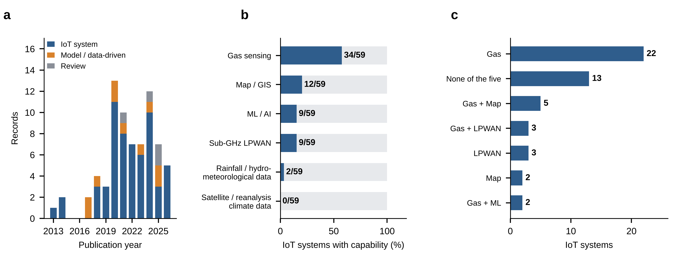
Fig. 1 | Composition and capability coverage of the evidence base. a, Records per publication year by type (73 records). b, Share of the 59 IoT systems with each capability; numbers give counts. c, Most common capability combinations among the 59 systems (15 distinct combinations occur). Rain, rainfall or hydro-meteorological data.

Machine learning sits outside live telemetry. Of the 59 IoT systems, 9 (15%) apply a learned model (S8, S9, S17, S18, S21, S27, S53, S71, S72). Among the 14 other records, 12 involve machine learning: 8 of the 10 model-based studies and all 4 reviews. These studies address image-based defect detection (S40, S41, S50), process-model sulfide prediction (S48, S49), LSTM soft sensing (S47) and gas-hazard classification on offline data (S57). As recorded, none provides live telemetry, mapping and alerting. Where ML does appear inside deployed systems, the evidence is narrow: S8 was evaluated in simulation, S17 does not generalize across seasonal rainfall or pipe topologies, S27 used a prototype dataset only, S71 relied on simulated sequences, and S53 requires a calibrated hydraulic model. Rule-based expert systems (S36) and algorithmic detectors (S64) were not counted as machine learning.
Cellular links dominate reported communications; LPWAN systems are the most capable. Twenty-one systems (36%) use a cellular link (GSM/GPRS, NB-IoT, 4G or LTE-M) in whole or in part, 16 (27%) use Wi-Fi, 9 (15%) use LoRa, LoRaWAN or Sigfox, 5 use short-range personal-area protocols and one is wired; 16 (27%) do not report a link (Fig. 2a; some systems are hybrids). Reported weaknesses follow the link type (Table 1): subscription cost (S4) and carrier-coverage dependence (S13, S43, S63) for cellular systems; poor penetration of deep concrete or unreliable coverage for Wi-Fi (S5, S42, S68); packet loss for multi-hop ZigBee meshes (S10); and, for LPWAN, a Sigfox payload of 12 bytes and 140 messages per day (S59), low LoRaWAN bandwidth (S16) and dependence on utility-owned gateways (S58). LPWAN systems have a higher mean capability count (1.78 of 5) than cellular (0.95), Wi-Fi (1.25) or short-range systems (1.00), although with n = 9 this is descriptive only.

Table 1 | Communication archetypes and the capabilities they carry
Archetype | Systems (n) | Gas sensing | Map | ML / AI | Mean capabilities (of 5) | Typical limitation reported in the corpus
Cellular (GSM, GPRS, NB-IoT, 4G) | 21 | 10 | 5 | 3 | 0.95 | Subscription cost; carrier coverage dependence; edge hardware cost and power (S4, S13, S21, S43, S63)
Wi-Fi | 16 | 16 | 2 | 2 | 1.25 | Poor underground penetration; cloud channel limits on actuation; no energy harvesting (S5, S11, S15, S42, S68)
Short-range PAN (ZigBee, NRF24, Bluetooth) | 5 | 4 | 0 | 0 | 1.00 | Short range; multi-hop packet loss; sensor fouling (S3, S10, S19)
Sub-GHz LPWAN (LoRa, LoRaWAN, Sigfox) | 9 | 4 | 2 | 1 | 1.78 | Static thresholds; low bandwidth and payload limits; gateway dependence (S2, S16, S58, S59)
Link not reported | 16 | 6 | 4 | 4 | 1.00 | Link type, range and power budget not described
Hybrid systems are counted in every class they use, so rows overlap (one wired system is not shown). Capabilities: gas sensing, map/GIS, ML/AI, sub-GHz LPWAN, rainfall or hydro-meteorological data.

No convergence over time. The mean IoT system exhibits 1.1 of five capabilities (median 1; Fig. 2b), and no system exhibits more than three: S16 (gas, map, LPWAN), S21 (gas, map, ML) and S72 (map, ML, rainfall data). Although the volume of publications has risen, with 50 of the 59 systems appearing since 2020, capability breadth has not (Spearman ρ = 0.07, P = 0.60, n = 59; Fig. 2c). The literature is growing by adding more single-feature prototypes, not by combining capabilities.

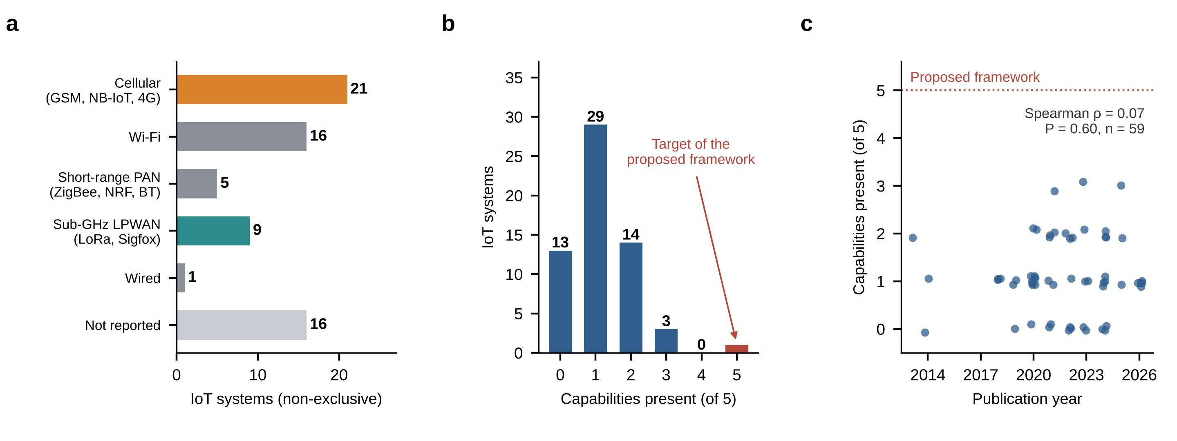
Fig. 2 | Communication technologies and capability breadth among 59 IoT systems. a, Systems by communication class (non-exclusive). b, Number of capabilities present per system (maximum 5); the red bar marks the proposed framework. c, Capability count against publication year (small jitter added); the Spearman rank correlation is shown.

Six unresolved gaps
Synthesising the gap statements recorded for each record, we identify six gaps that persist across the period (Table 2). G1, hydroclimate decoupling. Drain telemetry is analysed in isolation from rainfall forecasts, antecedent soil wetness and humidity, although these govern how much rainfall reaches the sewer. No system uses satellite or reanalysis data, only two use rainfall inputs, and one study proposes adding rain gauges as future work (S59). G2, undifferentiated root cause. Rising water in a conduit can reflect hydraulic surcharge from intense rainfall or structural blockage with little rainfall. Fifty of the 59 systems use no learned model, and heuristic detectors (S36, S43, S64) cannot separate the two causes, which call for different responses (waiting versus dispatching a clearing crew). G3, no civic routing. Twelve systems offer a map, but these serve responders (S34 notifies corporation workers only) or show flood hotspots (S72); none documents a link between flood telemetry and a routing engine that redirects vehicles. G4, communication and energy. Cellular dependence, short-range protocol failures, the absence of duty-cycling or energy harvesting (S11) and edge-hardware power draw (S21) constrain deployment at city scale. G5, gas safety. Twenty-five systems (42%) omit gas sensing, and where it is present it relies on general-purpose metal-oxide sensors that are not gas-selective (S25, S26, S34), drift by up to ±18% (S68) and lose sensitivity in high humidity (S69). G6, thin field validation. Evidence comes largely from simulation or single sites: S8 in simulated environments, S25 by circuit simulation, S71 on simulated sequences, S47 on one chamber, and S17 with failure to generalize.

Table 2 | Gaps, supporting evidence, proposed framework response and pre-specified test
Gap | Evidence in corpus | JOLODHAR-ML response | Primary test
G1 Hydroclimate decoupling | 0 of 59 systems use satellite or reanalysis data; 2 use rainfall inputs (S71, S72) | NASA POWER precipitation (PRECTOTCORR), root-zone soil wetness (GWETROOT), relative humidity (RH2M) and temperature (T2M) as LSTM covariates | H1: covariates reduce 1–3 h level-forecast error versus a sensor-only LSTM (paired ablation)
G2 Root cause | 50 of 59 systems use no learned model; heuristic detectors (S36, S43, S64) | XGBoost classifier comparing observed level with rainfall-expected level to label surcharge versus structural blockage | H2: higher F1 and MCC than threshold and rainfall-only baselines on labelled events
G3 Civic routing | 12 of 59 offer a map; none documents vehicle rerouting | WebSocket map linked to OSRM/Mapbox routing that excludes segments with predicted flooding | Alert-to-route latency; share of simulated trips diverted correctly
G4 Link and energy | 21 cellular, 9 LPWAN; no duty-cycling or harvesting (S11) | 433 MHz LoRa (SX1278) under the cover with an above-ground gateway; sleep–wake duty cycling; compressed payloads | H3: packet delivery ratio and battery life meet pre-set targets under cast-iron covers
G5 Gas safety | 25 of 59 omit gas sensing; non-selective, drifting MOS sensors (S25, S26, S34, S68) | MQ-135 gas channel with reference calibration and worker-facing threshold alerts | Detection latency; calibration drift against a reference instrument
G6 Field validation | Simulation-only or single-site evidence (S8, S25, S47, S71) | Multi-site field deployment; blocked temporal and leave-one-district-out validation | Skill retained on unseen seasons and districts (H4)

The JOLODHAR-ML framework
To close G1–G6 jointly, we propose a four-layer cyber-physical architecture (Fig. 3). Sensing layer. IP67-sealed nodes under manhole covers measure water level (JSN-SR04T ultrasonic), flow velocity (YF-S201), toxic gas (MQ-135) and lid tamper or tilt (MPU-6050) on an ESP32 microcontroller with sleep–wake duty cycling and a rechargeable battery pack. Link layer. Nodes transmit by 433 MHz LoRa⁸ (SX1278 transceiver) to an above-ground gateway, avoiding recurring cellular fees and exploiting the sub-GHz band's better penetration, with edge compression to fit LPWAN payload limits. Analytics layer. Daily NASA POWER indices are ingested for 38 selected districts of Bangladesh (2012–2024). An LSTM forecasts conduit water level 1–3 h ahead, and an XGBoost classifier compares observed level with rainfall-expected level to separate hydraulic surcharge from structural blockage. Civic action layer. A WebSocket map shows live and predicted flooding, links to a routing engine to divert traffic, and issues municipal and worker-safety alerts.

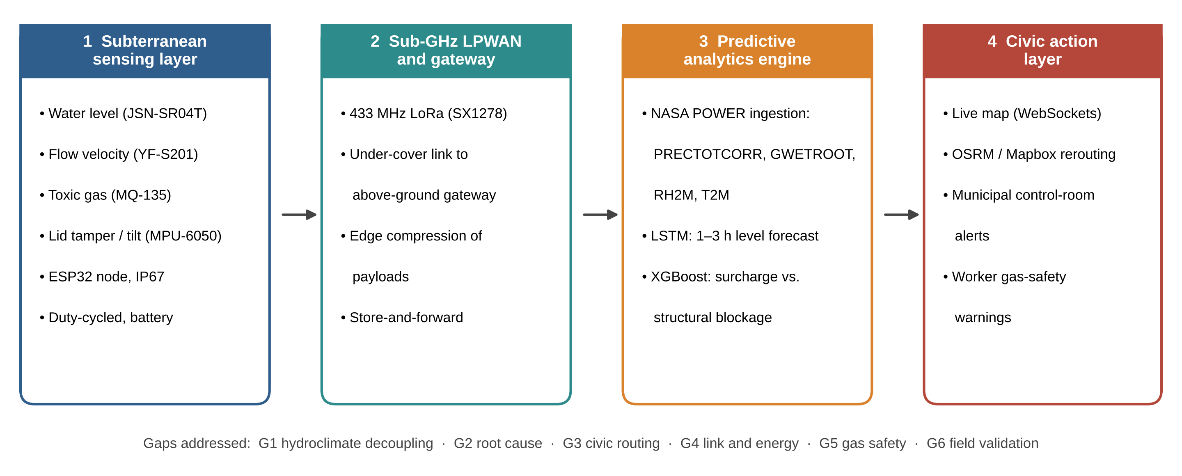
Fig. 3 | The JOLODHAR-ML cyber-physical framework. Four layers convert underground telemetry and external hydroclimate indices into forecasts, cause attribution and civic action. The strip below indicates the gaps (G1–G6, Table 2) the design targets.

Discussion
Our analysis suggests that smart-drainage research has produced many working sensors but few integrated systems. Reaching the sensor from under a manhole cover is no longer the bottleneck, since LoRa-class links are reported in nine systems; the bottleneck is what is done with the data. Each system adds a feature to an isolated alarm pipeline: 22 monitor gas only and 13 offer none of the five capabilities. Machine-learning activity and deployed IoT systems form two communities with little overlap. The former works on image-based defect detection, process-model sulfide prediction and soft sensing without live telemetry, whereas the latter relies on thresholds and local alarms. Neither delivers early warning that reaches road users.
The most testable claim of our framework is that antecedent hydroclimate state improves short-lead forecasts of conduit surcharge (H1). Rainfall–runoff modelling with LSTM networks has already shown that recurrent models can exploit meteorological forcing⁴, so the hypothesis is plausible, but it has not been tested with in-conduit telemetry. The framework also makes a design choice that deserves scrutiny: NASA POWER meteorology derives from the MERRA-2 reanalysis⁷ on a grid of roughly 0.5° × 0.625°, and several variables, including root-zone wetness, are daily. Such data cannot resolve street-scale rainfall, so we treat them as boundary and antecedent conditions, while the sub-hourly sensor stream carries the short-lead signal. Whether this division of labour is sufficient for 1–3 h warnings is exactly what the protocol below will test; if the climate covariates add no skill, H1 is rejected and the contribution reduces to G2–G6.
Validation protocol. We will compare the full model with three baselines: a threshold rule, persistence, and a sensor-only LSTM. Forecast skill will be reported as RMSE and Nash–Sutcliffe efficiency at 1, 2 and 3 h, and event warnings as probability of detection, false-alarm ratio and critical success index. Because the main weakness of earlier ML systems is generalization (S17) and single-site validation (S47), we will use blocked temporal cross-validation across monsoon seasons and leave-one-district-out spatial validation (H4). Cause attribution will be scored by F1 and Matthews correlation coefficient against events labelled by field inspection. Link and energy performance will be measured as packet delivery ratio and node lifetime beneath cast-iron and concrete covers.
Limitations. First, each capability was coded as present or absent, which hides differences in quality, scale and validation, and absence may reflect incomplete reporting rather than absence in the system. Of the 50 added records, 44 were coded from abstracts or record indexes and 4 from full text, so abstract-level coding probably under-reports capabilities. Second, 16 systems lack a country and 16 lack a communication link; S46 has an inferred country, S26 an approximate year and S47 a truncated title, and the original 23 records carry no venue or DOI. Third, the classification into IoT systems, model-based studies and reviews is ours, and the corpus is not a registered systematic review; the search procedure should be reported in full⁹ before submission. Fourth, reported weaknesses are summaries of each study and have not been independently reproduced. Fifth, the framework is a design and hypothesis set: no field performance data are presented, and the labelled blockage events that H2 requires must be collected. Finally, use of the 433 MHz band must be confirmed against local spectrum regulations.
Methods
Corpus and coding. The corpus comprises the 23 systems of the team's research-gap matrix and 50 records added later, each with title, link, country, year, communication technology, alert mechanism and a one-sentence gap statement; the added records also carry source, venue or DOI and a verification note. Study selection is reported following PRISMA 2020 (ref. 9) only to the extent that the screening records allow. The 73 records are those retained after the team’s literature screening; the databases searched, search strings, search dates, and the numbers of records identified, de-duplicated, screened, excluded and assessed in full text were not recorded and are reported as unavailable (Supplementary Data 2). For the 50 added records the matrix lists the publisher or host of each record (most often IEEE, n = 18; ScienceDirect/Elsevier, n = 8; Springer, n = 7); it does not record the databases searched, the search strings or the search dates. No eligibility criteria were recorded at screening. The scope of the retained records implies studies of drainage, sewer, manhole, stormwater or waterlogging monitoring or prediction using sensing, wireless communication or machine learning (including reviews), published between 2013 and 2026 with English-language titles (Supplementary Note 1). These criteria are inferred, not pre-specified, and the two blocks of records (S1–S23 and S24–S73) are not assumed to be separate screening stages. We classified each record as an IoT monitoring system, a model-based or data-driven study without field telemetry (S37, S40, S41, S44, S47–S50, S57, S66) or a review (S56, S60–S62). For IoT systems we coded gas sensing, map or GIS interface (responder-facing or public) and machine learning as recorded; machine learning means a learned model, and rule-based expert systems and algorithmic detectors were excluded. Sub-GHz LPWAN means LoRa, LoRaWAN or Sigfox. Rainfall or hydro-meteorological data means such variables used in the analytics, and satellite or reanalysis data was coded separately. Capability breadth is the number of these five capabilities present (0–5). Communication classes are non-exclusive.
Statistics. Association between publication year and capability breadth was assessed with a two-sided Spearman rank correlation (SciPy). Percentages are descriptive; given the sample size, no inferential claims are made beyond this correlation.
Framework specification. Component choices (JSN-SR04T, YF-S201, MQ-135, MPU-6050, ESP32, SX1278) follow the team's design. NASA POWER variables are PRECTOTCORR (bias-corrected precipitation), GWETROOT (root-zone soil wetness), RH2M (relative humidity at 2 m) and T2M (temperature at 2 m), retrieved through the POWER API⁶ for 2012–2024.
Data availability. The coded matrix of 73 records (Supplementary Data 1), the PRISMA 2020 selection summary (Supplementary Data 2) and Supplementary Note 1 are available in the project repository. [Add repository DOI for the matrix and for collected telemetry.] Code availability. [Add repository link for analysis and model code.]
References
1. Rentschler, J., Salhab, M. & Jafino, B. A. Flood exposure and poverty in 188 countries. Nat. Commun. 13, 3527 (2022).
2. Hochreiter, S. & Schmidhuber, J. Long short-term memory. Neural Comput. 9, 1735–1780 (1997).
3. Chen, T. & Guestrin, C. XGBoost: a scalable tree boosting system. In Proc. 22nd ACM SIGKDD Int. Conf. Knowledge Discovery and Data Mining 785–794 (ACM, 2016).
4. Kratzert, F., Klotz, D., Brenner, C., Schulz, K. & Herrnegger, M. Rainfall–runoff modelling using long short-term memory (LSTM) networks. Hydrol. Earth Syst. Sci. 22, 6005–6022 (2018).
5. Mosavi, A., Ozturk, P. & Chau, K. Flood prediction using machine learning models: literature review. Water 10, 1536 (2018).
6. Sparks, A. H. nasapower: a NASA POWER global meteorology, surface solar energy and climatology data client for R. J. Open Source Softw. 3, 1035 (2018).
7. Gelaro, R. et al. The Modern-Era Retrospective Analysis for Research and Applications, Version 2 (MERRA-2). J. Clim. 30, 5419–5454 (2017).
8. Augustin, A., Yi, J., Clausen, T. & Townsley, W. M. A study of LoRa: long range & low power networks for the Internet of Things. Sensors 16, 1466 (2016).
9. Page, M. J. et al. The PRISMA 2020 statement: an updated guideline for reporting systematic reviews. BMJ 372, n71 (2021).
Acknowledgements [Funding, supervisors and support] Author contributions [e.g., A.O.: conceptualization, data curation, analysis, writing] Competing interests The authors declare no competing interests. Additional information Supplementary data are available in the project repository (see Data availability).

