Beacon Center Homepage Code Guide
Sep 30, 2026 · @tyler conti

How the file is organized
The map page is three files that sit in the same folder. The HTML links the other two in its <head>, and each file reads top to bottom in the same order the page draws.
File | Lines | What it holds
beacon-center-homepage-mobile.html | 327 | The page, top to bottom: icon sprite, top bar, <main> with the campus map and disclaimer, bottom nav, toast. Its <head> links styles.css and loads script.js with defer, so the script runs after the HTML is read
styles.css | 269 | Part 1, the page: design tokens, base, top bar, map frame, bottom nav, toast, then responsive rules. Part 2, the map widget: everything nested under #beaconMap, then the page integration overrides
script.js | 652 | Part 1, the map widget: map data, markers, popup, sign-in, flag form, page hooks. Part 2, the page: toast, bottom nav highlight, map search, actions. The map runs first because the page calls window.beaconMap
Naming rules the file follows
- Page classes use kebab-case: .topbar-inner, .dock-btn.
- Map widget classes and ids use camelCase with a bc prefix: .bcMarker, #bcPopup. The prefix keeps them from clashing with the page.
- States start with is- (.is-active, .is-visible) or use ARIA (aria-pressed).
- Scripts find elements through data- attributes, never style classes, so restyling can't break behavior.
- CSS is written by hand, one rule per line. JavaScript is formatted with Prettier (2 spaces, single quotes, 120-character lines).

Design tokens and color code
Every color and size the page reuses is a CSS variable on :root, at the top of styles.css. Change a value there and it updates everywhere.
Variable | Value | Controls
--navy | #132245 | Toast background
--navy-deep | #0d1b38 | Bottom nav background
--blue | #005a8b | Brand mark, drop-a-flag button in the bottom nav, top bar icons
--sky | #78afe9 | Keyboard focus outline, Home highlight in the bottom nav
--ink | #182b43 | Main text
--muted | #5f7288 | Secondary text, disclaimer
--line | #dbe4ee | Borders and dividers
--paper | #f5f8fc | Page background, search field
--shadow | soft 14px shadow | Toast
--dock-height | 62px | Bottom nav height, and the page padding that keeps content above it
Color code. Two category colors are in use; add a main and light pair here when you build a new section.
Category | Tokens | Used on
Games | --game #d9620f | Messages badge, Meetups count in the bottom nav
Map and places | --place #1b7f52 / --place-bg #e3f3ea | Map section top border, map title icon, place highlight after a search
The bottom nav highlight comes from --dock-accent, set by .dock-home and .dock-map. Games, Meetups and Hubs have no highlight class yet because they don't have sections.
The map widget has its own tokens under #beaconMap (--bcBg, --bcPanel, --bcInk, --bcMuted, --bcLine, --bcSoft, --bcBlue), so its colors never mix with the page's.

Page sections
The visible Campus map title in the map toolbar is the page's only <h1>. The map section's id is the scroll target for the Map button in the bottom nav.
Section | Element and id | Title text | What's inside
Top bar | header.topbar | Brand: Beacon Center | .brand, .campus-badge (UMass Boston logo), .search, two .icon-btn, .avatar; below 700px the search box wraps onto its own row
Main | main.page#top | none | The map section and the disclaimer
Campus map | section.map-section#campus-map | h1: Campus map (inside the widget toolbar) | The whole #beaconMap widget
Disclaimer | div.disclaimer | none | Student project notice, kept because the page shows the UMass Boston logo
Bottom nav | nav.dock (after main) | none | Six .dock-btn buttons
Toast | div.toast#toast | none | Short status message, filled by the script

Buttons and interactive elements
On the page, a button's job is set by one data- attribute: data-scroll jumps to a section and data-action runs the matching function in the page script's actions list. Inside the map, buttons are found by id.
Page buttons
Button | Where | Classes | Data attribute | What it does
Messages, Notifications | Top bar | .icon-btn | data-action="chat", "notifications" | Placeholder toast
Search field | Top bar (its own row on phones) | .search | data-search-input | Enter finds the first map place whose name contains the text and flashes it; no match shows a toast
Home | Bottom nav | .dock-btn .dock-home | data-scroll="top" | Scrolls to the top
Map | Bottom nav | .dock-btn .dock-map | data-scroll="campus-map" | Scrolls to the map
+ (center) | Bottom nav | .dock-btn .dock-create | data-action="create" | Scrolls to the map, then opens sign-in or the Drop a flag form
Games, Meetups, Hubs | Bottom nav | .dock-btn | data-action="games", "meetups", "hubs" | Placeholder toast until those sections exist
Map widget buttons
Button | id or class | What it does
Start | #bcStart | Opens the demo sign-in panel
Enter demo map | button in #bcLogin | Signs in, swaps Start for Drop a flag, opens the first flag
Drop a flag | #bcDrop (toolbar), #bcHomeDrop (panel) | Opens the new flag form; blocked at 3 active flags
Map markers | .bcMarker with data-event | Selects the flag and opens its summary popup; guests go to sign-in
View event, Back | #bcView, #bcBack | Switch the popup between summary and full details
Remove my flag | #bcRemove | Deletes your own flag and frees its slot
Simulate recipient acceptance | #bcConsent | Marks a two-person flag as accepted
Drop flag / Send demo invitation | #bcSubmit | Checks the form, then adds the flag
Cancel | #bcCancel | Back to the signed-in panel
× | .bcPopupClose | Closes the popup; Esc or a click on empty map does too
Preview GPS marker | #bcGps | Shows or hides a sample position marker; no real location is used

CSS class reference
Part 1 of styles.css runs in the same order as this table, so each group is one block in the file. Class names start with their component's name (.brand-mark belongs to .brand).
Component | Classes
Base | .icon, .icon-sprite
Top bar | .topbar, .topbar-inner, .topbar-spacer, .brand, .brand-mark, .brand-name, .brand-tagline, .campus-badge, .search, .icon-btn, .badge, .avatar
Main | .page, .map-section (frame only; the map's own classes are below), .tag-dot (map title icon), .disclaimer
Bottom nav | .dock, .dock-btn, .dock-home, .dock-map, .dock-create, .dock-count, state .is-active
Toast | .toast, state .is-visible
Map widget layout | .bcWork, .bcToolbar, .bcActions, .bcStatus, .bcSide, .bcBottom
Map widget map | .bcMapWrap, .bcMap, .bcBase, .bcMapNote, .bcPlace, .bcMarker, .bcSelected, .bcP2p, .bcPrivateBadge, .bcLighthouse, .bcPhoto, .bcLegend, .bcAttrib; base map drawing: .building, .road, .footway, .coast, .green
Map widget popup and panel | .bcPopup, .bcPopupBody, .bcPopupClose, .bcOnLeft, .bcOnRight, .bcEyebrow, .bcTag, .bcRow, .bcFields, .bcError
Map widget shared | .bcButton, .bcPrimary, .bcFull, .bcIcon, .bcSprite, .bcMuted; .bcFlash is added by the page when a search finds a place
Breakpoints. The page uses screen width: @media at 700px (phone layout: full-width bottom nav, search on its own row, smaller campus badge) and 380px (small phones hide the brand name). The map uses its own width through @container at 800px (panel stacks under the map) and 480px (popup becomes a bottom sheet above the nav).

Page script
The page script is part 2 of script.js, wrapped in one function so its names stay private. It only reaches the map through window.beaconMap. Constants are in UPPER_CASE; everything else is camelCase.
Settings and content
Name | Type | Value or purpose
TOAST_MS | constant | 3200, how long a toast stays up (ms)
TOP_OFFSET | constant | 60, scroll distance (px) where the bottom nav switches back to Home
SPY_SECTIONS | constant | Section ids the bottom nav follows while scrolling; today only campus-map
actions | object | One function per data-action value; today only create
Element variables
Name | Points at
toast | #toast
searchInput | The search field ([data-search-input])
toastTimer | The running toast timeout, so a new toast resets it
spy | The IntersectionObserver that watches SPY_SECTIONS
Functions
Function | What it does
$(selector), $$(selector) | Find one or all matching elements
showToast(message) | Shows the toast, hides it after TOAST_MS
scrollToSection(id) | Smooth-scrolls a section to the top
setActiveNav(id) | Puts .is-active on the bottom nav button for that section
searchMap(text) | Finds the first map place whose name contains the text, scrolls to the map and calls beaconMap.focusPlace(); shows a toast when nothing matches
showPlaceholder() | Toast for buttons with no action yet: chat, notifications, games, meetups, hubs
actions.create | Scrolls to the map, calls beaconMap.create()
Event listeners
- One click listener on the whole page handles every data-scroll and data-action button, so new buttons work without extra wiring.
- A scroll listener resets the nav to Home near the top; spy handles the rest.
- The search field searches the map when you press Enter.

Map widget script
The map script is part 1 of script.js, so it runs before the page script. It is split into numbered sections, script: 1 to script: 9, each marked by a comment. Every lookup is scoped to #beaconMap, so none of its names leak into the page.
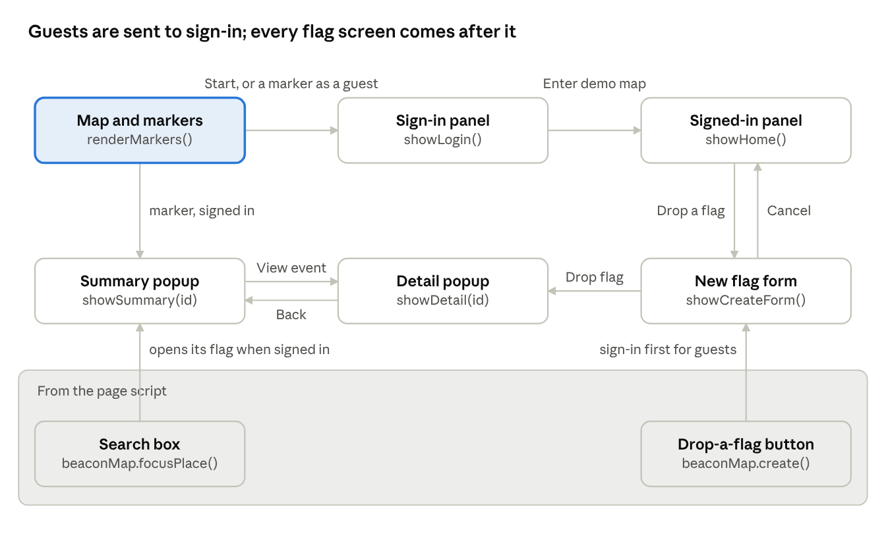
map widget screens · 3 panel screens, 2 popup views, 1 form, 2 page hooks
A guest who presses Start or a marker lands on the sign-in panel. After that, markers open the summary popup and Drop a flag opens the form; the page script reaches these screens only through its two hooks.
Settings and demo data (section 2)
Name | Value or purpose
demoNow | '2026-09-21T12:00', the demo's fake current time
maxFlags | 3 active flags per student
flagSlots | Three slots, each usable once: Current event, Later event, Other use
places | Six meetup places. Each has x / y as % positions on the map, a short label, and lonLat saved for real GPS later
events | The sample flags. Each has id, title, place, type (group or p2p), visibility (public or private), owner, desc, start, end, created, slot, plus group or peer and consent where they apply
Elements and state (sections 1 and 3)
Name | Holds
root, panel, popup, mapArea | #beaconMap, #bcPanel, #bcPopup, .bcMap
signedIn | true after the demo sign-in
selectedId | id of the highlighted marker
nextId | id given to the next new flag
popupId | id of the flag shown in the popup, null when closed
Other map elements
id | What it is
#bcCount | Toolbar text: "Campus preview" for guests, "0 / 3 flags used" once signed in
#bcStatus | Status line under the toolbar, written by announce()
#bcLabels, #bcMarkers | Empty boxes the script fills with place labels and flag markers
#bcAvatar | Sample GPS marker, hidden until Preview GPS marker is turned on
#bcAccount | Footer account line; changes to the demo account after sign-in
#bcLogin | The demo sign-in form in the side panel
#bcCreate | The new flag form. #bcVisibilityLabel, #bcGroupLabel, #bcPeerLabel and #bcConsentNote show or hide as the flag type changes; #bcError shows form errors
Functions
Section | Function | What it does
4. helpers | $, escapeHtml, formatDate, icon, rowHtml, myFlags, findEvent | Lookup, safe text, date text, icon HTML, one label/value row, your flags, one flag by id
4. helpers | announce(message) | Writes a message to the status line #bcStatus
5. rendering | renderLabels() | Draws place names once at start
5. rendering | renderMarkers() | Redraws the flag counter and every marker; guests see public flags only
6. popup | openPopup(id, html), closePopup(returnFocus) | Show or hide the flag popup
6. popup | placePopup() | Positions the popup beside its marker; on phones it's a bottom sheet instead
6. popup | showSummary(id), showDetail(id) | Popup views: short summary, then full details with remove and consent actions
7. panel | showLogin(), showHome(), showCreateForm() | Side panel screens: demo sign-in, signed-in home, new flag form
7. panel | updateFields(), showError(message) | Inside showCreateForm(): show the fields for the chosen flag type, and write a message to #bcError
8. wiring | listeners | Start, Drop a flag, GPS preview, Esc, empty-map click, resize
8b. page hooks | window.beaconMap.focusPlace(name) | Flashes a place label; opens its first flag when signed in
8b. page hooks | window.beaconMap.create() | Opens sign-in, or the flag form when already signed in
9. start up | renderLabels(), renderMarkers() | First draw
Section 8b is the only part written for this page. The rest of the script matches Beacon-Center-Map.html, so a newer version of the map can be pasted in as long as 8b is kept.

Editing guide
Most changes are a copy of an existing block with new text; the scripts pick new buttons up on their own.
Change | Where | How
Add a map place | places in script.js, map section 2 | Add a name with x / y map percentages, a short label and lonLat. It shows on the map, in the flag form and in search automatically
Build out Games, Meetups or Hubs | The HTML, styles.css, script.js | Add a <section id="…"> inside main.page after the map, and style it in part 1 of styles.css. Add its color pair to :root. On its .dock-btn, swap data-action for data-scroll set to the section id and add a .dock-* class that sets --dock-accent. Add the id to SPY_SECTIONS in script.js so the nav follows it
Wire up messages or notifications | script.js part 2, actions | Add a chat or notifications function to actions; the buttons already carry those data-action values
Add a button action | script.js part 2, actions | Put data-action="yourName" on the button and add yourName: (button) => { … } to actions
Change a color | :root at the top of styles.css | Edit the token
Pull in a newer map | Part 2 of styles.css, the #beaconMap block in the HTML, part 1 of script.js | Replace the widget CSS but keep the page integration overrides, and leave out the header, side nav, .bcShell and .bcMain rules. In the HTML, leave out the widget header, the side nav and its icons, and the .bcShell / .bcMain wrappers, and keep the Campus map toolbar title as the page h1. Replace the script but keep section 8b. The original map file already writes CSS one rule per line, so it pastes in without reformatting
Formatting. Write CSS one rule per line, selector { property: value; }, and don't run Prettier on styles.css, because it would put every property back on its own line. Format script.js with Prettier, singleQuote: true and printWidth: 120. Indent HTML 2 spaces per level. Keep new comments in each file's style: /* ---------- name ---------- */ for CSS sections, <!-- html: name --> for HTML, // ---------- name ---------- for scripts.

Change log
Add a row here whenever the page changes, newest first.
Date | Change
Sep 30, 2026 | Split the page into three files: the HTML (327 lines), styles.css with every style (269 lines) and script.js with every script (652 lines), loaded with defer. Nothing else changed; screenshots matched the single-file version
Sep 30, 2026 | Rewrote the CSS one rule per line (styles unchanged) and merged the two search boxes into one that wraps onto its own row on phones. File went from 2,021 to 1,242 lines; screenshots matched the previous version
Sep 30, 2026 | Removed code for anything not on the page: unused color tokens and category classes, the hidden heading (the Campus map title is now the page h1), highlight styles for Games, Meetups and Hubs, the map's header and side nav styles, five unused map icons, and the .bcShell / .bcMain wrappers. File went from 2,186 to 2,021 lines; screenshots matched the previous version
Sep 30, 2026 | Narrowed the page to the top bar, campus map and bottom nav. Removed the headline, color key, hero, games, meetups, hubs, Welcome Week and the dialog. Search now finds map places; Games, Meetups and Hubs in the bottom nav became placeholders
Sep 29, 2026 | Cleaned up the code: Prettier formatting, consistent kebab-case class names, data- attributes for behavior, section comments. All 153 original comments kept; the page looked the same before and after

