**Program Structure**

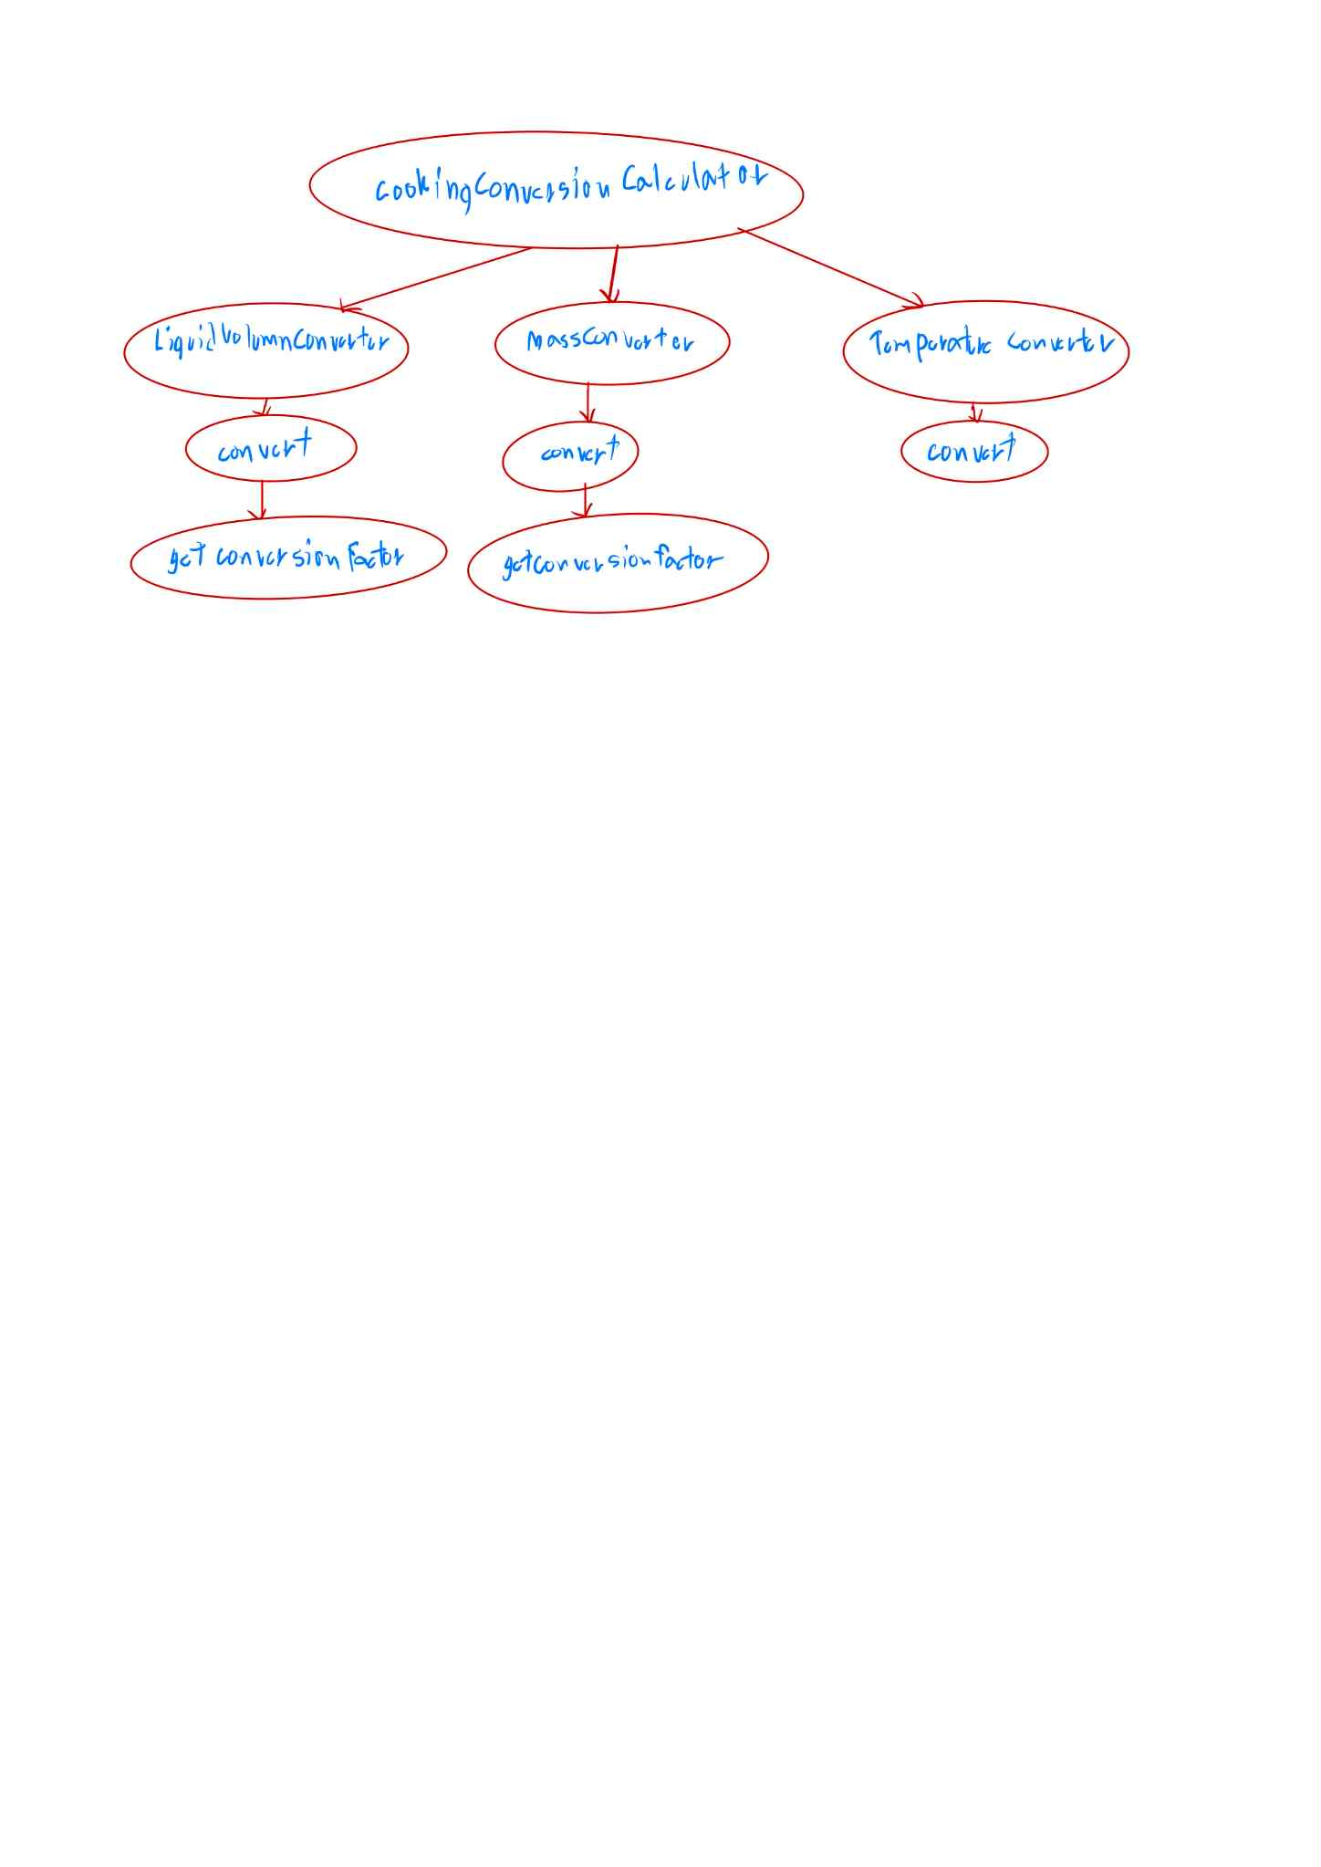

**Top-down Integration**

|  |  |  |  |  |  |  |
| --- | --- | --- | --- | --- | --- | --- |
| Unit under test | List of Stubs/Drivers | result | Stub’s return value | Expected results | Actual results | Pass/Fail/No run |
| CookingConversion Calculator | LiquidVolume Converter, MassConverter, Temperature Converter | 5.0 | 5.0 | 5.0 | 5.0 | Pass |
| LiquidVolume Converter | Convert (liquid) | 1000.0 | 1000.0 | 1000.0 | 1000.0 | Pass |
| Convert (liquid) | getConversion Factor (liquid) | 1000.0 | 250.0 | 1000.0 | 1000.0 | Pass |
| getConversion Factor (liquid) | - | 250.0 | - | 250.0 | 250.0 | Pass |
| MassConverter | Convert (mass) | 80.0 | 80.0 | 80.0 | 80.0 | Pass |
| Convert (mass) | getConversion Factor (mass) | 80.0 | 8.0 | 80.0 | 80.0 | Pass |
| getConversion Factor (mass) | - | 8.0 | - | 8.0 | 8.0 | Pass |
| Temperature Converter | Convert (temp) | 10.0 | - | 10.0 | 10.0 | Pass |
|  |  |  |  |  |  |  |
|  |  |  |  |  |  |  |

Bottom-up Integration

|  |  |  |  |  |  |  |
| --- | --- | --- | --- | --- | --- | --- |
| Unit under test | List of Stubs/Drivers | result | Stub’s return value | Expected results | Actual results | Pass/Fail/No run |
| getConversion Factor (mass) | Convert (mass) | 28.349 | – | 28.349 | 28.349 | Pass |
| getConversion Factor (liquid) | Convert (liquid) | 5.000 | – | 5.000 | 5.000 | Pass |
| Convert (temp) | Temperature Converter | 0.00 | – | 50.00 | 0.00 | Fail |
| Convert (temp) | Temperature Converter | 0.00 | – | 122.00 | 0.00 | Fail |
| Convert (mass) | MassConverter | 283.49 | – | 283.49 | 283.49 | Pass |
| Convert (liquid) | LiquidVolume Converter | 50.00 | – | 50.00 | 50.00 | Pass |
| Convert (liquid) | LiquidVolume Converter | 4731.76 | – | 4731.76 | 4731.76 | Pass |
| LiquidVolume Converter | CookingConversion Calculator | – | – |  | ผ่านทั้งหมด | Pass |
| MassConverter | CookingConversion Calculator | – | – |  | ผ่านทั้งหมด | Pass |
| Temperature Converter | CookingConversion Calculator | – | – |  | ผ่านทั้งหมด | Fail |
| CookingConversion Calculator | – | – | – |  | ผ่านทั้งหมด | Fail |