**STEVE GUTFREUND – 342873791**

**YOEL JASNER – 204380992**

The parameters we used:

* embedding size 64
* representation size 64
* out dim LSTM_#1 32
* out dim LSTM_#2 32
* learning rate 0.0005
* optimizer Adam

Graph 1 – POS data

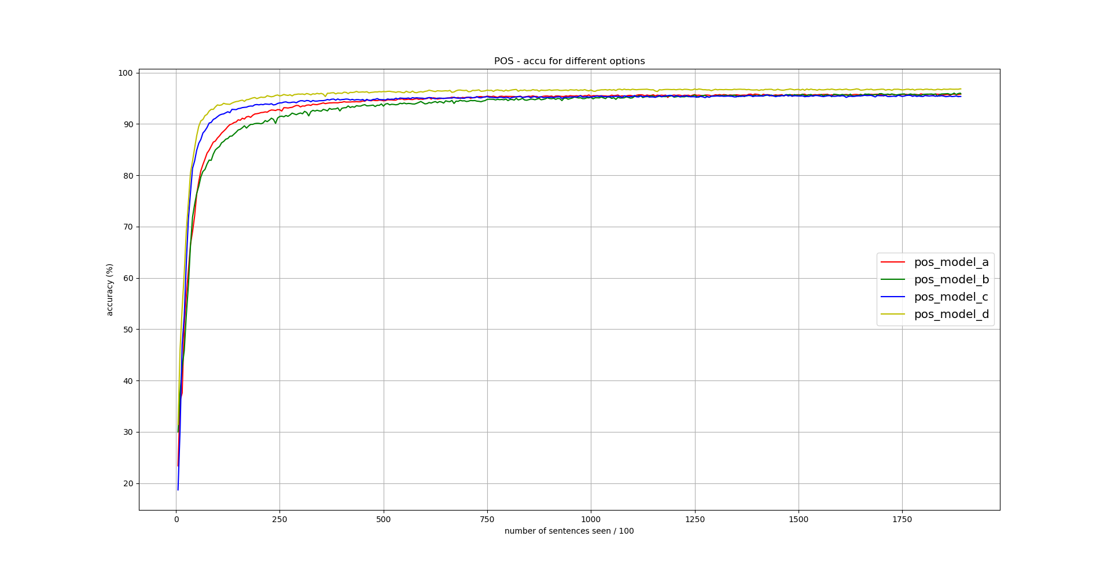(the graphs are well indicated which represents what)

Graph 2 – NER data

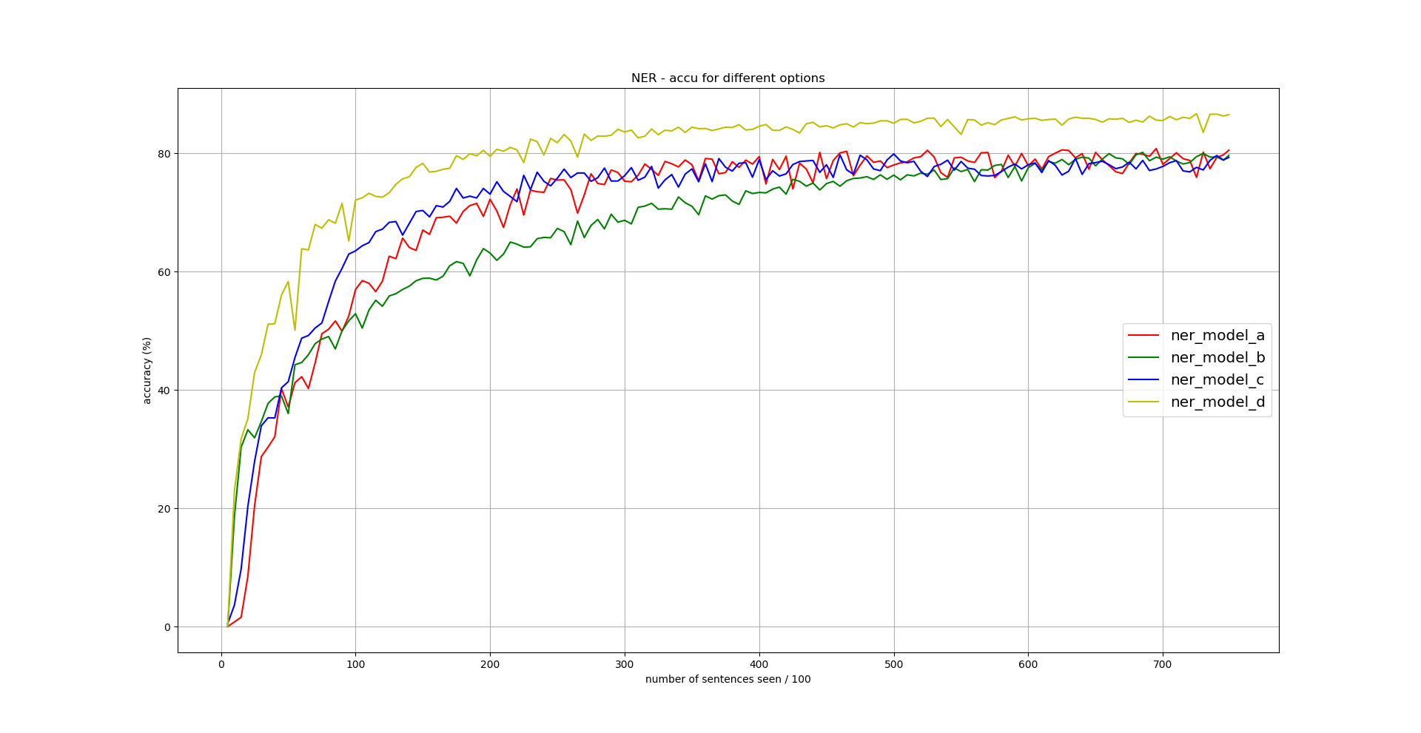(the graphs are well indicated which represents what)