GachaBot Vending Machine

Joseph Dillon   
*Mechanical and Aerospace Engineering  
University of Central Florida*Orlando, USA  
[jo029662@ucf.edu](mailto:jo029662@ucf.edu)

Yoendry Ferro  
*College of Engineering and Computer Science  
University of Central Florida*Orlando, USA  
[yo034336@ucf.edu](mailto:yo034336@ucf.edu)

Zahid Padilla   
*Mechanical and Aerospace Engineering  
University of Central Florida*Orlando, USA  
[za103930@ucf.edu](mailto:za103930@ucf.edu)

Casimir Parker  
*Mechanical and Aerospace Engineering  
University of Central Florida*Orlando, USA  
[ca156586@ucf.edu](mailto:ca156586@ucf.edu)

*Abstract* – As a staple in arcades, the design of gamified vending machines has stagnated in recent years in the United States. GachaBot serves to break this cycle by optimizing the benefits of these machines by improving key factors such as the human-robot interaction and the devices approachability. It also seeks to optimize the attention that it receives by drawing attention to itself during times that the robot has been commonly interacted with at previous time intervals. The design created allows room for further optimizations including supplying the data generated in interactions to its operator to support the success of the business.

*Keywords – Arduino, Gacha, Gashapon, vending.*

# INTRODUCTION

This project aimed to create a social, semi-intelligent robot to engage users purely through facial and auditory interactions. Designed as an homage to the Gachapon, a style of coin-operated vending machine that dispenses collectible capsules, the GachaBot enhances the experience by providing unique, tiered reactions based on the coins inserted.

# METHOD

## Background and Inspiration

Although the Gachapon has a long history worldwide, its modern version came about in Japan during the 1960s. [2,4] These machines were created to dispense small, affordable prizes in capsules, making them accessible to many users. The random nature of the prizes added an element of anticipation that kept people coming back. [4] Over time, their nostalgic and unique appeal made them a cultural staple, enjoyed by both children and adults. [2,4]

The GachaBot borrows heavily from the existing design language of the Gachapon, mimicking its simplicity while focusing on a sleek, minimal design to allow the interactions to focus through. Although a key characteristic of the Gachapon, the crank was removed due to time constraints, making the bold decision to clean up the design. Furthermore, a stylistic digital face and static arms were added to the sketch to give the robot personality and character, as seen in Fig 1.

Fig. 1. Concept Drawings

## Description of Algorithm

A matrix of hours was created in which any interactions with the robot would be added to the relevant row of the hour of the day in which it the interaction was made. This matrix was preset with one interaction at each of the hours of 0800 and 1700 to have pre-set hours in which the robot would call out to be interacted with directly out of the box. As this matrix would be appended with further interactions over subsequent days, the GachaBot will continue to call out at the two hours of the day that it is has been most frequently interacted with since power cycling. While this algorithm would require extensive testing and access to a real-world arcade environment in order to be able to evaluate its success, the logic was found to be sound.

## Computer Aided Design

CAD was an important part of bringing this project to reality. With a one-off concept and design, almost all non-electrical components would need to be designed from the ground up. There are many CAD software’s available, with many offering academic licenses to students. SolidWorks and Shapr3D were chosen for this project for their familiarity and capabilities. Both allow for high precision modeling, and support similar features.

Additive manufacturing would be the primary method of construction, as this project would have a production run of just one prototype. With a team well versed in Fused Deposition Modeling (FDM), it would be the first choice for part manufacturing. FDM is the process of using a nozzle to melt and extrude thermoplastic filaments to build an object layer by layer. This is the most common method of 3D printing. Amongst the team, three printers were available, with only two being utilized.

With the method of production covered, the components to be designed must be addressed. As previously mentioned, SolidWorks and Shapr3D were used to create 3D models of components based on provided concept drawings. Using the volume of the 3D printer as a size constraint, the outer shell of the robot was given an arbitrary perimeter. Height was assigned to make the proportions of the robot similar to the one pictured in the concept drawings, however total height would exceed the print volume. The solution was to separate the base from the head of the robot. This would also allow for easy access to the electronics located inside the head.

Fig. 2. GachaBot Head

Fig. 3. GachaBot Base

Working off the body design, the off-the-shelf coin mechanism would be inserted into the lower body, revealing the size constraints for fitting electronics and the vending mechanism. The Vending mechanism would be designed similarly to a traditional gumball dispenser but would utilize electronic components and logic for functionality rather than the traditional fully mechanical dispenser. An old gumball dispenser uses a rotary coin mechanism that simply will not transfer rotation to the vending mechanism if a coin is not inserted. When a coin is inserted, the rotational energy is transferred along the outer gearing of the coin mechanism to turn a gumball in the vending wafer to a hole that allows it to drop to the dispenser slot.

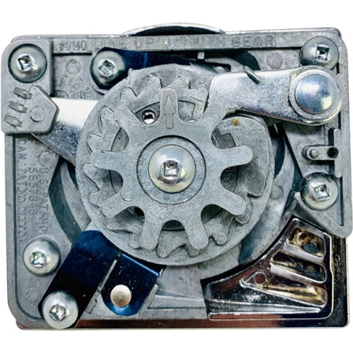

Fig. 4. Gumball Coin Mechanism

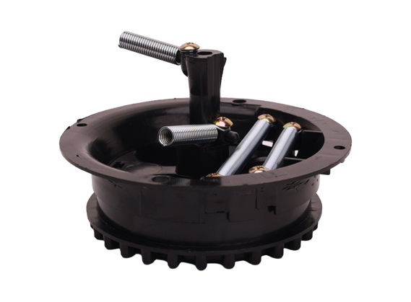

Fig. 5. Gumball Dispensing Mechanism

The system would require a digital coin receptacle for tracking coin counts and responding to coin inputs. Since the signal will be processed by an Arduino, it can also be utilized for vending a capsule when it has been paid for. The initial design aimed to have a constantly rotating mechanism that would stop when a physical momentary switch was pressed by a capsule, just before the drop point. The DC motor this required was large and rather tall, so a servo motor would be used in final design. This servo motor provided a challenge, with only 180 degrees of rotation possible. Luckily the feeding mechanism could be adapted to fit within 180 degrees of the disk from the vending location. Using encoder values and the switch, the vending mechanism could still function as initially designed, only rotating 180 degrees in total, going back to get a capsule once one was vended.

Fig. 6. Vending Mechanism

To avoid the common issue of capsules jamming during the dispensing process, a design in which capsules can be loaded sequentially was adopted, as is shown in Fig. 6. This design also allows the operator to control which prizes will be dispensed and in what order, allowing for further optimization based on traffic pattern data that has been previously collected about the location’s traffic patterns.

While it was originally intended for the arms to participate in the feeling of excitement brought on by the animations, this part of the design was discarded due to the limited interior volume incurred by the size constraints of the available 3D Printers. To replace them, stationary arms were printed and glued to the base of the frame. These arms were modeled in a style similar to Disney’s Eve Robot.

## Electrical Design

The heart of the system was a laptop running Windows which drove the display system and an Arduino Uno, the latter of which drove the coin acceptor, switch, and servo motor. All power was supplied via external power supplies to ensure consistency in the supplied voltage. Capacitors were used to further smooth the voltage supplied to the coin acceptor and servo. Jumper cables were connected from both the 12-volt and the 5-volt power supplies to the Arduino to provide a common ground. Due to these external power supplies, a voltage regulator was not required. Please see Fig. 7 for the configuration of all electrical components. As noted, the arm mechanisms were removed from the design in favor of stationary ones due to the financial and time constraint but adding them would be a simple step of adding two servos to the design in a similar configuration to the one shown that drove the capsule dispenser.

Fig. 7. Electrical Diagram

The purpose of the servo is to drive the capsule dispenser as described in section II C, and the switch is used to verify that a capsule has been properly loaded into the dispensing mechanism. The coin acceptor will send a 100ms signal to the Arduino when a coin is detected, and the angular velocity of the servo is adjusted such that the sampling rate of the Arduino is sufficient to detect the signal from the switch.

## Animations

Given the GachaBot's goal, it was critical to design animations that matched the robot's programmed states. The behavior of the robot's code was mapped out, and preliminary sketches were created as a checklist for the animation process.

The animations were developed using a combination of Alight Motion and Cap Cut and then converted into GIFs for display. However, due to technical limitations, the GIFs were spliced into individual frames and replaced with still images on the GachaBot’s screen.

# RESULTS

## Tentative Evaluation of Machine Learning

While the system did not necessarily utilize machine learning, the algorithm used to find peak interaction times facilitated the robot's adaptation to its environment to maximize its success. The code is comprised of two files, one file to handle the Arduino input and output and another file to handle the display and audio mechanisms. The Arduino file communicated with the display file via serial communications to have the coin count available on both files. The Arduino code sensed coin input and would print the count per insertion until four coins were reached where it would then activate the servo motor to release the capsule. The servo motor would iterate until the tactile push sensor was triggered by the capsule to prevent false capsule releases. The display code would read the serial data from the Arduino and display the proper face based on the coin count. Coin insertions in the display code would trigger the audio as well as increment the interaction counter for the appropriate hour of the day. The robot's algorithm loops through the interactions array and finds the two hours with the most interactions which will then be set as the predefined interaction times for the following day. The display codes loop checks if the current hour is the same as one of the predefined hours and if the condition is found true then the call out face is displayed and the call out audio is played to promote user interaction.

## Demonstration - [YouTube Video](https://youtu.be/DQZd-8DKpCk)

## Code Base – [GachaCode](https://1drv.ms/f/c/b850d4eebf767426/Ej9bNYQ2oYdEicOdRPhUvAcBDRpvGZFpK3bwYswzELrzGQ?e=luFWih)

# DISCUSSION

## Successes

The initial design goals of display functionality and capsule dispensing were executed flawlessly. The emotions were able to be displayed using the display and audios, and the arms were set at an angle that implied the robot’s excitement to be interacted with. The callout functions were also successful in drawing attention to the robot at hours that it had been interacted with during previous days, thereby improving its chances of success over its peers. The capsule dispensing was improved over commercially available modules by adding a validation test to ensure that a capsule was loaded into the mechanism before dispensing.

## Opportunities for Improvement

While all goals were achieved, these goals were simplified from the original project proposal due to unanticipated constraints. The two goals that were simplified but would be possible given a longer time constraint are the display running on GIF’s rather than images and the removal of the articulation of the arms.

## Potential Further Evaluations

Given further time and access to an arcade environment, the robot’s success with respect to the variables of the callout function and emotional cues should be properly evaluated.

1. CONCLUSION

The three-dimensional articulation of the arms was unsuccessful due to the size constraints of the 3D printing process. It will also be beneficial to replace the laptop requirement of the system by adding a low-cost onboard computer. The capsule capacity is currently limited, and it may be beneficial to design a system that requires refilling less frequently. Converting the images that were displayed to an animated gif may also improve the chances of success by making the robot seem more natural during the human-robot interactions. The interactions of the robot were successfully made to be more human in a way that promoted interaction, but did not go so far as to enter the uncanny valley. As an unintentional result, a more reliable method of dispensing prizes was also developed and optimized.

1. CONTRIBUTION

## Dillon, Joseph

## Ferro, Yoendry

## Padilla, Zahid

## Parker, Casimir

1. REFERENCES

[1] “Beaver 75 Cent Coin Mechanism Replacement.” *CandyMachines*, [www.candymachines.com/Beaver-75-Cent-Coin-Mechanism-Replacement-P7300.aspx](http://www.candymachines.com/Beaver-75-Cent-Coin-Mechanism-Replacement-P7300.aspx). Accessed 30 Nov. 2024.

[2] Chen, Shun-Hsing, et al. “An empirical analysis of the joy of purchasing Gashapon and customer satisfaction survey.” *International Journal of Business Management and Economic Review*, vol. 06, no. 04, 2023, pp. 80–92, <https://doi.org/10.35409/ijbmer.2023.3507>. Accessed 24 Nov. 2024.

[3] “Gum Wheel Assembly for Wizard Spiral Gumball Machine.” *Gumball*, <http://www.gumball.com/products/gum-wheel-assembly-for-wizard-spiral-gumball-machine.> Accessed 30 Nov. 2024.

[4] Zhuoyun, Lin, and Zhang Yankun. “From brand identity to brand loyalty.” *Advances in Economics, Business and Management Research*, 2021, <https://doi.org/10.2991/assehr.k.211209.434>. Accessed 24 Nov. 2024.